JEWS
AND
GENTILES

A. T. JONES

Source:
Advent Review and Sabbath Herald
September 12, 1899 to April 17, 1900

Cover:
Wild Olive Tree in Adamkayalar, Mersin
Zeynel Cebeci, November 20, 2016
wikimedia

Fonts:
Liberation Sans Narrow
Linux Biolinum
Linux Libertine


August 2021
www.srac.info
www.practicaprophetica.com

Contents
- The Meaning of the Names 1
- Jeremiah’s Prophecy 3
- Ezekiel’s Prophecy 7
- The Vineyard 9
- The Gospel Supersedes the Old Order 13
- All Justified by Faith 17
- No Difference 21
- What Advantage? 25
- Why Was Paul Sorrowing? 29
- Has God Cast Them Away? 35
- The Green Olive Tree 41
- The Gathering of Israel 45
Editor’s Note:
This series was a prelude to the studies on “The Millennium” which are also available in a separate book.
The reader should also bear in mind that when A. T. Jones adamantly insisted that the Jews would not “return” he was referring not to a mere physical return to a physical Palestine (which has happened), but rather to a return to the spiritual privileges and position they had as a “nation under God.” This is made clear in his statement in Chapter 5:
“…their re-establishment there as a nation and a peculiar people for whom and by whom God is to do great things.”
Any other kind of “return” which is not a return to God, is not in harmony with the promises and prophecies.
- The Meaning of the Names
Advent Review, September 12, 1899
IT IS interesting, it is also important, to note and to know the reason of the distinction in terms always made in the Bible between Jews and Gentiles.
The term “Gentiles” simply signifies “nations.” When the word “Gentile,” only signifies the nations, why should there be a distinction, and how could there be a distinction fairly drawn, between Israel and the other? between the Jews, who were a nation, and the Gentiles, who were nations?
The distinction is a proper one. Turn to God’s word concerning Israel as they were yet in the wilderness, before they had entered the promised land; when Balaam cursed them, and God turned the curse into a blessing. One of the things which God caused Balaam to say, at that time, was this:
Numbers 23
9 Lo, the people shall dwell alone, and shall not be reckoned among the nations.
There is the ground of distinction between Israel and the Gentiles, which are the nations. Israel, in God’s order, never was intended to be a kingdom, a state, a government, nor a nation, in this world, as the nations are, and as Israel became when she rejected God, and set up a state of her own, and called for a king.
When Israel called for a king to rule over them, Samuel was greatly displeased, and prayed to the Lord. And the Lord told him that he need not grieve over this matter;
1 Samuel 8
7 ...for they have not rejected you; but they have rejected me, that I should not reign over them.
Thus Israel became a nation of the earth only by rejecting God. All the other peoples had rejected God, and become nations, from the time of Nimrod downward.
Israel, instead of holding fast to God by faith, and having Him to reign over them, rejected God, that they might be like all the nations. And the only result followed that could follow: having rejected God, that they might be like all the nations, they became like all the nations that rejected God: and, as a nation, perished like them all.
Numbers 23
9 Lo, the people shall dwell alone, and shall not be reckoned among the nations.
That is the basis of the distinction between Jew and Gentile, between Israel and the nations. And that basis holds, forever the same. Today the Gentiles are the nations, and the nations are the Gentiles. And today, as ever, it is God’s will that His “people shall dwell alone, and shall not be reckoned among the nations.”

- Jeremiah’s Prophecy
Advent Review, December 12, 1899
Jeremiah 19
1 Thus says the Lord, Go and get a potter’s earthen bottle, and take of the ancients of the people, and of the ancients of the priests;
2 And go forth unto the valley of the son of Hinnom, which is by the entry of the east gate, and proclaim there the words that I shall tell you,
3 And say, Hear the word of the Lord, O kings of Judah, and inhabitants of Jerusalem; Thus says the Lord of hosts, the God of Israel; Behold, I will bring evil upon this place, the which whosoever hears, his ears shall tingle.
4 Because they have forsaken me, and have estranged this place, and have burned incense in it unto other gods, whom neither they nor their fathers have known, nor the kings of Judah, and have filled this place with the blood of innocents;
5 They have built also the high places of Baal, to burn their sons with fire for burnt offerings unto Baal, which I commanded not, nor spoke it, neither came it into my mind:
6 Therefore, behold, the days come, says the Lord, that this place shall no more be called Tophet, nor The valley of the son of Hinnom, but The valley of slaughter.
7 And I will make void the counsel of Judah and Jerusalem in this place; and I will cause them to fall by the sword before their enemies, and by the hands of them that seek their lives: and their carcasses will I give to be meat for the fowls of the heaven, and for the beasts of the earth.
8 And I will make this city desolate, and a hissing; every one that passes thereby shall be astonished and hiss because of all the plagues thereof.
9 And I will cause them to eat the flesh of their sons and the flesh of their daughters, and they shall eat every one the flesh of his friend in the siege and straitness, wherewith their enemies, and they that seek their lives, shall straiten them.
10 Then shall you break the bottle in the sight of the men that go with you,
11 And shall say unto them, Thus says the Lord of hosts; Even so will I break this people and this city, as one breaks a potter’s vessel, that cannot be made whole again: and they shall bury them in Tophet, till there be no place to bury.
PLEASE read over and consider carefully that passage of Scripture. First, notice the point of time at which it certainly applies: then its force and bearing upon this subject will be more fully discerned. The point of time at which it applies is not the siege and destruction of the city and the captivity of the people by Nebuchadnezzar:
- Because in that siege there was no such straitness as is here described; although “all the bread in the city was spent,” and there was great distress; yet they were not so sorely driven by want as to eat human flesh, much less the flesh of their own children.
- Because the same prophet Jeremiah told that same people that the destruction of the city and the scattering of the people by Nebuchadnezzar would be for only seventy years, and then they should be gathered again from every nation, and the city would be rebuilt, saying,
Jeremiah 33
10 Thus says the Lord; Again there shall be heard in this place, which you say shall be desolate without man and without beast, even in the cities of Judah, and in the streets of Jerusalem, that are desolate, without man, and without inhabitant, and without beast,
11 The voice of joy, and the voice of gladness, the voice of the bridegroom, and the voice of the bride, the voice of them that shall say, Praise the Lord of hosts: for the Lord is good; for His mercy endures for ever: and of them that shall bring the sacrifice of praise into the house of the Lord. For I will cause to return the captivity of the land, as at the first, says the Lord.
5 They come to fight with the Chaldeans, but it is to fill them with the dead bodies of men, whom I have slain in my anger and in my fury, and for all whose wickedness I have hid my face from this city.
6 Behold, I will bring it health and cure, and I will cure them, and will reveal unto them the abundance of peace and truth.
7 And I will cause the captivity of Judah and the captivity of Israel to return, and will build them, as at the first.
8 And I will cleanse them from all their iniquity, whereby they have sinned against me; and I will pardon all their iniquities, whereby they have sinned, and whereby they have transgressed against me.
9 And it shall be to me a name of joy, a praise and an honor before all the nations of the earth, which shall hear all the good that I do unto them: and they shall fear and tremble for all the goodness and for all the prosperity that I procure unto it.
These facts make it certain that the prophecy of Jeremiah 19, given by the symbol of the potter’s earthen bottle and the breaking of the bottle, had no reference to the destruction of the city and the captivity of the people by Nebuchadnezzar.
A study of the facts and the Scriptures, however, makes it certain that the point of time at which Jeremiah 19 does apply is the destruction of Jerusalem and the scattering of the people by the Romans, under Titus:
- Because at that time the siege and straitness was so desperate that the frantic people did actually eat their own children. Read the terrible story, in literal fulfillment of Jeremiah 19:9, in Josephus.
- This was also foretold by Moses in Deuteronomy 28:53-57. And Moses said that this siege would be by “a nation whose tongue you shall not understand,” which absolutely fixes it to the Romans; for the Jews never had any difficulty in understanding the Babylonians, while the Latin of the Romans was altogether a strange tongue.
It being certain then that the time at which Jeremiah 19 applies is the destruction of Jerusalem and the scattering of the people by the Romans, what now says this scripture as to the return of the Jews? What was done with that bottle?
Jeremiah 19
10 Then shall you break the bottle in the sight of the man that go with you.
What kind of bottle was it?
1 ...A potter’s earthen bottle.
What of such a bottle when it has been broken?
11 [It] cannot be made whole again.
If it were a glass bottle or a brazen bottle, and it were broken, it could be made whole again, even if only by melting and molding again. But when clay has once been burned, nothing can ever be made of it afterward even if it be reduced again to dust. An earthen bottle, therefore, once broken, literally “cannot be made whole again.”
And when he had broken that bottle, which could not be made whole again, then he said to the witnesses:
11 Thus says the Lord of hosts: Even so will I break this people and this city, as one breaks a potter’s vessel, that can not be made whole again.
Then as an earthen vessel, when broken, “cannot be made whole again,” even so the people and nation of the Jews since their having been broken by the Romans, “cannot be made whole again.” And whatever any other may say, even “Thus says the Lord of hosts.”
- Ezekiel’s Prophecy
Advent Review, December 19, 1899
EZEKIEL was one of the persons who had been carried captive to Babylon in the second captivity that was made by Nebuchadnezzar.
In captivity he wrote his book; and in the 16th chapter of his book he wrote of the wickedness of Jerusalem in comparison with the wickedness of Samaria and of Sodom, and said that though Samaria had been wicked, and Sodom had been wicked, the wickedness of Jerusalem was even greater than theirs; and then he said:
Ezekiel 16
55 When your sisters, Sodom and her daughters, shall return to their former estate, and Samaria and her daughters shall return to their former estate, then you and your daughters shall return to your former estate.
As in the passage noted last week—Jeremiah 19—it is plain that this verse can have no connection with the subject of the return from the captivity to Babylon, because the word was plainly given that they should return in seventy years, while of this the only possible thought conveyed is that there cannot be any return; for Samaria was utterly destroyed, and her people scattered: nevermore mentioned nor known. Sodom, as everybody knows, was consumed with fire from heaven.
Now that the destruction of Sodom was final, and that from it there can be no possible return, is certain from the word which says that in that destruction, Sodom, with her neighboring cities, suffered “the vengeance of eternal fire;” that is, the destruction accomplished by that fire was so thorough that from it there can be no possible return until the day of Judgment, of which Jesus spoke.
And, indeed, these words of Ezekiel are confirmed by the words of Jesus when He upbraided…
Matthew 11
20 ...the cities wherein most of His mighty works were done.
Among these cities was Capernaum, to which He said:
Matthew 11
23 And you, Capernaum, which are exalted unto heaven, shall be brought down to hell: for if the mighty works, which have been done in you, had been done in Sodom, it would have remained until this day.
24 But I say unto you, That is shall be more tolerable for the land of Sodom in the day of Judgment, than for you.
And this same thing was said by Jesus concerning every city and every house which received not Him, nor is messengers, nor hearkened to their words; for when He sent forth His disciples to the cities and houses of the people of Israel in that day, He said:
Matthew 10
14 Whosoever shall not receive you, nor hear your words, shake off the dust of your feet.
15 Verily I say unto you, It shall be more tolerable for the land of Sodom and Gomorrah in the day of Judgment, than for that city.
And when Jerusalem, the national city, and by the national authority, through the national representatives, did even worse than did these cities, how can it possibly be better with her than with them? And when it will be more tolerable for Sodom and Gomorrah than for her, then what can possibly be for her?
Upon all this is can be said of the return of the Jews, exactly in the words of Ezekiel: When Sodom shall return, then the Jews shall return. And as it is certain that Sodom will not return until the Judgment, and will then return only unto judgment; so it is just as certain that the Jews will not return until the Judgment, and will then return only to judgment, and a severer judgment than that of Sodom and Gomorrah.
- The Vineyard
Advent Review, December 26, 1899
IN Matthew 21:33-44 Jesus spoke to the Jews the parable of the householder, who planted a vineyard, and hedged it about, and dug a winepress in it, and built a tower, and let it out to husbandmen, and went into a far country, expecting the husbandmen to render to him the fruits of the vineyard.
But, lo! when he sent his servants to receive the fruits, instead of rendering the fruits to the master of the vineyard, the husbandmen took the servants, and beat one, and killed another, and stoned another, and continued so to do until at the last the owner of the vineyard sent unto them his son, saying,
Matthew 21
37 ...They will reverence my son.
But instead of reverencing the son; and, even at the last, rendering the fruit of the vineyard to the owner, they said among themselves:
38 This is the heir; come, let us kill him, and let us seize on his inheritance. And they caught him, and cast him out of the vineyard, and slew him.
Now, though this is a parable, it is not by any means an imaginary story; for, from the very first word of it until the last, it is simply the report of actual occurrences. It was all, from first to last, simply gathered from what for ages had been written in the Scriptures, which those people were constantly studying, and which they pretended to reverence so highly as to make them above all things “the people of the Book.”
The most of the scripture which is the basis of the story is in Psalm 80:8-16 and Isaiah 5:1-7. And in Isaiah the appeal is made:
Isaiah 5
3 And now, O inhabitants of Jerusalem, and men of Judah, judge, I pray you, betwixt me and my vineyard.
And when Jesus had recounted the story up to the point where they had caught the son, and cast him out of the vineyard, and had slain him, He said to them:
Matthew 21
40 When the lord therefore of the vineyard comes, what will he do unto those husbandmen?
Here now is the time for the decision and the judging; and the judging is submitted to those very husbandmen to whom had been committed the care of the vineyard.
What, then, is the judgment which pronounced in this case, as between the master of the vineyard and the husbandmen to whom he had committed its care? Whatever it is, it is the judgment which they passed upon themselves. What judgment is it, then, which they passed now upon themselves?
41 They say unto him, He will miserably destroy those wicked men, and will let out his vineyard unto other husbandmen, which shall render him the fruits in their seasons.
Then said Jesus:
43 Therefore say I unto you, The kingdom of God shall be taken from you, and given to a nation bringing forth the fruits thereof.
Thus it is certain, by the judgment of the nation of the Jews, which they pronounced between the Lord and themselves, and thus pronounced upon themselves; and by the word of God plainly spoken, that the kingdom of God was taken from the Jews and given to another nation.
And there is no word that it should ever be taken from this other nation, and given back to the Jews. The only thing henceforth is that, whatever part the Jews shall have in that kingdom, they must get it exactly as do this other nation to whom the kingdom is now given. In other words, they must get it exactly as the Gentiles do.
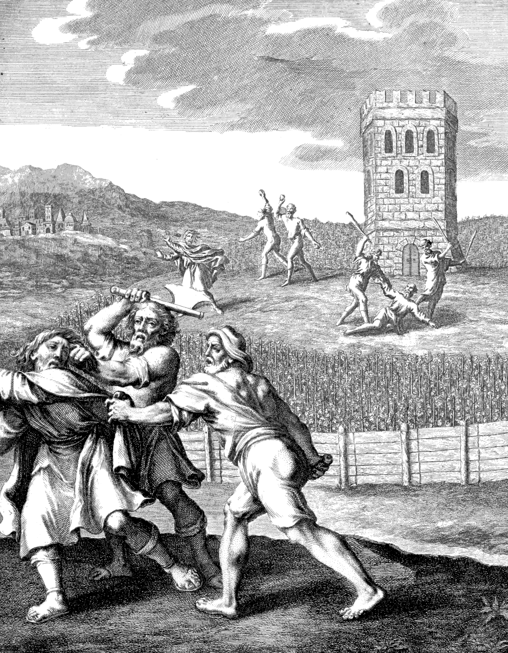Parable of the Vineyard and Householders
(Biblia, 1751)

And that this is so, is plain from the word of the Lord in the passage in Isaiah, which is a principal part of this parable spoken by Jesus. There the Lord appeals to all, thus:
Isaiah 5
4 What could have been done more to my vineyard, that I have not done in it?
If there could have been another thing which could possibly have been done by the Lord for that people, it would have been done before they were scattered. But when the Lord had done everything that even He could do; and had so thoroughly done everything that He could appeal to the wide universe for anybody to tell Him what more could have been done, then it is certain that there is nothing more that can possibly be done.
From this appeal, it is plain that if anybody can suggest anything that can be done that has not been done, he will in that have discovered something that the Lord never could find out. But that never can be. Nobody can conceive of anything that could be done for the Jews that has not already been done for them by the Lord.
And any Jew who is not brought to God and saved to the uttermost by that which God has already done, can never be brought to God at all; which is only to say again that since the kingdom of God, by their own judgment, has been justly and rightly taken from the Jews, and given to another nation, all of them that shall ever see the kingdom of God must find it exactly as do all those of this other nation who find it.

- The Gospel Supersedes the Old Order
Advent Review, January 2, 1900
FOR anybody to claim, to advocate, or to believe in, the “return of the Jews,” shows that such person has no true conception of the gospel. This is plain from the words quoted in last week’s article,—the Lord’s appeal to all people before this people were scattered:
Isaiah 5
4 What could have been done more to my vineyard, that I have not done in it?
The final thing which the Lord did, was, as He himself says, to send His Son. And, in His Son, God gave himself; for
2 Corinthians 5
19 God was in Christ, reconciling the world unto himself;
and
Colossians 2
9 ...in Him dwells all the fullness of the Godhead bodily.
And whosoever accepts Him is, in the nature of the case,
10 ...complete in Him.
And any Jew can find all this any moment that he chooses, and at any place that he may be in this wide world. He can find it in America as well as in Palestine: he can find it in New York City, in Hong Kong, in Calcutta, in London, or anywhere else, just as well as in Jerusalem.
Then, what possible need can there be that the Jews should return to Jerusalem? What can God do for them there, more than He did for the Jews before they were ever scattered from there? Has He another Son whom He can give? Has He yet a greater gift than himself that He can bestow? Has He a greater gift than “all the fullness of the Godhead bodily” to give, even though He had another Son whom He might send?
It is perfectly plain, therefore, that any claim of the return of the Jews to Jerusalem, or to Palestine, betrays an utter lack of the true value of the gospel. For there can be no question whatever that what we have here suggested must inevitably be involved in any return of the Jews; but there is no possible place for any such that as that. God has no other Son to give. He has no greater gift than “all the fullness of the Godhead bodily,” to give, even though He had ten thousand other sons, greater even than Jesus.
Then, as He has already given His only begotten Son; as in Him He has given…
Colossians 2
9 ...all the fullness of the Godhead bodily;
–as all this was given to the Jews while they were yet a people, and was rejected by them, and upon their own judgment was given…
Matthew 21
43 ...to a nation bringing forth the fruits thereof,
–as God has thus done all that it can be possible for even Him to do; and as the benefit of all this can be had by any Jew, wherever he is on earth, at any moment when he will choose to receive it; so there is neither necessity, nor place, nor yet a possibility, of any return of the Jews to Palestine or Jerusalem, or of their re-establishment there as a nation and a peculiar people for whom and by whom God is to do great things.
Another feature of this claim of the return of the Jews, which betrays an absolute lack of knowledge of the gospel, is that those who claim it actually hold not only that the Jews are to return, but that they are to rebuild the city of Jerusalem, to rebuild the temple, and re-establish the temple services, sacrifices, offerings, etc., etc.
But since the time of the offering of Christ once for all, the offering of a sacrifice is the denial of Christ. And the establishment of a priestly service on earth is a denial of the priesthood of Christ, which is simply denial of His intercession. To establish a sanctuary service on the earth would be only to deny the sanctuary and its services in heaven.
Thus any such scheme as is proposed in the claim of the return of the Jews is a denial of all that God has done in the gift of Christ, and if carried out, would be only a repudiation of all that Christ has done since His ascension to heaven, and all that He is now doing.
But this whole subject was discussed, and this whole ground was covered, in the first days of Christianity, in the contest carried on by “the Pharisees which believed,” against the gospel as preached by Stephen in the earliest days of the gospel after the ascension of Christ, and by Paul afterward.
And the truth of the question—the truth of the gospel, as against this destructive error—is all made plain in the book of Galatians. There it is made plain that all distinctions in behalf of the Jew are utterly broken down, exactly as Jesus said in the parable; and exactly as the Jews decided in their judgment upon the case as presented in the parable,—that the kingdom of God was taken away from them and given to others,—and that whatsoever the Jew obtains must be obtained precisely as by any others. Accordingly, over and over it is written:
Galatians 3
28 There is no difference between the Jew and the Greek.
A thorough study, therefore, of the book of Galatians is the best course to an understanding of the truth of the gospel as concerns the Jews, and so is the best refutation of all claims of “the return of the Jews.”
From these considerations it is perfectly plain that under the present order of things in the gospel, there can be no “return of the Jews” according to the claims that are made as to the return of the Jews; that the only possible way that there can be any such return of the Jews would be to pass by all the present order of things in the gospel, and for the Lord to set up an altogether new system of things, an absolutely new procedure.
Accordingly, to every claim of the “return of the Jews,” there is inevitably attached an “age to come,” in which is involved the millennium. And this is why it is that the subject of the “return of the Jews” and “the millennium” are so intimately connected. And thus we are brought to the study of the truth as to the millennium, as further answer to all claims of the “return of the Jews.”

- All Justified by Faith
Advent Review, February 20, 1900
IN OUR studies on the “return of the Jews,” we found that the Scriptures, and the whole principle of the gospel, are directly against it. we found also that those who claim and advocate a return of the Jews as a people—a nation, to be re-established in the land of Palestine—are, by their claim, obliged to find another order of things from that of the true gospel as it is in Christ—another long period of time, indeed, an “age to come,” this “age” including the “millennium.”
In the studies on the Millennium, we have found, by the straightforward story of the word of God, from the present day entirely through to the creation of the new earth and its everlasting occupation by the saved, that there is no possible place for any such long period of time, or “age, to come,” and, therefore, no possible place for any such return of the Jews as a people, a nation, to be re-established in the land of Palestine, as is claimed by those who advocate the return of the Jews.
And even so says the Scripture. How often in the New Testament there stands the expression,
Romans 10 [see also Acts 15:9, Romans 3:22]
12 There is no difference between the Jew and the Greek.
But what can be the force of any such expression when there is to be manifested such an enormous difference as is involved in this claim of the return of the Jews,—that they must be gathered from all the nations of other people, to that one particular place; and blessings, bounties, and favors be showered upon them, and not upon other people?
It is true that the claim contemplates that these shall be made the means of conveying these things to other people; but this does not relieve the scheme from the charge that it does make a decided difference between the Jew and the Greek—the Jew and the Gentile. This, because the claim is that the Jews are to be gathered thus simply because they are Jews, without any reference whatever to character.
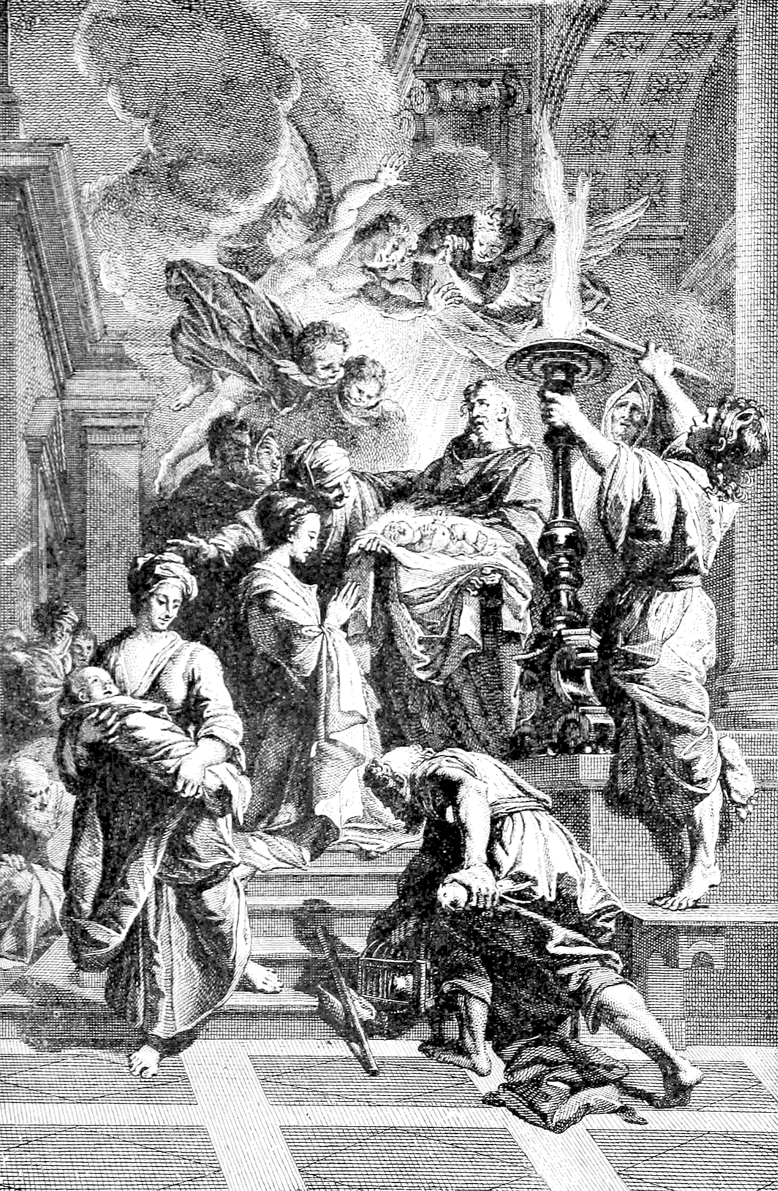Simeon prophesies: "A Light to lighten the Gentiles."
(Spirit of the Holy Bible, 1874)

It is true that God uses those who receive His blessing, His light, His truth, to convey all these to those who have them not; but all His blessing, all His light, and all His truth are equally open and free to all people alike to be received. And those who receive them are used to convey His blessings to others, not because they have been especially chosen from among all other people, without regard to character; but solely because of the character they have obtained in the accepting of these things from God, which were equally open to all. This is the gospel call and the gospel work, always and everywhere.
But such is not in any sense the claim to the return of the Jews. In that scheme a man is to be drawn to Jerusalem simply because he is a Jew, without reference to what his character is. Then, when these Jews have been gathered there, it seems that the claim is that the Lord is to manifest himself to them in such a stupendously impressive and open way that they simply can’t refuse to believe in Him and to receive Him as the Messiah.
And, surely, that can be nothing else than the making of a boundless difference between the Jew and the Greek. For if the Jew is thus to be gathered there simply because he is a Jew, and without reference to character, and, after he gets there, the Lord is to be so astonishingly revealed to him that he simply cannot refuse any longer to believe, would not the same plan be equally effective in bringing any other man, and, indeed, EVERY other man, to the same point? And to do it for one man, or for one set of men, and not for all alike, could not possibly be anything else than putting a difference between those and others.
But there stands the Scripture forever:
Acts 10
34 God is no respecter of persons.
Romans 10
12 There is no difference between the Jew and the Greek.
Therefore it is certain that every Jew must believe in and receive Christ, and what He has to give, precisely as every Gentile must believe in and receive Him.
Romans 3
29 Is He the God of the Jews only? is He not also of the Gentiles? Yes, of the Gentiles also:
30 Seeing it is one God, which shall justify the circumcision [the Jews] by faith, and uncircumcision [the Gentiles] through faith.
It follows that for both alike the means of justification, of salvation, is faith—not faith for the Gentile, and sight for the Jew; but faith alone for both alike. For,
Romans 10
12 There is no difference between the Jew and the Greek; for the same Lord over all is rich unto all that call upon Him.

- No Difference
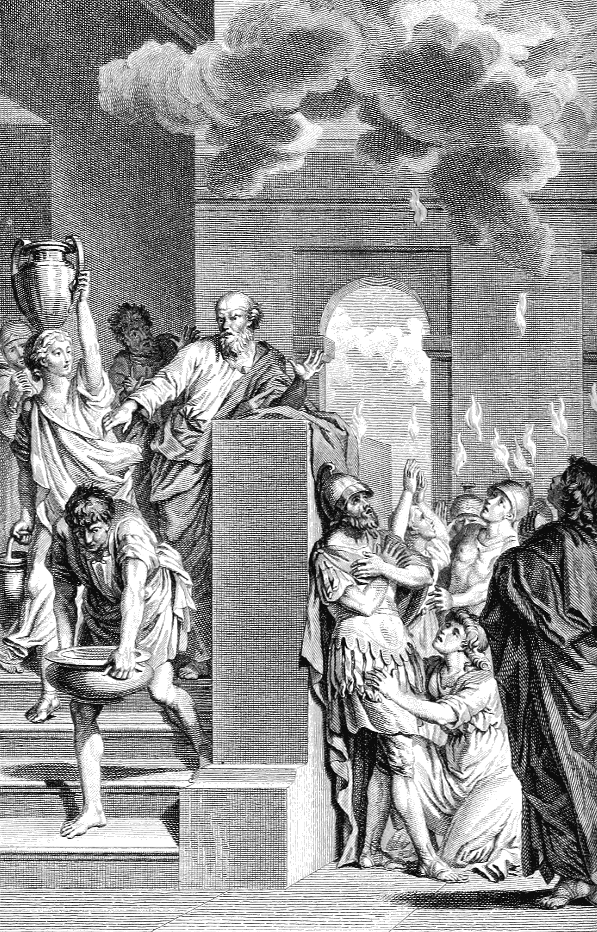The Holy Spirit descends on the Gentiles as Peter speaks.
(La Sainte Bible, 1789)

Advent Review, February 27, 1900
Romans 10
12 For there is no difference between the Jew and the Greek.
IT WILL be of interest to notice the scriptures which discuss the great truth that there is no difference between the Jew and the Gentile. Here is one passage of divine argument as to the relative standing, and the true standing, of the Jews and the Gentiles:
Romans 2
17 Behold, you are called a Jew, and rest in the law, and make your boast of God,
18 And know His will, and approve the things that are more excellent, being instructed out of the law;
19 And are confident that you yourself are a guide of the blind, a light of them which are in darkness,
20 An instructor of the foolish, a teacher of babes, which have the form of knowledge and of the truth in the law.
21 You therefore which teach another, teach not yourself? you that preach a man should not steal, do you steal?
22 You that say a man should not commit adultery, do you commit adultery? you that abhor idols, do you commit sacrilege?
23 You that make your boast of the law, through breaking the law dishonor you God?
24 For the name of God is blasphemed among the Gentiles through you, as it is written.
25 For circumcision [being a Jew] verily profits, if you keep the law: but if you be a breaker of the law, your circumcision is made uncircumcision.
26 Therefore if the uncircumcision [the Gentile] keep the righteousness of the law, shall not his uncircumcision be counted for circumcision?
27 And shall not uncircumcision [the Gentile] which is by nature, if it fulfill the law, judge you [the Jew], who by the letter and circumcision do transgress the law?
28 For he is not a Jew, which is one outwardly; neither is that circumcision, which is outward in the flesh:
29 But he is a Jew, which is one inwardly; and circumcision is that of the heart, in the spirit, and not in the letter; whose praise is not of men, but of God.
Now, how would it be possible more forcibly to show that there is not, and cannot be, any sort of difference between Jew and Gentile; for the whole question of the relation of either to God, turns upon character. “There is no respect of persons with God;” there is respect of character.
And the sole standard of character is the righteousness of God, which is expressed in His law. And when a Jew disregards the law of God, in character he is a Gentile, and in person he is as a Gentile. And when a Gentile keeps the righteousness of the law, and so fulfills the law, he becomes in character a true Jew, and in person is as a Jew. This because being truly a Jew consists altogether in character, in the true circumcision,
Romans 2
29 ...of the heart, in the spirit,
–which is, indeed,
Colossians 2
11 ...the putting off of the body of the sins of the flesh,
–and having the love of God shed abroad in the heart, which love is manifested in the keeping of the His commandments.
Since, then, when a Jew according to the flesh, wanders from God, and by transgression of the law of God his circumcision is made uncircumcision, and he becomes a Gentile in character, and as a Gentile in person; and when a Gentile comes to God, and his uncircumcision becomes circumcision, and he becomes in character truly a Jew, and in person is as a Jew, what is this but a return—a true return—of the Jew? And even so says the Scripture, in another place:
Romans 9
6 They are not all Israel, which are of Israel;
7 Neither, because they are the seed of Abraham, are they all children; but, In Isaac shall your seed be called.
8 That is, They which are the children of the flesh, these are not the children of God: but the children of the promise are counted for the seed.
And,
Galatians 4
28 WE, brethren [Galatians—Gentiles], as Isaac was, are the children of promise.
29 But as then he that was born after the flesh persecuted him that was born after the Spirit, even so it is now.
30 Nevertheless what says the scripture? Cast out the bondwoman and her son: for the son of the bondwoman shall not be heir with the son of the freewoman.
And when the son of the bondwoman shall not be heir with the son of the freewoman, how much less shall he be heir above the son of the freewoman, as the theory of the “Return of the Jews” represents him!
And all this is simply to say again that the only way of return for the Jews is the way of the faith of Jesus Christ, the way of the truth of the one gospel of Christ, the way of return of all sinners alike: even as is demonstrated over and over in the books of Galatians, Romans, and Hebrews especially, as it is also in the other books of the New Testament, as well as in the very essence of the whole plan of the gospel itself.

- What Advantage?
Advent Review, March 6, 1900
IN VIEW of the fact that “there is no difference between the Jew and the Greek”; and that disregard of the law of God turns circumcision into uncircumcision, a Jew into a Gentile; while observance of the law of God turns uncircumcision into circumcision, a Gentile into a true Jew, the Scripture very appropriately asks the questions:
Romans 3
1 What advantage then has the Jew? or what profit is there of circumcision?
And although there is advantage, yet it is in no wise of a sort that calls for any return of the Jews, just because they are Jews—Jews after the flesh. The Scripture answers these questions; but in the answers to the questions, it is nowhere given as one of the advantages which the Jew has that he should return to Palestine.
Though there is much advantage, every way, yet the chief of all the advantages that ever were to the Jews for any cause, is:
2 Chiefly, because that unto them were committed the oracles of God.
And even these oracles were committed to them, not for their sakes but for the fathers’ sakes, that God might fulfill the promise made to the fathers. And the promise made to the fathers was not because of any personal favor that God would show to them; but was altogether because of the character that they had developed through faith in God.
And these oracles were committed to them that they, in turn, might convey to all nations of the Gentiles the knowledge of God as revealed in those oracles. And when, instead of doing so, those people abused those oracles, they became even worse than the heathen who had not had the great light that had been given to them.
So, then, neither were the oracles committed to them because they were better than other people, nor did the mere committing of the oracles to them make them better than others; for, in view of the fact of this chief advantage “that unto them were committed the oracles of God,” it is written:
Romans 3
9 What then? are we [the Jews] better than they [the Gentiles]? No, in NO WISE: for we have before proved both Jews and Gentiles, that they are all under sin;
10 As it is written, There is none righteous, no, not one:
11 There is none that understands, there is none that seeks after God.
12 They are all gone out of the way, they are together become unprofitable; there is none that does good, no, not one.
13 Their throat is an open sepulcher; with their tongues they have used deceit; the poison of asps is under their lips:
14 Whose mouth is full of cursing and bitterness:
15 Their feet are swift to shed blood:
16 Destruction and misery are in their ways:
17 And the way of peace have they not known:
18 There is no fear of God before their eyes.
19 Now we know that what things soever the law says, it says to them who are under the law: that every mouth may be stopped, and all the world may become guilty before God.
20 Therefore by the deeds of the law there shall no flesh be justified in His sight: for by the law is the knowledge of sin.
21 But now the righteousness of God without the law is manifested, being witnessed by the law and the prophets;
22 Even the righteousness of God which is by faith of Jesus Christ unto all and upon all them that believe: for there is no difference:
23 For all have sinned, and come short of the glory of God;
24 Being justified freely by His grace through the redemption that is in Christ Jesus:
25 Whom God has set forth to be a propitiation through faith in His blood, to declare His righteousness for the remission of sins that are past, through the forbearance of God;
26 To declare, I say, at this time His righteousness: that He might be just, and the justifier of him which believes in Jesus….
29 Is He the God of the Jews only? is He not also of the Gentiles? Yes, of the Gentiles also:
30 Seeing it is one God, which shall justify the circumcision by faith, and uncircumcision through faith.
Thus again it is demonstrated by the argument of the plain word of God that faith—the faith of Jesus Christ—is the only way for any return of either Jew or Gentile, and is the one only way for both alike. And this faith is equally within the reach of Jew and Gentile wherever they may be. It cannot be had any more certainly in Palestine than in any other country; and for the simple reason that it is not found in a place, but only in a Person—the person of Jesus Christ. And through the blessed administration of the eternal Spirit, this Person is now accessible to all people in all places alike.
And through Him both Jew and Gentile have access by the one Spirit unto the Father; all are the children of God by faith in Christ Jesus; and there, “there is neither Jew nor Greek;” for whosoever is Christ’s is “Abraham’s seed,” and an heir “according to the promise” made of God to Abraham.
Galatians 3
28 There is neither Jew nor Greek,...for you are all one in Christ Jesus.
29 And if you be Christ’s, then are you Abraham’s seed, and heirs according to the promise.
And this is the return, and the only true return, of the Jews to their own land; for the land that God swore to Abraham to give to him and to his seed is the only land that truly belongs to the Jews; and this belongs only to true Jews, the true seed of Abraham, who are such only by faith in Christ.
Romans 4
13 For the promise, that he should be the heir of the world, was not to Abraham, or to his seed, through the law, but through the righteousness of faith.
Hebrews 11
8 By faith Abraham, when he was called to go out into a place which he should after receive for an inheritance, obeyed; and he went out, not knowing whither he went.
9 By faith he sojourned in the land of promise, as in a strange country, dwelling in tabernacles with Isaac and Jacob, the heirs with him of the same promise:
10 For he looked for a city which has foundations, whose builder and maker is God.

- Why Was Paul Sorrowing?
Advent Review, March 27, 1900
Romans 9
1 I say the truth in Christ, I lie not, my conscience also bearing me witness in the Holy Ghost,
2 That I have great heaviness and continual sorrow in my heart.
3 For I could wish that myself were accursed from Christ for my brethren, my kinsmen according to the flesh:
4 Who are Israelites; to whom pertains the adoption, and the glory, and the covenants, and the giving of the law, and the service of God, and the promises;
5 Whose are the fathers, and of whom as concerning the flesh Christ came, who is over all, God blessed for ever. Amen.
Now, a pertinent question is,
“If the Jews are to return, if they are to be gathered because they are Jews, then why should Paul be willing to wish himself accursed from Christ, if only they might be saved?”
Under any phase of the claim of the return of the Jews, Paul’s heaviness, continual sorrow, and heart’s wish, are altogether an empty and groundless thing.
For if the Jews who are alive today must be gathered to Palestine, and given such evidences as they cannot resist, but must be converted and saved by them, then all the Jews from Paul’s time until now, who have not believed in Christ and been saved, must likewise be gathered with these of today. Otherwise, God would be a respecter of persons.
And if all the Jews from Paul’s day to the end of the world must be gathered again to Palestine, and there be saved by some specially new and wonderful means, then it is perfectly plain that all Paul’s anxiety and longing for their salvation are altogether a mistaken thing.
But that is simply not true. What Paul has here written is the truth. He did have great heaviness and continual sorrow in his heart, because his brethren, his kinsmen according to the flesh, would not accept the gospel and be saved; and because they persisted in rejecting the gospel in whatever of the many ways it came to them, and so were confirming themselves in everlasting loss.
The love of Christ in Paul’s heart caused him, in his longing after them, to be willing, if their salvation could be accomplished by it, to wish himself accursed from Christ, for them. All that is the truth; and it being the truth, it is thereby settled forever that except the Jews believe in Christ, they cannot be saved; that whoever will not believe in Him is lost; and that, therefore, there simply cannot possibly be any such thing as this claimed “return of the Jews.”
Though it be true that so many of the Jews, Paul’s kinsmen according to the flesh, persisted in rejecting the gospel, and so missing salvation, even all this did not make it…
Romans 9
6 ...as though the word of God has taken none effect.
The word of God abides faithful, and He abides faithful, even though they believed not; because:
6 ...they are not all Israel, which are of Israel;
7 Neither, because they are the seed of Abraham, are they all children; but, In Isaac shall your seed be called.
8 That is, They which are the children of the flesh, these are not the children of God: but the children of the promise are counted for the seed.
24 Even us, whom He has called, not of the Jews only, but also of the Gentiles?
25 As He says also in Hosea, I will call them my people, which were not my people; and her beloved, which was not beloved.
26 And it shall come to pass, that in the place where it was said unto them, You are not my people; there shall they be called the children of the living God.
30 What shall we say then? That the Gentiles, which followed not after righteousness, have attained to righteousness, even the righteousness which is of faith.
31 But Israel, which followed after the law of righteousness, have not attained to the law of righteousness.
32 Wherefore? Because they sought it not by faith, but as it were by the works of the law. For they stumbled at that stumblingstone;
33 As it is written, Behold, I lay in Sion a stumblingstone and rock of offense: and whosoever believes on Him shall not be ashamed.
We have before remarked that, by the scriptures quoted from Romans 3, it is demonstrated by the argument of the plain word of God that faith—the faith of Jesus Christ—is the only way for any return of either Jew or Gentile, and is the one only way for both alike. And this faith is equally within the reach of Jew and Gentile wherever they may be.
It cannot be had any more certainly in Palestine than in any other country: and for the simple reason that it is not found in a place, but only in a Person—the person of Jesus Christ. And through the blessed administration of the eternal Spirit, this Person is now accessible to all people in all places alike. And this is the further thought that is brought out in full in the 10th chapter of Romans. Study carefully the truth as it is there stated.
Romans 10
1 Brethren, my heart’s desire and prayer to God for Israel is, that they might be saved.
2 For I bear them record that they have a zeal of God, but not according to knowledge.
3 For they being ignorant of God’s righteousness, and going about to establish their own righteousness, have not submitted themselves unto the righteousness of God.
Again: we may ask,
“Why should Paul have such particular and great anxiety that Israel after the flesh might be saved, if all that Israel is to be saved anyhow?”
But since they insist upon “going about to establish their own righteousness,” and “have not submitted themselves unto the righteousness of God,” they simply cannot be saved; for whoever will not submit himself to the righteousness of God, simply cannot be saved. For nothing but the righteousness of God can save any soul, Jew, Gentile, or what not; and the righteousness of God will save every soul who has it, Jew, Gentile, or what not.
Romans 10
4 For Christ is the end [the object, the aim, the purpose,] of the law for righteousness to every one that believes.
5 For Moses describes the righteousness which is of the law, That the man which does those things shall live by them.
6 But the righteousness which is of faith speaks on this wise, Say not in your heart, Who shall ascend into heaven? (that is, to bring Christ down from above):
7 Or, Who shall descend into the deep? (that is, to bring up Christ again from the dead.)
The righteousness of faith speaks to all, to Jew and Gentile alike, saying,
“Say not in your heart, Who shall ascend into heaven to bring Christ down from above?”
Because Christ has come down from above; or saying,
“Who shall descend into the deep to bring up Christ again from the dead?”
Since, therefore, Christ has come down from heaven to men; since He became a man among men, even one of us, so that God with Him is God with us; since He descended into the deep, through the gates of death, and has come up again from the dead; since He has thus done all that can possibly be done,—and all this freely done for all men alike, and the gift of His righteousness free to all men alike,—it is but the simple soberness of divine truth that faith now says to every soul alike:
Romans 10
8 But what says it? The word is nigh you, even in your mouth, and in your heart: that is, the word of faith, which we preach;
9 That if you shall confess with your mouth the Lord Jesus, and shall believe in your heart that God has raised Him from the dead, you shall be saved.
10 For with the heart man believes unto righteousness; and with the mouth confession is made unto salvation.
11 For the scripture says, Whosoever believes on Him shall not be ashamed.
12 For there is no difference between the Jew and the Greek: for the same Lord over all is rich unto all that call upon Him.
13 For whosoever shall call upon the name of the Lord shall be saved.
And Christ, in what He has done, has brought to every soul in the world the opportunity to call upon the name of the Lord and be saved. Notice carefully the great argument in the following gradation of questions:
14 How then shall they call on Him in whom they have not believed? and how shall they believe in Him of whom they have not heard? and how shall they hear without a preacher?
15 And how shall they preach, except they be sent? as it is written, How beautiful are the feet of them that preach the gospel of peace, and bring glad tidings of good things!
18 But I say, Have they not heard? Yes verily, their sound went into all the earth, and their words unto the ends of the world.
16 But they have not all obeyed the gospel.
They have all heard it. And, having all heard it, God is fully justified, even though none at all should obey. Having all heard, the responsibility is with each one after that.
19 But I say, Did not Israel know? First Moses said, I will provoke you to jealousy by them that are no people, and by a foolish nation I will anger you.
20 But Isaiah is very bold, and says, I was found of them that sought me not; I was made manifest unto them that asked not after me.
21 But to Israel he says, All day long I have stretched forth my hands unto a disobedient and gainsaying people.
Thus closes the 10th chapter of Romans. And every word of it is as true today, and has been as true every day it was written first by the hand of Paul, as it was that day. And how would it be possible, even for Inspiration, to make plainer the truth that “there is no difference between the Jew and the Greek,”—the Gentile,—but that all alike are called, and are called all alike, to the full and free salvation of God, which has been accomplished in the gift and work of the Lord Jesus?
Faith in Christ,—the righteousness of God which is by faith of Jesus Christ,—this is the way, and the only way, of salvation, for either Jew or Gentile, forevermore. And that faith is nigh now and evermore to every Jew in the wide world; it is even in his mouth and in his heart; and there is no room, nor any possible need, that the Jews should go “far off” “beyond the sea,” in a grand return to Palestine to get it.
Accordingly all claim of a return of the Jews to Palestine is vanity and imposture. Read together Deuteronomy 30:11-14 and Romans 10:6-12.
- Has God Cast Them Away?
Advent Review, April 3, 1900
IN BOTH the 9th and 10th chapters of Romans, Paul had shown over and over, giving the full reasons for it, that there is no difference between the Jew and the Greek. He had shown that all alike are called to the salvation of God, and all must receive it alike—as the free gift of God by faith of Jesus Christ.
Romans 10
12 For the same Lord over all is rich unto all that call upon Him.
13 For whosoever shall call upon the name of the Lord shall be saved.
He had shown that all have heard, but not all have obeyed. He then had shown by the word of Isaiah, that the Lord had been found of them that sought Him not, and was made manifest unto them that asked not for Him. This was the Gentiles. While to Israel He said:
21 All day long have I stretched forth my hands unto a disobedient and gainsaying people.
Since, then, while the Gentiles had found God, and He had been made manifest to them, the Jews, whom He had called His people, and to whom He had stretched forth His hands all the day long, had refused Him and all that He had done, had He, in consequence of their disobedience and gainsaying attitude, cast them away? Therefore the question:
Romans 11
1 I say then, Has God cast away His people?
And the answer is, as everywhere else in the Bible, on such a subject,
1 ...God forbid.
In spite of all their gainsaying and rejecting of Him, His salvation is still for them; and they can be saved, as well as the Gentiles, if only they will believe the Lord. Therefore, whatever they have done, or whatever they might do, God had not, and He will not, cast them away.
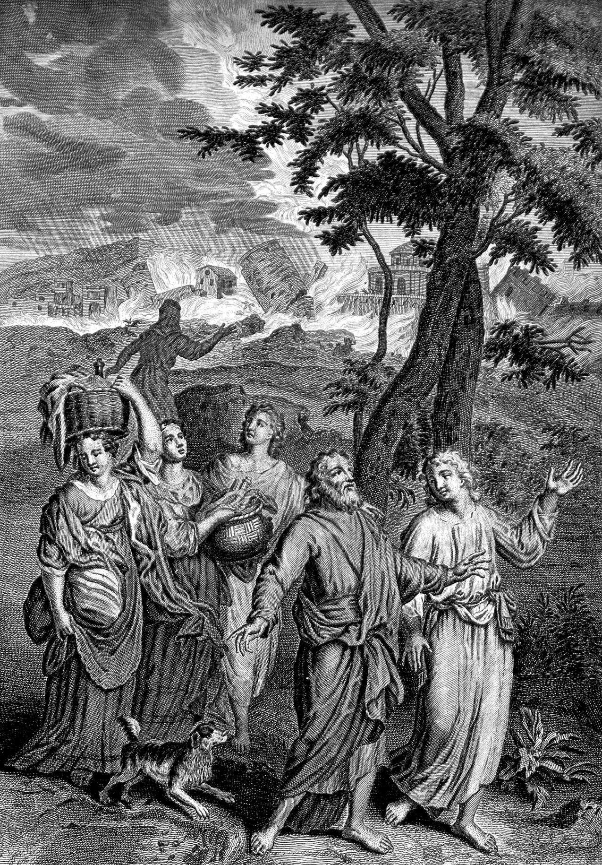Lot and his Family flee from Sodom
(Wellcome Collection)

And now he gives proof that the Lord had not cast them away. Note carefully his first proof. What evidence is there that God has not cast them away?
1 ...For I also am an Israelite, of the seed of Abraham, of the tribe of Benjamin.
And I, being thus an Israelite, am saved by the Lord. Now, if He had cast away His people, I, Paul, would have been cast away: I should not have had this salvation. Therefore,
2 God has not cast away His people which He foreknew.
Next, as proof that God has not cast them away, he cites Elijah and his time.
2 ...Wot you not what the scripture says of Elijah? how he makes intercession to God against Israel, saying,
3 Lord, they have killed your prophets, and dug down your altars; and I am left alone, and they seek my life.
4 But what says the answer of God unto him? I have reserved to myself seven thousand men, who have not bowed the knee to the image of Baal.
5 Even so then at this present time also there is a remnant according to the election of grace.
The time of Elijah, therefore, is an illustration, chosen by Inspiration, of the times of Paul, and of the standing of the Jews before God. And it is an illustration, in the fact that there was a remnant that had not bowed the knee to the image of Baal.
And now, says Paul, “even so then at this present time also there is a remnant.” This, of itself, shows that there is no promise at all of any salvation of the Jews as a whole people, altogether, because they are such; any more than there is a promise of universal salvation of the human race altogether, and just because they are such.
But according to the scripture, in the words of the prophet, “a remnant” believed,—"a remnant” were faithful,—and so were saved. Even as Paul had already quoted in:
Romans 9
27 Isaiah also cried concerning Israel, Though the number of the children of Israel be as the sand of the sea, a remnant shall be saved.
And except it had been for this remnant, there would have been none at all saved: the whole people would have gone, as Sodom and Gomorrah went.
29 And as Isaiah said before, Except the Lord of Sabaoth had left us a seed, we had been as Sodom, and been made like unto Gomorrah.
Thus quoted in Romans, the passage in Isaiah speaks of “a seed”—“except the Lord had left us a seed.” But the passage in Isaiah itself says:
Isaiah 1
9 Except the Lord of hosts had left unto us a very small remnant, we should have been as Sodom, and we should have been like unto Gomorrah.
How is it with Sodom and Gomorrah? How many of the people of Sodom and Gomorrah were saved? A very small remnant—Lot and his two daughters. And will the people of Sodom and Gomorrah, who were consumed in the fire, and were sunk in the waters of the Dead Sea that day—will these be saved? Will these return to Palestine, or to the plain of Sodom and Gomorrah, and meet there great and grand manifestations of the Lord, to convince them and get them to believe because they see, and so be saved?
To ask these questions is to answer them. The people of Sodom and Gomorrah will never return to their own land. That which alone awaits them is…
Jude
6 ...the judgment of the great day.
And even as Jesus said of the Jews, and to the Jews:
Matthew 11
24 I say unto you, That it shall be more tolerable for the land of Sodom in the day of Judgment, than for you.
More than a remnant could have been saved, just as well and just as easily as the remnant itself were saved. The whole people could have been saved, just as well and just as easily as were the remnant saved. But the great body of the people would not believe the Lord: they would not receive Him. Only a few, “a remnant,” and even “a very small remnant"—only these believed. Only these would believe, and so only these could be saved.
Therefore, as for anything more than “a remnant” of the nation and people of the Jews being saved, it is no more true than that the people of Sodom and Gomorrah will be saved. As for the Jews returning to Palestine, it is no more true than that the people of Sodom and Gomorrah will return to the plain of Jordan.
Ezekiel 16
55 When your sisters, Sodom and her daughters, shall return to their former estate, and Samaria and her daughters shall return to their former estate, then you and your daughters shall return to your former estate.
Even as further says the scripture:
Romans 11
7 Israel have not obtained that which he seeks for; but the election [“the remnant,” verse 5] have obtained it, and the rest were blinded. [“hardened,” margin]
8 (According as it is written, God has given them the spirit of slumber, eyes that they should not see, and ears that they should not hear;) unto this day.
9 And David says, Let their table be made a snare, and a trap, and a stumblingblock, and a recompense unto them:
10 Let their eyes be darkened that they may not see, and bow down their back always.

- The Green Olive Tree
Advent Review, April 10, 1900
In Jeremiah it is written:
Jeremiah 11
16 The Lord called your name, A green olive tree, fair, and of goodly fruit: with the noise of a great tumult He has kindled fire upon it, and the branches of it are broken.
THIS is the tree of Israel. The word in Jeremiah leaves the tree only where the branches of it are broken. In Romans 11, Inspiration takes up the subject, and carries it to completion. There it is shown that when the natural branches of the tame olive tree—the Jews—were broken off, in the place of these there are grafted in branches from…
Romans 11
17 ...a wild olive tree,
–the Gentiles. In Romans 11 it is also shown that these natural branches of the tame olive tree were broken off…
20 ...because of unbelief;
–and the branches of the wild olive tree are grafted in and remain…
20 ...by faith.
It is also shown that if the Jews, the natural branches,
23 ...abide not still in unbelief,
–they too shall be grafted in;
23 ...for God is able to graff them in again.
This settles it beyond all possibility of legitimate controversy that no Jew will ever return, or shall ever be counted among the children of God, except by faith: precisely as any Gentile comes to God and is counted among the children of God. This again demonstrates the truth that:
Romans 10
12 There is no difference between the Jew and the Greek.
The Gentile, from the wild olive tree, who is grafted in, is warned not to become exalted in his own merit and begin to boast against the branches that “were broken off, that I might graffed in.” And the caution to all such in this is:
Romans 11
20 Well; because of unbelief they were broken off, and you stand by faith. Be not high-minded, but fear:
21 For if God spared not the natural branches, take heed lest He also spare not you.
22 Behold therefore the goodness and severity of God: on them which fell, severity; but toward you, goodness, if you continue in His goodness: otherwise you also shall be cut off.
23 And they also, IF THEY ABIDE NOT STILL IN UNBELIEF, shall be graffed in: for God is able to graff them in again.
24 For if you were cut out of the olive tree which is wild by nature, and were graffed contrary to nature into a good olive tree: how much more shall these, which be the natural branches, be graffed into their own olive tree?
That tells the whole story, and in such a way that no one who will consider what it says can possibly fail to see that there is, indeed, no difference between the Jew and the Greek; but that when the Jews, because of their unbelief, rejected God, and, so, as dead and withered olive branches, were broken off, branches are taken from the wild olive tree of the Gentiles and grafted into the good olive tree in their places: so that, in the economy of God and the plan of His tree of Israel, the believing Gentile takes the place of the unbelieving Jew, just as He has said in another place:
Romans 9
8 They which are the children of the flesh, these are not the children of God: but the children of the promise are counted for the seed.
Those who are of the flesh have no claims upon the Lord; for the minding of the flesh is enmity against God, and…
Romans 8
7 ...is not subject to the law of God, neither indeed can be.
They which be of faith, these only are the children of Abraham, and so the children of God.
In the plan of God, there is the tree of Israel. As written, because of unbelief its branches withered, died, and were broken off. That left the tree incomplete. But He sends His husbandmen to the wild olive tree; and from that branches are gathered and grafted into the good olive tree—His own tree of Israel.
And that work will continue until the branches gathered from the wild olive tree and grafted into the good one, shall fill all the places of the branches broken off—till these branches from the wild olive tree, by being grafted in and partaking of the root and fatness of the good olive tree, become live, fruitful branches of that good tree. And thus the good olive tree shall be caused to stand full and complete in its symmetry, as originally conceived in the mind of God.
Thus the fullness of that broken olive tree is made up from the wild olive tree—the Gentiles. And this is the significance of that expression,
Romans 11
25 Until the fullness of the Gentiles be come in.
This “fullness of the Gentiles” is the fullness of that broken, good olive tree which is made up from the Gentiles as the wild olive tree. That good olive tree, with its branches all broken, is marred and incomplete: it in no sense represents the idea of God concerning it. But when all those broken branches are replaced from the wild olive tree, and that tree stands, full and flourishing, as originally planned in the mind of God, then the “fullness” of the tree is there, as originally designed: it is a complete tree. And this “fullness” of that tree—that which makes it a complete tree, after it was all marred and broken—comes from the Gentiles, from the wild olive tree. This is the “fullness of the Gentiles,” and this is how that “fullness” comes in.
And upon all this, as the conclusion of all, it is written:
Romans 11
26 And so all Israel shall be saved.
“So” signifies “in this way,” “by this means,” “after this manner.” Therefore it is written: “In this way, by this means, after this manner, shall all Israel be saved.” And that is the only return of the Jews, and the only salvation of Israel.
True, as already noted, from this the original branches are not arbitrarily excluded: any one of these will gladly be grafted in again,
Romans 11
23 ...if they abide not still in unbelief.

- The Gathering of Israel
The Second Advent of Christ
(Heinrich Halmen, Sabbath Rest Advent Church)

Advent Review, April 17, 1900
WHILE by every consideration of the Scriptures it is certain that there is not to be a return of the Jews, it is equally certain that there is to be a gathering of Israel. And this gather of Israel, and, in this sense, this return of the Jews, is to be, as was quoted in last week’s study on this subject, concerning Israel as the good olive tree.
Because of unbelief, the branches of that tree were broken, and so the tree stood all marred and incomplete; but from the wild olive tree, branches are taken and grafted into the good olive tree,—and also such of the original branches as abide not still in unbelief,—until all its lost branches are restored, and the tree stands full, complete, and perfect, as originally conceived.
Romans 11
26 And SO all Israel shall be saved.
And such has been the story of Israel always. It has always been true that:
Romans 9
8 They which are the children of the flesh, these are not the children of God: but the children of the promise are counted for the seed.
This was so in the family of Abraham, at the very beginning of God’s peculiar people. Ishmael was the child of Abraham, but was born after the flesh, and so was not a child of God. Abraham, in his natural affection, thought that Ishmael should be recognized by the Lord as His, according to His original design and purpose in the gospel; and so exclaimed,
Genesis 17
18 O that Ishmael might live before thee!
But the Lord said, No.
19 Sarah your wife shall bear you a son indeed; and you shall call his name Isaac: and I will establish my covenant with him for an everlasting covenant, and with his seed after him.
20 And as for Ishmael, I have heard you: behold, I have blessed him, and will make him fruitful, and will multiply him exceedingly…
21 But my covenant will I establish with Isaac.
Isaac was the child of faith, born by the promise of God,
Galatians 4
29 ...born after the Spirit.
Accordingly, though both were the sons of Abraham, only one was a son of God. This did not utterly exclude from the promises him that was born after the flesh; but he could become partaker of the promises only by himself becoming a child of promise.
And this “allegory,” which was worked out in the family of Abraham, was for the instruction of all people in all ages, that:
Romans 9
6 They are not all Israel, which are of Israel:
7 Neither, because they are of the seed of Abraham, are they all children: but, In Isaac shall your seed be called.
8 That is, They which are the children of the flesh, these are not the children of God: but the children of the promise are counted for the seed.
It tells to all people, forever, that that which is born of the flesh is flesh, and cannot inherit the things of the Spirit; that, unless one is born of promise, and thus becomes a child of promise, he never can be partaker of the promises.
Yet, although this lesson was worked out to completion in the family of Abraham at the very beginning of the course of Israel; though it was repeated in the family of Isaac—in Esau and Jacob; and though it was written for the instruction of all people afterward, great claim is, and ever has been, made in behalf of them…
Romans 9
8 ...which are the children of the flesh.
And in spite of all the instruction the Lord has given upon the subject, it is insisted that He is bound, in justice, to recognize as His children those who are children of the flesh. But such a thing never, in justice, can be. Such a thing would undo all righteousness, and would ruin the universe.
It is asking that God shall clothe sin with righteousness, that He shall accept sin as righteousness, and exalt it as righteousness, to the place of righteousness. But that is all that Lucifer wanted, in the beginning of sin: that is the secret of the whole controversy from that time when it began in heaven, unto this day, and even to the end of the controversy in the triumph of righteousness over sin, to the complete exclusion of sin.
And so from Abraham’s day until this hour, and unto the end of the world, the children of the promise are counted for the seed of Abraham, in place of the children of the flesh. Forever it is so, and is abundantly shown to be so, that they which be of faith, these only are the children of Abraham, and, as such, alone are heirs of Abraham, of Christ, and of God. And in the gathering of Israel, only these will come,—these who have been, when they lived, or are, while they live, children of the promise,
Galatians 3
7 ...they which are of faith.
Read the story of faith, in Hebrews 11, of Abraham, Isaac, Jacob, and Sarah, and of those that…
Hebrews 11
12 ...sprang of one, and him as good as dead, so many as the stars of the sky in multitude, and as the sand which is by the seashore innumerable.
13 These all died in faith, not having received the promises, but having seen them afar off, and were persuaded of them, and embraced them, and confessed that they were strangers and pilgrims on the earth;
16 [Because] they desire a better country, that is, a heavenly: wherefore God is not ashamed to be called their God: for He has prepared for them a city.
Read on in the story of faith, through Isaac, Jacob, Joseph, Moses, and the number of whom the time to tell would fail.
39 These all, having obtained a good report through faith, received not the promise:
40 God having provided some better thing for us, that they without us should not be made perfect.
Thus all Israel are to be made perfect together: they are all to be gathered at once. And that time of gathering all Israel is declared by the word of the Lord in Isaiah:
Isaiah 27
12 And it shall come to pass in that day, that the Lord shall beat off from the channel of the river unto the stream of Egypt, and you shall be gathered one by one, O you children of Israel.
13 And it shall come to pass in that day, that the great trumpet shall be blown, and they shall come which are ready to perish in the land of Assyria, and the outcasts in the land of Egypt, and shall worship the Lord in the holy mount at Jerusalem.
This day when “the great trumpet shall be blown” is the day when:
1 Thessalonians 4
16 The Lord himself shall descend from heaven with a shout, with the voice of the archangel, and with the trump of God: and the dead in Christ shall rise;
and
Matthew 24
31 He shall send His angels with a great sound of a trumpet, and they shall gather together His elect from the four winds, and from one end of heaven to the other,
and
1 Thessalonians 4
17 Then we which are alive and remain shall be caught up together with them in the clouds, to meet the Lord in the air: and so shall we ever be with the Lord.
And
Isaiah 66
22 As the new heavens and the new earth, which I will make, shall remain before me, says the Lord, so shall your seed and your name remain.
23 And it shall come to pass, that from one new moon to another, and from one Sabbath to another, shall all flesh come to worship before me, says the Lord.
This is the gathering of Israel: this is the return of the Jews. And there is no other.

Jeremiah 25:8-11
Josephus,Wars of the Jews, book 5, chap. 10; and book 6, chap. 3.
For the number of captives and the destruction and scattering of the people at this time, read Josephus, Wars of the Jews, book 6, chap. 9; and Milman’s History of the Jews, last paragraphs of book 16.
The studies on the Millennium are available in a separate book.
Available in a separate book, titled The Millennium.
Romans 5:5.
Galatians 5:14.
Romans 10:12.
Ephesians 2:11-19.
Galatians 3:26.
Romans 3:3.
2 Peter 2:6.
Galatians 3:9.

