F. T. WRIGHT
FACING THE JUDGMENT
ARE YOU READY?

Source:
Fourth Edition, 1979
Cover:
Justice
maxpixel.net

Fonts:
Gloucester MT Extra Condensed
Liberation Sans Narrow
Linux Biolinum
Linux Libertine
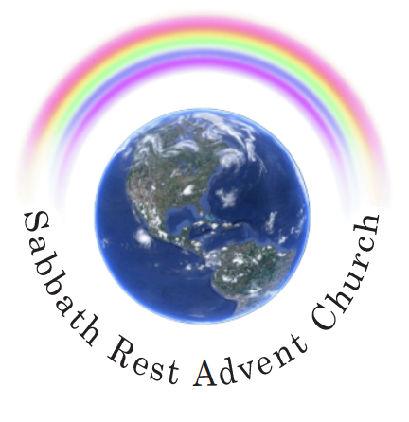

February 2024
practicaprophetica.com
srac.info

Contents
Statement of Purpose 1
- Are You Ready? 1
The Wedding Garment 1
Covenant Between the Father and Son 10
Sin Must Be Cleansed Before the Judgment 13
- The Teaching of the Sanctuary Service 19
- An Examination of an Erroneous Teaching 31
The Open Door 32
An Erroneous View 32
Convincing Logic 37
An Illustration 38
- Joshua and the Angel 42
Applied to the Daily Service 44
Applied to the Yearly Service 45
- Pleading for Purity of Heart 52
- In Conclusion 54
Appendix: Further Notes 57

Statement of Purpose
THIS publication has been prepared by request. With mounting strength the doctrine is being promulgated that perfection of life and character is neither necessary nor possible prior to the second advent of Christ. The arguments are well formulated, and, to many, entirely convincing.
Consequently, we have been approached with the plea to prepare an adequate appraisal of these views so that both the minds of the enquirers and those to whom they would take the truth could be settled on this matter. This booklet represents the attempt to meet that need.
It is necessary to emphasize that the issue being dealt with in this publication, is the character-condition to which the believer must come in order to pass the judgment’s searching scrutiny. It is not discussing (except to make a contrasting and distinguishing point here and there) the sinful records of the past. It is clearly recognized that without exception, each person will come to the judgment with a history of committed sins for which he will require the covering of Christ’s imputed righteousness.
There is no controversy over this point. It is so well recognized and accepted that it will be taken as read in this publication. The contention is in regard to the state or condition in which each person must be found within himself when he faces the judgment’s searching examination. It is of this question alone that this study is written. If the reader will keep this clearly in mind, there will be no possibility of charging this production with making one side of the question the whole of it.
The doctrine of perfection of character being the prerequisite for passing the judgment, is one which some find discouraging. They respond with the feeling that they have no hope of ever seeing heaven if this is the case. But this problem fades when it is realized that perfection of character is not so much God’s requirement for us as His offer to us. He is the One who, through the ministry of His Son, will take us and make us perfect in every respect.
Thoughts from the Mount of Blessing, p. 76:
God has made provision that we may become like unto Him, and He will accomplish this for all who do not interpose a perverse will and thus frustrate His grace.
Therefore, the standard of perfection required in the judgment should fill every believer with inspired enthusiasm as he sees what great things the Lord will do for him. Far from being a message of despair, it is, though solemn, one of hope and joy.
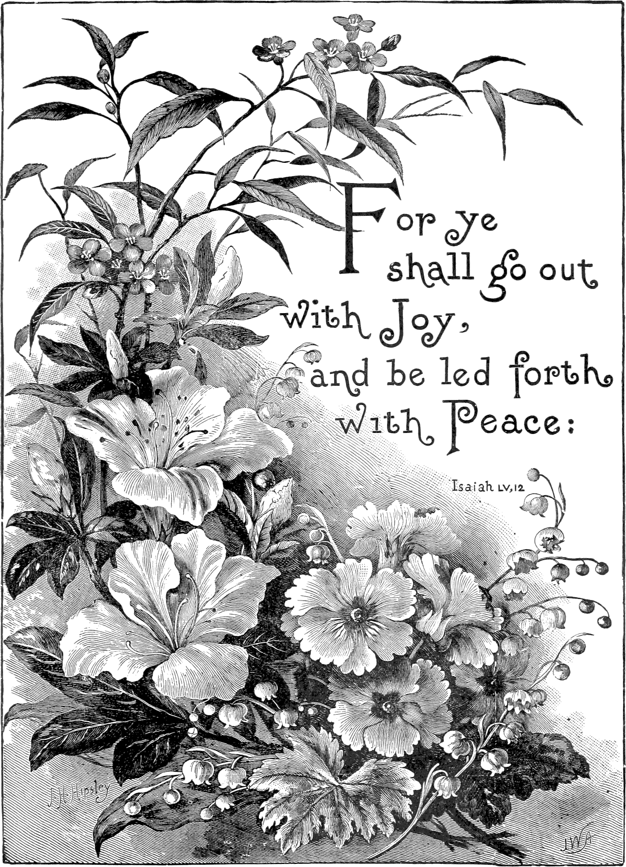
- Are You Ready?
LET’S face it! That is the most important question which can be asked. Beside it, all other questions sink into insignificance.
The Great Controversy, p. 490:
The judgment is now passing in the sanctuary above. For many years this work has been in progress. Soon—none know how soon—it will pass to the cases of the living. In the awful presence of God our lives are to come up in review.
Nobody can escape its searching scrutiny whereby the eternal destiny of each will be determined.
The Great Controversy, p. 490:
Every one must be tested...
It is an issue not merely of life and death but of eternal life and eternal death. Therefore, there can be no question of such crucial importance as this one,
“Am I ready to face the judgment?”
But, all-important as that question is, it cannot be answered unless there is firstly an understanding of what that judgment will require, what it will mean to be prepared for it, and what condition the candidate must be in, in order to pass its exacting investigation.
Just what will it demand?
There is only one authority by which that question can be satisfactorily and finally answered—the Word of God. It is to that Witness that appeal will here be made. It will be found that the testimony given will be comprehensive and accurate, leaving no question of the standard to be achieved.

The Wedding Garment
The first reference is:
Matthew 22
11 And when the king came in to see the guests, he saw there a man which had not on a wedding garment:
12 And he said unto him, Friend, how did you come in here not having a wedding garment? And he was speechless.
13 Then said the king to the servants, Bind him hand and foot, and take him away, and cast him into outer darkness; there shall be weeping and gnashing of teeth.
14 For many are called, but few are chosen.
We are not left to mere human assumption of what these verses mean. In Christ’s Object Lessons inspired comment is provided to inform us that the parable is intended to teach the spiritual condition of those who will successfully pass the judgment.
Christ’s Object Lessons, p. 310:
By the king’s examination of the guests at the feast is represented a work of judgment. The guests at the gospel feast are those who profess to serve God, those whose names are written in the book of life. But not all who profess to be Christians are true disciples. Before the final reward is given, it must be decided who are fitted to share the inheritance of the righteous.
This decision must be made prior to the second coming of Christ in the clouds of heaven; for when He comes, His reward is with Him, “to give every man according as his work shall be.” Revelation 22:12. Before His coming, then, the character of every man’s work will have been determined, and to every one of Christ’s followers the reward will have been apportioned according to his deeds.
It is while men are still dwelling upon the earth that the work of investigative judgment takes place in the courts of heaven. The lives of all His professed followers pass in review before God. All are examined according to the record of the books of heaven, and according to his deeds the destiny of each is forever fixed.
The Great Controversy, p. 428:
In the parable of Matthew 22 the same figure of the marriage is introduced, and the investigative judgment is clearly represented as taking place before the marriage. Previous to the wedding the king comes in to see the guests, to see if all are attired in the wedding garment, the spotless robe of character washed and made white in the blood of the Lamb. He who is found wanting is cast out, but all who upon examination are seen to have the wedding garment on, are accepted of God, and accounted worthy of a share in His kingdom and a seat upon His throne.
This work of examination of character, of determining who are prepared for the kingdom of God, is that of the investigative judgment, the closing work in the sanctuary above.
Let us note the points set forth in these paragraphs:
- The King’s examination of the guests is the investigative judgment which takes place before the second advent.
- The guests examined are those who profess to serve God. The wicked are not included here.
- The work of that judgment is to determine—not those who are to be prepared for the kingdom—but those “...who are fitted to share the inheritance of the righteous”; those “...who are prepared for the kingdom of God”; those in whom the work of the gospel has been finished.
- That fitness is symbolized by the possession of the wedding garment.
- That garment must be on the candidate when the king comes in. This means that the garment is not put on in the judgment but before it, so that, when the King comes in and not a moment later, he must be found in that garment. In fact, the purpose of this examination is to see if the wedding garment is on.
- When the king enters, he has only one consideration in mind—does each guest have the wedding garment on? If so, there is no problem, but, if not, then that person is ejected into outer darkness forever. Therefore, the guest’s remaining in the wedding feast hinges on his being clad in the wedding garment.
Consequently, the only opportunity for acquiring the wedding garment is before the king comes in, which in real life, is the beginning of the investigative judgment. This is a work which concerns every one who would gain eternal life, and it must be attended to today. It cannot and must not be deferred.
Inasmuch as passing the judgment is contingent upon wearing the wedding garment, it is vital to know what the garment actually is, what it means to wear it, and how it can be acquired.
Of the Word, by His Spirit, we must ask that question, and by the Word, through His Spirit, we shall find the answer so clearly and distinctly that we shall know it exactly. We turn in the first instance to:
Revelation 19
7 Let us be glad and rejoice, and give honor to Him: for the marriage of the Lamb is come, and His wife has made herself ready.
8 And to her was granted that she should be arrayed in fine linen, clean and white: for the fine linen is the righteousness of saints.
That in which a bride is arrayed is a wedding garment which is here described firstly as fine linen, clean and white, and secondly as the righteousness of saints. Note that it is their own righteousness, though not for a moment by their own effort. Neither is it theirs because they have earned it, developed it, or merited it. Oh, no! But it is theirs nonetheless.
Originally and always it is God’s righteousness, His character, His works. He has the perfect right and the fullness of desire to give this to whomsoever He will, provided they will accept it. His children are those who have gladly received the offered treasure, it thereby becoming their possession so that of them it can truthfully be said that they are righteous in themselves though not of themselves.
Initially, the believer receives this righteousness imputed and imparted to him in the new birth experience. He then enters the school of Christ, where his spiritual development is continued toward the objective of total sinlessness.
When the full realization of the last depths of sinfulness has been attained, together with the full renunciation of the evil, then Christ’s work is done and He is able to present His workmanship to the Father in the judgment,
Ephesians 5 [ESV]
27 ...without spot, or wrinkle, or any such thing.
We learn more of the nature of the wedding garment from:
Christ’s Object Lessons, p. 310:
By the wedding garment in the parable is represented the pure, spotless character which Christ’s true followers will possess. To the church it is given…
Revelation 19
8 ...that she should be arrayed in fine linen, clean and white,
Ephesians 5
27 ...not having spot, or wrinkle, or any such thing.
The fine linen, says the Scripture,
Revelation 19
8 ...is the righteousness of saints.
It is the righteousness of Christ, His own unblemished character, that through faith is imparted to all who receive Him as their personal Saviour.
We are apt to think of this righteousness of Christ not as being a “pure, spotless character” which we are to possess, but as something imputed, credited, or accounted to us as a covering for our sinfulness. But we cannot use this as a cloak for any known sin. Far from it. It is true that the imputed righteousness of Christ covers our unknown sins, but, as soon as they are revealed to us, then it is our privilege and duty to lay hold on the power of the gospel to remove them.
Selected Messages, vol. 1, p. 366:
But while God can be just, and yet justify the sinner through the merits of Christ, no man can cover his soul with the garments of Christ’s righteousness while practicing known sins, or neglecting known duties. God requires the entire surrender of the heart, before justification can take place; and in order for man to retain justification, there must be continual obedience, through active, living faith that works by love and purifies the soul.
Day by day the believer’s knowledge of the righteousness of God is to advance. This in turn, searches out the heart, progressively reducing the amount of unknown sin in the life. By the time the true child of God comes to the judgment of the living, this work will be complete so that no hidden sin of any kind is left in the life. He will stand in the judgment possessing a pure, spotless character in the full sense of the word.
Ever remember that true righteousness is that right-doing which is the result of right-being.
1 John 3
7 Little children, let no man deceive you: he that does righteousness is righteous, even as He is righteous.
He that does righteousness as the fruit of right-being is righteous. Only then, as a doer of righteousness, the possessor of a pure, spotless character, is he wearing the wedding garment. This point is further emphasized in:
Christ’s Object Lessons, p. 312:
By His perfect obedience He has made it possible for every human being to obey God’s commandments. When we submit ourselves to Christ, the heart is united with His heart, the will is merged in His will, the mind becomes one with His mind, the thoughts are brought into captivity to Him; we live His life. This is what it means to be clothed with the garment of His righteousness. Then as the Lord looks upon us He sees, not the fig-leaf garment, not the nakedness and deformity of sin, but His own robe of righteousness, which is perfect obedience to the law of Jehovah.
This statement plainly tells us what it means to be clothed in the garment of His righteousness. It is:
- to have the heart united with His heart, which is to be indeed “a partaker of the divine nature,” and thus be brought into oneness with Him;
- to have the will merged with His will;
- to have the mind become one with His mind;
- to have even the thoughts brought into captivity to Him.
And all this is summed up in this one sentence,
Christ’s Object Lessons, p. 312:
...we live His life. This is what it means to be clothed with the garment of His righteousness...which is perfect obedience to the law of Jehovah.
This is not a vicarious obedience—an obedience that someone else has rendered in our stead so that we are freed from the obligation of perfect obedience. That is not so at all! It is “perfect obedience to the law of Jehovah” on our part. No other conclusion could be drawn from the context of this statement, and no one who knows the saving power of the gospel as a living, personal experience would think of drawing any other conclusion.
Only those who do not know God’s power to save them from their sins, and yet still want a place in heaven, would seek to find any other standard. There are many such teachers abroad today, and each is coming forward with a more cunning and plausible theory as time passes.
2 Corinthians 11
13 For such are false apostles, deceitful workers, transforming themselves into the apostles of Christ.
14 And no marvel; for Satan himself is transformed into an angel of light.
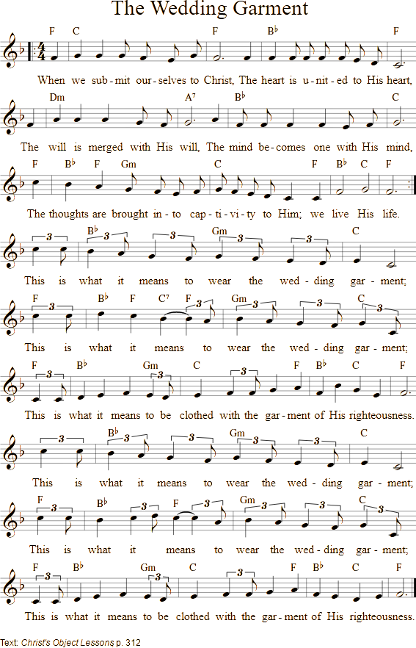
15 Therefore it is no great thing if his ministers also be transformed as the ministers of righteousness; whose end shall be according to their works.
Thus, in explicit terms, it is plainly declared that to be found in the wedding garment when the King comes in, is to be living His life which is perfect obedience to the law of Jehovah. That means exactly what it says.
This is how it has to be in the very nature of the situation as it stands. Sinless perfection is the condition of eternal life in heaven or in Eden. Man fell from that state and so lost his Eden home. It simply follows then that to regain the home, he must regain that state of sinless perfection.
Steps to Christ, p. 62:
The condition of eternal life is now just what it always has been,—just what it was in Paradise before the fall of our first parents,—perfect obedience to the law of God, perfect righteousness. If eternal life were granted on any condition short of this, then the happiness of the whole universe would be imperiled. The way would be open for sin, with all its train of woe and misery, to be immortalized.
Inasmuch as the very work and purpose of the judgment is to determine who, among the vast throngs of this world’s inhabitants, have gained a fitness to enter heaven, it follows that a state of sinless perfection must have been regained through the provisions made by heaven, before the judgment sits.
Should anyone raise the argument that “the judgment does not determine who has reached full maturity of soul perfection,” which is the condition of fitness to enter the kingdom, he will be silenced by the plain, clear Word of truth:
The Great Controversy, p. 428:
This work of examination of character, of determining who are prepared for the kingdom of God, is that of the investigative judgment, the closing work in the sanctuary above.
The statement plainly says that the judgment determines who are prepared, not those who are to receive any further work of preparation. Again:
The Great Controversy, p. 490:
Every one must be tested, and found [not made] without spot or wrinkle or any such thing.

Covenant Between the Father and Son
This is still more plainly seen when one understands the covenant into which the Father and Son have entered on man’s behalf. That covenant was formed before the foundations of the earth were laid:
Fundamentals of Christian Education, p. 403:
Before the foundations of the earth were laid, the covenant was made that all who were obedient, all who should through the abundant grace provided, become holy in character, and without blame before God, by appropriating that grace, should be children of God.
This covenant, made from eternity, was given to Abraham hundreds of years before Christ came. With what interest and what intensity did Christ in humanity study the human race to see if they would avail themselves of the provision offered.
It was ratified immediately subsequent to the death and resurrection of Christ.
The Desire of Ages, p. 790:
The Father ratified the covenant made with Christ, that He would receive repentant and obedient men, and would love them even as He loves His Son. Christ was to complete His work, and fulfill His pledge to…
Isaiah 13
12 ...make a man more precious than fine gold; even a man than the golden wedge of Ophir.
Here then is plainly set before us the fact that there is a most solemn covenant agreement between the Father and the Son and, most important, the terms of that agreement. Both the Father’s and the Son’s parts are clearly shown.
The Father has entered into the most solemn covenant agreement with the Son that He, the Father, would accept repentant and obedient men. Only those kind of men will be accepted by Him. That means a repentance and an obedience that will pass His searching scrutiny.
The Father will recognize only one standard as being fit for admission into His kingdom, and that is perfect, sinless obedience. Therefore, Christ’s side of the covenant agreement is to produce that kind of man for the Father’s examination and acceptance.
It is as plain and straightforward as that. Note this in the words from the statement above:
The Desire of Ages, p. 790:
Christ was to complete His work, and fulfill His pledge to “make a man more precious than fine gold.”
So with this objective in view, of Him it is said:
Malachi 3
3 And He shall sit as a refiner and purifier of silver: and He shall purify the sons of Levi, and purge them as gold and silver, that they may offer unto the Lord an offering in righteousness.
In the refining of silver, the purifying process is carried forward until the craftsman can look upon the molten surface of the metal and see his image perfectly reflected there, with not one speck of impurity marring the picture. As it is in this, so in the work of Christ. Day by day He continues the refining process. At last,
Christ’s Object Lessons, p. 69:
When the character of Christ shall be perfectly reproduced in His people, then He will come to claim them as His own.
Christ is able to fulfill His side of the covenant and He will fulfill it. In the judgment He will present for the closest examination the lives of those who have faithfully cooperated with Him. It will be their lives which will be examined; their works which will be tested; their characters which will be weighed. No one, not even Christ Himself, will stand in their place to be examined in their stead.
The Saviour has no fear that His work will fail the test of the judgment. He knows that the life and character He has imparted to His people will stand the most exacting scrutiny. He knows that He has fulfilled His part of the covenant and that therefore the Father will accept those whom He presents to Him. They have been made ready for the eternal kingdom of heaven. Their place is sure.
- It is because the gospel is the power of God to save from sin;
- It is because all the powers of heaven, which are infinitely greater than the powers of sin, are directed toward saving man; and
- It is because Jesus has solemnly promised and wholly dedicated Himself to transform every evil person who is willing, into a person fit for the kingdom;
–that the Father has every right, when He comes in to inspect the guests, to expect to find them in the wedding garment. Therefore, He will accept nothing less than perfect obedience to His law which necessitates that they be the possessors in themselves, not of defective, but of pure and spotless characters.
Failure to be found in that condition will result in eternal expulsion from God’s kingdom. Therefore, nothing less than spotless perfection is the condition in which the judgment must find each person when the King comes in, as we further read:
The Great Controversy, p. 490:
Every one must be tested [by the judgment, when the king comes in], and found [not made] without spot or wrinkle or any such thing.

Sin Must Be Cleansed Before the Judgment
Any honest soul will recognize that this leaves no room for the theory that we can come to the judgment with still defective characters. For a person in this condition there will be no further cleansing from sin, and no further deliverance from its bondage.
At the moment when the name of any one of the living righteous is called up in the judgment, the work of cleansing in him will have been completed. Therefore the judgment does a great deal for the believer but nothing in him. The two must not be confused.
Thus let it be forever established that the Word of God teaches that there is only one process of cleansing the soul from sin, and that is before the judgment. There is no second cleansing afterwards.
Testimonies for the Church, vol. 2, p. 355:
When He comes He is not to cleanse us of our sins, to remove from us the defects in our characters, or to cure us of the infirmities of our tempers and dispositions. If wrought for us at all, this work will all be accomplished before that time. When the Lord comes, those who are holy will be holy still. Those who have preserved their bodies and spirits in holiness, in sanctification and honor, will then receive the finishing touch of immortality.
But those who are unjust, unsanctified, and filthy will remain so forever. No work will then be done for them to remove their defects and give them holy characters. The Refiner does not then sit to pursue His refining process and remove their sins and their corruption. This is all to be done in these hours of probation. It is now that this work is to be accomplished for us.
This statement needs little comment. It leaves no room for the theory that part of the work is done after probation closes. Consider for a moment, when a man’s probation closes. For those who die prior to the judgment of the living, it closes at the moment of death. For those who live through the judgment it closes when their names are called for investigation. Then follows the examination of each case, the decision on it, and finally, the execution of the decision. The name will either be retained in the book of life or it will be blotted out of it.
All the cleansing from sin, all the removing of our defects of character, all the curing of the infirmities of our tempers and dispositions, must be done now in these hours of probation. That leaves nothing to be done after the hours of probation have ceased, which they do the moment our names are called for investigation.
If this is so, then it follows that the cleansing processes of the daily experience…
Testimonies for the Church, vol. 2, p. 355:
...will accomplish the work for us which is necessary to give us a moral fitness for the kingdom of glory and for the society of the heavenly angels.
It must follow that day by day—not day by day plus some special work in the future—as we lay hold upon the sanctifying truth of God, it will so cleanse us from every imperfection and sin, of whatever nature, that there will be no need or occasion for any special cleansing in the judgment. That is precisely and exactly what this statement goes on to say:
Testimonies for the Church, vol. 2 p. 355-356:
We embrace the truth of God with our different faculties, and as we come under the influence of that truth, it will accomplish the work for us which is necessary to give us a moral fitness for the kingdom of glory and for the society of the heavenly angels.
We are now in God’s workshop. Many of us are rough stones from the quarry. But as we lay hold upon the truth of God, its influence affects us. It elevates us and removes from us every imperfection and sin, of whatever nature. Thus we are prepared to see the King in His beauty and finally to unite with the pure and heavenly angels in the kingdom of glory. It is here that this work is to be accomplished for us, here that our bodies and spirits are to be fitted for immortality.
What message could be plainer than that, or this:
Review and Herald, April 12, 1870:
Opportunity is now given you to improve and become perfect this side of the Judgment.
These words mean exactly what they say. It is for us to accept them as they read, and to see in them, not the impossible demands of a righteous God, but the glorious prospect of perfect righteousness which He offers to all. He has told us just what He expects. Can you dare to think of God as a Being who would demand the impossible? Never! He who has all power in heaven and in earth,
Thoughts from the Mount of Blessing, p. 76:
...has made provision that we may become like unto Him, and He will accomplish this for all who do not interpose a perverse will and thus frustrate His grace.
The great sin which lies at the door of the church in every age is unbelief. It was because of this that it failed again and again, and if we come short in the judgment, it will be because we have not believed explicitly and absolutely in the commands and promises of God that the work will be done in, and for, and through us.
This practical aspect of how to believe is covered in other publications, but for now, we want to come to the place where we truly see that when the King comes in, we must be in that wedding garment which is plainly shown to be:
- the righteousness of saints;
- which is the righteousness of Christ, His own unblemished character;
- which is the pure, spotless character which Christ’s true followers will possess;
- which is to actually live His life;
- which is perfect obedience to the law of Jehovah;
- which is to be tested and found to be without spot or wrinkle or any such thing;
- which is, upon examination, to be found prepared for the kingdom of God;
- which is to be tested and found to be fitted to share the inheritance of the saints;
To be found with anything else than this, or anything less than this, or even if it were possible, a part only of this, be it ever so large a part, can only mean that the King will say of you to His servants,
Matthew 22
13 Bind him hand and foot, and cast him into outer darkness.

The Hour of Judgment
by Rebekah Smith
1. The time has come, that all-important day,
When sins must be confessed and washed away!
When hearts must feel, and conscience’ voice be heard
In swift obedience to God’s holy word.
2. “Be zealous and repent,” is God’s command.
We must in humble ranks united stand.
With us, ’tis said, the judgment first begins;
And we must soon be cleansed from all our sins.
3. We must let Jesus in. Our mighty foe
Is ready to effect our overthrow.
With Christ we’re safe; in conflict He’ll unite,
Help on to victory, and maintain the right.
4. The eye-salve, well applied, sheds light around,
And all our secret faults and sins are found,
To be confessed, while Jesus intercedes,
And while for us His precious blood He pleads.
5. Though scarlet be our sins—of crimson dye—
If penitent, He’ll not our suit deny.
He waits for full confession, which, when made,
Whate’er our sin and guilt, He’ll not upbraid.
6. He’s ready to acquit and set us free,
And will proclaim our perfect liberty.
He’ll seal us His, and make us here His care;
He’ll fit us for His throne, and take us there.
7. He’s cutting short His work in righteousness,
And coming soon His waiting saints to bless.
When once He’s left the mediatorial place,
No ray of mercy lights our ruined race.
8. ‘Twill then be known, the offers we’ve refused,
The blood-bought privileges that we’ve abused—
How must it sharpen every pang of guilt
To think, for us the Saviour’s blood was spilt;
9. To know we might have had our sins forgiven,
And lived forever with the loved in Heaven.
In view of anguish deep we then must feel.
No wounds of sin may we here slightly heal.
10. Broad as th’ offense, confession I will make,
And all my dear, loved idol sins forsake.
Yes, glory be to God! the victory’s gained,
And self-denial shall be hence maintained.
11. ‘Twill take our all to buy the pure tried gold;
And nought of earth can we in heart withhold.
A cheaper way I would not, could I, go;
A dearer way no one can ever show.
12. I love the blessed way; it buoys me up;
My Saviour’s here, and with Him I may sup.
I’ll be content with nothing short of this;
And this alone makes Heaven perpetual bliss.
13. Then let us make our hope and calling sure;
And all our trials patiently endure.
They’ll soon be o’er; our lives we’ll not hold dear,
And soon in glory with our Lord appear.


- The Teaching of the Sanctuary Service
AMONG the many vital lessons God provided the sanctuary to teach, is the truth that perfection of character is the requirement of the judgment.
There were two main types of services provided for the removal of sin from the people. The first was the daily, and the second, the yearly. The comprehensive study of these goes far beyond the scope of this little volume which is concerned with the critical point that the daily was designed to remove sin from the people and place it in the sanctuary, while the final service served to remove those same sins from the sanctuary and place them on the scapegoat.
The only period during which the sins could be taken from the persons themselves was during the daily ministration. Once that closed and the service of the great day of atonement began, there was no provision, and therefore no possibility, of any further sin being taken from the individual. Consequently, any sin still remaining in any person once the yearly service began, had to remain with him forever. That is why the person in this predicament was evicted from the encampment and could never return.
That which was true in the typical is of equal force in the antitypical. As Christ ministers the daily service in the sanctuary above, every true believer, while he still lives and while the judgment of the living has not yet commenced, can and will send his sins to the sanctuary above. This is the only opportunity for doing so.
But, when the judgment opens on his name, then every sin which he knows about yet has failed to have taken from him, must remain with him forever. There is no possible way in which it can then be removed because the one and only provision for this will have ended for him. Such an unfortunate soul must perish for, wherever he goes, his sin, which is an inseparable part of him, must also go. Inasmuch as sin cannot enter heaven, then neither can he, for he would bring it with him. Thus, he will have shut himself out of the heavenly home.
There are few things if any, which are more important than clearly seeing these vital distinctions between the work of the first and final services. Those who understand them will have no confusion over the question of perfection of character before the judgment.
Essential to this is a clear comprehension of what sin is. All too many view sin as being no more than guilt for what has been done. This is a superficial understanding. Sin is not only what we do. It is more importantly what we are. What we do is the fruitage of what we are, so the real problem to be solved is the latter, not the former. Unless there is a change from what we are as sinners, into righteousness, then the character remains sinful and imperfect.
No truth is more plainly taught in the Scriptures than this. It has been dealt with quite extensively in our other publications. This leaves only the necessity of making brief references to it here.
Leviticus 4:1-35 needs to be carefully studied until its truths are implanted in the mind and experienced in the life. It sets forth the way in which sin, during and through the daily rituals, was transferred from the person to the sanctuary. In brief, the procedure was as follows:
- The individual, having become aware of sin in his life through the convicting ministry of the Holy Spirit, brought his offerings to the door of the sanctuary.
- There he confessed the iniquity over the head of the victim and slew it with his own hand.
- The priest then took the blood and carried it within the veil where he sprinkled it on the horns of the altar and before the inner veil which separated the holy from the most holy.
By this means the sin was, through the blood, transferred in type to the sanctuary. But it was not merely the guilt which was taken in.
The Great Controversy, p. 418:
The blood, representing the forfeited life of the sinner, whose guilt the victim bore, was carried by the priest into the holy place and sprinkled before the veil, behind which was the ark containing the law that the sinner had transgressed.
What the blood represented in the typical service, is literally transferred to the sanctuary in the antitype. Therefore, the life of the sinner is removed from him and placed instead in the sanctuary where it remains until the great day of final atonement.
Reference is not being made to the physical life here, for, if it was removed, physical death would result. If this were so, then every person on true confession of sin, would end his earthly sojourn right there.
Each person has another life distinct from the physical. This finds residence within the physical body but is distinct from it. It is either the evil spiritual nature of which Satan is the father, as Christ testified when He told the Pharisees,
John 8
44 You are of your father the devil;
–or it is the holy, spiritual nature of which God is the Father. Physically, we are born of earthly parents as everybody knows, but spiritually we are initially born of Satan and retain that inheritance until we are born again of the Father in Heaven. In the ancient rituals, this entry into a new life was symbolized, not by the daily services but by the Passover when Israel was delivered from bondage.
But the departure from Egypt did not give them instant entrance into Canaan. There was a long journey in between, during which they had much to learn and much to unlearn. More great changes had to take place in their lives. This is the work of reformation that follows the revival and is designed to remove those aspects of life which are retained after basic conversion. They are described as being old…
Selected Messages, vol. 1, p. 128:
...ideas and theories, habits and practices.
These things have been acquired, not from Satan as our father, but from him as our teacher. They have been so deeply instilled that they are part of the life fabric, and as such, are an uncleanness which cannot be taken to heaven. The full revelation of these things does not come in a moment. It is the work of a lifetime to have them revealed and removed.
It is for this that the daily service was instituted. Thus is provided the means whereby the sinfulness, or life, is removed along with the guilt.
To remove this problem as quickly as it passes from being a sin of ignorance to a known sin, requires that the suppliant confess not only what he has done, but also what he is, and specifically lays that on the innocent victim, Jesus Christ. By faith, he knows that the sinfulness and its guilt are removed from him so that he stands before God as if he had never had it in the first case, so adequate and effective is this cleansing work.
Then from the Saviour, he receives a new life principle in place of the other, so that the vacuum is filled with the sweet graces of the Holy Spirit.
Christ’s Object Lessons, p. 419-420:
The religion of Christ means more than the forgiveness of sin; it means taking away our sins, and filling the vacuum with the graces of the Holy Spirit. It means divine illumination, rejoicing in God. It means a heart emptied of self, and blessed with the abiding presence of Christ.
When Christ reigns in the soul, there is purity, freedom from sin. The glory, the fullness, the completeness of the gospel plan is fulfilled in the life. The acceptance of the Saviour brings a glow of perfect peace, perfect love, perfect assurance. The beauty and fragrance of the character of Christ revealed in the life testifies that God has indeed sent His Son into the world to be its Saviour.
Note that the removal of guilt does not leave a vacuum, but the taking away of the life within does. This void is to be filled with the graces of the Holy Spirit which are the positive attributes of:
Galatians 5
22 ...love, joy, peace, longsuffering, gentleness, goodness, faith,
23 Meekness, temperance.
Thus, through this process, the believer becomes transformed in character and grows into the image of Christ more and more each day. In turn, he is being prepared to pass the judgment which determines:
The Great Controversy, p. 428:
...who are prepared for the kingdom of God;
Christ’s Object Lessons, p. 310:
...who are fitted to share the inheritance of the righteous;
The Great Controversy, p. 490:
...[who are to] be tested, and found without spot or wrinkle or any such thing.
There is an inseparable connection between the truth that the sin which is remitted to the sanctuary is much more than merely the guilt of it, but is the very life of it, and the truth that the standard for the judgment is perfection of character. What is more, the teaching of the sanctuary allows for no other standard than this. The following facts certify these verities.
The daily services are the only means by which, and during which, sin is removed from the sinner. Any sin still remaining when those provisions are no longer available must abide with and in the sinner for as long as he continues to exist.
Those who enter heaven must do so in a state of sinlessness. They cannot bring any sin with them. If the daily removed only the guilt, then no man would ever become fitted for heaven for no other service is provided by which the evil of his disposition is removed from him.
It is a false and misleading hope to expect that when Christ appears, He will remove these defects and evils. This is not so. All He does then is to give immortality to the fleshly body, not transform the character. This work must all be accomplished during these hours of probation. It is for this reason that the following words were penned by Inspiration:
Testimonies for the Church, vol. 2, p. 355:
We are preparing to meet Him who, escorted by a retinue of holy angels, is to appear in the clouds of heaven to give the faithful and the just the finishing touch of immortality.
When He comes He is not to cleanse us of our sins, to remove from us the defects in our characters, or to cure us of the infirmities of our tempers and dispositions. If wrought for us at all, this work will all be accomplished before that time.
When the Lord comes, those who are holy will be holy still. Those who have preserved their bodies and spirits in holiness, in sanctification and honor, will then receive the finishing touch of immortality.
But those who are unjust, unsanctified, and filthy will remain so forever. No work will then be done for them to remove their defects and give them holy characters. The Refiner does not then sit to pursue His refining process and remove their sins and their corruption. This is all to be done in these hours of probation. It is now that this work is to be accomplished for us.
It follows that the standard for passing the judgment is the same as for entry into heaven. It is not possible to believe the sanctuary teaching and hold any other view. The daily service is the only one provided during which Christ is able to separate sin from the person of the sinner.
The work of the daily was followed by the yearly. Read Leviticus 16 carefully and thoroughly, for therein is revealed in type, Christ’s ministry in the final atonement. The service performed on this day further confirms the truth that all the work of perfection of character must be accomplished before the judgment.
In brief, the ritual was as follows:
At the appointed hour on the tenth day of the seventh month, the whole congregation gathered around the sanctuary. The previous ten days had been spent in deep heart-searching and confession of sin which could be continued right up till the hour of the actual service.
Two goats were presented at the door of the tabernacle, one of which was appointed to be the Lord’s and the other the scapegoat, the symbol of Satan. On the head of the Lord’s goat no sin was confessed at this time. It was slain, and its blood taken into the most holy place where it was sprinkled before the ark and upon the mercy seat.
This blood did not transfer sin into the sanctuary. It was for the purpose of cleansing sin from the sanctuary. So, it specifically states in Leviticus that the atonement or cleansing was made for both the holy and the most holy places:
Leviticus 16
16 And he shall make an atonement for the holy place [the most holy place as it is usually called], because of the uncleanness of the children of Israel, and because of their transgressions in all their sins: and so shall he do for the tabernacle of the congregation [usually called the holy place], that remains among them in the midst of their uncleanness.
Atonement is cleansing. In this case it is cleansing from sin. Throughout the services of the year, while probation continued, there was a steady stream of sin being taken from the people and deposited in the sanctuary. By this means they were cleansed or freed from sin, but their cleansing meant the defilement of the tabernacle.
Before the yearly service could begin, this stream of uncleanness had to be stopped. No more confessions could be received. Then the flow was reversed as the accumulation of iniquity was taken out of the temple and placed upon the scapegoat for final disposal. Only then was it considered to have been fully separated from the people.
There were no modifications or exceptions to this sequence of events. The only way in which sin within the believer could arrive on the scapegoat and then into utter and final destruction was for it to be firstly taken into the sanctuary through the daily routine, and taken from the sanctuary in the yearly.
No sin could pass directly from the sinner to the scapegoat. This being so, it was essential for each Israelite to ensure that every sin had been sent on beforehand to judgment.
That sanctuary with its apartments, its priesthood, services, and worshipers, was set in the midst of their encampment to teach them and us these vital truths. The centuries rolling by have carried us into the great day of final atonement. The judgment of the living has not yet commenced and will not do so until the last test has been endured.
The Great Controversy, p. 490:
Solemn are the scenes connected with the closing work of the atonement. Momentous are the interests involved therein. The judgment is now passing in the sanctuary above. For many years this work has been in progress. Soon—none know how soon—it will pass to the cases of the living. In the awful presence of God our lives are to come up in review.
The time leading up to the close of our probation, whether it be at the point of death or at the judgment of the living, is the only period when provision has been made for the separation of sin from the individual. When the ending of Christ’s daily ministration has come, then any known sin still within must remain therein forever. For any with sin within, there is no hope of eternal life. These principles have been well expressed by A. T. Jones:
The service in the earthly sanctuary shows also that in order for the sanctuary to be cleansed and the course of the gospel service there to be finished, it must first be finished in the people who have a part in the service.
That is to say: In the sanctuary itself, transgression could not be finished, an end of sins and reconciliation for iniquity could not be made, and everlasting righteousness could not be brought in, until all this had been accomplished in each person who had a part in the service of the sanctuary.
The sanctuary itself could not be cleansed until each of the worshipers had been cleansed. The sanctuary itself could not be cleansed so long as, by the confessions of the people and the intercessions of the priests, there was pouring into the sanctuary a stream of iniquities, transgressions, and sins.
The cleansing of the sanctuary, as to the sanctuary itself, was the taking out of and away from the sanctuary all the transgressions of the people which, by the service of the priests, had been taken into the sanctuary during the service of the year. And this stream must be stopped at its fountain in the hearts and lives of the worshipers, before the sanctuary itself could possibly be cleansed.
Therefore the very first work in the cleansing of the sanctuary was the cleansing of the people. That which was preliminary and essential to the cleansing of the sanctuary itself, to the finishing of transgression and bringing in everlasting righteousness, there, was the finishing of transgression, and the making an end of sins, and making reconciliation for iniquity, and bringing in everlasting righteousness in the heart and life of each one of the people themselves.
When the stream that flowed into the sanctuary was thus stopped at its source, then, and then alone, could the sanctuary itself be cleansed from the sins and transgressions which, from the people, by the intercession of the priests, had flowed into the sanctuary.
And all that “was a figure for the time then present”—a “figure of the true.” Therefore by this we are plainly taught that the service of our great High Priest in the cleansing of the true sanctuary must be preceded by the cleansing of each one of the believers, the cleansing of each one who has a part in that service of the true High Priest in the true sanctuary.
It is plain that transgression must be finished, an end of sins and reconciliation for all iniquity must be made, and everlasting righteousness must be brought in, in the heart’s experience of every believer in Jesus, before the cleansing of the true sanctuary can be accomplished.
And this is the very object of the true priesthood in the true sanctuary. The sacrifices, the priesthood, and the ministry in the sanctuary which was but a figure for the time then present, could not really take away sin, could not make the comers thereunto perfect. Whereas the sacrifice, the priesthood, and the ministry of Christ in the true sanctuary does take away sins forever, does make the comers thereunto perfect, does perfect “forever them that are sanctified.”
Thus, through the teachings of His word and the plain symbolism of the sanctuary lesson book, God has made clear what the standard for the judgment is. It is the Lord who has made it clear what the standard is. This is necessary to silence the objections which are apt to rise.
A common one is that if we are to come to the judgment with a perfect character within ourselves, then this is certain to foster self-righteousness. It portrays a picture, it is charged, of the Pharisee who comes with head held high, proudly satisfied of what he has achieved and what he is. He is seen looking upon himself as being so perfect that he can readily pass the requirements of the law. Those who view the perfection of character in this light, reject it on these grounds.
The argument sounds logical, but is it truthful? It cannot be, for God would never institute a truth which would produce such a result. Therefore, this is an imagined, not a real outcome of such teaching.
Let it be emphasized again that it is God who has so plainly and firmly stated that perfection of character must be possessed by the people themselves before they will pass the searching scrutiny of the judgment. It is each person who is to be examined, not someone else on his behalf or in his place.
Accordingly, if it is the Lord of Heaven who has set this requirement, let no argument be raised against it, for to do so is to jeopardize the hope of eternal life. If God says it is so, then it is so.
Not one of God’s children will be strutting into the judgment. All will come devoid of self-sufficiency. They will know that their perfection is not their own achievement, for they are Christ’s workmanship. He is the One who will have brought them to the place where they are fitted to pass the judgment.
Why is it so important that this standard be emphasized if it is Christ’s work to achieve it in the individual? The answer is that Christ cannot achieve it in anyone who does not clearly understand this and with faith and intelligence cooperates with Christ in its accomplishment.
Those who contend for the teaching that no perfection of character is either possible or required in the judgment, point to the futile effort of the advent people to reach this standard. It is true that it has been a failure and the standard has not been achieved. If it had, then the judgment would have arrived, and the long struggle would be ended.
But the failure of the believers to reach perfection does not mean that the standard is to be lowered. It means only that the way they have tried to reach it has been wrong. They have been trying to do the right thing in the wrong way. Literally, the advent people have been seeking eternal life through the keeping of the law, whereas the eternal life is the gift of the one and only life-giver, God. The law is for the purpose of preserving the gift once it has been received.
For the way in which perfection is to be attained, we again recommend our other publications already mentioned.
Consideration has now been given to the teaching of the sanctuary service. Therein, it is most emphatically taught that perfection of character is essential for passing the judgment.
Today, there is still available the only provision by which sin can ever be removed from the individual and placed in the sanctuary. When that is no longer available, then the judgment will begin. Any sin, either in the form of guilt or nature still in the person then, must remain with him forever. There is no means by which it can ever again be removed from him.
To stand on the other side of the judgment with sin, is to be deprived of eternal life.
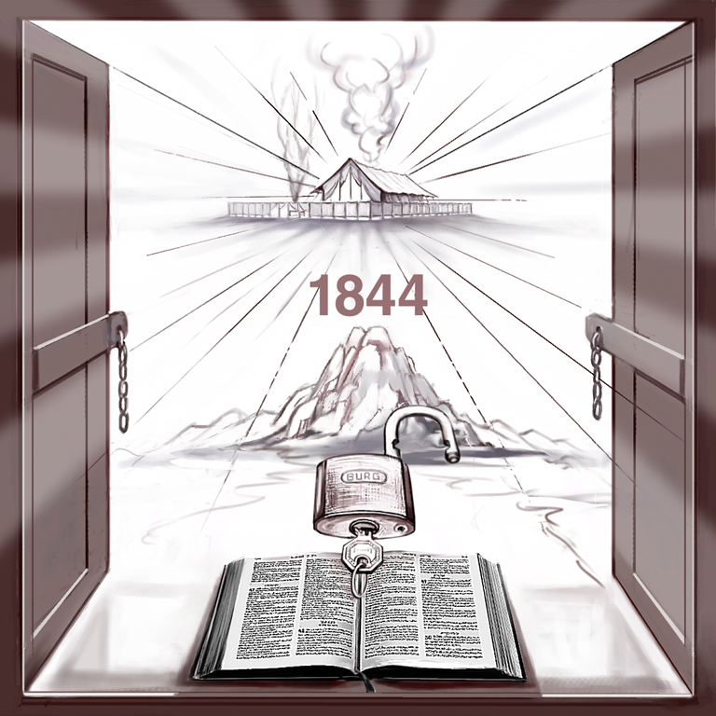
- An Examination of an Erroneous Teaching
VERY prevalent today is the teaching that inward perfection of character is not possible. Christ alone has this, His perfection being so immaculate that it is far beyond the reach of any human being clad in sinful flesh. Accordingly, it is taught, God, knowing this, accepts Christ’s character in the place of the believer’s imperfection so that, in fact, the individual is not judged, but Christ is judged in his place.
This is a fatal misconception, for Christ will do no such thing. Remember, as emphasized on the first page, the point being discussed here is the state in which the believer must be in himself when he faces the judgment. It is not discussing the records of the past for which the Saviour does substitute His perfect righteousness.
Every false doctrine is built on the failure to clearly distinguish between one work and another, and then to make one work the whole. A clear distinction must be maintained between the perfect character which each must have and the imperfect record of the past. Christ will not stand in our place in regard to the former, but He does in respect to the latter.
In the preparation of this study, full awareness of this distinction was maintained. But, it is not a study of both aspects of the work of Christ. It is a concentration on the problem of determining the state of being in which the successful candidate for eternal life must be found in the judgment.
To aid in a clearer understanding of the truth, an analysis will now be made of one presentation of the false teaching that Christ stands in the place of the believer in the judgment, offering His perfect character in place of the imperfect state of the suppliant.
In examining the main points and arguments in this statement, no aspersions whatsoever are leveled at the author. We are not concerned with his motives or character but only with the teaching. The former we have no right to examine. It is God’s work alone to judge character, but it is ours to determine whether a teaching is truth or error, and why.

The Open Door
The argument opens with the statement that Jesus is inviting us to enter through the open door into the most holy place of the heavenly sanctuary.
The Open Door—The Call to Enter
In Revelation, chapter three, verse 8, the Lord says to us, “Behold, I have set before you an open door.” And that door, as we’ve understood, and rightly so, is the door to the most holy place of the heavenly sanctuary. That door was opened in 1844. Now what does the Lord mean when He says to us: “Behold, I have set before you an open door”? Isn’t that an invitation to enter? To enter what? It is an invitation to enter this experience, friends, an eternal release from sin.
This is true, and it is also the truth that Christ’s invitation is to enter into a personal experience. Thus the presentation is launched from a platform of truth. What must now be watched is what the writer declares the experience to be. Is it the one to be obtained, or is it another? Is it offering too much, too little, or something else altogether?

An Erroneous View
It is next asserted that the advent people have not entered into this wonderful blessing because they have had an erroneous view of what they must be before they can enter in.
Now why don’t we enter? Why haven’t we as a people entered into that experience? Many haven’t entered into that experience, I suppose, because we have this view of perfection: “When we are fully perfect, then we can come to the judgment of the living and get the seal of the living God.” How many years will it take for us to be ready? Didn’t Jesus say in 1844 with His hand lifted to heaven, that there should be time (or delay) no longer? But there has been a delay of one hundred and sixteen years because we have been trying to work out our own righteousness, to develop a righteousness that would pass the judgment. And how many more years do you think we want to work out that righteousness? Hasn’t Jesus a perfect righteousness? Doesn’t He give the wedding garment as a free gift? Aren’t we complete in Him? Does it take long years to get that righteousness, friends? The true acceptance of the Lord Jesus gives us the righteousness of Christ.
That mistaken view, it is claimed, is that character perfection must be achieved before the believer can enter into the most holy place of the heavenly sanctuary and receive the benefits of the final atonement. This blessing, the writer teaches, is the final victory over all sin. Therefore, it is argued, the time has come to cease from attempting to develop a righteousness acceptable to the law, and boldly enter in here and now, to receive the promised benefits of full and complete justification.
Thus it is denied that perfection is the required standard for the judgment. Instead, each is to come just as he is with no further waiting. Jesus stands ready to impute His righteousness to cover all the imperfection of the believer and thus assure him of immediate and total release from all his sin.
“There is nothing, [it is urged,] to prevent this church from coming and laying hold of the eternal victory over sin.”
The victory referred to is the one to be gained through the ministry of the final atonement.
Let these propositions now be examined in the light of the Scriptures and the sanctuary. It is plainly understood that when reference is made to entering into the most holy place, it is really referring to the entry into the judgment of the living. This entering in, is not to be confused with the special work of purification which is ministered from the most holy place prior to the commencement of the judgment of the living.
The failure to make this distinction arises from the fact that few realize there is a difference between the day of atonement and the service on that day. The day was from even to even and occupied a full twenty-four hours. The actual service of the day occupied only a part of it. On the day of atonement right up till the service began, a full daily ministry was available, so that, wherever necessary, a person could still bring his sins on that day until the final atonement actually began. That this was so is made clear in the Scriptures:
Numbers 29
7 And you shall have on the tenth day of this seventh month a holy convocation; and you shall afflict your souls: you shall not do any work therein:
8 But you shall offer a burnt offering unto the Lord for a sweet savor; one young bullock, one ram, and seven lambs of the first year; they shall be unto you without blemish:
9 And their meat offering shall be of flour mingled with oil, three tenth deals to a bullock, and two tenth deals to one ram,
10 A several tenth deal for one lamb, throughout the seven lambs:
11 One kid of the goats for a sin offering; beside the sin offering of atonement, and the continual burnt offering, and the meat offering of it, and their drink offerings.
These verses prove that on the great day of atonement, a full daily service was maintained. There was the complete provision of burnt, meat (meal), and sin offerings, apart from the sin offering of the final atonement.
In the antitype, this arrangement is reproduced. On October 22, 1844, the great day of atonement began, and it has been proceeding ever since. On that day, Christ entered the most holy place and began His ministry there. But the final atonement did not begin on that day except for those who had previously died. A full daily ministration is still being offered to the living and will continue to be until the final atonement commences for each one in turn. For the living, that is still future. For the dead, it opens at the point of death.
In 1844 and ever since, God’s people have been called upon to enter into the most holy place by faith. They do this by following their High Priest in His ministration there, by understanding His work and by responding to the greatly expanded light which comes from the ministry in this apartment. This was designed to do a great work in them, a transformation which would occupy a period of time. When that work was completed, they would be ready to enter into the second phase of the most holy place ministry—the judgment.
The distinction between these two works needs to be clearly kept in mind. The first is a work within the people themselves by which they will be brought to a state of readiness for translation, and the second is the judgment which determines that this condition has been achieved. The ideas set forth in the quotation under study call for the bypassing of the first as unnecessary. There, the ideas are erroneous.
The history of the 1844 period testifies to the truth of these distinctions. Prior to the opening of Christ’s ministry in the inner apartment, the people of God had been engaged in the most intensive preparation for the coming of Christ. They had abandoned every known sin, had made a complete consecration and a full sacrifice, and they expected to be translated to heaven. But they were not because they did not understand the full implications of the work to be accomplished before they could be ready.
Early Writings, p. 239:
A spirit of solemn and earnest prayer was everywhere felt by the saints. A holy solemnity was resting upon them. Angels were watching with the deepest interest the effect of the message, and were elevating those who received it, and drawing them from earthly things to obtain large supplies from salvation’s fountain. God’s people were then accepted of Him. Jesus looked upon them with pleasure, for His image was reflected in them. They had made a full sacrifice, an entire consecration, and expected to be changed to immortality.
But they were destined again to be sadly disappointed. The time to which they looked, expecting deliverance, passed; they were still upon the earth, and the effects of the curse never seemed more visible. They had placed their affections on heaven, and in sweet anticipation had tasted immortal deliverance; but their hopes were not realized.
A tremendous work of sanctification had been done within those believers, and they confidently expected to be translated, but there was a reason why this was not done for them.
The Great Controversy, p. 424-425:
But the people were not yet ready to meet their Lord. There was still a work of preparation to be accomplished for them. Light was to be given, directing their minds to the temple of God in heaven; and as they should by faith follow their High Priest in His ministration there, new duties would be revealed. Another message of warning and instruction was to be given to the church.
The people living before October 22, 1844, had received none of the light to be ministered from the most holy place. They had received the light from the first apartment, and it had wrought a wonderful work in their lives, but not sufficient had been accomplished to fit them for translation. They had to pass on to the additional light from the next apartment so that they could have the further fitting up which would prepare them for a place in the kingdom. When that preparation was complete, then they could enter into the judgment and be declared fit for translation.
The advent people were not mistaken when they understood that perfection of character is the standard by which they are to be judged. That this standard has not been achieved is the fault of the people who failed to understand and apply the correct way to achieve it.

Convincing Logic
There is considerable convincing logic in the argument.
And thus, He says to us: “Behold, I have set before you an open door.” “There should be delay no longer.” And in the confidence of the righteousness of the Lord Jesus which we receive as we accept Him as our personal Saviour, in the confidence of that righteousness, friends, we are bidden and we are invited to come up around that sanctuary to plead before the judgment bar of God for the seal of the living God—for the free gift.
There is nothing to prevent this church from coming and laying hold of the eternal victory over sin. This work can be cut short in righteousness. In Hebrews, the tenth chapter, the invitation of the Holy Spirit is given: “Having therefore, brethren, boldness to enter into the holiest.” That means having freedom, having liberty, having confidence, having fearlessness. In other words we can have the fearlessness, that through the provision that Jesus has made for us we can have the boldness to come to the judgment by faith pleading and agonizing before that judgment shall sit and take away from our lives the dominion of sin forevermore, and give us an eternal victory over sin; that while the angels are holding the four winds of strife, we might be sealed with the seal of the living God; that we might receive from the most holy place the latter rain.
We all have in Christ the perfect freedom and privilege to come by faith to the judgment along with God’s people at this time and claim an eternal victory over sin. The door is open. The Holy Spirit invites us to come. Some look upon themselves and say, “Well, how can I come to the judgment? I don’t have a perfect character to pass the judgment.” Oh what blindness! Are we told to open the book and look thereon ourselves? We are told in Revelation that no man can open the book and look thereon.
“Having therefore, brethren, boldness to enter into the holiest by the blood of Jesus.” There in the most holy place is a lamb, as it had been slain. We come in the confidence of His blood which justifies us from all sin. “By a new and living way, which He has consecrated for us, through the veil, that is to say, His flesh.” Hebrews 10:19-20. Jesus took our nature. He developed a perfect character. He is the forerunner who has entered into the most holy place. He stands in the presence of God for us.
When it is believed that character perfection is not the requirement of the judgment, then it is logical to conclude that the people can enter into it at any time. Consequently a strong point is made of this. Having declared that it is a mistake to spend long hard years attempting to achieve perfection when it is unnecessary, the writer then urges his hearers to come directly and immediately to Christ to receive the benefits of the final atonement.
Today, the same author believes even more emphatically that it is impossible for any person to have perfection of character within; that this is a condition reserved for Jesus Christ who credits His abundant righteousness to the believer’s account. However, something of the consistency displayed in 1960 has disappeared, for there is no longer any urging to enter in immediately to receive the bountiful blessing.
That the doctrine is fallacious is proved by the witness of time. There were thousands of people who completely subscribed to the theory when it was preached eighteen years ago. They gathered in assemblies around the world and followed the preacher’s instructions to enter in. But they did not receive the blessing they sought because they could not. It was entirely necessary for the special work of purification to be undertaken first, for, without this, no man can be prepared for the judgment.

An Illustration
An illustration is provided so that there can be no mistaking the writer’s thought.
The name of Bro. Jones is called in the judgment. Bro. Jones has accepted Christ as his very own Saviour, he is hiding his life in Him. Thus Jesus virtually stands in the judgment and says, “I am Bro. Jones.” And to the law which virtually says, “I want a perfect character,” Jesus stands there and says, “Here is the perfect character.” And thus we can come to the judgment through the new and living way which He has consecrated.
Brother Jones is the subject of this story. He presents himself to the judgment with an imperfect character which cannot pass the scrutiny of the law. But he is not dismayed by this, for he expects that Christ will answer to his name, and thus the law will judge Christ on his behalf. In this way he believes he will pass the judgment.
There is some truth in this. Everyone will come with a sinful record. Christ will substitute His perfect righteousness for this imperfect past. But, a sinful record is not a sinful character. The argument that the story of Brother Jones is intended to support is that Christ will substitute His perfect character in place of the suppliant’s imperfect character.
This Christ will not do. Furthermore, it is a disparagement of His power and ministry to suggest such a doctrine.
Christ has a covenant with the Father which was made before the foundations of the earth were laid. In this contract, Christ has agreed to take sinful men and fashion them into beings fit for the inspection of God who will not permit into heaven any who are with spot or wrinkle or any such thing.
Christ has the power to do this, and He will do it. In the judgment He will have no cause to be ashamed of His workmanship. He will not need to ask God not to inspect Brother Jones. Rather He will be able to say that Brother Jones is His workmanship, a man who, through the saving power of Jesus, has been prepared for just such an inspection. He will then confidently submit Brother Jones to the most searching scrutiny knowing that His workmanship is well able to pass such investigation. Not one person whom Christ has prepared for the judgment will fail to pass.
But to suggest that Christ has to ask God not to examine His workmanship because it is defective, is to disparage the Saviour’s wonderful power, the marvelous and entirely adequate ministry of our great High Priest. Let none be guilty of such insult to their Divine Majesties.
Thoughts from the Mount of Blessing, p. 76:
God has made provision that we may become like unto Him, and He will accomplish this for all who do not interpose a perverse will and thus frustrate His grace.
This provision leaves Brother Jones with no excuse. He is represented as coming to the judgment without the wedding garment on and when asked by the King why this is so, he cannot reply.
The Scriptures make it plain that each person is to be judged, not someone else in his place.
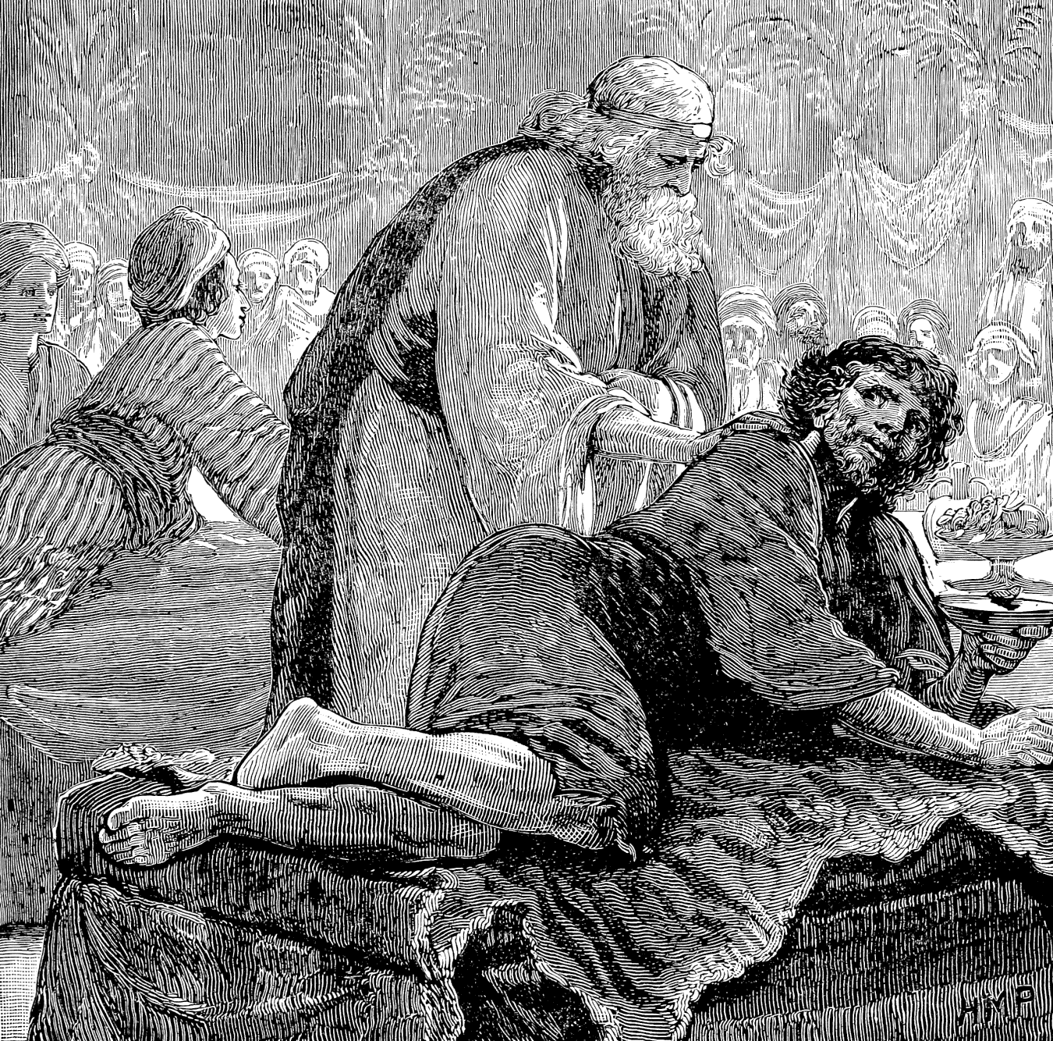"Friend, how did you come in without a wedding garment?"
Romans 2
5 But after your hardness and impenitent heart treasure up unto yourself wrath against the day of wrath and revelation of the righteous judgment of God;
6 Who will render to every man according to his deeds.
2 Corinthians 5
10 For we must all appear before the judgment seat of Christ; that every one may receive the things done in his body, according to what he has done, whether it be good or bad.
Christ’s Object Lessons, p. 312:
Righteousness is right doing, and it is by their deeds that all will be judged. Our characters are revealed by what we do. The works show whether the faith is genuine.
The Great Controversy, p. 490:
Though all nations are to pass in judgment before God, yet He will examine the case of each individual with as close and searching scrutiny as if there were not another being upon the earth. Every one must be tested, and found without spot or wrinkle or any such thing.
In respect to character, there is only one question which will be asked in the judgment. It will NOT be any of these:
- Is he a member of the Remnant Church?
- Has he believed all the doctrines?
- Is his life hidden in Christ?
- Is he sorry for his sins?
- Is he agonizing for the blotting out of sins?
It will only be this:
Gospel Workers, p. 315:
The only question asked in the judgment will be, “Have they been obedient to my commandments?”
Inasmuch as what we do, rightly evaluated, is the revelation of what we are, then this question is the same as asking,
“Does he have a perfect character?”
That is the question by which eternal life will be determined.

- Joshua and the Angel
THE truth that perfection is the standard for the judgment is attested to by plain statements, the teaching of the sanctuary rituals, and in parables. The examination of these evidences has not been dealt with exhaustively, but sufficient evidences have been presented to initiate the student into his own confirming study of this vital question.
The evidence with which this study began was found in the parable of the marriage in Matthew 22. But this is not the only one dealing with the marriage. There is the Old Testament parable of Joshua and the Angel recorded in Zechariah 3:1-10.
When the two parables are considered, it appears that they directly contradict each other. The marriage parable affirms that the believer must be in the wedding garment when he comes into judgment, but the other represents him as appearing in filthy garments which symbolize a defective character.
When a strong advocate of the doctrine of character imperfection being satisfactory in the judgment, was asked to explain this seeming contradiction, he was unable to do so. He pointed to Joshua and the Angel and declared that this confirmed that the believer does come with a defective character, but how to explain Matthew 22 was, by his own admission, more than he could do.
But there are no actual contradictions in the Bible. They do not exist. There will appear to be such only because the student has not yet come to understand the full depth of spiritual truth. Patient, confident waiting on the Lord will bring this all into perfect harmony.
Actually, there is no mystery between the witnesses provided in Matthew 22 and Zechariah 3. It is only a matter of seeing what the Scriptures really say and of keeping the messages therein, related to the other truths in the Scriptures.
Anyone, though, who clings to the idea that the believer comes to the judgment with a defective character, will have no hope of reconciling the two. But, believing that the candidate for eternal life comes in a perfect character, is the basis for understanding the harmony between these two revelations of truth.
The parable of Joshua and the Angel is a further lesson in regard to the sanctuary service. It is not the first lesson. Therefore, it is to be understood in the light of the sanctuary rather than the sanctuary being understood in the light of the parable. Of course, as it throws more light on the sanctuary, it will give greater clarity to it, but it is not the place to start.
Here is the main part of the parable.
Zechariah 3
1 And he showed me Joshua the high priest standing before the angel of the Lord, and Satan standing at his right hand to resist him.
2 And the Lord said unto Satan, The Lord rebuke you, O Satan; even the Lord that has chosen Jerusalem rebuke you: is not this a brand plucked out of the fire?
3 Now Joshua was clothed with filthy garments, and stood before the angel.
4 And he answered and spake unto those that stood before him, saying, Take away the filthy garments from him. And unto him he said, Behold, I have caused your iniquity to pass from you, and I will clothe you with change of raiment.
5 And I said, Let them set a fair mitre upon his head. So they set a fair mitre upon his head, and clothed him with garments. And the angel of the Lord stood by.
There are three principal characters, Joshua, Satan, and the Lord. Each is represented as playing a role demonstrating the nature of his position and work. Joshua stands clad in filthy garments, the symbol of a defective character, while Satan presses his accusations upon him thus seeking to discourage him from securing the cleansing he needs. The Lord rebukes the accuser and calls for the change of raiment from filthy to clean.
The message which the parable is intended to teach more than any other is the character of Satan as the accuser of the brethren, and the marvelous capacity of the Saviour to silence these charges.

Applied to the Daily Service
The parable has an application to both the daily and the yearly services. It is necessary to understand the daily application before it is possible to comprehend the peculiar force of its message in the final atonement. In Testimonies for the Church, volume 5, a clear explanation is given of the way the parable relates to the daily experience. This statement clearly delineates the roles played by the suppliant, Satan, and the Lord in the daily service, as revealed in the parable of Joshua and the Angel.
Testimonies for the Church, vol. 5, p. 470:
As Satan accused Joshua and his people, so in all ages he accuses those who are seeking the mercy and favor of God.
This sentence assures that the lesson is not to be limited to the last days, but is applicable in every age. All men who have come to Christ have experienced it, for it is not confined to those who shall pass alive through the judgment of the living.
The controversy is repeated over every soul that is rescued from the power of evil and whose name is registered in the Lamb’s book of life. Never is one received from the family of Satan into the family of God without exciting the determined resistance of the wicked one.
Satan’s principal weapon for diverting God’s people from His saving ministry is to discourage them with the thought that their sins are too great to be forgiven. He points to their filthy garments, their defective characters, and argues that the pure and spotless God can never forgive such iniquity. It is true that the garments are sin-stained, and in this condition the suppliant stands before the Lord.
Testimonies for the Church, vol. 5, p. 471:
But Jesus our Advocate presents an effectual plea in behalf of all who by repentance and faith have committed the keeping of their souls to Him. He pleads their cause and vanquishes their accuser by the mighty arguments of Calvary. His perfect obedience to God’s law, even unto the death of the cross, has given Him all power in heaven and in earth, and He claims of His Father mercy and reconciliation for guilty man.
To the accuser of His people He declares: “The Lord rebuke you, O Satan. These are the purchase of my blood, brands plucked from the burning.” Those who rely upon Him in faith receive the comforting assurance: “Behold, I have caused your iniquity to pass from you, and I will clothe you with change of raiment.” All that have put on the robe of Christ’s righteousness will stand before Him as chosen and faithful and true. Satan has no power to pluck them out of the hand of Christ. Not one soul that in penitence and faith has claimed His protection will Christ permit to pass under the enemy’s power.
Those who understand Christ’s work in the daily will recognize this transaction. The sinner comes to the door of the tabernacle bearing his sinful life within him. This is the iniquity symbolized by the filthy garments. In strong faith, he confesses this problem and gives the old sinfulness to Jesus, the High Priest. The Saviour then takes the filthy garments from him and gives him, in exchange, His own spotless character.
In this work, the filthy garments, the defective character, are taken from him. Therefore, they are no longer with him or on him. It is impossible to take them away from him and yet at the same time leave them there. They are removed to the sanctuary until the day of final atonement.

Applied to the Yearly Service
That service provides for the further removal of the sins from the people by taking them out of the sanctuary and placing them on the scapegoat, Satan. This is the last thing he desires to see happen. Therefore, he labors incessantly to forestall such a fate.
To be successful, he must initially prevent the sin from reaching the sanctuary during the daily service, or, if he has failed there, he must prevent it from being taken out of the sanctuary onto himself in the yearly service. He has to divert it back to the individual. Thus, should he fail in round one, he still has round two. If he fails both of them, then he is doomed to receive the sins and be forced to bear them into the final destroying fires.
It is because Satan still has a role to play in the judgment scene, that the parable of Joshua and the Angel has an application to this event.
Testimonies for the Church, vol. 5, p. 472:
Zechariah’s vision of Joshua and the Angel applies with peculiar force to the experience of God’s people in the closing up of the great day of atonement.
Once again in that day, Satan will point to their filthy garments, the defective characters, and once more, Christ will take away those filthy garments and will clothe them with the garments of spotless righteousness. The language used to describe this final work is the same as that used to describe the earlier ministry. But there are differences, as can be readily seen if the nature of the work in the sanctuary is kept clearly in mind.
When the archenemy levels his accusing finger at their filthy garments, he must point to them where they are at the time. While the people still have them, it is to their persons that he will direct his charges, but when those garments have been removed to the sanctuary, then he must level his accusations there. In the daily, he points to their filthy garments. He also does this in the judgment, but it is to two different places that he is pointing in each case.
However, while the places to which he levels his charges are different, the technique he employs to achieve his purpose is the same. It is so, because the steps which the people of God must take are the same in both cases.
For the people to receive the ministration of the daily, they have to:
- Understand the problem which confronts them; that is, they must know that they are clad in filthy garments and need a change of raiment;
- Be conversant with the mighty ministry of Christ, His position, and work in the sanctuary above;
- Fully believe that Christ is able to satisfy their need;
- Come to Him and commit the whole of the work to Him.
Only then can He remove their filthy garments and give them change of raiment. Satan understands this procedure and sees in it the opportunity to thwart these purposes. Recognizing the key factor of the people’s knowing, believing, coming, and committing, he works with desperate determination to prevent them from doing so. With those souls over whom he is successful, he has no further concern, for he knows that as surely as their sins have never reached the sanctuary, so surely will they never reach him.
The same procedures of faith necessary to secure the blessing of the first apartment are needed to obtain the benefits of the final atonement. This affords Satan the opportunity to contest the issue then, with the same methods he used in contesting the daily issue.
No one can receive the benefits of the final atonement unless he understands his need. This is enormous. Between him and eternal life stands the satisfactory disposal of his accumulated sins in the sanctuary. Unless final atonement is made for them and they are thereby transferred to the scapegoat, they will be returned to him again. If they are, they will once again become an inseparable part of him, thus preventing him from ever entering heaven. Consequently, his need cannot be more critical.
What makes the problem more difficult is the fact that he is helpless to remove them himself. He cannot ascend into heaven and do it. So, he has to depend upon another to do it for him. There is only One who can and that is Christ.
Such dependence is not easy under the circumstances which will then be prevailing. It will require a faith which has to endure the greatest possible pressure. Satan is no more anxious to have these sins than are the righteous. Therefore, while they are putting forth the utmost spiritual struggle to ensure that they do not receive them back, Satan is exerting all his power to certify that they do. This is the issue of the contest in the yearly.
Let it be emphasized that Satan will not be the least concerned about any person who, at this time, still has known, unconfessed sin in him. He knows that such a person, having failed to avail himself of the provisions of the daily when it was available, has nowhere to turn to have those sins removed once probation has closed. Those sins cannot pass directly from the sinner to Satan, and, when probation has closed, they cannot come to him via the sanctuary, for such transfers will no longer be taking place.
This is why the doctrine of imperfection of character being the requirement of the judgment is such a deadly heresy. No one’s experience will reach any higher than his faith. If a person is taught to believe that he will come to the judgment possessed of an imperfect character, then this is how he will come, with his sins still being an integral part of him. His soul will then be tortured with the awful realization that he has a load of sin on his hands with nowhere to send it. He will then know that he is eternally lost as the result of accepting a misleading doctrine.
On the other hand, those who have sent their sins to the sanctuary will receive the full concentration of Satan’s concerned attention. He well knows that, unless he can break their faith in Christ’s final atonement ministry, he will lose the battle entirely. The key to his success and, in fact, the only means whereby he can succeed, is to break their faith.
To achieve this, he must persuade them that their case is hopeless; that the witness of circumstances provided in the awful accumulation of their wretched iniquity, denies that there is any hope that the pure and spotless Redeemer will handle such impurity. He will press his case with great determination and skill, knowing that for him, this is the final opportunity. It will be lose all or gain all.
He mounts his assault by pointing to their filthy garments. But, in so doing, he must and will point to where those garments will be at that time—in the sanctuary in heaven. They will no longer be on the people themselves. Therefore, Satan is not making any issue over the condition in which the people themselves will be at that time. They will be clad in the wedding garment, which is the fitness to pass the judgment, and he knows this. He realizes that there is no value in arguing over this fact.
But he and they know that the lives they have lived have been far from righteous, so he points to them, not as they will be at that time, but as they were prior to the opening of the judgment. Note how, in the inspired prophecy of his behavior, he is quoted as pointing to the sinfulness of the past while making no mention of the perfection of the present.
Testimonies for the Church, vol. 5, p. 473-474:
The tempter stands by to accuse them, as he stood by to resist Joshua. He points to their filthy garments, their defective characters. He presents their weakness and folly, their sins of ingratitude, their unlikeness to Christ, which has dishonored their Redeemer. He endeavors to affright the soul with the thought that their case is hopeless, that the stain of their defilement will never be washed away. He hopes to so destroy their faith that they will yield to his temptations, turn from their allegiance to God, and receive the mark of the beast.
Satan urges before God his accusations against them, declaring that they have by their sins forfeited the divine protection, and claiming the right to destroy them as transgressors. He pronounces them just as deserving as himself of exclusion from the favor of God. “Are these,” he says, “the people who are to take my place in heaven and the place of the angels who united with me? While they profess to obey the law of God, have they kept its precepts? Have they not been lovers of self more than of God? Have they not placed their own interests above His service? Have they not loved the things of the world? Look at the sins which have marked their lives. Behold their selfishness, their malice, their hatred toward one another.”
Satan does not say any of this in the present tense. He does not claim,
“While they profess to obey the law of God, are they keeping its precepts? Are they not lovers of self more than of God? Are they not placing their own interests above His service? Do they not love the things of this world? Look at the sins marking their lives. Behold their selfishness, their malice, their hatred toward one another.”
This is not the way he talks, for he knows that at this time they stand in the wedding garment of a perfect character and none of these charges are true. He does not waste time on this when he is concerned with what they were. It is to that, that he points, all of which has been sent on beforehand to judgment.
Testimonies for the Church, vol. 5, p. 474:
But while the followers of Christ have sinned, they have not given themselves to the control of evil. They have put away their sins, and have sought the Lord in humility and contrition, and the divine Advocate pleads in their behalf.
Once more, the command is given to take away the filthy garments and clothe them in the garments of Christ’s righteousness. In response, the defective characters, the sinfulness, the iniquity, are removed from them forever. But, and this is the critical point, the sinfulness is removed from its place in the sanctuary, not from their persons.
The removal of sin began with taking it from their persons and placing it in the sanctuary, but this did not complete the task. The next step is to remove it from the sanctuary and place it on the scapegoat. This is still taking the sin away from them for, by this action, it is taken much further away. The final work of taking the sin away from them is to commit it and Satan to the all-consuming fires. Then, the work of removing sin will at last be complete.
There seems to be a limited understanding of this work, for many appear to believe that only when the sin is removed from them personally is it taken away from them. They fail to recognize that when the sin is taken away from the sanctuary, it is still being taken away from them.
There is no contradiction between the marriage parable and the one in Zechariah 3. The former pictures how the people of God will be in themselves in the judgment day, while the latter simply relates how they will be in the records of the sanctuary. When the record is cleansed, their position in the sanctuary will then be clothed in perfect righteousness as they stand before God as if they had never sinned. Satan will have lost both rounds of the battle.
- In the daily he will have failed to prevent the filthy garments from being taken from God’s people into the sanctuary, and
- In the yearly he will likewise have failed to prevent the same unclean rags from being taken still further away from them by being removed from the temple of God in heaven.
The worst will have happened for Satan when the sins are placed upon him, and he is forced to bear them away into the wilderness of destruction.

- Pleading for Purity of Heart
SOME people point to the following statement as proof that at this time the people are concerned with sin being taken from them personally:
Testimonies for the Church, vol. 5, p. 475:
As the people of God afflict their souls before Him, pleading for purity of heart, the command is given, “Take away the filthy garments” from them, and the encouraging words are spoken, “Behold, I have caused your iniquity to pass from you, and I will clothe you with change of raiment.”
It is argued that they are asking for the transfer of sin from themselves to the sanctuary; that the great blessing they are seeking in the judgment is the purification of their own souls. Otherwise, why should they be pleading for purity of heart?
The plea for purity of heart is an essential prerequisite for receiving the blessing of the day of atonement. Only those who have sent every sin on beforehand to judgment, will be found worthy to receive the blotting out of their sins from the sanctuary above. Knowing this, each child of God in that day will be searching his heart as never before, to certify to himself that there is nothing remaining which needs to be cleansed away.
The time does not come when each will know that the last sin has been revealed and cleansed away so that he can confidently say,
“Now I am completely cleansed and am therefore ready for the judgment.”
God does not work this way. Progressively, sin is revealed. As one problem is dealt with, the way is cleared for the next. But when a particular sin is overcome, the individual does not know if it is the last one or not. He feels as if it is, for, at that moment, he is not conscious of any further depths to be reached.
As the progressive work advances, he comes to understand that even though the present cleansing is complete as far as he has seen the difficulty, there will certainly be more yet to be uncovered and removed.
So, in the great day of judgment, having become familiar with this pattern, he will have no way of knowing if the last thing has been revealed and removed. Fearing that there are yet unseen depths of iniquity, the plea for purity of heart will be a very earnest one. The believer knows that without it, he can never face the judgment’s searching scrutiny and be declared fit for eternal life.
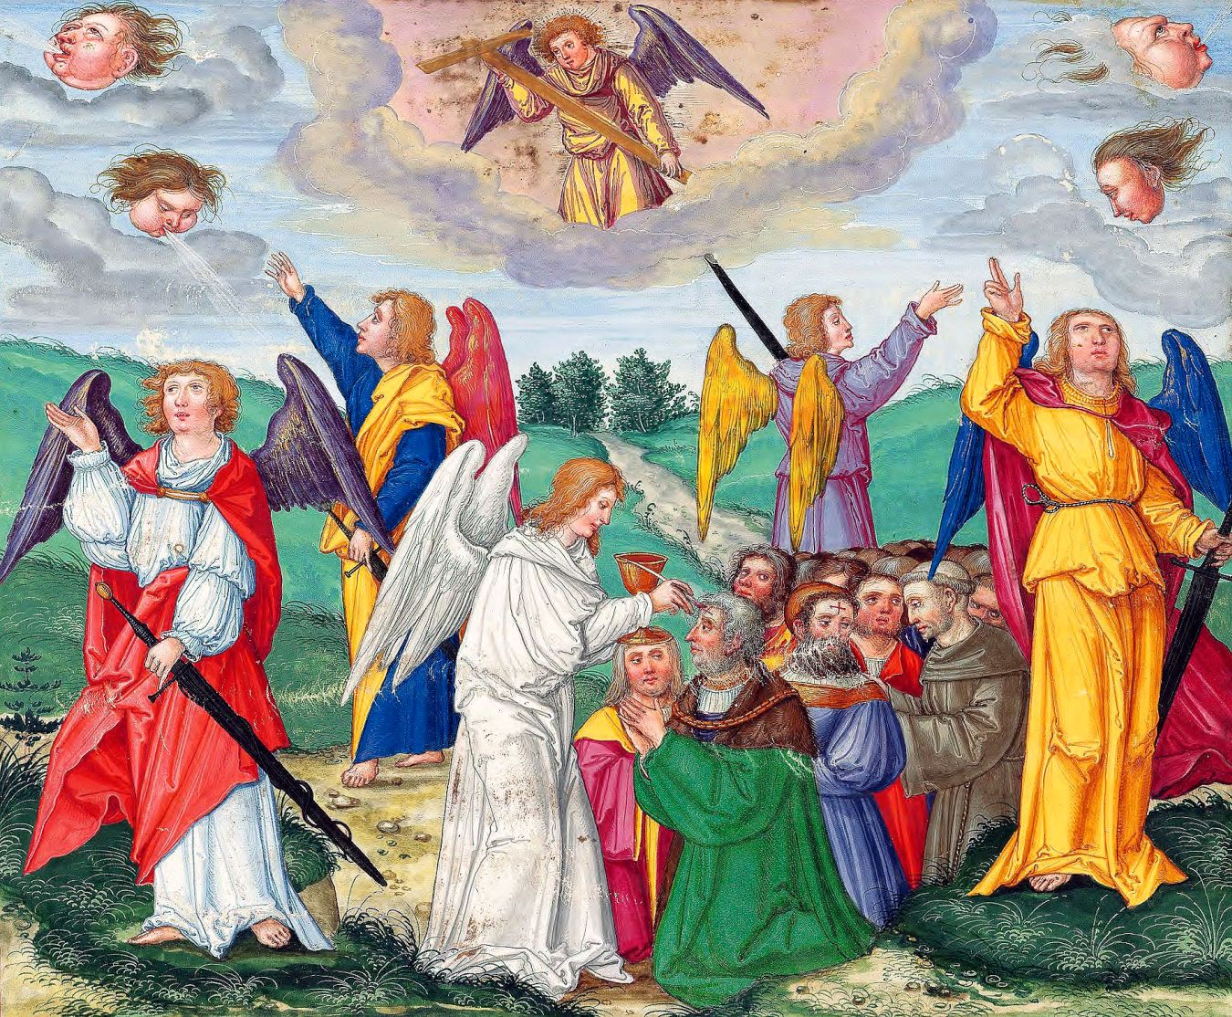
- In Conclusion
THE judgmental investigation of the life of every person upon the earth is coming. There is not a soul who can avoid passing through that screening. With impartial exactitude it will measure the worth of each individual, calculating the opportunities gained or lost for obtaining the fitness of character for a place in eternity.
Today, millions pass along ignorant of, and unconcerned about, this appointment with destiny. Others know it is coming but have been persuaded that they do not need to obtain perfection of character, for Another who has absolute perfection, will stand in their place.
Fortunate indeed are those who know it is coming and who know that the requirement is perfection of character. More fortunate still are those, who, knowing this, have the living faith to believe that the Lord will take in hand this perfecting work, to bring them forth “without spot, or wrinkle, or any such thing.”
There is no one living today who is yet prepared for the judgment of the living. It will require all the light still to be revealed under the ministry of the four angels of Revelation 14 and 18, to penetrate to the bottom of the sin problem in the lives of the last generation.
It will not be until the full depth of sin has been revealed, confessed, and forsaken, that a people will be ready to pass the judgment of the living. Christ still has a great work to do from the most holy place, but He has the power to do it, and He will accomplish it fully and completely before the judgment of the living begins.
On the other hand, every child of God who has put away each sin the Lord has revealed to him, according to the principles of acceptable confession, is ready for the judgment of the dead. This means that anyone who passes to his rest today, still with unrevealed sin in his life, will not fail to pass the judgment because of that. God does not make us responsible for the unknown sins. These are covered by His righteousness, and will keep no one out of the kingdom.
Thus, in one sense, there is a difference between those who face the judgment of the living and those who face the judgment of the dead. Yet in another sense there is none. The difference lies only in degree, not in quality. Both classes must have put away every known sin. Both must therefore have perfected characters as far as the light has been revealed to them.
With those who face the judgment of the dead, the work is incomplete because some sins of ignorance remain, but for those who face the judgment of the living, the revelation must be complete, leaving them in the full sense of the word, “without spot, or wrinkle, or any such thing.”
There is, therefore, a great work to be done by those who are determined to inherit eternal life. Before the day of atonement began in ancient Israel, ten days were spent in deep heart-searching, during which each, aided by the Holy Spirit, closely examined his life to discover every sin which needed to be forsaken before the great day of atonement arrived.
Likewise, in this great antitypical hour of God’s judgment, each one is called upon to closely examine his heart and life to see what is standing between him and full perfection of character. This is a grave work which no one can do for another.
Let these solemn facts stir all to actively undertake this critical assignment so that the great and terrible day of the Lord will not catch any unawares.
The Great Controversy, p. 489-491:
We are now living in the great day of atonement. In the typical service, while the high priest was making the atonement for Israel, all were required to afflict their souls by repentance of sin and humiliation before the Lord, lest they be cut off from among the people.
In like manner, all who would have their names retained in the book of life, should now, in the few remaining days of their probation, afflict their souls before God by sorrow for sin and true repentance. There must be deep, faithful searching of heart. The light, frivolous spirit indulged by so many professed Christians must be put away. There is earnest warfare before all who would subdue the evil tendencies that strive for the mastery.
The work of preparation is an individual work. We are not saved in groups. The purity and devotion of one will not offset the want of these qualities in another. Though all nations are to pass in judgment before God, yet He will examine the case of each individual with as close and searching scrutiny as if there were not another being upon the earth. Every one must be tested, and found without spot or wrinkle or any such thing.
Solemn are the scenes connected with the closing work of the atonement. Momentous are the interests involved therein. The judgment is now passing in the sanctuary above. For many years this work has been in progress. Soon—none know how soon—it will pass to the cases of the living. In the awful presence of God our lives are to come up in review. At this time above all others it behooves every soul to heed the Saviour’s admonition,
Mark 13
33 Watch and pray: for you know not when the time is.
Revelation 3
3 If therefore you shall not watch, I will come on you as a thief, and you shall not know what hour I will come upon you.
When the work of the investigative judgment closes, the destiny of all will have been decided for life or death. Probation is ended a short time before the appearing of the Lord in the clouds of heaven. Christ in the Revelation, looking forward to that time, declares:
Revelation 22
11 He that is unjust, let him be unjust still: and he which is filthy, let him be filthy still: and he that is righteous, let him be righteous still: and he that is holy, let him be holy still.
12 And, behold, I come quickly; and my reward is with me, to give every man according as his work shall be.

Appendix: Further Notes
HERE are some further notes to throw into plain focus the erroneous teaching that it is impossible for us to come perfected before the judgment. Compare these statements with the Law and the Testimony:
We live in the hour of God’s judgment. The law demands of us a perfect character, as perfect as God is perfect. There are sincere souls who trust in Christ to justify them, but imagine that they must either develop the ultimate in character perfection before the judgment or be lost. . . . Let it be thoroughly understood that God does not expect His people to attain to the ultimate in sinless perfection before they come by faith to the judgment.
The final cleansing follows the judgment. Let this fact be firmly established in the mind. It will crush any ideas anyone may have about getting absolute perfection in himself before the judgment. The final atonement is not made for the believer until he is judged. It is affliction of soul and utter self-abasement that will merit as the mercy of the Judge. We must plead before the judgment bar of God for this final cleansing.
This should be duly noted for God’s people have no perfection in themselves to offer at the judgment. The judgment does not determine who has reached the finality (ultimate, absolute, acme, full maturity) of perfection. The judgment determines who shall reach ultimate and absolute perfection.
An idea prevalent is that when God’s people have reached perfection of character through a process of sanctification, they are then ready for the judgment, which judgment, it is thought, will merely recognize their perfect characters and seal them for eternity. But this concept of the judgment is the evidence of the most fatal blindness in our understanding of righteousness by faith. As the reader has seen chapter after chapter of this book point out the serious errors being nourished in the church of God, he is asked to consider that this false concept of the work of Jesus in the most holy place is the root of the error; the other discrepancies are merely the branches.
Although God’s people have put away all sin, they do not stand perfect in the judgment.
Without final atonement of the most holy place it would be impossible to attain to the finality of moral perfection.
Compare the first five statements with the statements from the Bible, the Spirit of Prophecy, the Sanctuary, and the men of 1888, already given in the study and the last one with this:
SDA Bible Commentary, vol. 7, p. 903:
Paul attained to the fully moral stature of a man in Christ Jesus. By what a process was his soul developed! His life was a continual scene of hardship, conflict, toil.
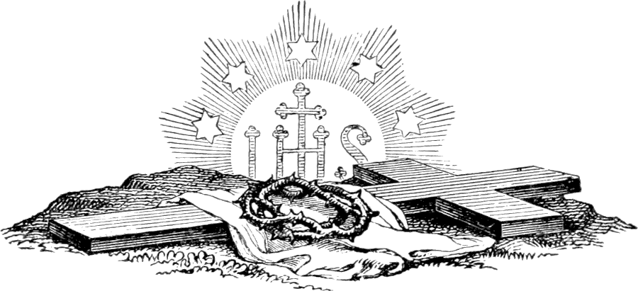

Christ’s Object Lessons, p. 310.
The Great Controversy, p. 428.
See The Consecrated Way to Christian Perfection, by A. T. Jones, Chapter 15, “The Cleansing of the Sanctuary.”
Christ’s Object Lessons, p. 310; The Great Controversy, p. 428.
Compare with Christ’s Object Lessons, p. 310.
Let the reader remember that this study is discussing the state of perfection in which the believer must be found when the judgment comes. It is not discussing the records of sins committed. So far as this aspect is concerned, no person will come with a righteous past, and therefore, all will need the imputed righteousness of Christ to care for this need. Where the past is concerned, Christ will stand in the sinner’s stead and offer His perfect righteousness in place of His children’s blemished lives. This is the other aspect of the judgment and must be kept distinct from the personal character perfection which has to be attained by that time. So far as the examination of what the state of the person is at that time, it is he who will be examined, not someone else in his place. Christ will present us to the Father as His finished workmanship, not as something for which He must substitute.
Hebrews 3.
See From Bondage to Freedom (also called Freedom from Sin), Justified by Faith, Acceptable Confession, Awake to Righteousness, The Three Temples, and Living Righteously.
Revelation 19:8.
Christ’s Object Lessons, p. 310.
Ibid.
Idem., p. 312.
Ibid.
The Great Controversy, p. 490.
Ibid., p. 428.
Christ’s Object Lessons, p. 314.
See: From Bondage to Freedom (also called Freedom from Sin), Acceptable Confession, Justified by Faith, The Destiny of a Movement, and Living Righteously.
See The Three Temples for a deeper explanation of this theme.
The Consecrated Way to Christian Perfection, Chapter 15 “The Cleansing of the Sanctuary,” p. 115-117.
Robert D. Brinsmead, Perfection Through the Sanctuary Service, p. 25-27, as given at College Place, Washington, 1960. See also Appendix.
Ibid.
Ibid.
Ibid.
R. D. Brinsmead, Tidings of Great Joy, p. 15-16.
Idem, p. 22.
R. D. Brinsmead, Australian Division Committee Report Reviewed, p. 12.
R. D. Brinsmead, Weighed in the Balances, p. 45.
Idem, p. 47.
R. D. & J. B. Brinsmead, Open Reply to the General Conference Committee, May 20, 1961, p. 12.

