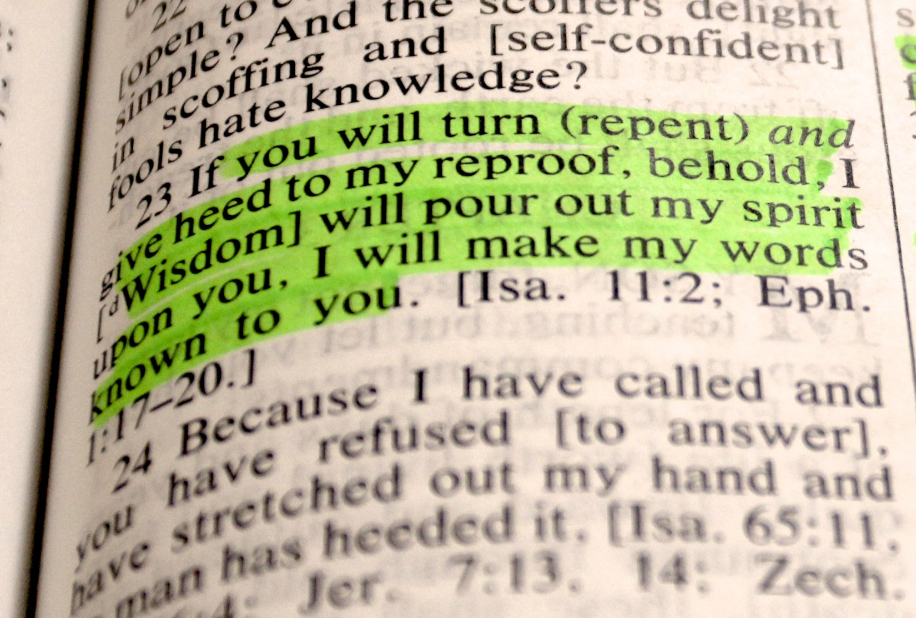
Cutting
Reproof

James White
Source:
Advent Review
September 1850
Cover:
Proverbs 1:23
Savio Sebastian
Flickr.com

Fonts:
Rage Italic
Liberation Sans Narrow
Linux Biolinum
Linux Libertine

September 2021
www.srac.info
www.practicaprophetica.com

Contents
- The Seal or the Mark 1
- The Elijah Message 7
- Human Ingenuity – A False Hope 15
- Rise of Spiritualism 17
- Liberty of Conscience Set Aside 19
- Precious Promises 21

- The Seal or the Mark
IN A BOOK called An Antidote, or Treatise of Thirty Controversies (1622), by Sylvester Norris, intended as a reply to the writings of Dr. Faulk, Dr. Whitaker, Dr. Field, and others, the author speaks thus:
The Word of God commands the seventh day to be the Sabbath of our Lord, and to be kept holy; you [Protestants,] without any precept of scripture change it to the first day of the week, only authorized by our traditions.
Divers English Puritans oppose against this point, that the observation of the first day is proved out of Scripture, where it is said the first day of the week Acts 20:7; 1 Corinthians 16:2; Revelation 1:10. Have they not spun a fair thread, in quoting these places?
If we should produce no better for purgatory and prayers for the dead, invocation of the saints, and the like, they might have good cause indeed to laugh us to scorn; for where is it written that these were Sabbath days in which those meetings were kept? Or where is it ordained they should be always observed? Or, which is the sum of all, where is it decreed that the observation of the first day should abrogate or abolish the sanctifying of the seventh day which God commanded everlastingly to be kept holy? Not one of those is expressed in the written word of God.
In this extract the Papists justly charge the Protestants of changing the keeping of the seventh day, to the first day of the week, without any precept of scripture, “only authorized by their traditions.” So says the first beast [of Revelation 13:1-10]. In this, the two horned beast [Revelation 13:10-18], Protestant Rome, has done just what was predicted that he would do:
Revelation 13
12 And he exercises all the power of the first beast before him, and causes the earth, and them which dwell therein to worship the first beast, whose deadly wound was healed.
And all must admit that there is no point of religious faith, so prominent in the Roman world, as that of Sunday-keeping, and that there is no other principle in their religious character, upon which such unity of faith exists as upon Sunday-keeping. In this the great majority of the Roman world are agreed. This is their most prominent characteristic mark, and it is “of the beast.”
The third angel is raising his loud and warning voice against worshiping the beast, or receiving his mark, and has he no mark to administer? Yes, he has the seal (or mark) of the living God. What is it?
Revelation 14
12 [Keeping] the commandments of God, and the faith of Jesus.
Why is it said “here are they that keep the commandments of God”? Evidently because one of them had been cast down to the ground, and trodden under foot for more than 1200 years. And although the other nine had been kept, yet it could not be said that they were keeping the commandments, because it is written,
James 2 [Campbell]
10 For whosoever shall keep the whole law, but shall fail with respect to one precept, has become guilty of all.
Therefore the trodden down commandment must be restored and kept, before it can be said,
Revelation 14
12 Here are they that keep the commandments of God.
Nine of them are universally admitted to be in full force, and binding upon mankind. And there is no particular cross, or test of faith in admitting or confessing them. The veriest worldling will do this.
But the cross and test is, in confessing and obeying the trodden down Holy Sabbath commandment. God has always had a present truth test for his church to believe, which was the sealing, saving truth of the time then present. In the days of the apostles, it was the present sealing truth to believe that Jesus Christ had come in the flesh, and had suffered and had risen again from the dead, etc.
Then come down to the proclamation of 1843, the hour of God’s judgment, the fall of Babylon and the Midnight cry. These were the then present saving truths, and the world by rejecting them sealed their own damnation.
And think you that the third angel has no testing, sealing truth? Strange indeed if he has not. What then, could be the object of his message?
Some tell us that they have no objection to our believing, and obeying the Sabbath commandment, if we will not make it a test of salvation. I ask, what would be the object of teaching this truth, if there was no salvation in it? It is the last testing sealing truth that will ever be offered to mortals, and all who reject it will speedily drink the wine of God Almighty’s wrath.
So far as the third angel’s message has been proclaimed, it is known that the burden of the message has been to restore the down-trodden Sabbath commandment. This is the most prominent characteristic mark of those who are proclaiming the present truth. It is the seal or mark of the living God.
But some require a “thus says the Lord”, that the Sabbath is the seal. They might with equal propriety require the same of every sealing truth that has ever been proclaimed to man. But thank heaven, we have got a “thus says the Lord” for the Sabbath seal. He has said by his prophet, speaking of the present crisis:
Isaiah 8
16 Bind up the testimony, seal [or ratify] the law among my disciples.
This could never be done while they were violating one precept of that law.
Again, when the children of Israel had left Egypt, the first commandment urged on them was the Sabbath of the Lord our God. So, also, it was with us, after we got out of Babylon into the wilderness of the people, this side of 1844. Then it began to ring in our ears,
Exodus 16
28 And the Lord said unto Moses, How long refuse you to keep my commandments and my laws?
29 See, for that the Lord has given you the Sabbath...
It was the last important truth and commandment urged from Mount Sinai, when God…
Exodus 31
18 ...made an end of communing with Moses upon the Mount.
It was then and there urged and enjoined by the most powerful motives.
12 And the Lord spoke unto Moses, saying,
13 Speak also unto the children of Israel, saying, Verily my sabbaths you shall keep: for it is a sign between me and you throughout your generations; that you may know that I am the Lord that does sanctify you.
14 You shall keep the sabbath therefore; for it is holy unto you: every one that defiles it shall surely be put to death: for whosoever does any work therein, that soul shall be cut off from among his people.
15 Six days may work be done; but in the seventh is the sabbath of rest, holy to the Lord: whosoever does any work in the sabbath day, he shall surely be put to death.
16 Wherefore the children of Israel shall keep the sabbath, to observe the sabbath throughout their generations, for a perpetual covenant.
17 It is a sign between me and the children of Israel for ever: for in six days the Lord made heaven and earth, and on the seventh day He rested, and was refreshed.
It was enjoined as a holy sanctifying truth, and by keeping it they should know that the Lord their God did sanctify them. It was enjoined by the most heavy penalties that could be inflicted upon the one who dared to violate or defile it. By doing any work therein,
Exodus 31
14 ...that soul should be cut off from among his people,
–and should surely be put to death. Again, the greatest favor and blessing that could be bestowed upon mortal man, was held out as the most powerful motive, to the willing and obedient:
13 ...a sign between me and you,...that you may know that I am the Lord that does sanctify you.
Walker’s definition of a sign is “a token, to mark, to ratify by hand or to seal.” So also, now the Sabbath is enjoined upon the little flock, as a mark, a seal, and it is now enjoined and urged from the same powerful motives that it was then.
All who reject this truth after receiving the light upon it, and continue to defile the Holy Sabbath, by doing any work therein, are to be cut off from among His people, and purged out from among them as rebels, and are surely and speedily to be put to death, by drinking the wine of God’s wrath, in the seven last plagues.
But it is a sign, a seal, a mark to the willing and the obedient, that the Lord their God does sanctify them. Paul says,
1 Corinthians 10
6 Now these things were our examples; [margin, our figures].
Once more,
11 Now all these things happened unto them for ensamples [margin, types], and they are written for our admonition, upon whom the ends of the world are come.
12 Wherefore let him that thinks he stands [while he is defiling the Holy Sabbath, by doing any work therein], take heed lest he fall.

- The Elijah Message
God has said,
Malachi 4
5 Behold I will send you Elijah the prophet before the coming of the great and dreadful day of the Lord.
Said Jesus,
Matthew 17
11 Elijah truly shall first come, and restore all things.
YOU have heard the voice of Elijah in the advent doctrine, which has been proclaimed in the spirit and power of Elijah, and will you now turn a deaf ear to his voice in the message of the third angel, crying in the wilderness of the people,
Isaiah 40
3 Prepare the way of the Lord, make strait in the desert a highway for our God.
Isaiah 57
14 Cast up, cast up, prepare the way, take up the stumbling-block out of the way of my people.
Isaiah 62
10 Go through, go through the gates; prepare the way of the people; cast up, cast up the highway; gather out the stones; lift up a standard for the people.
Isaiah 35
8 And a highway shall be there, and a way, and it shall be called, The way of holiness; the unclean shall not pass over it; but it shall be for those: the wayfaring men, though fools, shall not err therein.
9 No lion shall be there, nor any ravenous beast shall go up thereon, it shall not be found there; but the redeemed shall walk there:
10 And the ransomed of the Lord shall return, and come to Zion with songs and everlasting joy upon their heads: they shall obtain joy and gladness, and sorrow and sighing shall flee away.
The highway for the redeemed and ransomed of the Lord to walk in, and return and come to Zion, is so plain that the wayfaring man shall not err therein.
Jeremiah 6
16 Thus says the Lord, Stand in the ways, and see, and ask for the old paths, where is the good way, and walk therein, and you shall find rest for your souls. But they said, We will not walk therein.
17 Also I set watchmen over you, saying, Hearken to the sound of the trumpet. But they said, We will not hearken.
18 Therefore hear, you nations, and know, O congregation, what is among them.
19 Hear, O earth: behold, I will bring evil upon this people, even the fruit of their thoughts, because they have not hearkened unto my words, nor to my law, but rejected it.
Those who will not walk in this clear and plain highway, evidently do not delight in the law of the Lord, as did David and Paul.
The beast and his image, his mark and worship (Sunday-keeping), are clear. Also, it is clear the keeping the true Sabbath is the seal or mark of God. Those who worship the beast and his image, by observing the first day, are certainly idolaters, as were the worshipers of the golden calf in the wilderness.
1 Corinthians 10
7 Neither be idolaters, as were some of them.
14 Wherefore, my dearly beloved, flee from idolatry.
Satan always gets his counterfeit mark just as near the true mark of God as he can. This he has done in bringing into use the first day for the Sabbath. One is the true worship of the true God, and is his seal or mark, the other is the worship and mark or seal of the beast and his image.
The message of the third angel is the last to the little flock, to prepare them for the time of trouble. When this message is finished, the four winds will be loosed. This angel is the same as the one in:
Revelation 7
2 ...having the seal [or mark, as it is called in Ezekiel 9:4-6] of the living God.
His work is to seal (or mark) the servants of God in their foreheads. Seal, mark and forehead are figurative language in these texts. All must see that forehead in these texts refers to a prominent development of character, and that the mark in the forehead means the most prominent characteristic mark in the lives, profession, or conduct of those referred to.
God says, by His messenger, the third angel:
Revelation 14
9 If any man worship the beast and his image, and receive his mark in his forehead, or in his hand,
10 The same shall drink of the wine of the wrath of God...
The opposite, has power to both speak and cause that as many as will not worship the image of the beast, should be killed. This is what Daniel heard, when he said,
Daniel 7
11 I beheld then, [just before the beast was slain at the close of time] because of the voice of the great words which the horn spoke...
This is…
Revelation 13
6 ...opening his mouth in blasphemy against God.
John said,
11 ...he spoke as a dragon.
Revelation 12
17 And the dragon was wroth with the woman, and went to make war with the remnant of her seed, which keep the commandments of God and have the testimony of Jesus Christ.
God will have His followers united in His worship, and brought into the “unity of the faith,” by keeping the Holy Sabbath; also, the second commandment, in refusing to worship the image of the beast, by not keeping Sunday.
The opposite will have his followers united, and in unity, in his image worship, by keeping Sunday. And he makes war with the remnant for keeping the opposite commandments: the Holy Sabbath and not worshiping an image, in keeping Sunday.
This is the bone of contention. This is the foundation of the dragon’s declaration of war with the remnant.
The battle is coming between the two kingdoms,
The armies are gathering round;
The pure testimony and vile persecution
Will come to close battle ere long.
Then gird on your armor, you saints of the Lord
And He will direct you by His living word;
The pure testimony will cut like a sword.
Exodus 32
26 Then Moses stood in the gate of the camp, and said, who is on the Lord’s side? Let him come unto me. And all the sons of Levi gathered themselves together unto him.
The sons of Levi then separated themselves from the idolatry of image worship. So, also, under the loud voice of the third angel, it is to be declared, in the language of Moses,
“Who is on the Lord’s side? Let them come unto us.”
And we know that all who are on the Lord’s side, will manifest themselves to be the sons of Levi, by leaving the idolatry of Sunday-keeping. Such are the sons of Levi, referred to in:
Malachi 3
1 Behold, I will send my messenger, and he shall prepare the way before me: and the Lord, whom you seek, shall suddenly come to His temple, even the messenger of the covenant, whom you delight in: behold, He shall come, says the Lord of hosts.
2 But who may abide the day of His coming? and who shall stand when He appears? for He is like a refiner’s fire, and like fullers’ soap:
3 And He shall sit as a refiner and purifier of silver: and He shall purify the sons of Levi, and purge them as gold and silver, that they may offer unto the Lord an offering in righteousness.
The dragon will make war with them for keeping the Holy Sabbath, and refusing to worship the beast or his image. This will bring Jacob’s time of trouble—the fiery trial, which is to try them in this fiery furnace, and purge them as gold, etc. Well might Malachi, in view of all this, say:
2 Who may abide the day of His coming, and who shall stand when He appears? for He is like a refiner’s fire, and like fuller’s soap.
3 ...and He shall purify the sons of Levi, and purge them as gold,...
In the language of Elijah, we would say,
1 Kings 18
21 How long halt you between two opinions? If the Lord be God, then follow Him [break away from your idolatry, and keep God’s Holy Sabbath]; but if Baal, then follow him [keep his Sunday].
Do you answer, that you are not following Balaam, because you do not keep Sunday? This will avail you nothing. If you continue to defile the Sabbath, you will be cut off from among His people, and surely be put to death, by the seven last plagues. O you Laodiceans, to you is the word of this salvation sent. No longer halt between two opinions.
1 Kings 18
39 The Lord He is the God, the Lord He is the God.
Romans 13
11 And that knowing the time, that now it is high time to awake out of sleep; for now is our salvation nearer than when we believed.
12 The night is far spent, the day is at hand: let us therefore cast off the works of darkness, and let us put on the armor of light.
O, my beloved brethren, my soul goes out after you. I want to see you manifesting yourselves the sons of Levi, by marching out from that company of idolaters, and coming over on the Lord’s side. O, may God help you to buckle on the whole armor of God:
1 Thessalonians 5
8 ...for a helmet, [take] the hope of salvation,
–then,
Ephesians 6
17 ...the sword of the Spirit, which is the word of God;
16 But, above all, take the Shield of Faith, whereby you may be able to quench all the fiery darts of the wicked.
For “as the Lord lives, and as your soul lives,” there is but a step between us and the battle of the great day of God Almighty. And if you would not fall, but stand in that mighty contest, when the dragon shall make “war with the remnant,” because they refuse the mark and worship of the beast, and keep God’s Holy Sabbath, then step into this gap, and help repair and make up the breach in the law of God. Then you, with Israel, will…
Ezekiel 13
5 ...stand in the battle in the day of the Lord.
Isaiah 58
12 And they that shall be of you shall build the old waste places: you shall raise up the foundations of many generations; and you shall be called, The repairer of the breach, The restorer of paths to dwell in.
13 If you turn away your foot from the sabbath, from doing your pleasure on my holy day; and call the sabbath a delight, the holy of the Lord, honorable; and shall honor Him, not doing your own ways, nor finding your own pleasure, nor speaking your own words:
14 Then shall you delight yourself in the Lord; and I will cause you to ride upon the high places of the earth, and feed you with the heritage of Jacob your father: for the mouth of the Lord has spoken it.
Ezekiel 13
4 O Israel, your prophets are like the foxes in the deserts.
5 You have not gone up into the gaps, neither made up the hedge for the house of Israel to stand in the battle in the day of the Lord.
Ezekiel 22
30 And I sought for a man among them, that should make up the hedge, and stand in the gap before me for the land, that I should not destroy it: but I found none.
31 Therefore have I poured out my indignation upon them; I have consumed them with the fire of my wrath: their own way have I recompensed upon their heads, says the Lord God.
Isaiah 30 [margin]
1 Woe to the rebellious children, says the Lord, that take counsel, but not of me; and that cover with a covering, but not of my spirit, that they may add sin to sin:
8 Now go, write it before them in a table, and note it in a book, that it may be for the latter day:
9 That this is a rebellious people, lying children, children that will not hear the law of the Lord:
17 One thousand shall flee at the rebuke of one; at the rebuke of five shall you flee: till you be left as a beacon upon the top of a mountain, and as an ensign on an hill.
18 And therefore will the Lord wait, that He may be gracious unto you, and therefore will He be exalted, that He may have mercy upon you: for the Lord is a God of judgment: blessed are all they that wait for Him.

- Human Ingenuity – A False Hope
BUT I want to say a little more about the two-horned beast. It is said that…
Revelation 13
13 ...he does great wonders, so that he makes fire come down from heaven on the earth, in the sight of men,
14 And he deceives them that dwell on the earth by the means of those miracles [or wonders], which he had power to do in the sight of the beast.
How common is the remark, that this is an age of wonders. The mind can scarce keep pace with the march of improvement. And when the truth of the second speedy coming of Messiah to raise the righteous dead and change the living saints, and usher in the glorious jubilee, the seventh thousand years reign with Christ, the true Bible millennium, was proclaimed, the priesthood of Protestant Rome, opposed this glorious truth, and have taught “them that dwell on the earth” that there was to be a temporal millennium.
And the road which they marked out as leading to it, was through the improvement of the arts and sciences, and that by this means the earth would be brought into a high state of cultivation—society would be improved—a congress of nations would be established to adjust and amicably settle all difficulties, and thus all war be avoided, and that all nations would:
Micah 4
3 ...beat their swords into plough-shares, and their spears into pruning-hooks: [and that] nation should not lift up sword against nation, neither learn war any more.
And that by means of improvement in navigation and the magnetic telegraph, the nations of the earth could communicate with each other as readily as though they lived in one common neighborhood.
And thus they, like “Jannes and Jambres,” have withstood the truth, and “deceived them that dwell on the earth” with the fable of a temporal millennium, when in fact, the seven last plagues, and the battle of the great day of God Almighty, when…
Jeremiah 25
33 The slain of the Lord will be many from one end of the earth to the other,
–is just ready to burst upon them in all its fury and vengeance.

- Rise of Spiritualism
THE wonders and miracles performed by ancient magicians, especially those done by Jannes and Jambres, by which Pharaoh and the Egyptians were deceived, are among the former things of old to be remembered as declaring the end from ancient times, the things now being done. It was an example of the wonders and miracles which the two-horned beast was to perform:
Revelation 13
13 ...he does great wonders, so that he makes fire come down from heaven on the earth, in the sight of men,
14 And he deceives them that dwell on the earth by the means of those miracles [or wonders], which he had power to do in the sight of the beast.
This prophecy is already in process of fulfillment, by the wonderful discoveries by mesmerism, the Rochester knockings, etc.
2 Timothy 3
8 As Jannes and Jambres withstood Moses, so [will] these resist the truth.
1 Timothy 4
1 Now the Spirit speaks expressly, that in the latter times some shall depart from the faith, giving heed to seducing spirits, and doctrines of devils.
They profess to have found out the principle by which Christ and the Holy Apostles did miracles. Through these agencies, Satan will work…
2 Thessalonians 2
9 ...with all power and signs, and lying wonders,
10 And with all deceivableness of unrighteousness in them that perish; BECAUSE they received not the love of the truth, that they might be saved.
11 And FOR this cause God shall send them strong delusion, that they should believe a lie:
12 That they all might be damned who believed not the truth, but had pleasure in unrighteousness.
Instead of seeking unto the living God, those who reject the truth, will seek unto mesmerizers and unto familiar spirits, such as the Rochester knocking spirits. In this way they will fill up the cup of their iniquity, as did the Amorites, who dwelt in the land of Canaan, and were driven out for doing these things.
Isaiah 8
19 And when they shall say unto you, Seek unto them that have familiar spirits and unto wizards that peep, and that mutter; should not a people seek unto their God? for the living to the dead?
20 To the law [of God, ten commandments] and to the testimony [of Jesus Christ]; if they speak not according to this word, it is because there is no light in them.
The Rochester knocking professes to be the spirits of the dead, conversing with the living who seek unto them.
19 Should not a people seek unto their God? for the living to the dead?
But instead of seeking unto the living God for instruction, those who are carried away with this delusion, seek unto the dead, of whom the scriptures testifies as follows:
Ecclesiastes 9
5 But the dead know not any thing.
Here we see that Isaiah 8:19, is being fulfilled, just at this point of time, when the “law” of God is being sealed “among the disciples,” [verse 16] under the third angel’s message.

- Liberty of Conscience Set Aside
Once more,
Revelation 13
14 ...saying to them that dwell on the earth, that they should make an image to the beast which had the wound by a sword, and did live.
16 And he causes all, both small and great, rich and poor, free and bond, to receive a mark in their right hand, or in their foreheads:
17 And that no man might buy or sell, save he that had the mark, or the name of the beast, or the number of his name.
WHEN such a law as this last text describes is passed by the image beast, it will make void the law of free toleration, and the right of liberty of conscience. The passing of such a law would indeed seem to be exercising the power of the Papal beast, and would manifest it to be truly the image of the beast. This would bring Protestants and Catholics on to one common platform. It would be like Ahab, king of Israel, taking Jezebel to wife.
Revelation 17
8 The beast that you saw, was, and is not; and shall ascend out of the bottomless pit, and go into perdition. And they that dwell on the earth shall wonder,...when they behold the beast that was [Papacy] and is not [civil power gone], and yet is. [The image beast.]
The “image”…
11 ...is the eighth, and is of the seven, and goes into perdition.
It is “of the seven,” because it is but an image of Papacy, which is one of the seven. It is to “go into perdition” therefore it is the son of perdition, to be destroyed by…
2 Thessalonians 2
8 ...the brightness of Christ’s coming.
Said the angel,
Revelation 17
12 The ten horns which you saw are ten kings, which have received no kingdom as yet, but receive power as kings ONE HOUR WITH the beast.
13 These have one mind, and shall give their power and strength unto the beast.
14 These shall make war with the Lamb,…
ONE HOUR is allotted for the ten horns, and the beast to have power. This will be the hour of Babylon’s judgment.
Revelation 18
10 Standing afar off for the fear of her torment, saying, Alas, alas, that great city Babylon, that mighty city! for in one hour is your judgment come.
19 And they cast dust on their heads, and cried, weeping and wailing, saying, Alas, alas, that great city, wherein were made rich all that had ships in the sea by reason of her costliness! for in one hour is she made desolate.
And when the image puts forth the decree that as many as will not worship the image shall be killed, then will be the…
Revelation 3
10 ...hour of temptation which shall come upon all the world to try them that dwell upon the earth.
It will be the trial of the saints, mentioned in:
Daniel 12
10 Many shall be purified and made white and TRIED,
–and the time of Jacob’s trouble when the saints will have to flee, without taking anything out of their houses to carry with them; and those that are in the field are not even to return back to take up their garments, but REMEMBER LOT’S WIFE, and flee for their lives as did Elijah.
- Precious Promises
BUT does your heart sadden or fail you, on account of the roughness of the way? Read some of the precious promises that God has given for our special benefit, and comfort in this last mighty conflict with the powers of darkness.
Isaiah 43
1 But now thus says the Lord that created you, O Jacob, and He that formed you, O Israel, Fear not: for I have redeemed you, I have called you by your name; you are mine.
2 When you pass through the waters, I will be with you; and through the rivers, they shall not overflow you: when you walk through the fire, you shall not be burned; neither shall the flame kindle upon you.
3 For I am the Lord your God, the Holy One of Israel, your Saviour: I gave Egypt for your ransom, Ethiopia and Seba for you.
4 Since you were precious in my sight, you have been honorable, and I have loved you: therefore will I give men for you, and people for your life.
5 Fear not: for I am with you: I will bring your seed from the east, and gather you from the west;
6 I will say to the north, Give up; and to the south, Keep not back: bring my sons from far, and my daughters from the ends of the earth;
7 Even every one that is called by my name: for I have created him for my glory, I have formed him; yea, I have made him.
Isaiah 54
6 For the Lord has called you as a woman forsaken and grieved in spirit, and a wife of youth, when you were refused, says your God.
7 For a small moment have I forsaken you; but with great mercies will I gather you.
8 In a little wrath I hid my face from you for a moment; but with everlasting kindness will I have mercy on you, says the Lord your Redeemer.
9 For this is as the waters of Noah unto me: for as I have sworn that the waters of Noah should no more go over the earth; so have I sworn that I would not be wroth with you, nor rebuke you.
10 For the mountains shall depart, and the hills be removed; but my kindness shall not depart from you, neither shall the covenant of my peace be removed, says the Lord that has mercy on you.
11 O you afflicted, tossed with tempest, and not comforted, behold, I will lay your stones with fair colors, and lay your foundations with sapphires.
12 And I will make your windows of agates, and your gates of carbuncles, and all your borders of pleasant stones.
13 And all your children shall be taught of the Lord; and great shall be the peace of your children.
14 In righteousness shall you be established: you shall be far from oppression; for you shall not fear: and from terror; for it shall not come near you.
15 Behold, they shall surely gather together, but not by me: whosoever shall gather together against you shall fall for your sake.
16 Behold, I have created the smith that blows the coals in the fire, and that brings forth an instrument for his work; and I have created the waster to destroy.
17 No weapon that is formed against you shall prosper; and every tongue that shall rise against you in judgment you shall condemn. This is the heritage of the servants of the Lord, and their righteousness is of me, says the Lord.
Isaiah 66
13 As one whom his mother comforts, so will I comfort you; and you shall be comforted in Jerusalem.
14 And when you see this, your heart shall rejoice, and your bones shall flourish like an herb: and the hand of the Lord shall be known toward His servants, and His indignation toward His enemies.
15 For, behold, the Lord will come with fire, and with His chariots like a whirlwind, to render His anger with fury, and His rebuke with flames of fire.
16 For by fire and by His sword will the Lord plead with all flesh: and the slain of the Lord shall be many.
Psalm 91
2 I will say of the Lord, He is my refuge and my fortress: my God; in Him will I trust.
3 Surely He shall deliver you from the snare of the fowler, and from the noisome pestilence.
4 He shall cover you with His feathers, and under His wings shall you trust: His truth shall be your shield and buckler.
5 You shall not be afraid for the terror by night; nor for the arrow that flies by day;
6 Nor for the pestilence that walks in darkness; nor for the destruction that wastes at noonday.
7 A thousand shall fall at your side, and ten thousand at your right hand; but it shall not come nigh you.
8 Only with your eyes shall you behold and see the reward of the wicked.
9 Because you have made the Lord, which is my refuge, even the most High, your habitation;
10 There shall no evil befall you, neither shall any plague come nigh your dwelling.
11 For He shall give His angels charge over you, to keep you in all your ways.
12 They shall bear you up in their hands, lest you dash your foot against a stone.
Psalm 124
1 If it had not been the Lord who was on our side, now may Israel say;
2 If it had not been the Lord who was on our side, when men rose up against us:
3 Then they had swallowed us up quick, when their wrath was kindled against us:
4 Then the waters had overwhelmed us, the stream had gone over our soul:
5 Then the proud waters had gone over our soul.
6 Blessed be the Lord, who has not given us as a prey to their teeth.
7 Our soul is escaped as a bird out of the snare of the fowlers: the snare is broken, and we are escaped.
8 Our help is in the name of the Lord, who made heaven and earth.
Psalm 102
1 Hear my prayer, O Lord, and let my cry come unto You.
2 Hide not your face from me in the day when I am in trouble; incline your ear unto me: in the day when I call answer me speedily.
3 For my days are consumed like smoke, and my bones are burned as a hearth.
4 My heart is smitten, and withered like grass; so that I forget to eat my bread.
5 By reason of the voice of my groaning my bones cleave to my skin.
6 I am like a pelican of the wilderness: I am like an owl of the desert.
7 I watch, and am as a sparrow alone upon the house top.
8 My enemies reproach me all the day; and they that are mad against me are sworn against me.
9 For I have eaten ashes like bread, and mingled my drink with weeping,
10 Because of your indignation and your wrath: for You have lifted me up, and cast me down.
11 My days are like a shadow that declines; and I am withered like grass.
12 But You, O Lord, shall endure for ever; and your remembrance unto all generations.
13 You shall arise, and have mercy upon Zion: for the time to favor her, yea, the set time, is come.
14 For your servants take pleasure in her stones, and favor the dust thereof.
15 So the heathen shall fear the name of the Lord, and all the kings of the earth your glory.
16 When the Lord shall build up Zion, He shall appear in His glory.
17 He will regard the prayer of the destitute, and not despise their prayer.
18 This shall be written for the generation to come: and the people which shall be created shall praise the Lord.
19 For He has looked down from the height of His sanctuary; from heaven did the Lord behold the earth;
20 To hear the groaning of the prisoner; to loose those that are appointed to death;
21 To declare the name of the Lord in Zion, and His praise in Jerusalem;
22 When the people are gathered together, and the kingdoms, to serve the Lord.
23 He weakened my strength in the way; He shortened my days.
24 I said, O my God, take me not away in the midst of my days: your years are throughout all generations.
25 Of old have You laid the foundation of the earth: and the heavens are the work of your hands.
26 They shall perish, but You shall endure: yea, all of them shall wax old like a garment; as a vesture shall You change them, and they shall be changed:
27 But You are the same, and your years shall have no end.
28 The children of your servants shall continue, and their seed shall be established before You.
Mark the heading of Psalm 102, and verses 16-20, and:
Psalm 79
11 Let the sighing of the prisoner come before You; according to the greatness of your power preserve those that are appointed to die.
Luke 12
32 Fear not, little flock; for it is your Father’s good pleasure to give you the kingdom.
33 Sell that you have, and give alms; provide yourselves bags which wax not old, a treasure in the heavens that fails not, where no thief approaches, neither moth corrupts.
34 For where your treasure is, there will your heart be also.
35 Let your loins be girded about, and your lights burning;
36 And you yourselves like unto men that wait for their lord, when he will return from the wedding; that when he comes and knocks, they may open unto him immediately.
The way is narrowing up;
Matthew 7
14 Straight is the gate, and narrow is the way that leads unto life, and few there be that find it.
God has ever brought His people into a straight place before delivering them, that He might manifest His mighty power in their salvation and get to himself honor and glory. And shall we murmur at the roughness of the way before us? Shall we, like…
Psalm 78
9 ...Ephraim, being armed,...turn back in the day of battle?
God forbid. Let our motto and watchword be, ONWARD, ONWARD to victory; for victory will turn on Zion’s side.
If you seek to save your life by worshiping the image, you will speedily lose it by drinking the wine of God’s wrath. But if you will lose your life, as Daniel and the three Hebrews did, rather than commit idolatry, you will then preserve your life, as Daniel and the three Hebrews did.
God has promised to deliver us out of this snare of the fowler; and that no weapon formed against us, at this crisis, shall prosper. He has promised:
Isaiah 43
2 When you pass through the waters, I will be with you, and through the rivers, they shall not overflow you; when you walk through the fire, you shall not be burned; neither shall the flame kindle upon you.
Said Jesus,
Luke 12
32 Fear not, little flock, for it is your Father’s good pleasure to give you the kingdom.


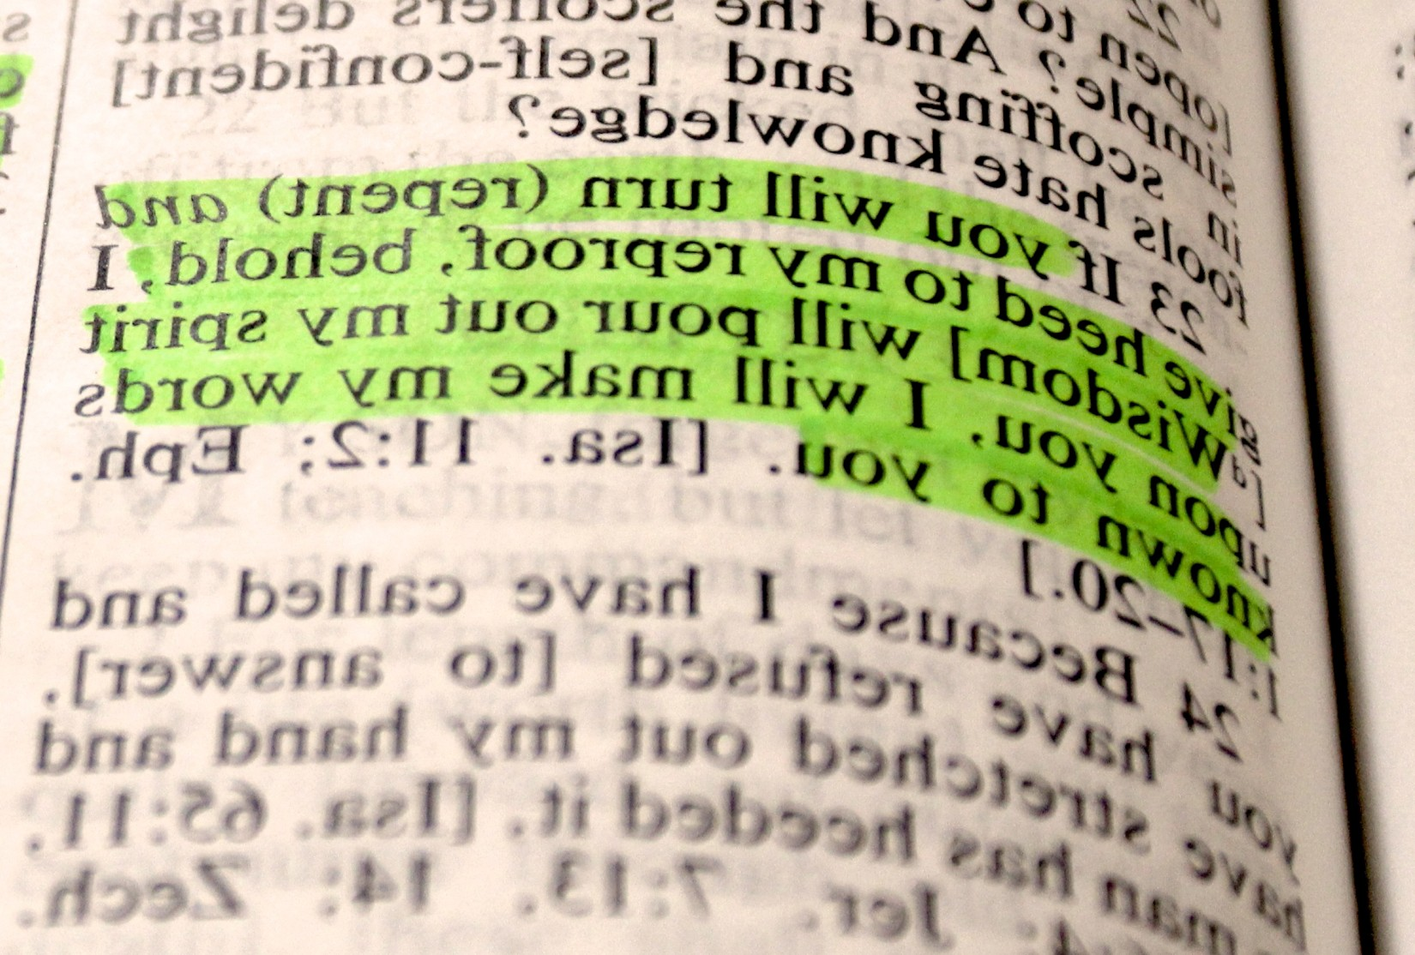

2 Corinthians 1:22; Ephesians 1:13-14; 4:30; 2 Peter 1:12.
Compare Exodus 32:1-10 with 1 Corinthians 10:7, 14.
Revelation 14:9-13.
See Revelation 17:5; Ezekiel 3:8-9.
1 Samuel 20:3.
Revelation 12:17.
Ezekiel 22:30.
Isaiah 58:12, Ezekiel 13:5.
See Deuteronomy 18:9-14; 1 Samuel 28:7-9; Exodus 22:18; Leviticus 19:26, 30, 31; Leviticus 20:6, 27; 2 Kings 17:16-18.
Mark 13:15-16.
Luke 17:32.
“A Prayer of the afflicted, when he is overwhelmed, and pours out his complaint before the Lord.”
Psalm 91:3.
Isaiah 54:17.

