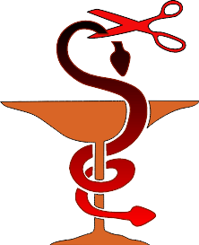
How to Keep
the Doctor
Away

Robert D. Brinsmead
Source:
International Health Institute printing
1972
Cover:
Sky and Grass Background
publicdomainvectors.org

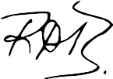

Fonts:
Liberation Sans Narrow
Linux Biolinum
Linux Libertine
Stuyvesant BT


February 2023
practicaprophetica.com
srac.info

Contents
Introduction
Health and the Physical Laws of Life 1
1. Air 2
2. Water 12
3. Food 16
4. Sunlight 28
5. Circulation 30
6. Elimination 31
7. Exercise 37
8. Rest 40
9. Hygiene and Sanitation 48
10. Temperance 53
The Relation Between the Mind and Good Health 54
The Moral Laws of Life 57
1. Sin and Sickness 62
2. The Divine Remedy 63
What Doctors Say 68

Introduction
GOOD health is not the result of chance or accident. It is not found in bottles, pills or potions. Rather, it is found in living in harmony with the unalterable laws of life.
Disease does not strike down “unlucky” victims. Sickness never comes without a cause. The way is always prepared, the disease invited, by some violation of the laws of life. Wrong habits of eating, breathing, dressing, resting, working or thinking lie at the foundation of sickness.
The human body is the most wonderful living machine. A great scientist said it would be easier for him to believe that Handel’s “Messiah” resulted from an explosion in a print shop than to believe that man evolved by chance. A great Designer was responsible for the arrangement of the human body. He established laws to govern its proper function. To obey these laws means health; to disregard them means sickness and death.
Some people will find this truth unwelcome. They have come to expect recovery from sickness through drugs. A drug may have its place when relief from pain or some other extremity necessitates, but drugs never cure the basic cause of the disease. People become sick through violating nature’s laws. When nature exacts her price in the form of suffering, they hasten to a doctor for a miracle drug to rid them of the pain and inconvenience of sickness. They have no desire to change their bad habits, but expect drugs to give them health while they continue to abuse the laws of health. If the doctor insists that they change their living habits, they will often look for another doctor, hoping he will give them some quick and convenient “cure.”
There is one true prescription for health—obedience to the laws of health. No man can transgress the laws of life—either natural or moral—without suffering the consequences. As Paul said,
Galatians 6
7 Whatsoever a man sows, that shall he also reap.
This book makes a survey of the principles of good health in a nontechnical way so that they may be appreciated by young and old, learned and unlearned. To know and appreciate these principles of life is the road to real health, wealth and happiness.
Robert D. Brinsmead

Health and the Physical Laws of Life
THOUSANDS of years ago the earliest Bible writer said,
Leviticus 17
11 The life of the flesh is in the blood.
That is a scientific truth. Health depends on good blood and good circulation of the blood throughout brain and body. It is impossible to have good health without good blood, for “the life...is in the blood.” The mind is also affected by the bloodstream more than most people realize.
Our Creator has arranged that the life current of blood be sustained by four things—air, water, food and sunshine. Therefore we must give first attention to supplying the blood with proper amounts of these items.

- Air
AIR is the most vital commodity of life and health, yet millions suffer all kinds of ailments due to an insufficient supply of air. The majority of people do not breathe correctly and are thereby robbing themselves of the chance to enjoy better health. An outstanding book on health says:
The Ministry of Healing, p. 272-273:
In order to have good blood, we must breathe well. Full, deep inspirations of pure air, which fill the lungs with oxygen, purify the blood. They impart to it a bright color, and send it, a life-giving current, to every part of the body. A good respiration soothes the nerves; it stimulates the appetite, and renders digestion more perfect; and it induces sound, refreshing sleep. . . .
The blood moves sluggishly [if an insufficient supply of oxygen is received]. The waste, poisonous matter, which should be thrown off in the exhalations from the lungs, is retained, and the blood becomes impure. Not only the lungs, but the stomach, liver, and brain are affected. The skin becomes sallow, digestion is retarded; the heart is depressed; the brain is clouded; the thoughts are confused; gloom settles upon the spirits; the whole system becomes depressed and inactive, and peculiarly susceptible to disease.
Air is the greatest doctor that nature has provided. Therefore attention must be paid to the following basic principles in order to secure and maintain optimum health:
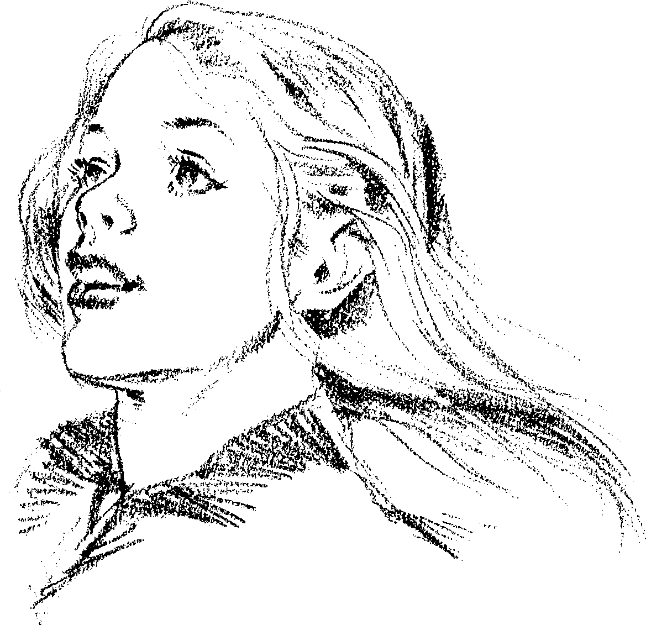

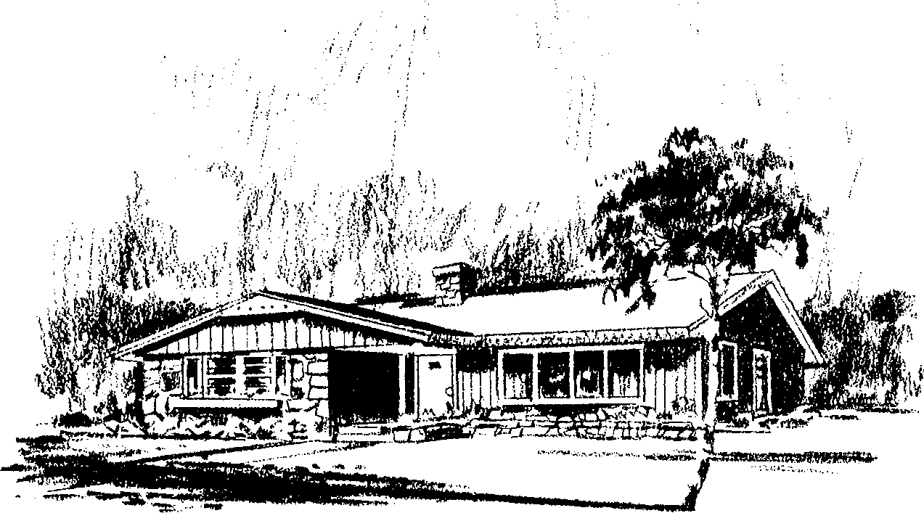
- As far as possible, place yourself in an environment where you have copious supplies of pure, unpolluted air.

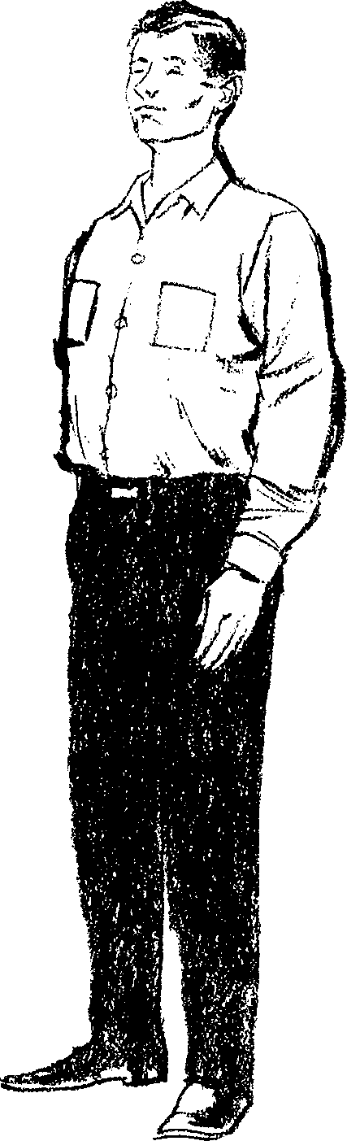
- In order to breathe well, you must have a correct posture in standing and sitting. The Bible says that God made man upright. An erect bearing carries not only the grace and dignity of self-possession, but it promotes physical health and mental
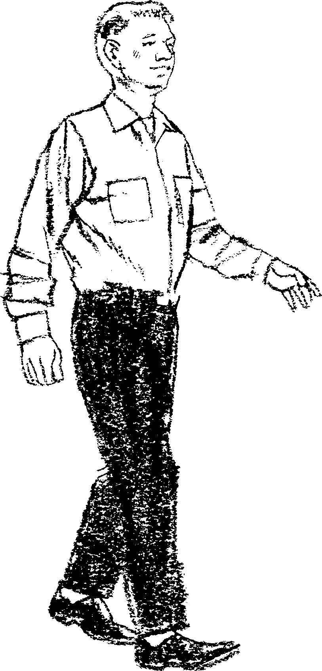

alertness. Walk like a thoroughbred—not in a proud sort of way, but in recognition that man was made in the “image of God” (Genesis 1:26-27).
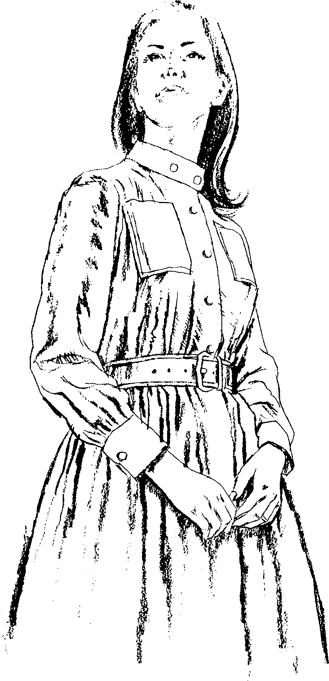

- In dressing, always allow the lungs the greatest freedom possible.
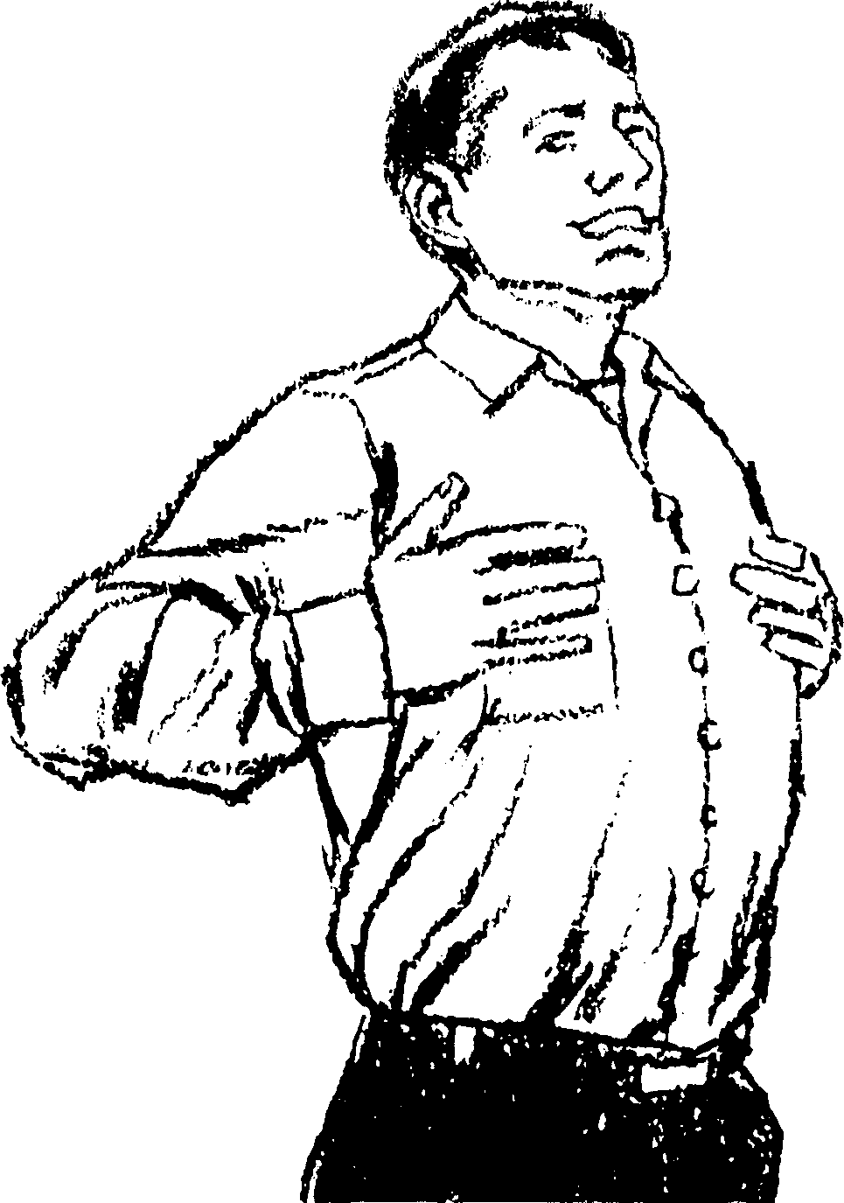

- Develop the habit of deep breathing. Shallow breathing restricts your life as surely as an engine is restricted that is running on a choked carburetor. Exhale completely, and then take full, deep inspirations of air. Do not just fill the top of your chest, but bring the abdominal muscles into play to aid in full breathing. Always speak from the diaphragm, using deep inspirations of air.

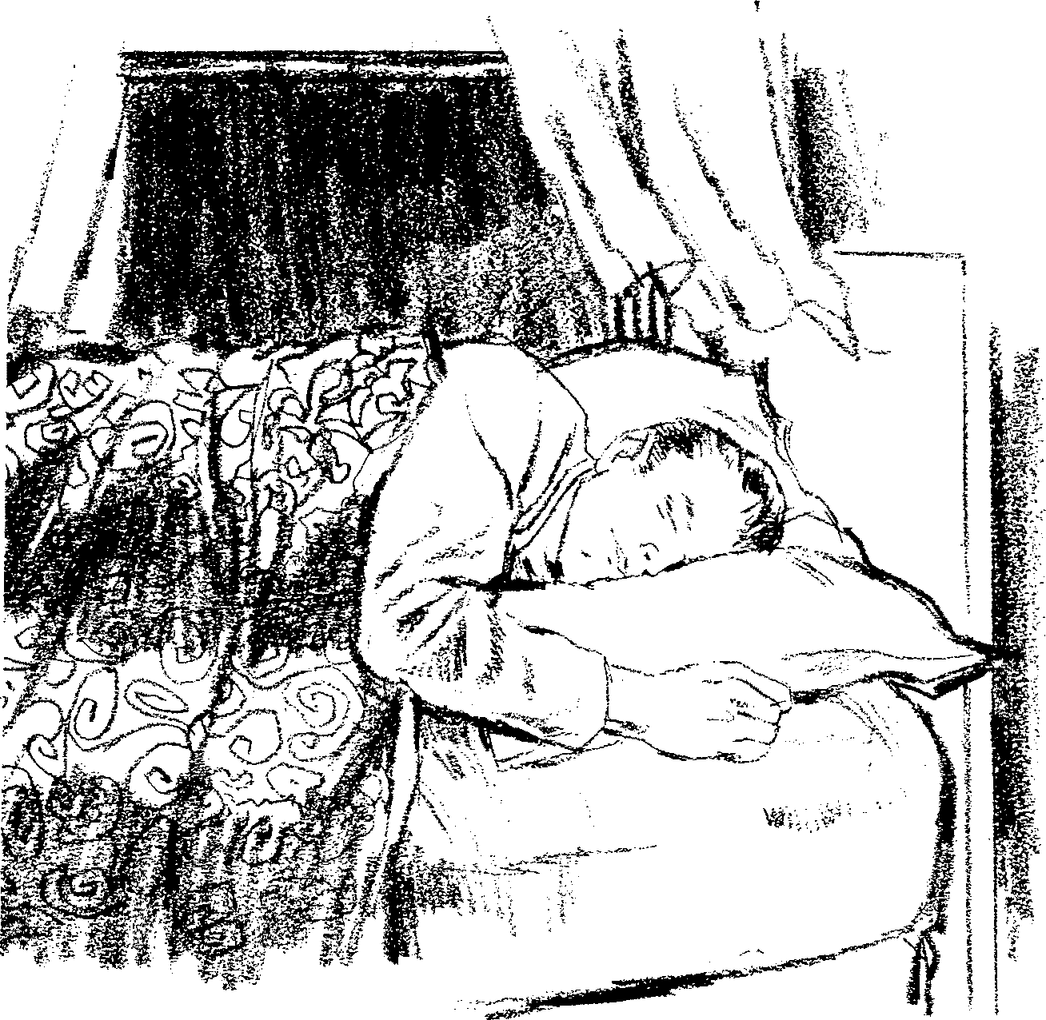
- Avoid overcrowded or poorly-ventilated rooms. Never sleep without copious supplies of fresh air.

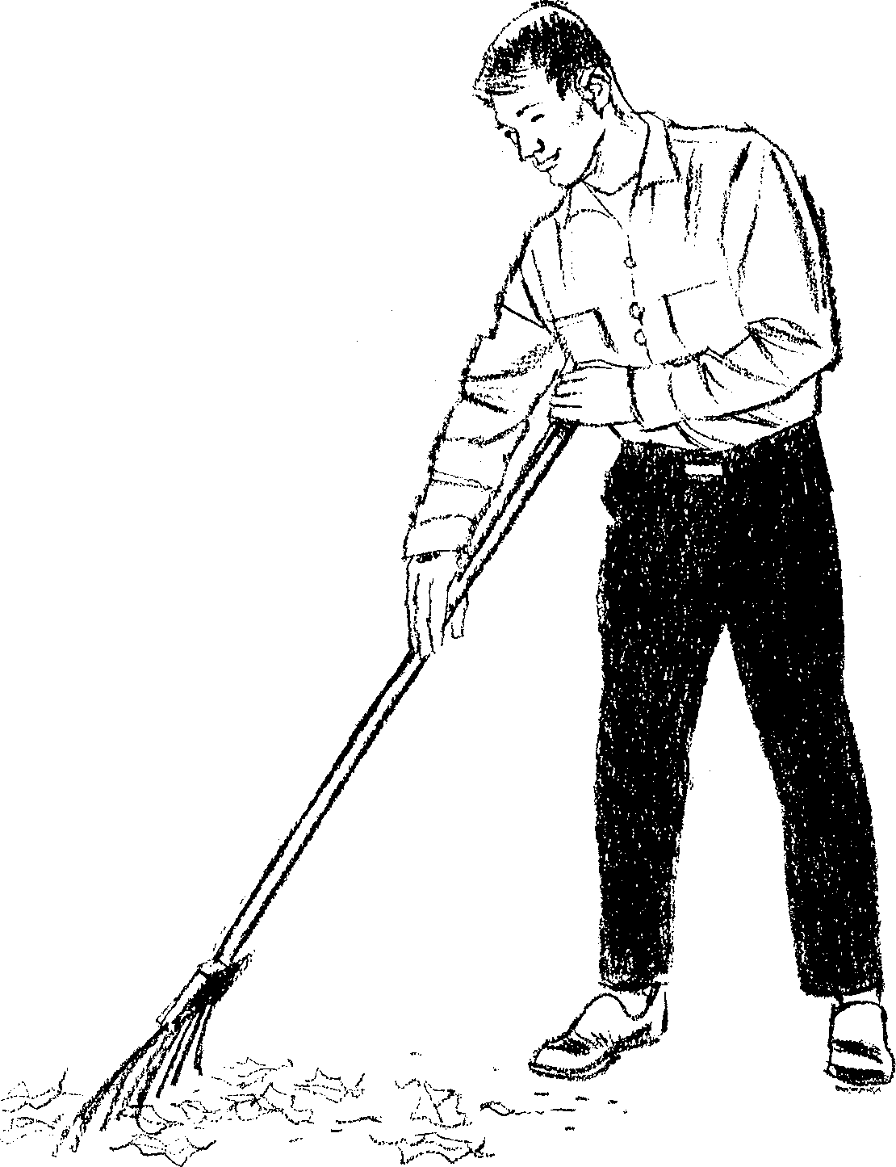
- Be outdoors as much as possible, and enjoy the blessing of the open air.
- Take plenty of exercise daily, and if your age and physical condition will allow it, do some vigorous exercise every day that will cause you to “huff and puff.’’
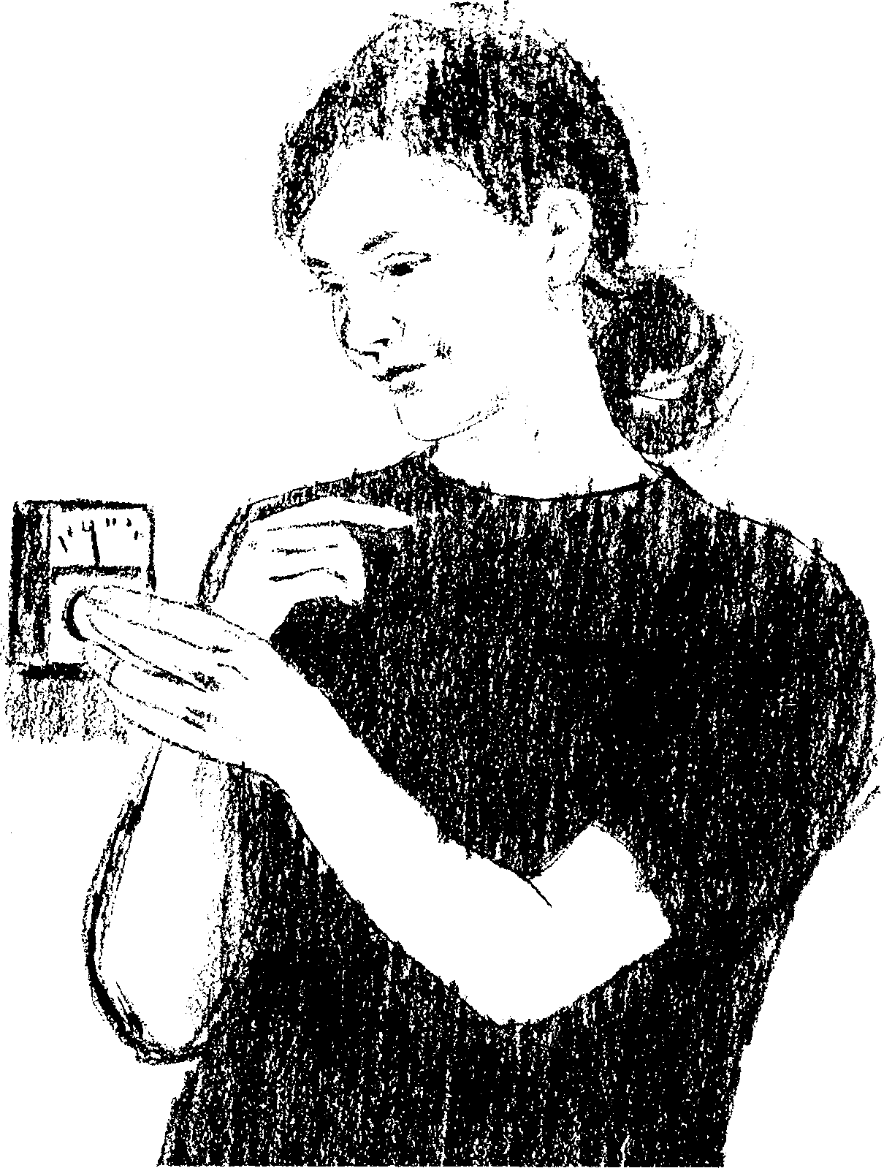
- Do not heat your home above sixty-five to seventy degrees in the winter. If the humidity is properly adjusted, these temperatures will be comfortable. Overheated air loses its vitality. It is better to dress more warmly and have a clear mind and good health.
- Water


Pure water is the next great doctor provided by nature. Every day it should be used in abundance, both internally and externally. Water helps nature free the system of impurities. It cleanses the body tissues and invigorates the vital organs. Used externally, it cleanses the skin so that it may do its work of
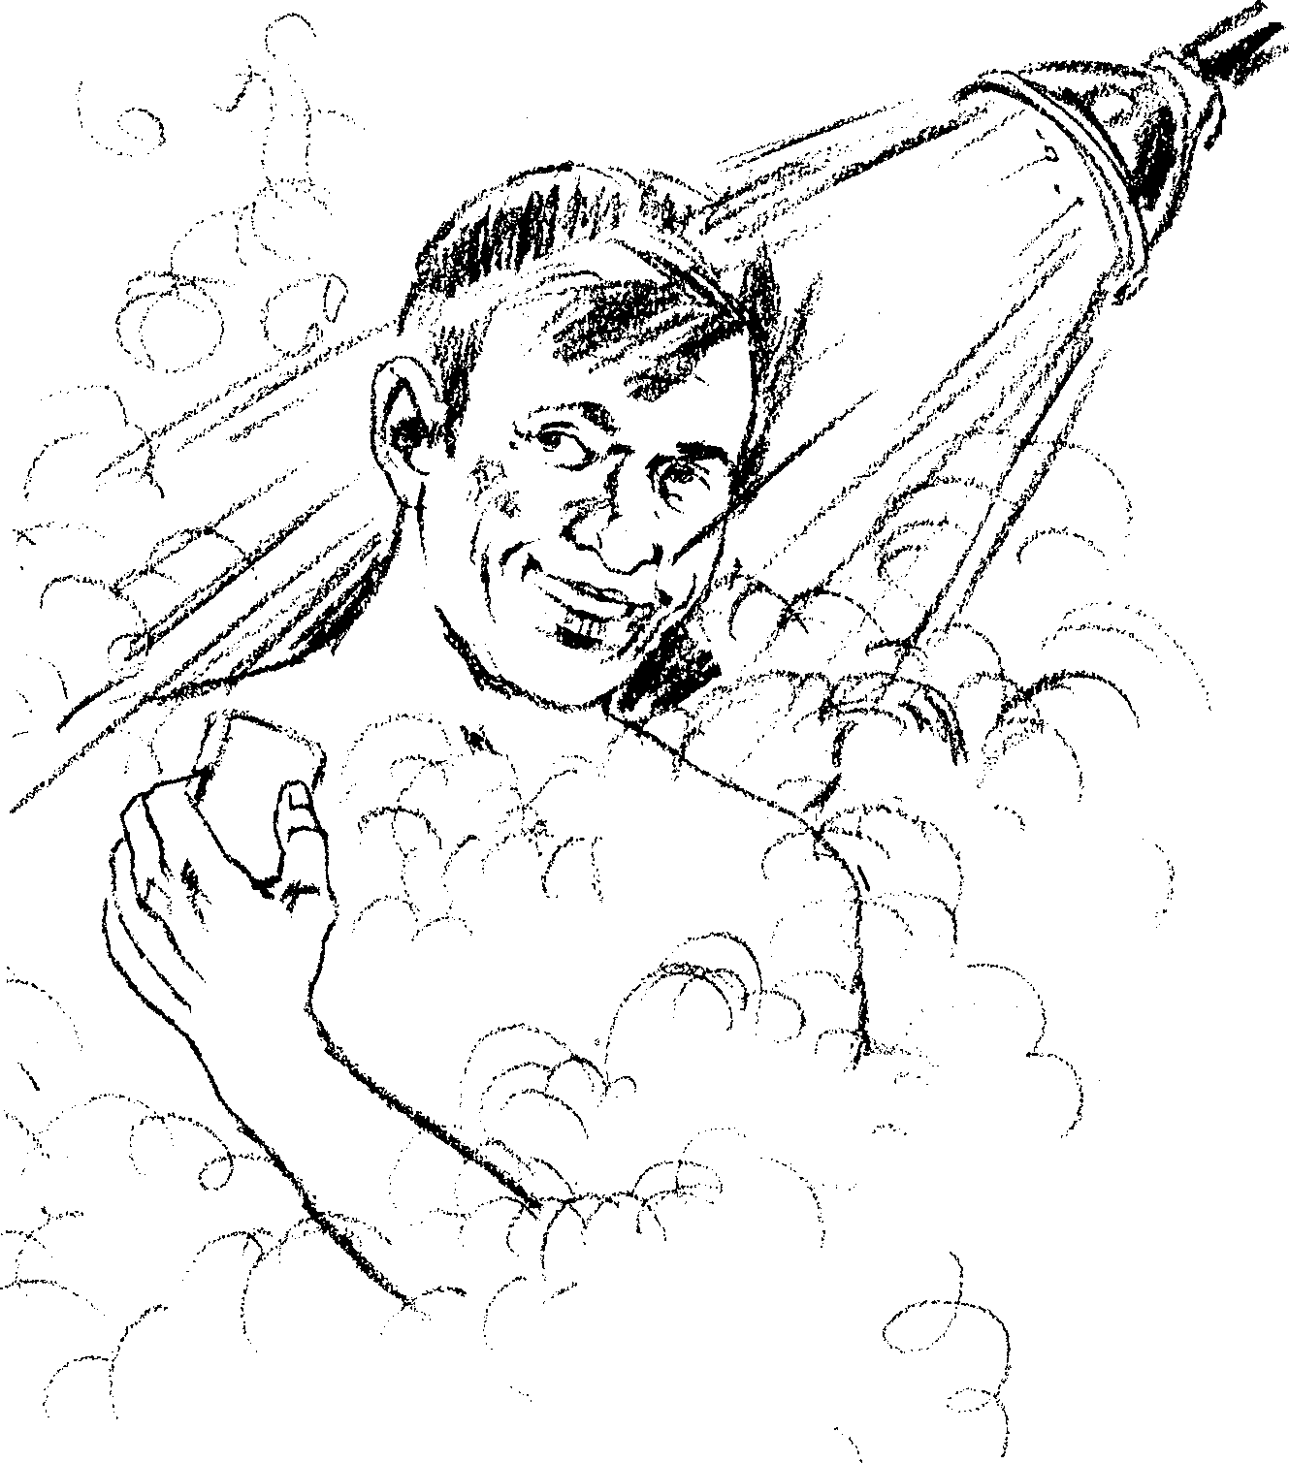

breathing and throwing off body wastes. Water is one of the best ways to regulate the circulation of the blood in the system. It will help to reduce fever or relieve a congested head and many other ailments. Here are some simple and basic principles to follow in the use of water:

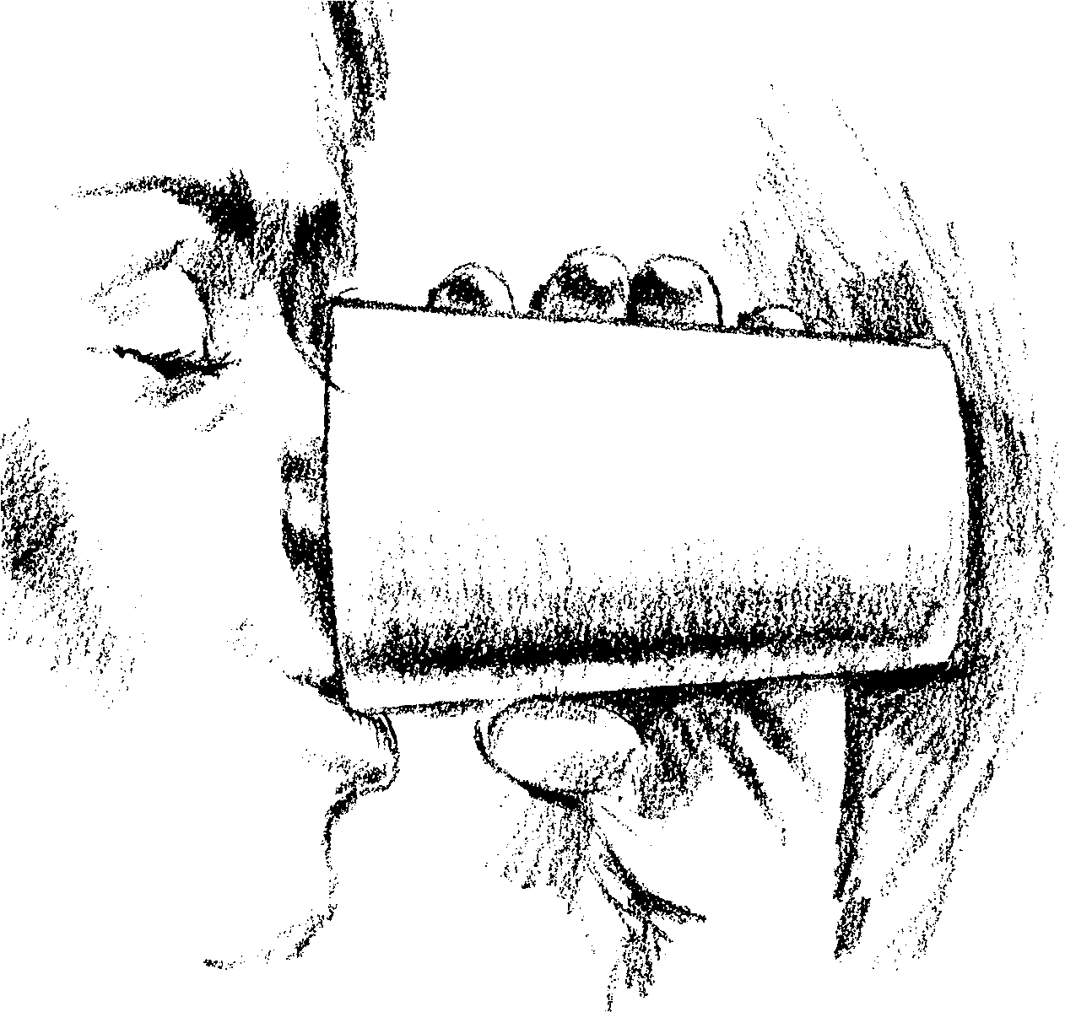
- Drink several glasses of pure water daily. One or two warm glasses of water about a half hour before breakfast will cleanse the stomach and sharpen the appetite for the most important meal of the day.
- Do not drink water at mealtimes. Digestion is a chemical process, and it is a fundamental scientific fact that excess water slows down a chemical reaction. Also, the habit of drinking ice-cold water is a bad one for the system and should be abandoned.
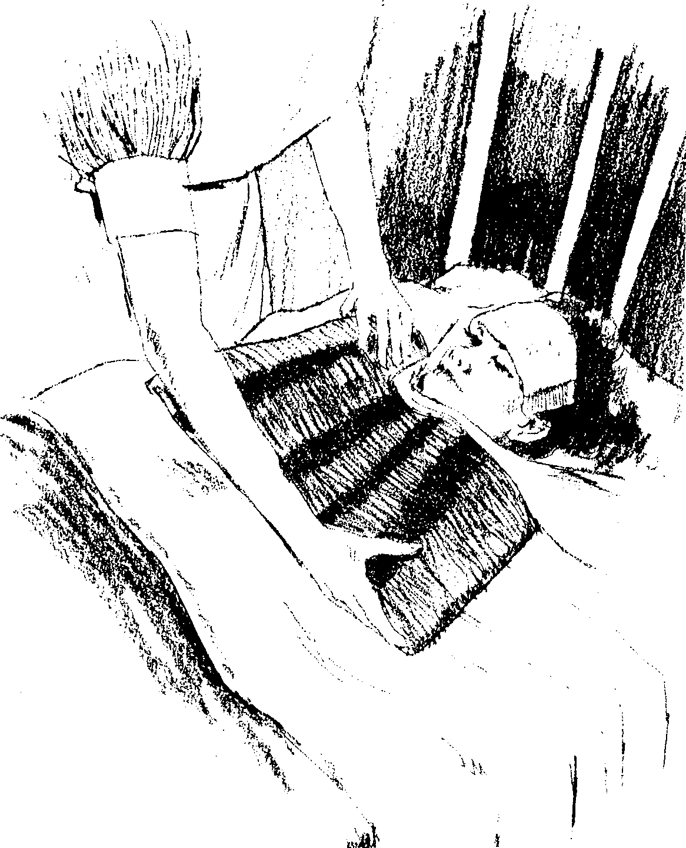

- Bathe the entire body at least twice a week. The daily bath is best.
- To reduce fevers, use water freely, both internally and externally. Fever is a fire—nature’s effort to burn up body wastes or poisons. This fire may be regulated by the intelligent use of water. Employ it freely to help nature combat disease. Learn how to apply compresses, hot and cold water treatments, and baths to aid in the recovery from different ailments.
- Food
CORRECT eating habits are among the greatest factors in health. Faulty nutrition lies at the foundation of many diseases. Millions dig their own graves with their teeth. Then what shall we eat? The multitude of books on this subject that have poured from the press have often confused rather than helped people.
The first thing to do is to forget about any single food or any fancy, rare or expensive food or diet as containing the answer to nutrition, and avail yourself of the information your Creator has provided. Use plain common sense.
The Bible says that the original diet that God gave man was grains, fruits, vegetables and nuts. Whenever or wherever people eat these in generous yet temperate supply, as near as practicable to their natural condition, they have little problem with nutrition and, in fact, very little disease.
One who has access to an adequate supply of natural food, and eats it sensibly, need entertain few worries about lacking proteins, vitamins or minerals. Let us consider some basic principles of nutrition:

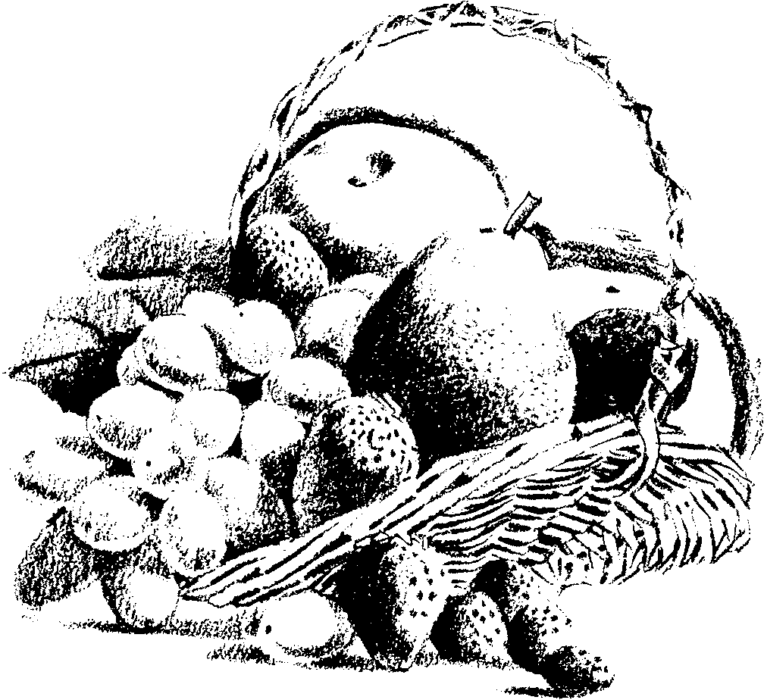
- Follow man’s original diet as closely as possible.

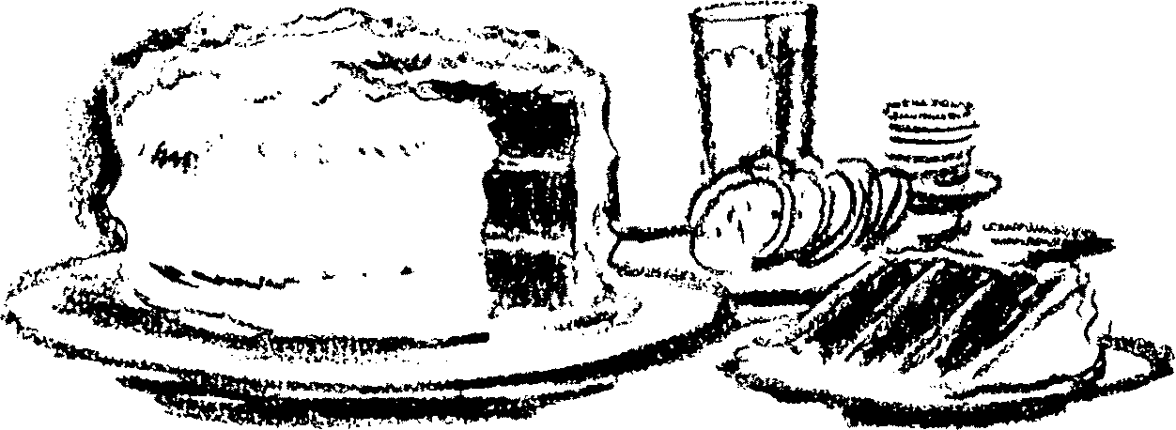
- Partake very sparingly of highly refined or processed foods, i.e., white flour, sugar, cakes, pastries, etc.


- Eat as simply as possible, and learn to enjoy food in its natural state.
- Avoid highly-seasoned, pickled and spiced foods, as they irritate the stomach and inflame the blood (and tend to do the same to the temper as well). A little salt is necessary for good blood, but many people would benefit by restricting their salt intake.
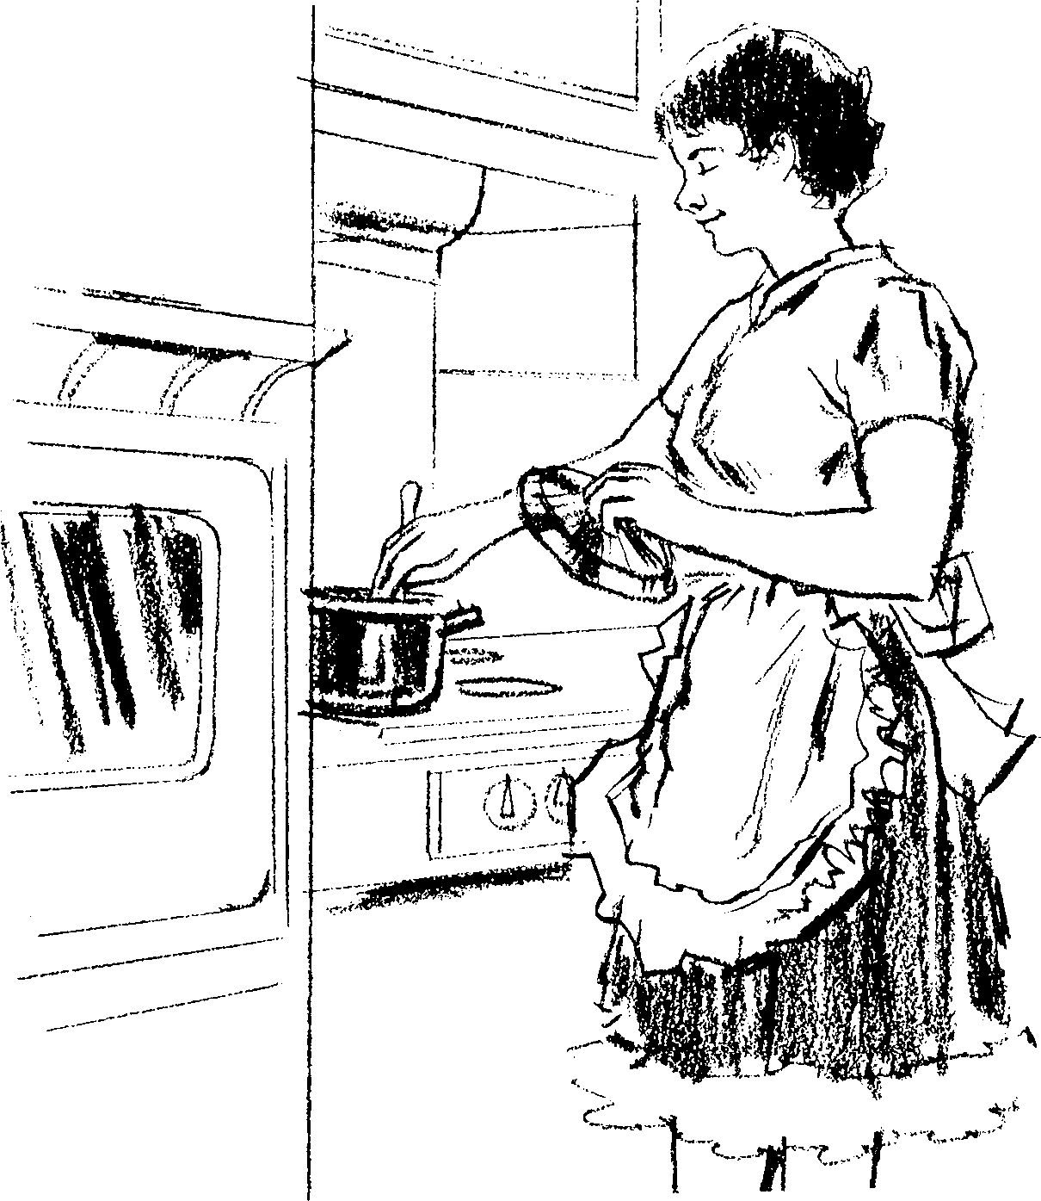

- Do not overcook food or throw away the water after boiling vegetables.
- Do not eat too many mixtures at once, and avoid dishes that are a conglomeration of good food mixed together. Fruits and coarse vegetables should not be eaten at the same meal. Two to four dishes at a meal are plenty. Just as your mind cannot dwell on many different subjects at once, your stomach cannot tolerate many kinds of food at one meal.
- Do not eat any more than two or three times a day, and allow at least five hours between each meal. Avoid the habit of eating between meals. This hinders digestion, burdens the stomach and often turns good food into poison inside the system.
- Ordinarily, do not eat before bedtime. When you retire, be sure that your stomach has retired. Food takes three to five hours to digest in the stomach.
- Do not eat the heavy meal in the evening. The habit of a very light breakfast and a very heavy evening meal is contrary to natural law. Remember: breakfast is gold, lunch is silver, and supper is lead. You do not drive your car on an empty gas tank all day, then fill it up in the evening.
- Do not overeat. The good book says, “Eat...for strength, and not for drunkenness.’’ Ecclesiastes 10:17. Too much food afflicts the stomach and causes an extra burden to be placed upon the liver, which is the great chemical factory of the body. Surplus food must be altered and reconstructed into such form that it can be stored, or if this is not possible, it must be changed into a form that can be excreted by the kidneys. All this places an extra burden on the system and lessens vitality. Toxic manifestations may take place. An overburdened stomach also calls life and energy from the brain, checks the free flow of thoughts, hinders the memory and has a prostrating effect upon the entire system. Leave the table feeling that you could comfortably eat more.
- Be regular in your eating habits. Rhythm is a basic law of the human body. Heart impulses, digestive processes and everything in the body work on a scheduled rhythm. Therefore, for best health, meals should be eaten on time.

- Eat slowly, and chew your food thoroughly. Let the mealtime be a pleasant social occasion. Do not bring your worries to the meal table. Avoid strenuous brain work immediately before and after eating a meal. Avoid strenuous exercise immediately after a meal, but mild exercise, such as a short walk, is desirable.
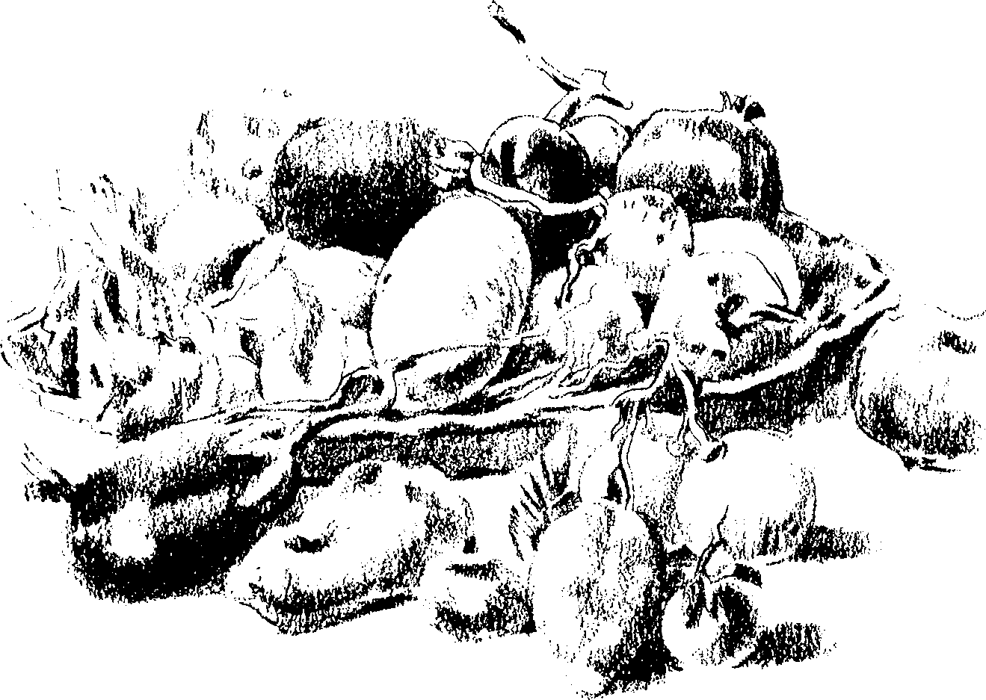

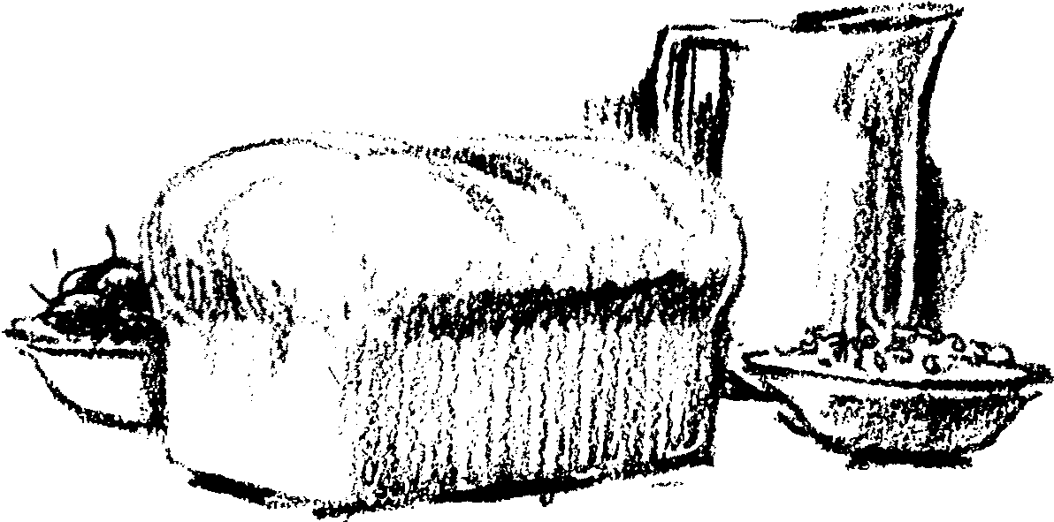

- An adequate supply of whole grains, eaten as bread or cereal, should be the basis of a good diet. Most processed grains and packaged breakfast cereals are devitalized and demineralized. Any owner of prize animal stock would know better than to feed such material to his animals. Obtaining your own grinder is an excellent way to insure unadulterated grain and fresh, whole-grain flour. Genuine whole-meal bread is almost impossible to buy, so there is much benefit in learning how to make your own bread from whole grains.

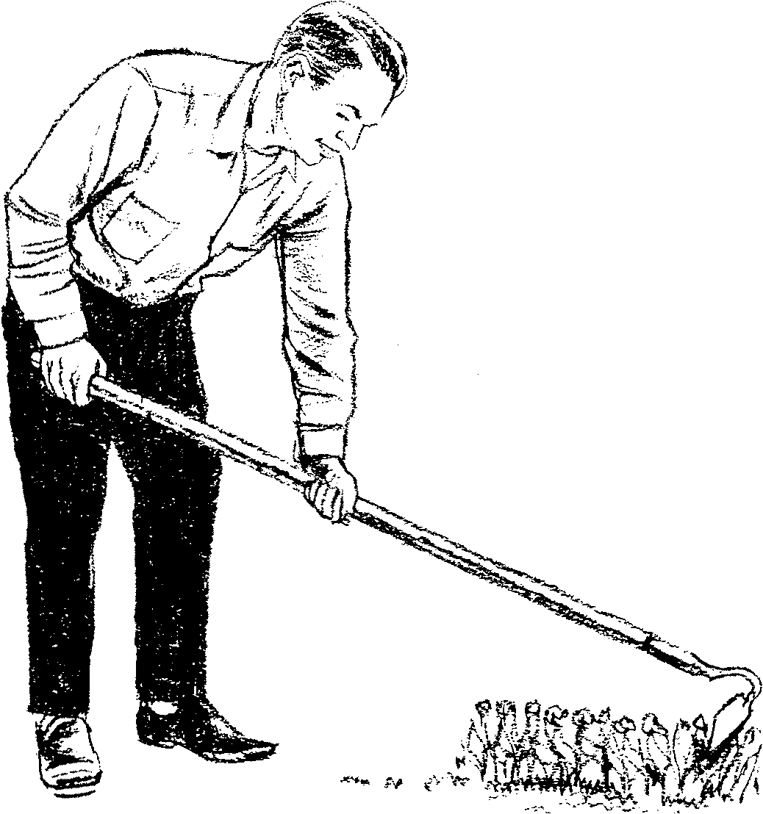
- Obtain your fruits and vegetables as fresh as possible. Many of them deteriorate very quickly. The best health-food store is your own garden. Get a small piece of land and learn to raise healthy fruits and vegetables. Besides, the exercise in the open air and sunshine will do you a wonderful amount of good.

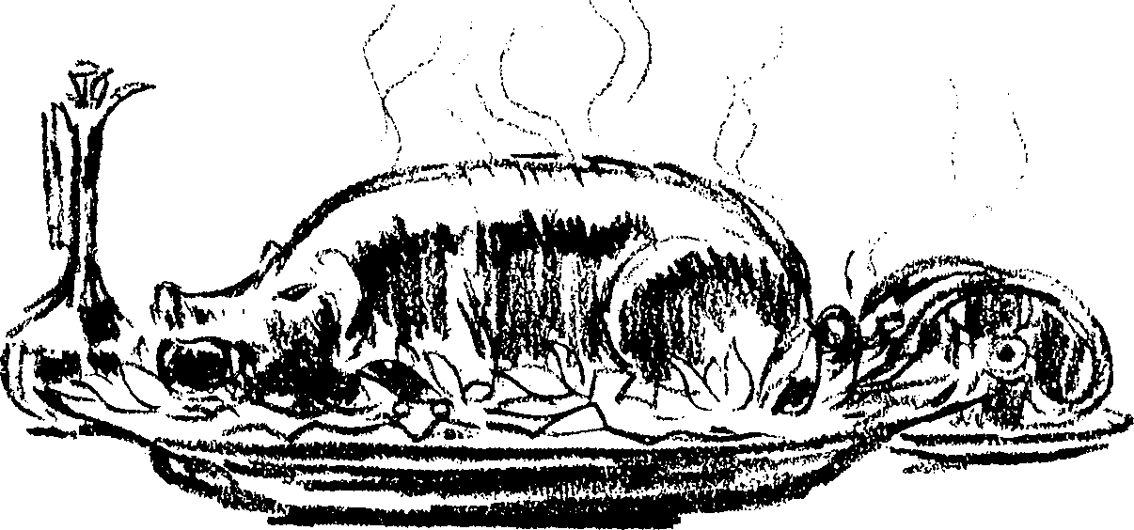
- Do not eat blood or animal fat such as lard or drippings. God has a good reason for warning people to abstain from the blood and fat of animals (see Leviticus 7:23-27; Acts 15:20). Only recently has medical science discovered why animal fat can be responsible for many cases of heart trouble.
- Never eat unclean meats, such as pork, crab, etc. The Bible clearly identifies what animals are clean and unclean for eating (see Leviticus 11).
- Learn to do without eating dead animals of any description. Man’s original diet did not consist of animal flesh. With disease in animals on the increase, meat eating is a definite hazard to health. The eating of animal flesh actually tends to shorten life.

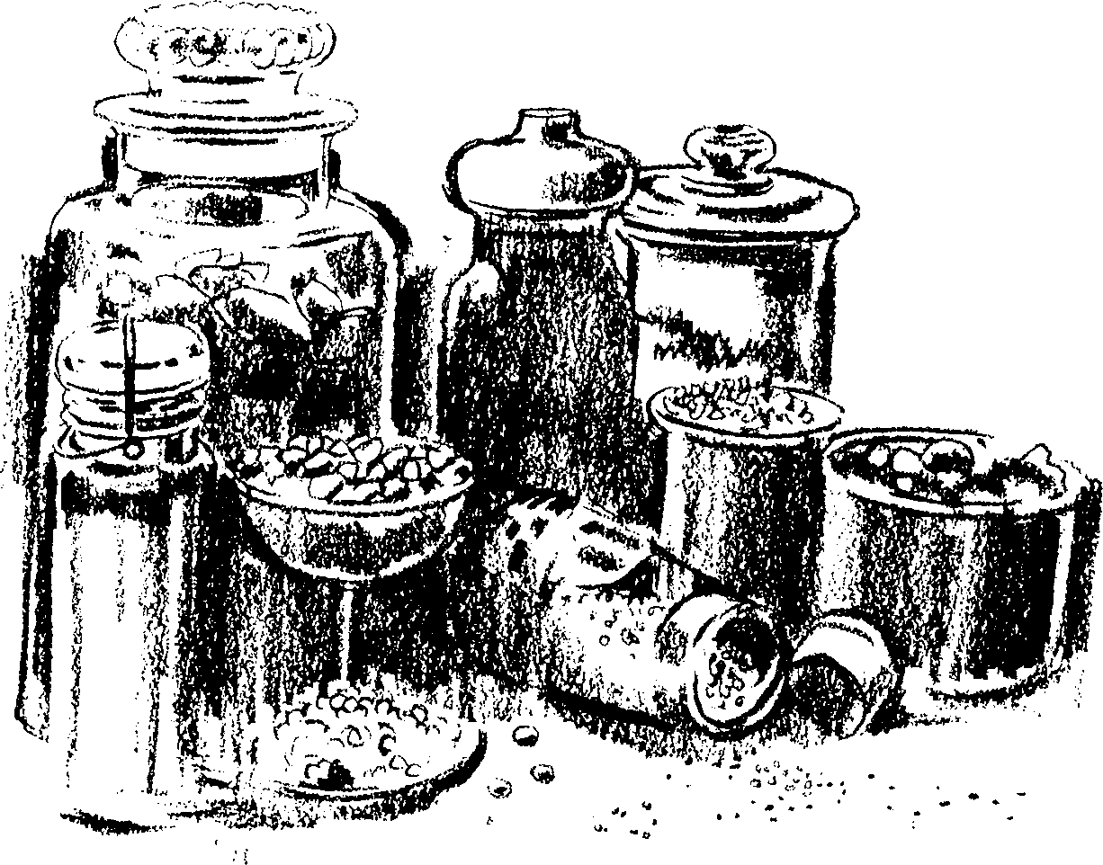
- Avoid extremes in diet—either excessively rich, spiced or seasoned foods on the one hand, or an impoverished diet on the other hand.
- Eat a very generous variety of foods (but not at the same meal), and you will be assured of adequate nutrition. No single food contains all the nutrients essential for good health.
- It is better to drink between meals and upon rising in the morning. Excessive water taken with food dilutes the digestive juices and retards digestion. Soup and liquid food should normally be used sparingly. Nature intended that man should eat some foods that require thorough chewing.
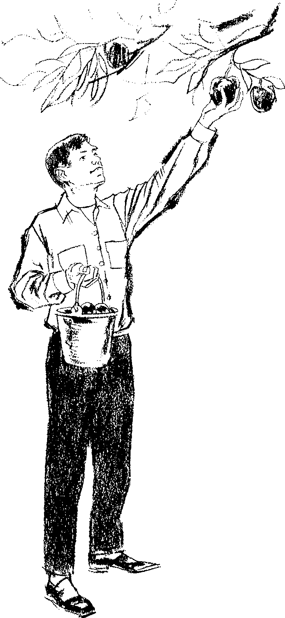

- Do not eat overripe fruit or fruit which is partly spoiled.

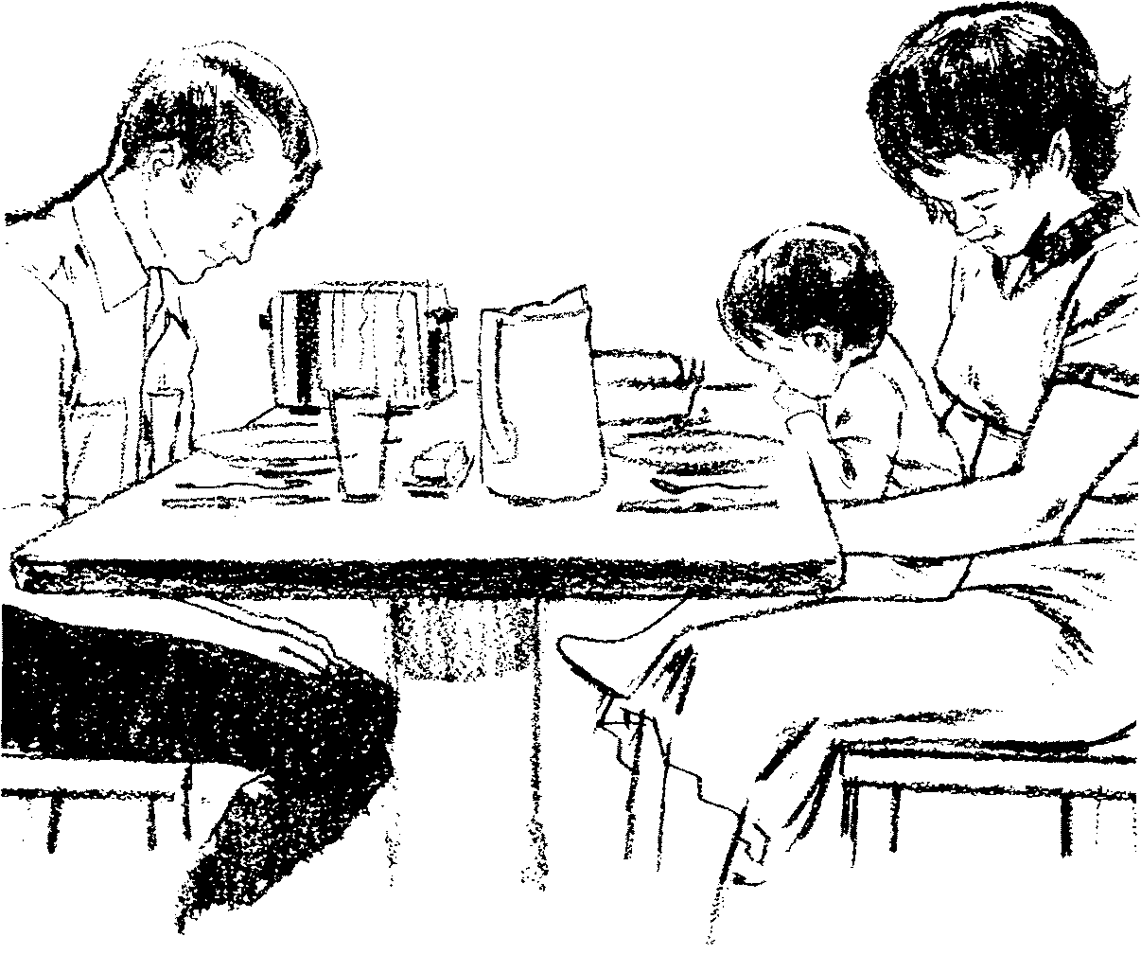
- Eat with thankfulness to God for supplying your needs, and do not think too much about your stomach. If you think that your food will do you harm, it surely will. Life and health are much more than eating and drinking.
- Sunlight
THERE can be no life without light. The sun which heats the seed in the ground, colors the vegetation and tints the flowers, gives health and life to your body.
Essential vitamin D is most ideally furnished by exposure to sunlight. The deeper layers of the skin manufacture and store it so that it can be drawn upon by the body in seasons when sunshine is scarce and less effective. Sunlight will give a glow to your cheeks and aid in your digestion. Whether you are young or old, you need plenty of it.
Expose the rooms of the house to sunlight. Draw back the drapes to admit God’s doctor. It may fade your furniture and carpets, but it will add vigor to your life. Remove the morning bedclothes (blankets) one by one, and expose them to the light of the sun. Be careful to gradually build up your outdoor exposure to sunlight.

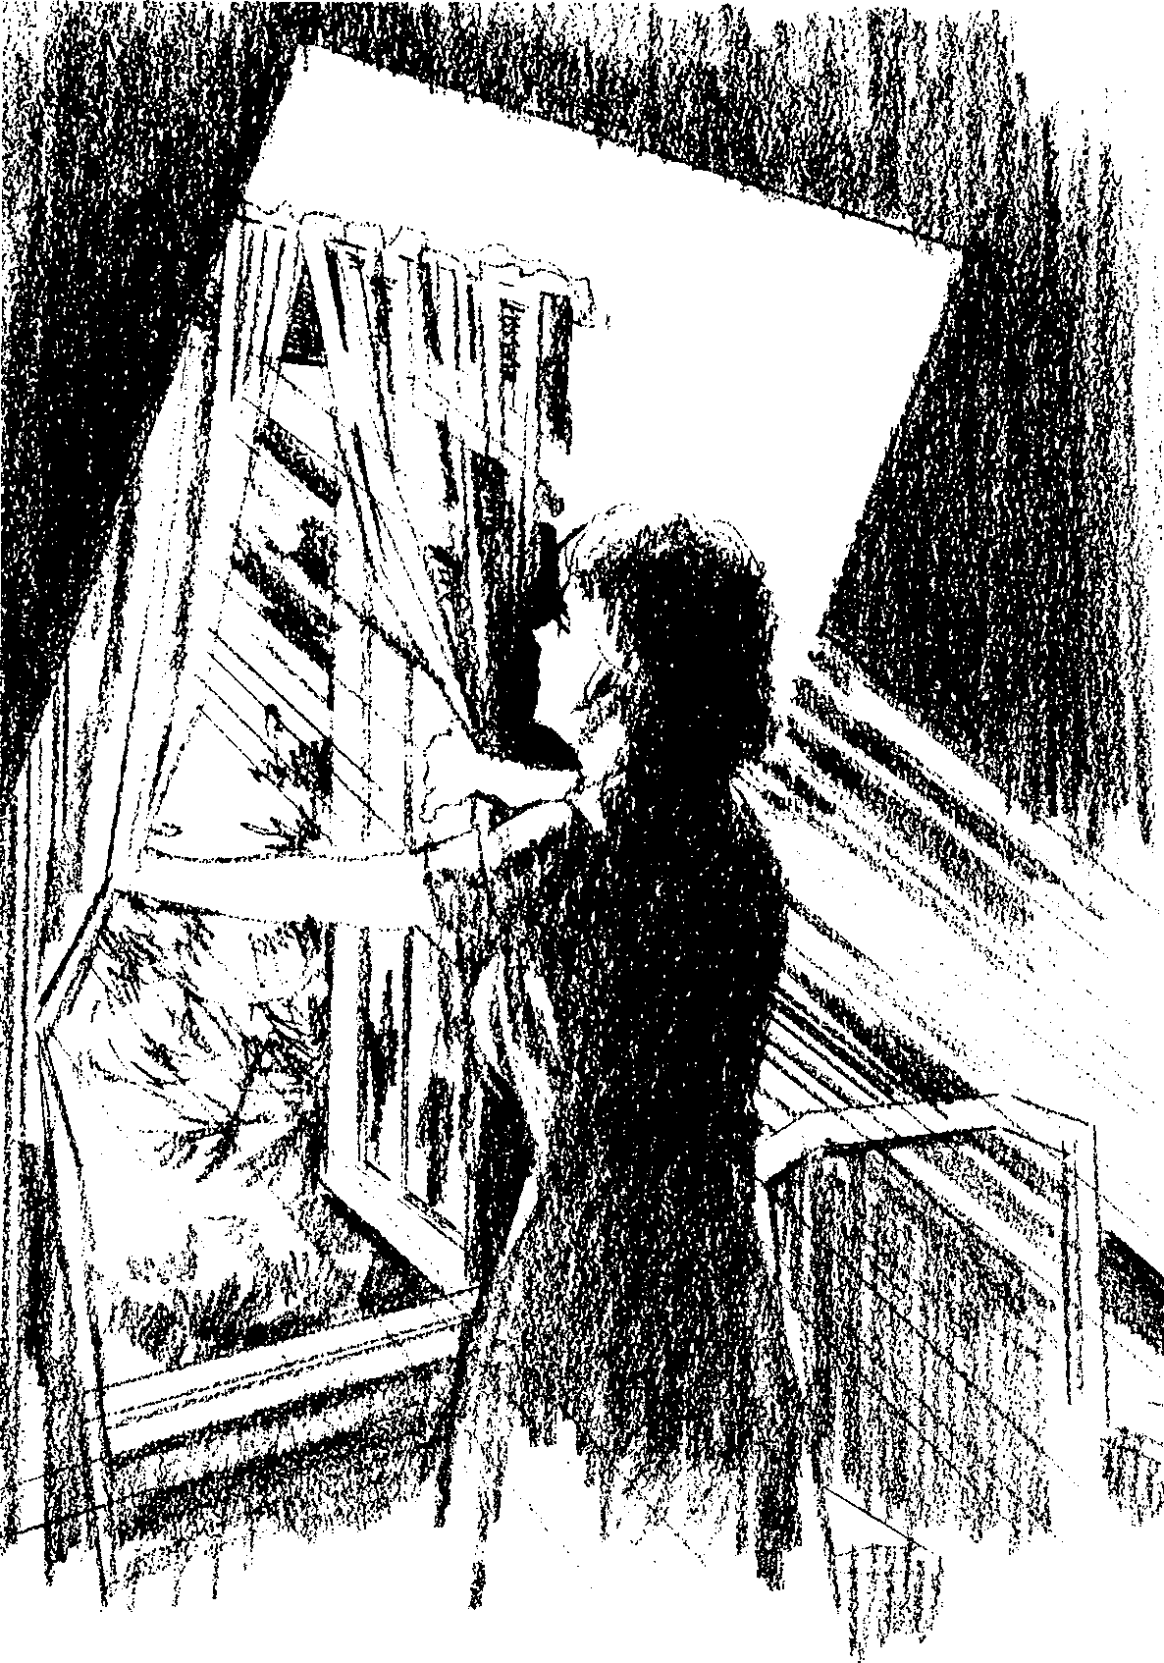
- Circulation
WE HAVE now considered how blood receives its life from air, water, food and sunlight. Good blood not only depends on a proper and adequate supply of these, but it depends on a good circulation throughout the body. Poor circulation will bring on coughs, congestion of the head or chest, nervous conditions, heart palpitations, indigestion, congestion of the internal organs, nosebleed, stomach trouble, enfeebled mind and other diseases. In order to obtain and maintain a good circulation, observe the following principles of healthful living:
- Correct posture and deep breathing are the first essentials to good circulation.
- Avoid chilled body extremities, which put a double strain on the heart. Clothe the limbs well.
- Take a daily bath or shower, and if you have the will power, end with a good cold shower followed by a rub.
- Obtain adequate exercise and sufficient rest.
- Do not overeat.
- Do not wear anything that compresses the body and restricts the circulation of the blood.
- A mind that is active, alert, purposeful, cheerful and happy tends to send the blood bounding through the arteries and veins.
- Know how to apply water to the body to improve circulation, i.e., for a congested head, put the feet in a hot bath. Adding some dry mustard to the water makes it still more effective.
- Elimination
THE body must not only take in substances to maintain life, but it must throw off wastes and poisons. Therefore it is most important that all the channels of elimination are in proper working order. If any of these become clogged, life and health are endangered. In order to assist the channels of elimination so that they function normally, observe the following principles of healthful living:
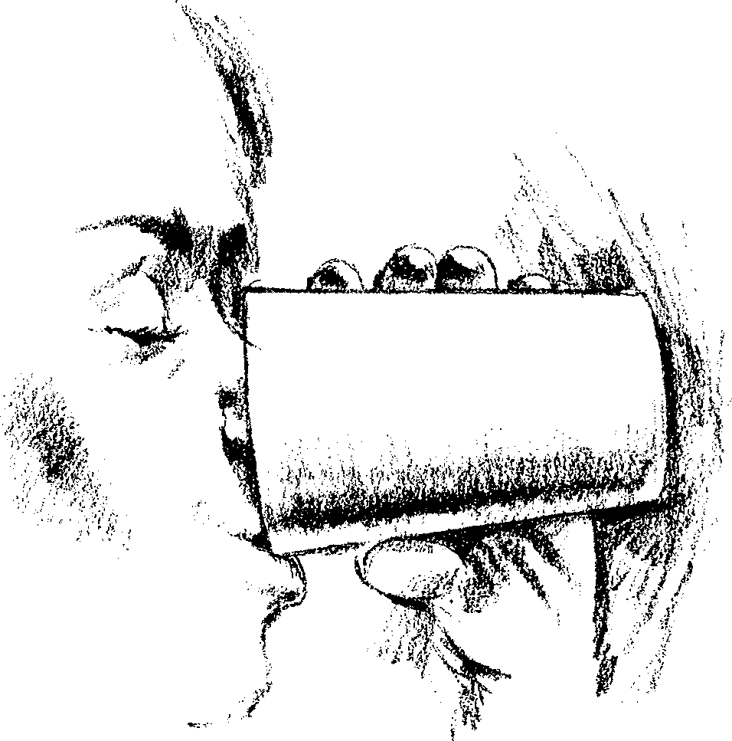
- Drink adequate water, which cleanses the body internally and helps maintain regularity.
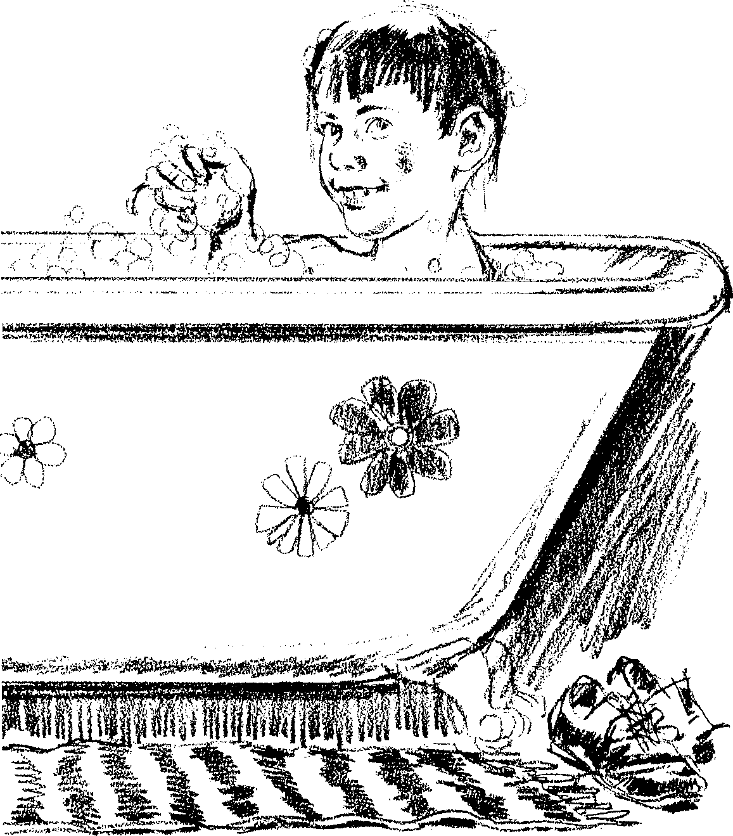
- Cleanse the skin surface daily, and occasionally do something that will cause you to perspire freely. You have millions of little pores that act as excretory ducts which throw off body wastes. Keep them cleansed.
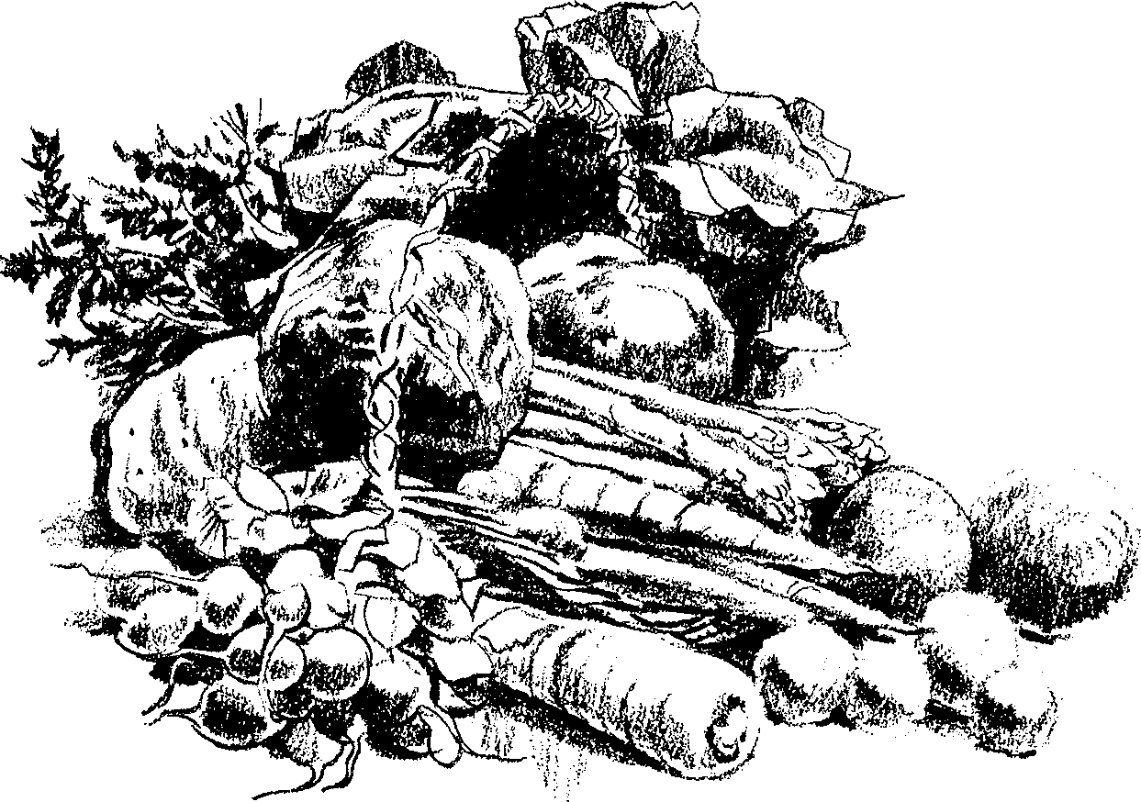

- Eat foods in their natural state, avoiding those which are refined. Today, with our wonderful skills, we remove the bran and other vital parts from the wheat before we eat it, with resulting constipation.

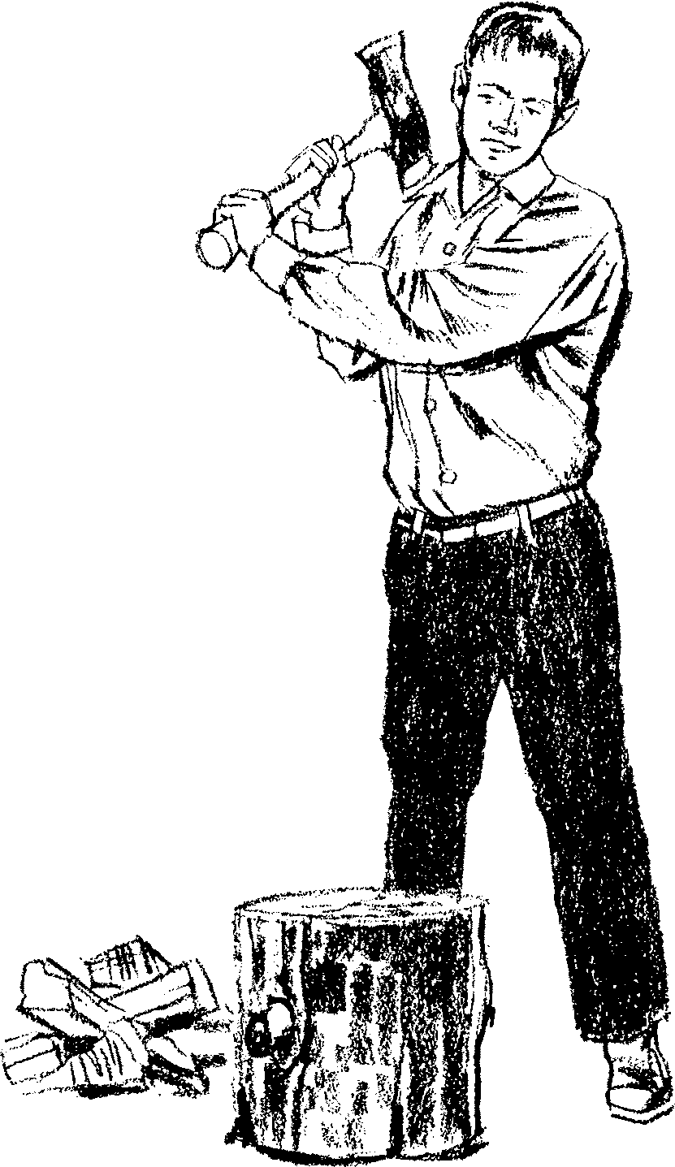

- Obtain adequate amounts of exercise.

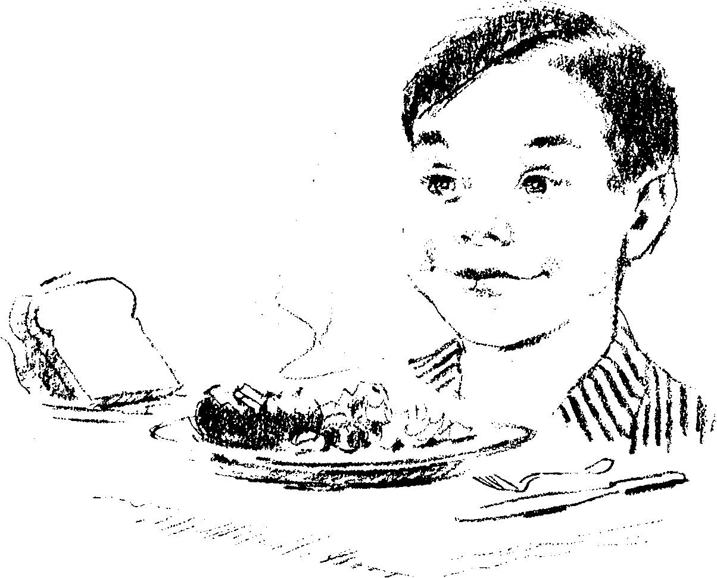
- Chew your food thoroughly.

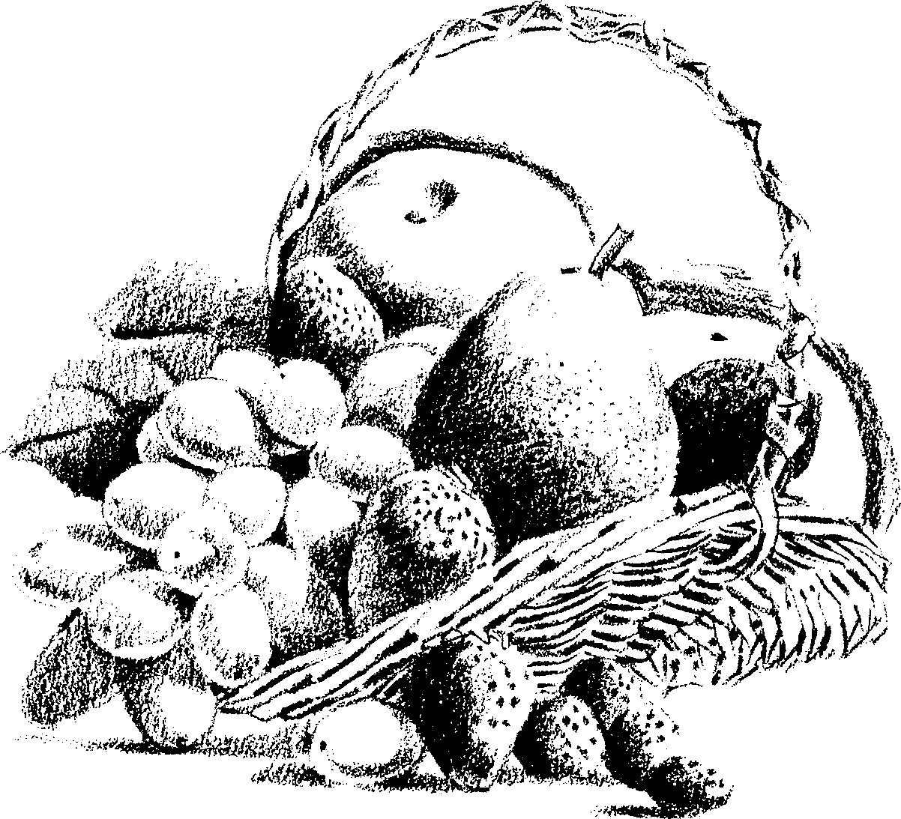
- Fresh fruits are good, natural laxatives. Remember, you cannot be well unless you have good elimination. When the bowels are sluggish, the blood is affected.
- Exercise
EVERY part of the living machine is made for action and service. It is the law of life that activity tends to life and inactivity tends to death. More people die for want of exercise than from over fatigue. Many more rust out than wear out.
God ordained that man should work and sweat (Genesis 3:19). Exercise equalizes the blood circulation, quickens the blood, helps the body expel impurities, invigorates the body, strengthens the bowels, aids digestion, relieves nervousness, prevents disease, strengthens the kidneys and liver, keeps the lungs in good condition and tones up the muscles. Exercise is one of nature’s greatest doctors.
Practical work is more beneficial than a gymnasium. Young men need some stern and severe exercise. Exercise is very necessary for students and for those doing much brain work. Lack of exercise depresses the blood circulation, causes dyspepsia, brings on weakness of limbs and feebleness of mind, deranges the nervous system and can cause mental breakdown or heart failure.
It has been found that astronauts, when deprived of exercise in space for a short time, actually lose calcium from their skeletons. Aged or infirm individuals aggravate their infirm state by not getting enough exercise. Their bones become weakened and fracture easily. Lack of exercise induces a calcium loss.

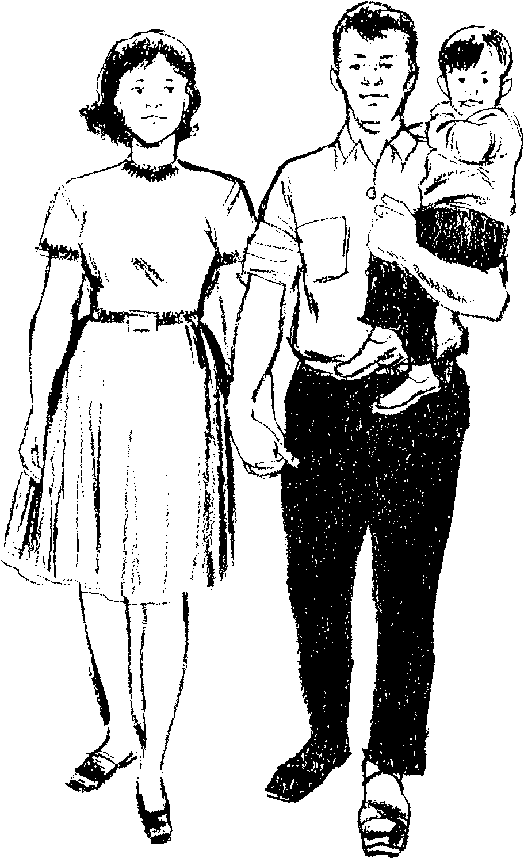

Endeavor to practice these principles of healthful living:
- Exercise daily in the open air.
- Try to equalize muscle work and brain work as much as possible.
- If your age and health will allow, exercise vigorously enough to induce perspiration and some good “huffing and puffing.’’
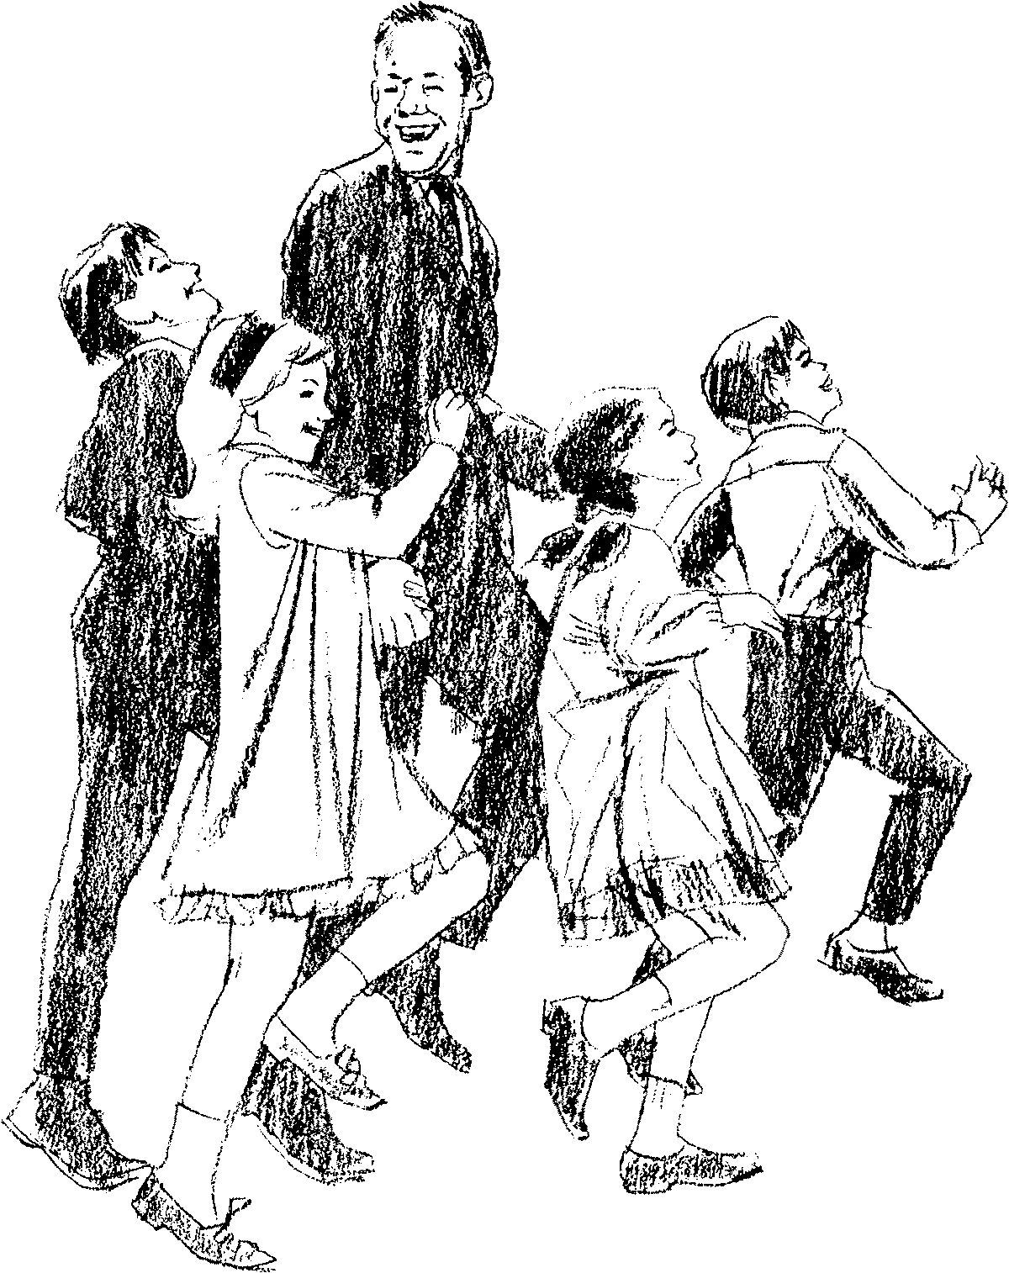

- Walking is an excellent form of exercise, as it brings into play almost every muscle of the body.
- The disposition to avoid exercise is a sure sign that death is stealing over you. Shake it off.
- When you exercise, put your mind and will into it until it becomes a pleasure.
- Rest

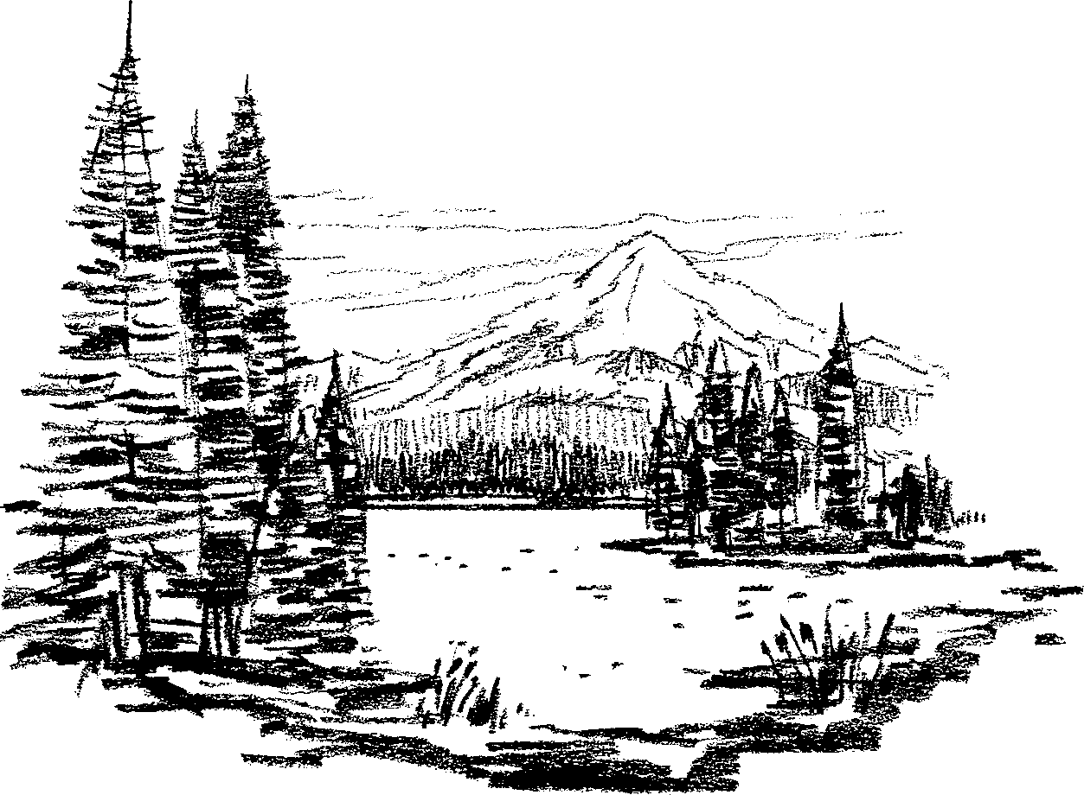
Hard work and exercise must be balanced by adequate rest. Even Jesus advised His disciples, who were busily engaged in the greatest work committed to mortals, “Come...apart...and rest awhile.” Mark 6:31. He also said that ‘‘the Sabbath was made for man.” Mark 2:27. God has seen that man needs to rest from his work one day in seven. Those who obey His Word and keep His Sabbath know the benefits to both body and mind.
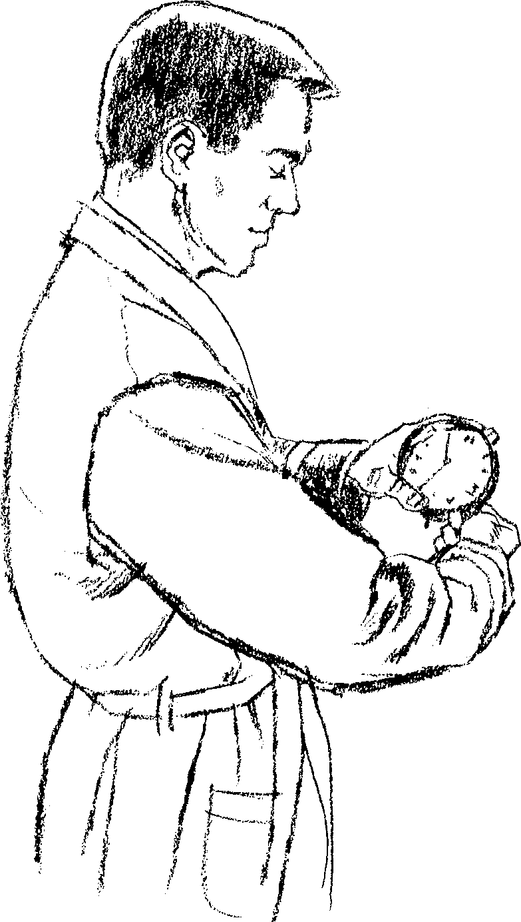

During the sleeping hours the body is repaired and invigorated for another day. Youth need abundant sleep. Observe these basic principles for good health:
- Be regular in your hours of rest.

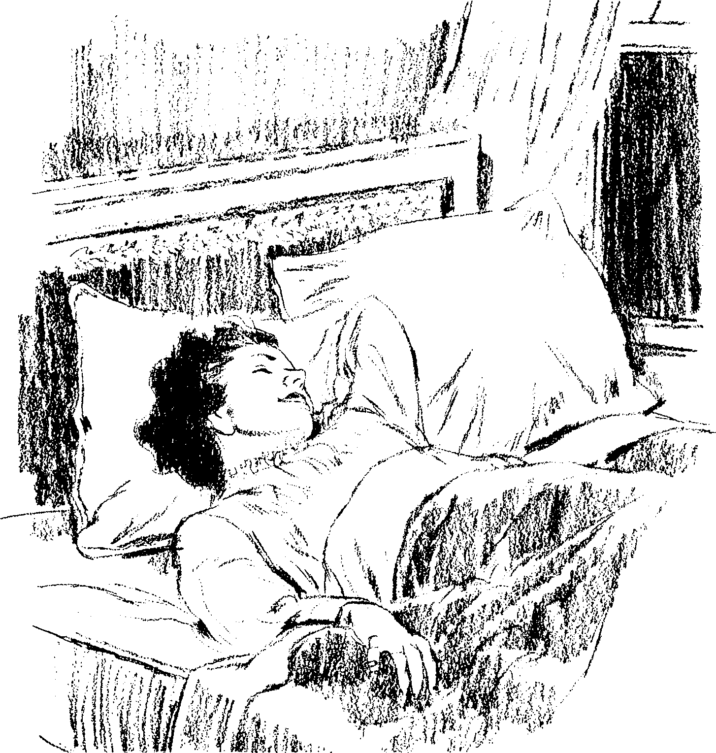
- Sleep with an abundant supply of fresh air in your room. Otherwise you may awake feeling tired and exhausted.
- Remember that the wise man said, “The sleep of a laboring man is sweet.” Ecclesiastes 5:12. Only those who work hard according to their strength can sleep well.
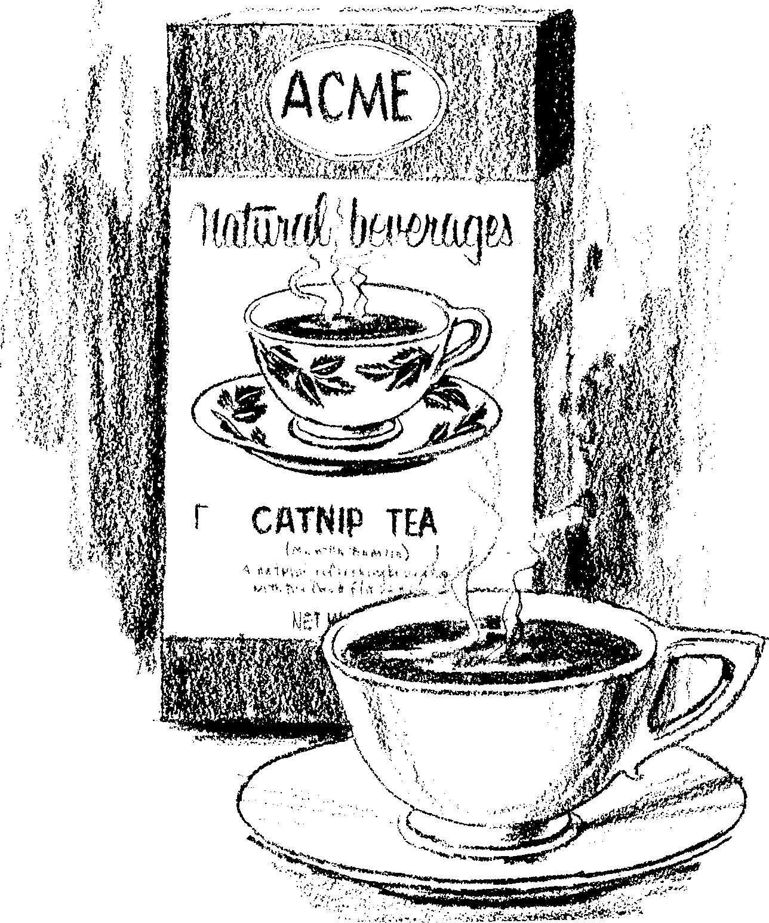

- Go to bed early, and rise early. Staying up late and then sleeping away the morning hours is not healthful.
- If you cannot sleep, take a warm bath. It is relaxing and brings sleep. Catnip or herb teas will help.

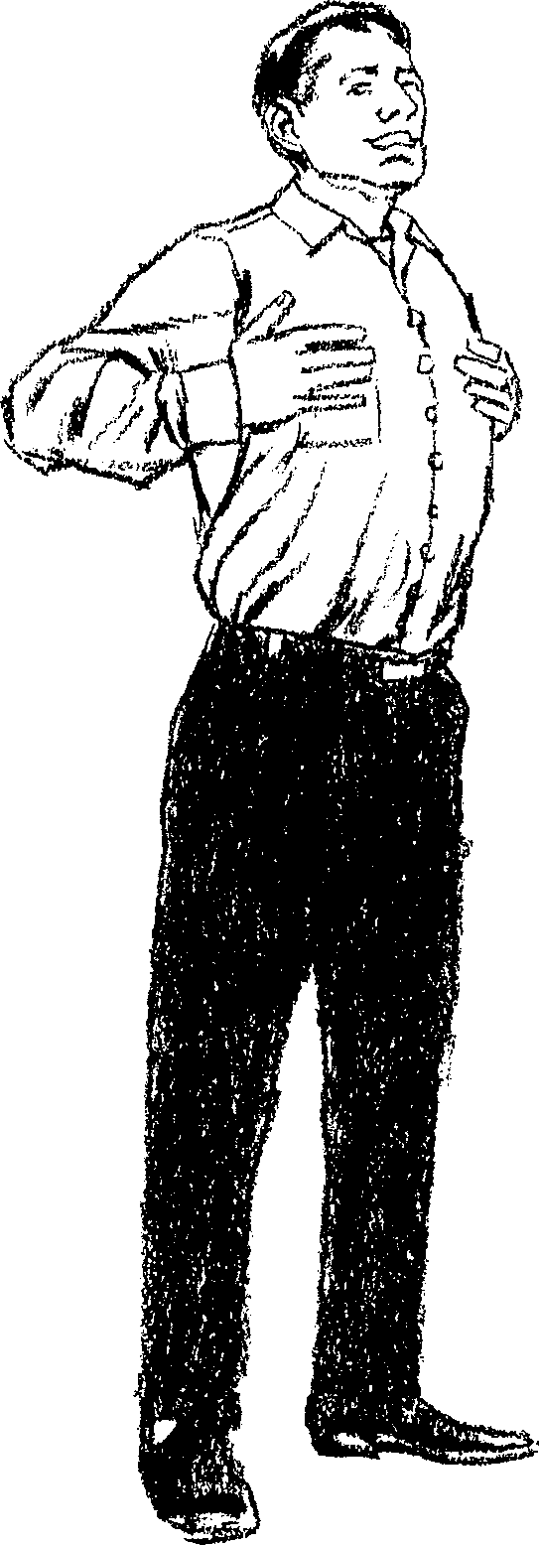
- Deep breathing induces sound, refreshing sleep.
- Avoid the habit of eating before retiring. The stomach should retire before you do.

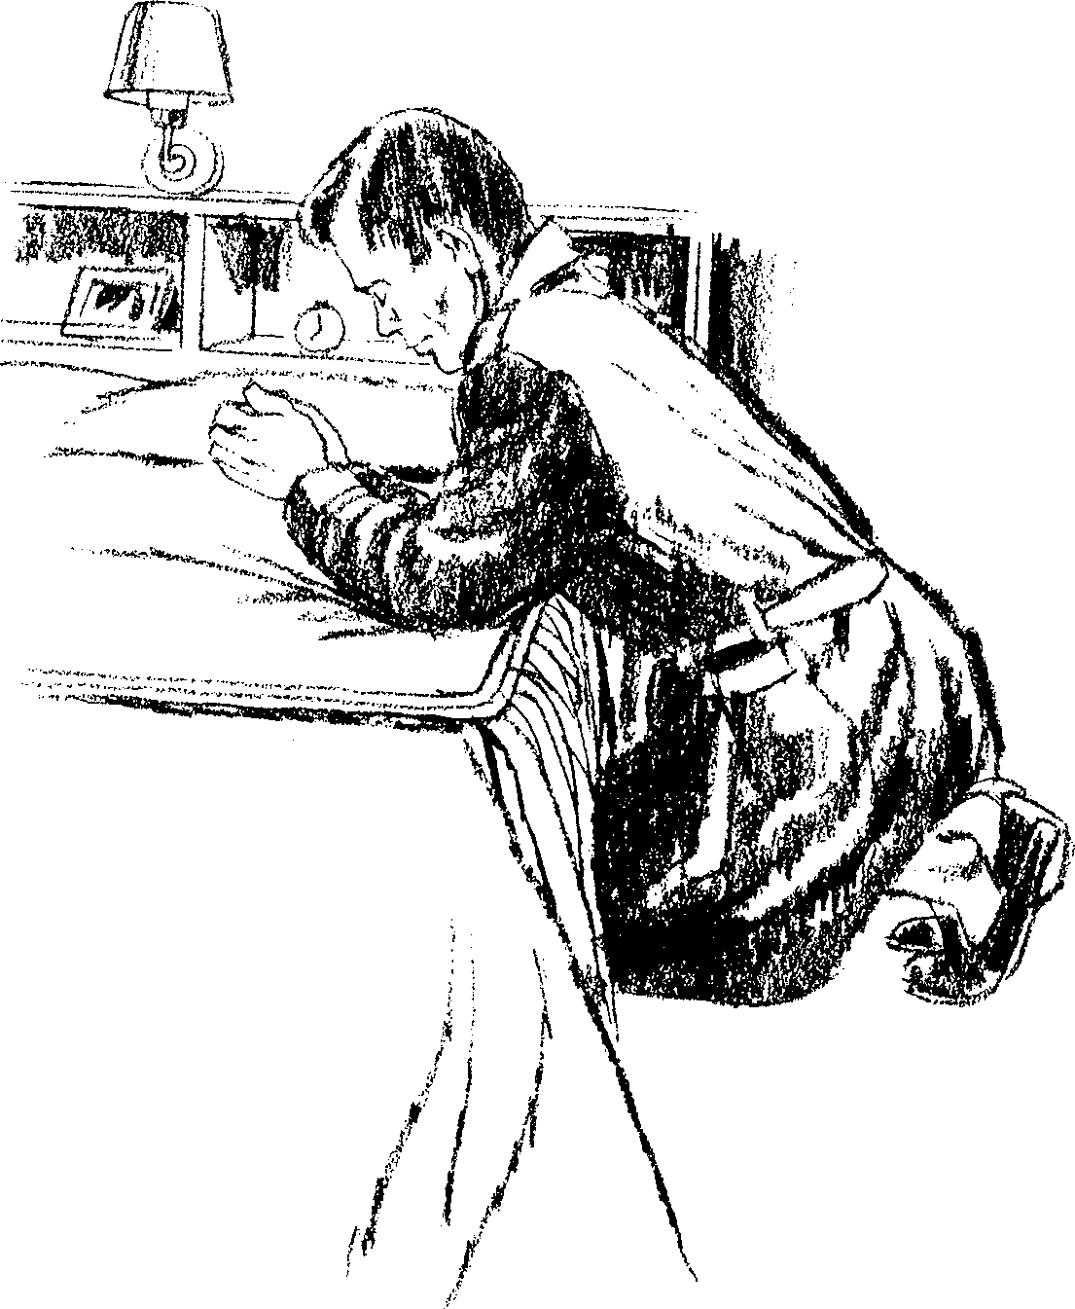

- A clear conscience and trust in God have much to do with good sleep. Read in Acts 12 of how Peter slept soundly the night before his intended execution. The Bible says that God “gives His beloved sleep.” Psalm 127:2. Prayer will help you to sleep well.
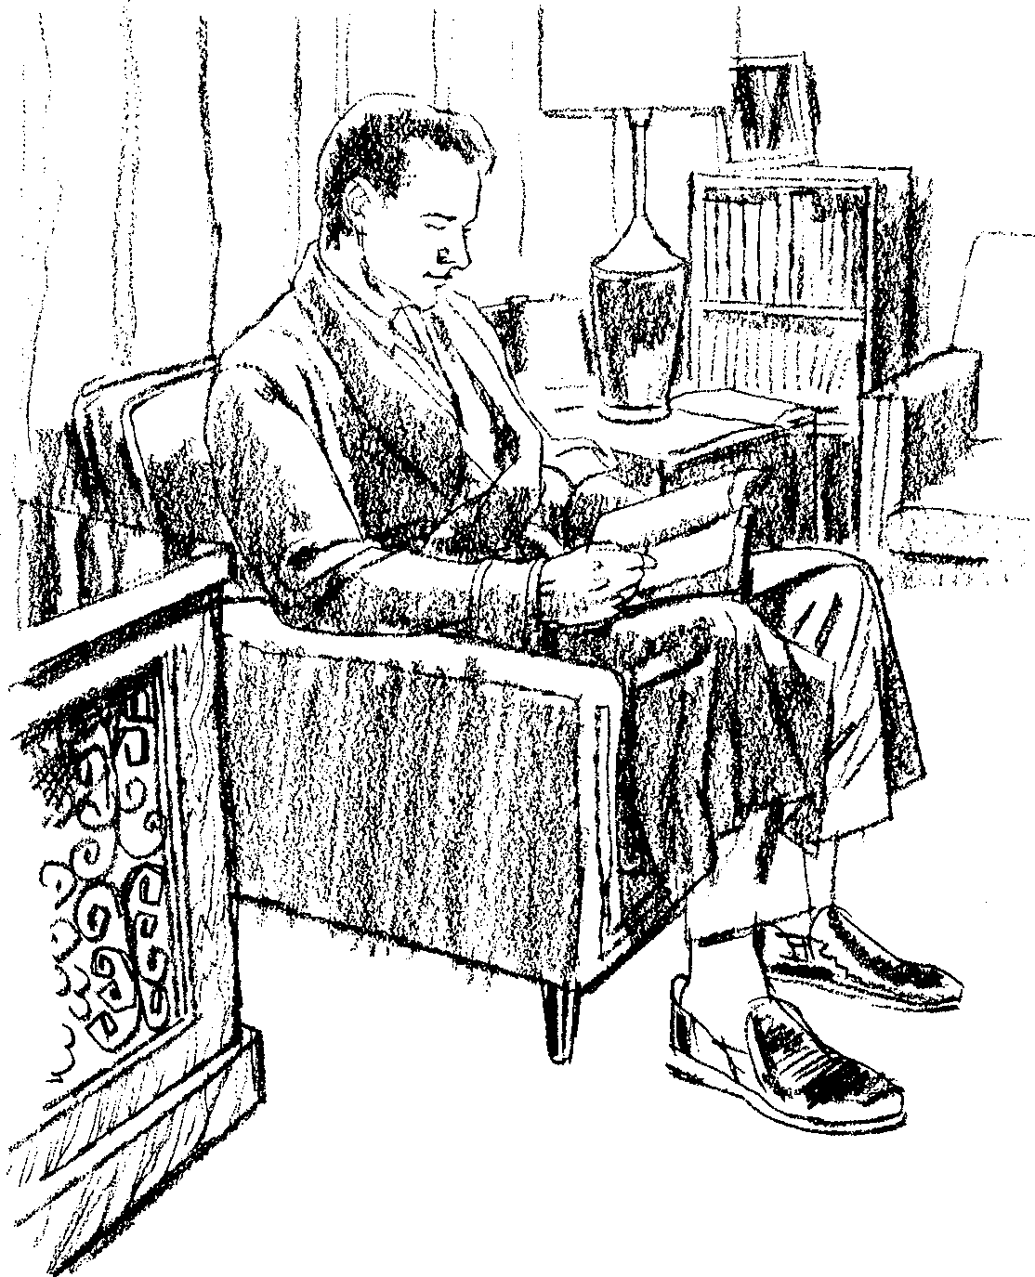

- Before closing your eyes to sleep, read from the Word of God and, by so doing, take your mind off the cares of the day. Watching exciting amusements on television or racing through exciting novels injures the mind, tends to derange the nervous system and is a hindrance to sound, refreshing sleep.

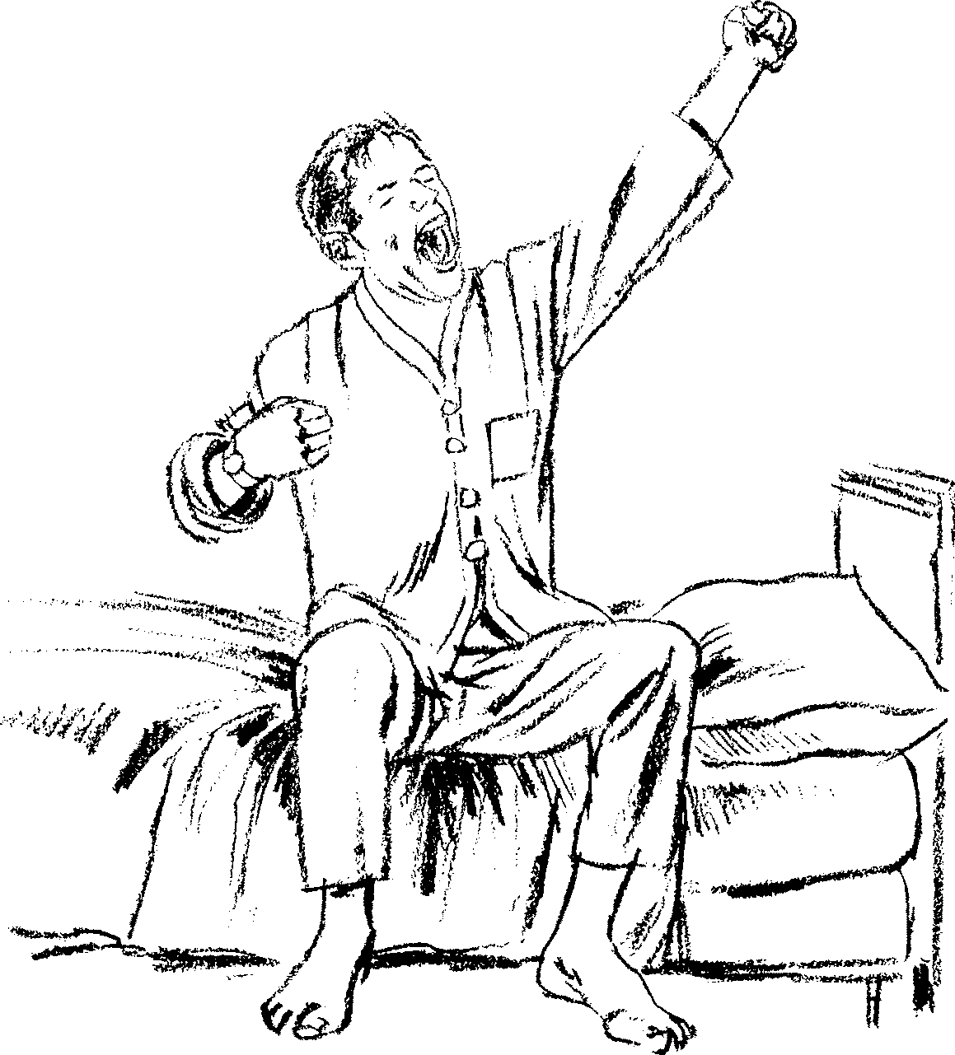
- Do not be a late riser. When nature awakes, you should be awake. The daylight is not for sleep (except for a siesta during the day). The sluggards who cannot rise early from bed are more often in poorer health than those who tend to be a little short on sleep.
- Hygiene and Sanitation
LACK of sanitation is still one of the biggest public health problems facing the world.
Moses has been described as the greatest hygienist of all time. God chose him to be the leader of a nation emancipated from slavery, and through him the Lord gave to the people principles of strict cleanliness and hygiene. People with contaminating diseases, or who came in contact with contaminating things, were to be separated from the encampment.
Not only were the persons of the Israelites to be clean, but order and cleanliness were to be found inside and outside their tents. No waste matter was allowed to remain about the encampment. When the people were careful to observe the instructions given to Moses, they were a disease-free people. Whoever will observe the same principles will reap the same results.
Some principles to remember are:
- First there must be a clean mind in a clean body. Introduce nothing into the body or mind that would defile it. The Bible says that the body is “the temple of God,” and that if a man defiles that temple, ‘‘him shall God destroy” (1 Corinthians 3:16-17; 6:19). Especially should the tobacco habit be regarded as expensive, dirty and poisonous. Liquor is a beverage that degrades both body and mind. Anger, worry and unclean thoughts “defile the temple” also.
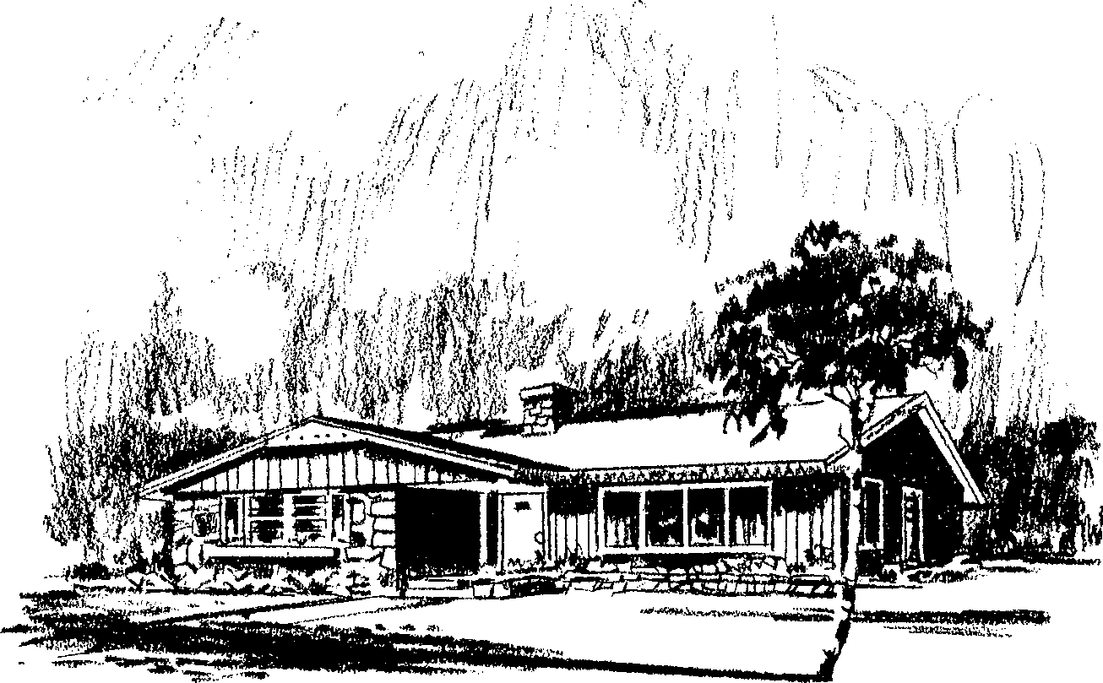
- As far as possible, the home should be situated on elevated or well-drained land, away from damp or shaded places.
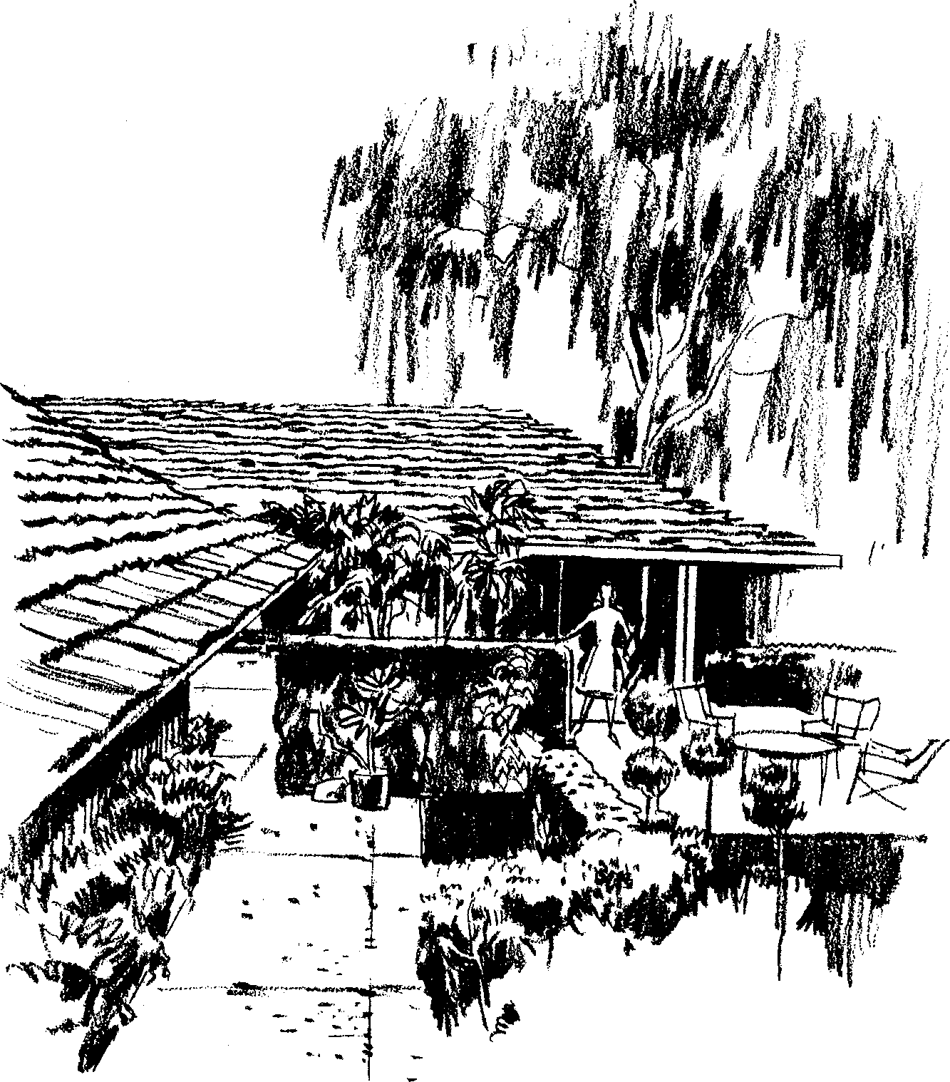

- The rooms of the house should be accessible to sunlight and have a free flow of air in them day and night.

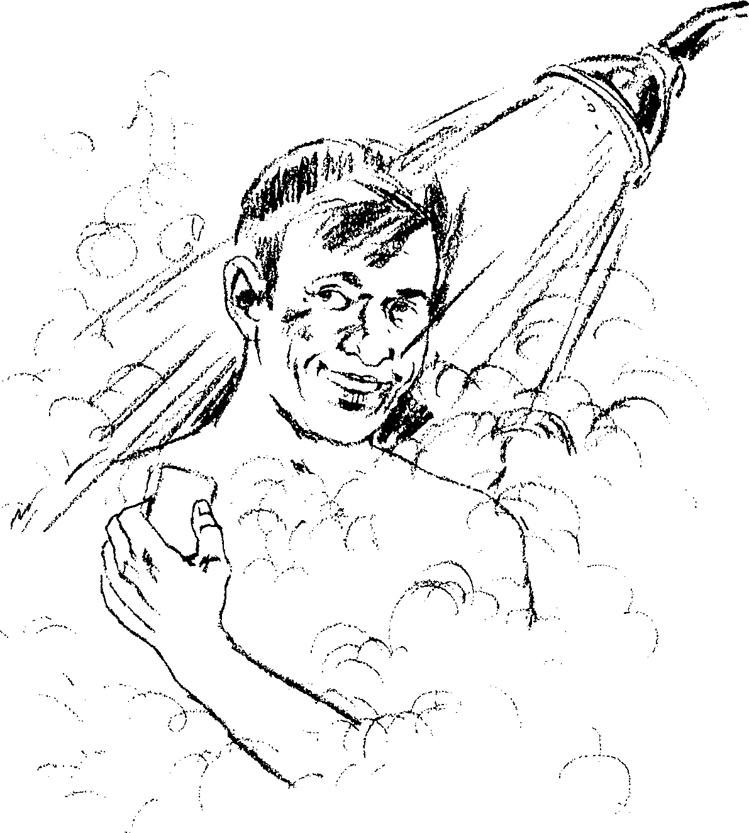
- Take a bath or shower often—preferably every day. Change and wash clothes frequently. Otherwise the poisons that are thrown off through the skin will be reabsorbed back into the body.
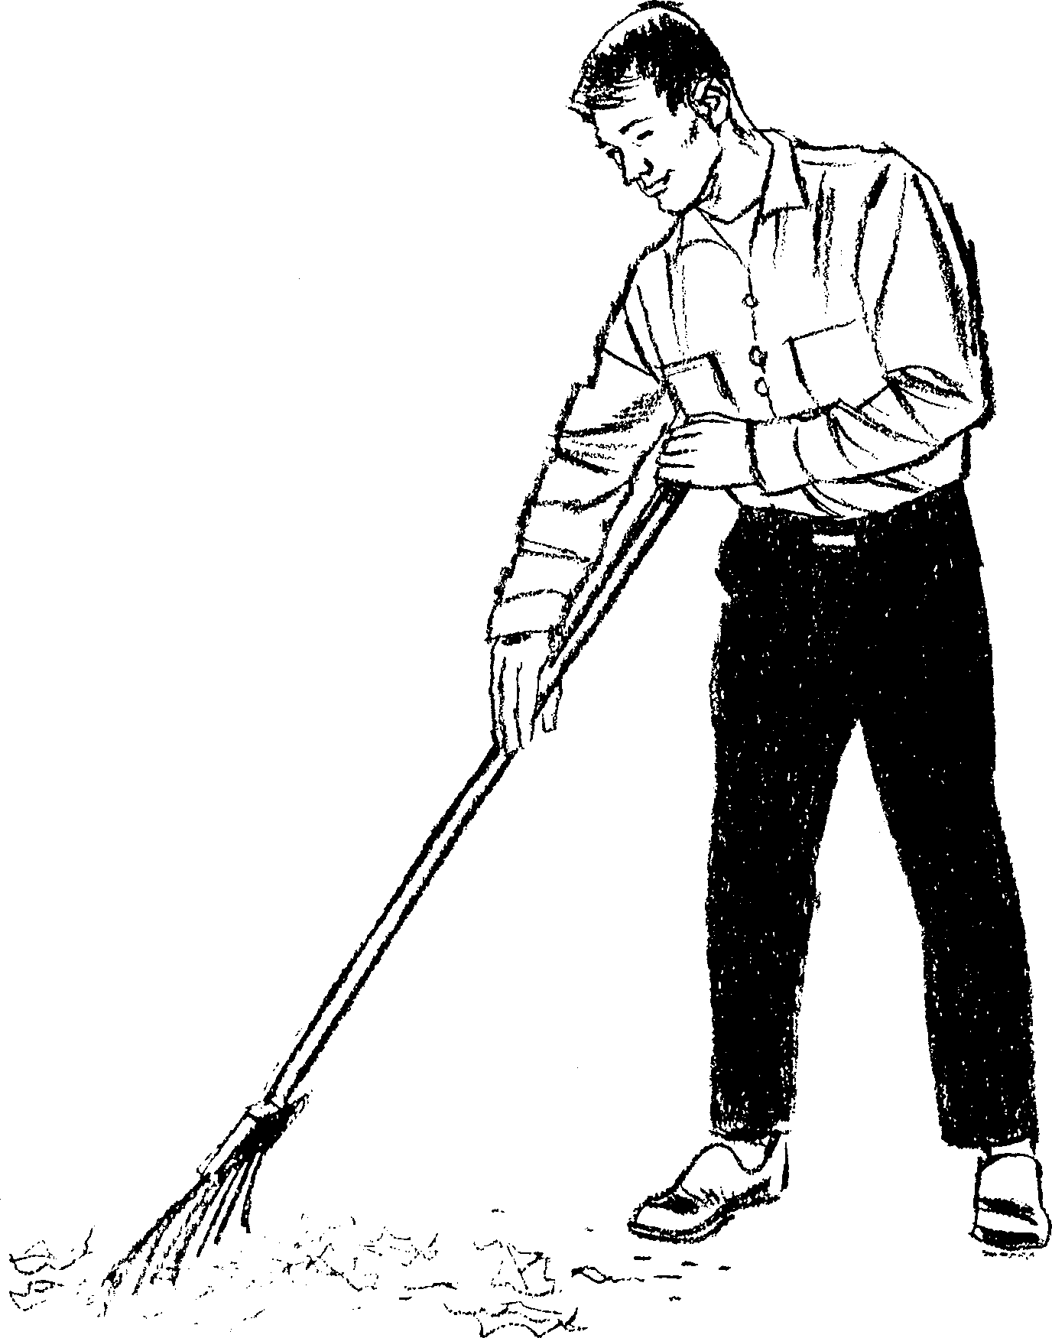

- See that you live in clean, sweet premises that are kept tidy and orderly.
- Never allow decaying fruits or vegetables, or rotting material of any kind, to lie around the house or its premises.
- Temperance
NO SURVEY of the laws of our physical life would be complete without a consideration of the importance of temperance. Paul the evangelist admonishes us to be…
1 Corinthians 9
25 ...temperate in all things.
This means that we should shun that which is harmful, avoid extremes in anything and be moderate in the enjoyment of those things which are lawful. Health is impossible without temperance. Our natural appetites must be kept under the control of enlightened reason.
Sexual intemperance tends to paralyze the nerves and brain, causes loss of memory, weakens physical and mental strength and breaks down the life forces.
Indulgence of appetite is the greatest single cause of physical and mental debility. All men have a tendency to intemperance, and in order to be truly temperate in all things, we need a power outside of ourselves to bring all the powers of mind and body under the control of the laws of life. That power is Christ.

The Relation Between
the Mind and Good Health
THE mind has a vital bearing on physical health. It functions through the delicate brain nerves, which connect with every part of the body. Mental impressions, emotional feelings and every innermost thought convey their effects to every part of the body. It has been reliably estimated that nine-tenths of all sickness has its foundation in the mind. Those who treat disease as merely a physical problem are wide of the mark, in order to enjoy good health, we must pay attention to the laws that govern the proper functioning of the mind.
The electrical power of the brain is necessary to vitalize the whole system and to resist disease. This vital electrical force can be developed or squandered.
Vital electrical force is developed by mental activity. An active mind is a wonderful stimulus to life and health. Vigor of mind tends to vigor of blood circulation. A mind that is possessed of a purpose in life, lawful ambition and a will to live, energizes the entire system. Just as the body is made strong by exercise, so is the mind. The mental faculties—perception, judgment, memory, observation, etc.—need developing by being put to the stretch to wrestle with hard problems.
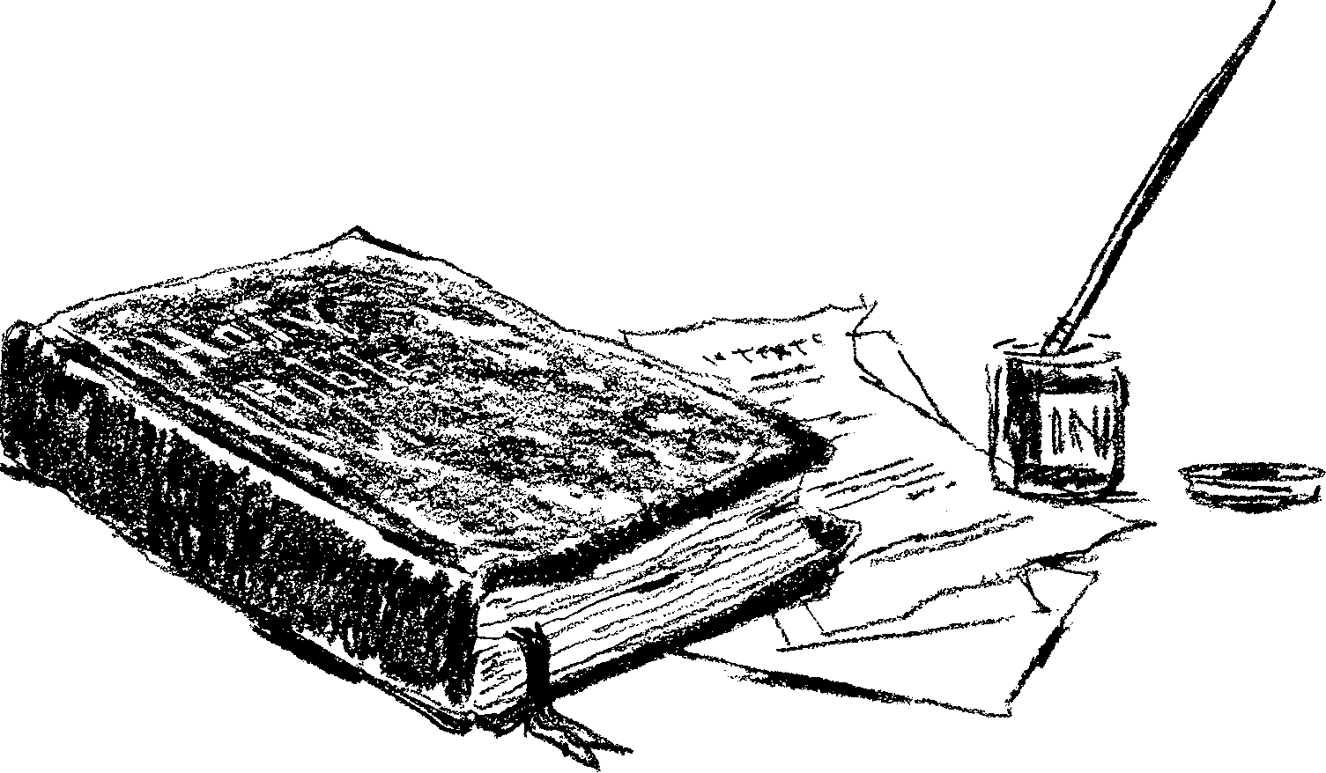
The mind is made to invent and grapple with questions of truth. Those who allow others to do their thinking for them, even though they may appear to be brawn without brain, are not really healthy brawn. This class will fall more readily to disease because they have little vital force from the brain to resist it. Vital force can also be squandered by wrong physical habits, by excess in eating and drinking or by intemperance of any kind.
In many respects the mind should be treated as the stomach. Nothing impure should be placed in it. (You may wash your stomach out, but what is put in your mind is there to stay.) If the mind has no hard things to “chew,” it will become soft and feeble.
Some imagine that the more they cram into their minds, the better; but they do not consider that overloading the mind is worse than overloading the stomach. Cramming the mind with a mass of matter which it cannot digest, or the habit of hasty, superficial reading, even of that which is good, can do permanent injury to the mind and cause it to lose its power of expansion. Sometimes less information and more discipline will be of far more benefit to the mental and physical health.
Like the stomach, the mind should have variation for its “food.” Otherwise it may become unbalanced. It also needs rest as well as exercise. Too much study is detrimental to health. The wise man said,
Ecclesiastes 12
12 Much study is a weariness of the flesh.
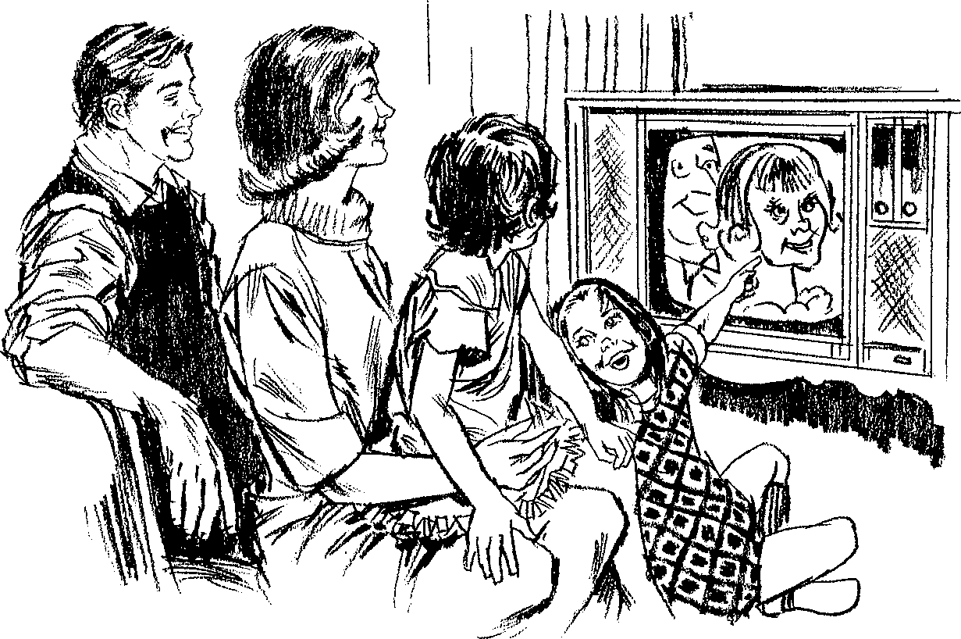
Do not become a television or novel-reading addict. The mind is degraded and enfeebled, the nerves are deranged and the body is weakened by filling the mind with exciting trash. It is especially bad for children and youth, for its excitation of the central nervous system does incalculable harm.

The Moral Laws of Life
THE mind is not just a wonderful computer that can handle and store information; it is also a moral and spiritual entity. By this we mean that it has the power to discriminate between that which is morally right and morally wrong, and it is endowed with the capacity to enjoy a spiritual life in fellowship with the Creator. The relation to the moral and spiritual laws of one’s being has a vital bearing on physical health.
The Bible says,
Proverbs 14
30 A sound heart is the life of the flesh: but envy the rottenness of the bones.
By “heart” is meant the mind, where the thought processes are located.
Proverbs 23
7 As [a man] thinks in his heart, so is he.
This means that right thinking will promote life and health, while wrong thinking will invite decay and death.
Thoughts are accompanied by corresponding feelings. If the thoughts are wrong, the feelings will be wrong. If the thoughts run in the channel of complaining, distrust, suspicion, murmuring, jealousy, envy, resentment or anger, the feelings will be dark and gloomy.
Such feelings have a negative, poisonous effect on the glands, the blood, stomach, liver, heart and, indeed, the whole body. Paul’s prescription is a good one for life and health:
Philippians 4
8 Whatsoever things are true, whatsoever things are honest, whatsoever things are just, whatsoever things are pure, whatsoever things are lovely, whatsoever things are of good report; if there be any virtue, and if there be any praise, think on these things.
The Word of God gives the true standard for right thoughts. That standard is the law of God—the Ten Commandments. There is health in obedience to God’s law. His Word says:
Proverbs 3
1 Let your heart keep my commandments:
2 For length of days, and long life, and peace, shall they add to you.
8 It shall be health to your navel, and marrow to your bones.
Concerning God’s commandments, the Bible also says,
Proverbs 4
22 They are life unto those that find them, and health to all their flesh.
The promise given to the ancient Israelites still holds true today:
Exodus 15
26 If you will diligently hearken to the voice of the Lord your God, and will do that which is right in His sight, and will give ear to His commandments, and keep all His statutes, I will put none of these diseases upon you, which I have brought upon the Egyptians: for I am the Lord that heals you.
God’s law of Ten Commandments is the most perfect document governing the conduct of life. The first thing to notice concerning it is that it is an enunciation of the principle of love.
1 John 4
8 God is love,
–and His commandments are a transcript of His character, an expression of what He wants us to be. By “love” the Word of God does not mean mere sentiment or emotional feeling, but the divine principle of unselfish concern for others. Christ, who came to this world and sought nothing for himself, who went about doing good, finally giving himself on the cross to save the world, even His enemies, is the embodiment of “love.” Paul, His evangelist, gives an inspired definition of love when he writes:
1 Corinthians 13 [NEB]
4 Love is patient; love is kind and envies no one.
5 Love is never boastful, nor conceited, nor rude; never selfish, not quick to take offense.
6 Love keeps no score of wrongs; does not gloat over other men’s sins, but delights in the truth.
7 There is nothing love cannot face; there is no limit to its faith, its hope, and its endurance.
8 Love will never come to an end.
In the economy of God’s universe, love is the law of life. Nothing is to live to itself. Even everything in nature is created to serve. The law of service to others is the law of life. On the other hand, selfishness is death. No part of the body could live unless it served its fellow members. So a life lived for the benefit of oneself is a living death, and every indulgence of selfishness tends to break down the life forces and invite disease and death. A mind centered upon self is a sick mind, and its influence is of positive injury to the entire body.
As an illustration of how unselfish love will promote life and health, we cite this passage from the Bible:
Isaiah 58 [NEB]
6 Is not this what I require of you...?
7 Is it not sharing your food with the hungry, taking the homeless poor into your house, clothing the naked when you meet them and never evading a duty to your kinsfolk?
8 Then shall your light break forth like the dawn and soon you will grow healthy like a wound newly healed.
Aside from the blessing of God, there is a physiological reason why this will promote health. An authority on this subject has said,
“The pleasure of doing good to others imparts a glow to the feelings which flashes through the nerves, quickens the circulation of the blood, and induces mental and physical health.”
When you pass light through a prism, it is dispersed into the colors of the rainbow. Just so, the Ten Commandments are love displayed in the spectrum of God’s Word. The first four commandments embody our duty to God—a duty to love Him because He first loved us. Jesus and Moses said,
Mark 12 [Deuteronomy 6:5]
30 You shall love the Lord your God with all your heart, and with all your soul, and with all your mind, and with all your strength.
In the first commandment we see that love embraces the principle of loyalty—loyalty to our Maker and Redeemer. In the second commandment we see the principle of worship—a duty we owe to God as our Creator. In the third we see that love embraces the principle of reverence. The fourth commandment inculcates the principle of holiness, and, as a sign of one’s allegiance to the God of heaven, it enjoins the blessing of the Sabbath rest. We rob ourselves of great physical and spiritual benefit when we neglect to rest from work one day in seven.
The last six commandments are concerned with love to our fellow men:
Mark 12 [Leviticus 19:18]
31 You shall love your neighbor as yourself.
In them we see the principles of respect for authority, sacredness of life, purity, honesty, truthfulness and contentment.
We should not look upon the commandments of God from a prohibitory viewpoint, but from the viewpoint of mercy. They are to guard our health and happiness.
This law of ten precepts is an expression of the greatest love that has been shown to man. There is life and health in the way of God’s commandments. A mind that rejoices in the worship and fellowship of God, that is respectful, pure, honest, truthful and contented, is a wonderful stimulus to health.

- Sin and Sickness
TRANSGRESSION of God’s law is what God’s Word calls “sin.” 1 John 3:4. It is not hardship or poverty which degrades humanity, but guilt, which comes through wrongdoing.
The greatest single cause of sadness and sickness in the world today is guilt. Guilt breaks down the life forces, leading to decay and disease of the entire human organism. Jesus illustrated the relation between sin and disease when He said to a man whom He had healed of a grievous disease,
John 5
14 Sin no more, lest a worse thing come unto you.
We need to understand that unbelief—distrust of God’s love and goodness toward us—is sin. When souls are shut up in the gloom of unbelief, their thoughts and affections turn inward to themselves, and grief, discontent, remorse, worry, guilt and distrust all work to break down the life forces and invite decay and death.

- The Divine Remedy
IT WOULD indeed be tragic if we only saw our need to live in harmony with all the laws of life, without realizing that apart from divine power it is impossible to do it. Especially is this true in regard to the Ten Commandments, which are a moral and spiritual law. There is no man able, of his own strength, to keep the commandments of God. Apart from God, man has no spiritual life, and the Word of God teaches us that, in his natural state, man’s nature is out of harmony with the law of God.
True, there exists in every heart a desire, placed there by God, for a better life of purity, goodness and truth; but against this there is in every man’s nature an evil force, a bent to wrongdoing. This is the result of man’s original sin of rebellion against the will of God. Unless a man receives a power from outside himself, he will find that the strong current of evil in his nature is too much for his good resolutions.
The basic and obvious truth is that:
Romans 3
23 ...all have sinned, and come short of the glory of God.
What we need are not just resolutions to live better lives, but cleansing from the guilt of our past sins and power to live in harmony with the laws of our being. Such a need is provided in Jesus Christ, God’s gift to all men. Through His sinless life, death on the cross and resurrected life, He provides pardon and power to all who believe on Him. Concerning pardon for the sins of the past, God’s Word has promised:
Proverbs 28
13 He that covers his sins shall not prosper: but whoso confesses and forsakes them shall have mercy.
Isaiah 55
17 Let the wicked forsake his way, and the unrighteous man his thoughts: and let him return unto the Lord, and He will have mercy upon him; and to our God, for He will abundantly pardon.
Isaiah 1
18 Though your sins be as scarlet, they shall be as white as snow; though they be red like crimson, they shall be as wool.
1 Corinthians 15
3 Christ died for our sins according to the Scriptures.
1 John 1
7 The blood of Jesus Christ His Son cleanses us from all sin.
Romans 3
22 The righteousness of God...is by faith of Jesus Christ unto all and upon all them that believe.
24 Being justified freely by His grace through the redemption that is in Christ Jesus.
We are not made righteous in God’s sight by good works, by promises to keep His law or even by attempts to keep His law. Faith that embraces Jesus Christ as a personal Saviour brings forgiveness of all sin and power for obedience unto life.
John 1
12 As many as received Him, to them gave He power to become the sons of God, even to them that believe on His name.
The power that God imparts to those who believe on His Son is even the very life of Christ. Christ came to give us life—a new life. The old life is corrupt and sinful. God does not intend to reform that old life, but He puts it to death with Christ and gives us a new spiritual life from above.
The old nature, born of flesh and blood, cannot keep God’s commandments or enjoy fellowship with God. Before we can do good, we must be made good. He gives to all who believe the gospel of Jesus Christ a new nature, as it is written,
2 Peter 1
4 Whereby are given unto us exceeding great and precious promises: that by these you might be partakers of the divine nature.
Through His Word and by His Spirit, Christ lives in the hearts of His followers, and by the power of His life, they…
Revelation 14
12 ...keep the commandments of God, and the faith of Jesus.
There is a vital relation between divine forgiveness and recovery of health. When Christ was on earth, He healed the sick and forgave their sins. The assurance of pardon and the promise of a new start in life are all that many people need to recover their health. They need the good words of the great Physician,
Matthew 9
2 Son, be of good cheer; your sins be forgiven you.
They need to know that:
Psalm 103
3 [God] forgives all your iniquities...[and] heals all your diseases.
Guilt and remorse are poisoning the springs of their life, and a disease is upon them that no earthly physician can heal. Such need to come to Christ. Then,
Isaiah 33
24 The inhabitant shall not say, I am sick: the people that dwell therein shall be forgiven their iniquity.
The apostle Paul instructs us that faith in Christ makes us righteous in God’s sight and brings us peace, hope, love and joy. With these great positive attributes go courage, sympathy, praise, thankfulness and contentment. These attributes prolong life and promote health.
In order to have optimum health, our hearts must be filled with faith and hope and joy in the Lord.
Proverbs 17
22 A merry [rejoicing] heart does good like a medicine.
God would have us know that in every trial we may have His strength to endure; in every sorrow, a sympathizing Friend; in every burden and care, One who will lift the heavy burden; and in every perplexity, wisdom from above. God is ready and willing to hear the sincere prayers of all who come unto Him in the name of Christ. Our Saviour’s words,
Matthew 11
28 Come unto me...and I will give you rest,
–are a prescription for physical, mental and spiritual ills. God will do great things for those who trust in Him.
We commend to you the words of the Bible as containing the true philosophy of healthful living. These are the leaves from the tree of life, which are…
Revelation 22
2 ...for the healing of the nations.


What Doctors Say

“How to Keep the Doctor Away contains the master keys for good health. Adherence to the principles found in this book would all but eliminate the great burden of medical expense placed on the citizen of today.”
Fred C. Metz, D.D.S., M.D.
Denver, Colorado
“The book, How to Keep the Doctor Away, is one of the best guides to healthful living that I have had the privilege of reading. Through the ages mankind has sought means of prolonging his life. Paracelsus thought that he had invented the elixir of life and yet died young; Ponce de Leon sought the fountain of youth in the swamps of Florida and died during his search: and modern man hopes to find prolonged life and health in the mysteries of manipulation of genetic proteins. Curiously enough, the life span of adult males has been increased only two years over the last seven decades. How to Keep the Doctor Away sets forth neither fad nor gimmick, nor does it advocate any particular bottle of pills to attain good health. Rather, it sets forth broad principles of healthful living which, if followed, will provide the basis for more healthful vigor than will all the inventions of the 20th century.”
Warren E. Parmelee, M.D.
Greenville, New York
“This profitable booklet will prove of invaluable assistance to the reader. Its philosophy gives the true insight into the natural laws which govern good health. Anyone truly interested in healthful living should surely read this valuable and informative publication. How to Keep the Doctor Away provides a great insight into the basic causes of sickness and health.”
Paul H. Freeman, M.D.
Santa Ana, California
“How to Keep the Doctor Away is a great book for those who are seeking a formula for perfect health. It is a library of practical health principles in one compact volume. A copy should be in every home.”
Harold C. Brockmann, D.D.S.
Lancaster, California
“I have been keeping How to Keep the Doctor Away in my office ever since it was first published and do feel that it is by far the most practical publication available for this purpose. When I present this booklet to my patients, I emphasize the fact that it is so simple that a child can understand it and yet so comprehensive that it deals with every phase of the health question. While the primary emphasis is on preventive medicine (or prevention of disease), it is still true that most of these principles have an important application when it comes to treatment. Not only are the physical aspects of health dealt with, but there is strong emphasis on the relationship between man’s spiritual condition and the condition of his physical health.”
Byron Harbolt, D.O.
Coalmont, Tennessee
“I do not recall ever having seen a comprehensive collection of sound health principles compressed into so few pages. The counsel contained in How to Keep the Doctor Away should be highly treasured, for, put into practice, it has the potential for preventing disease and promoting physical, mental and spiritual health.”
Harold N. Mozar, M.D.
Placerville, California

See Romans 13:10.
E. G. White, Testimonies for the Church, vol. 4, p. 56.
Ezekiel 20:12.
Romans 14:23.
See Romans 8:7.
See Romans 7:14-24.
John 3:16.
Romans 6:6.
See Romans 5:1-11.

