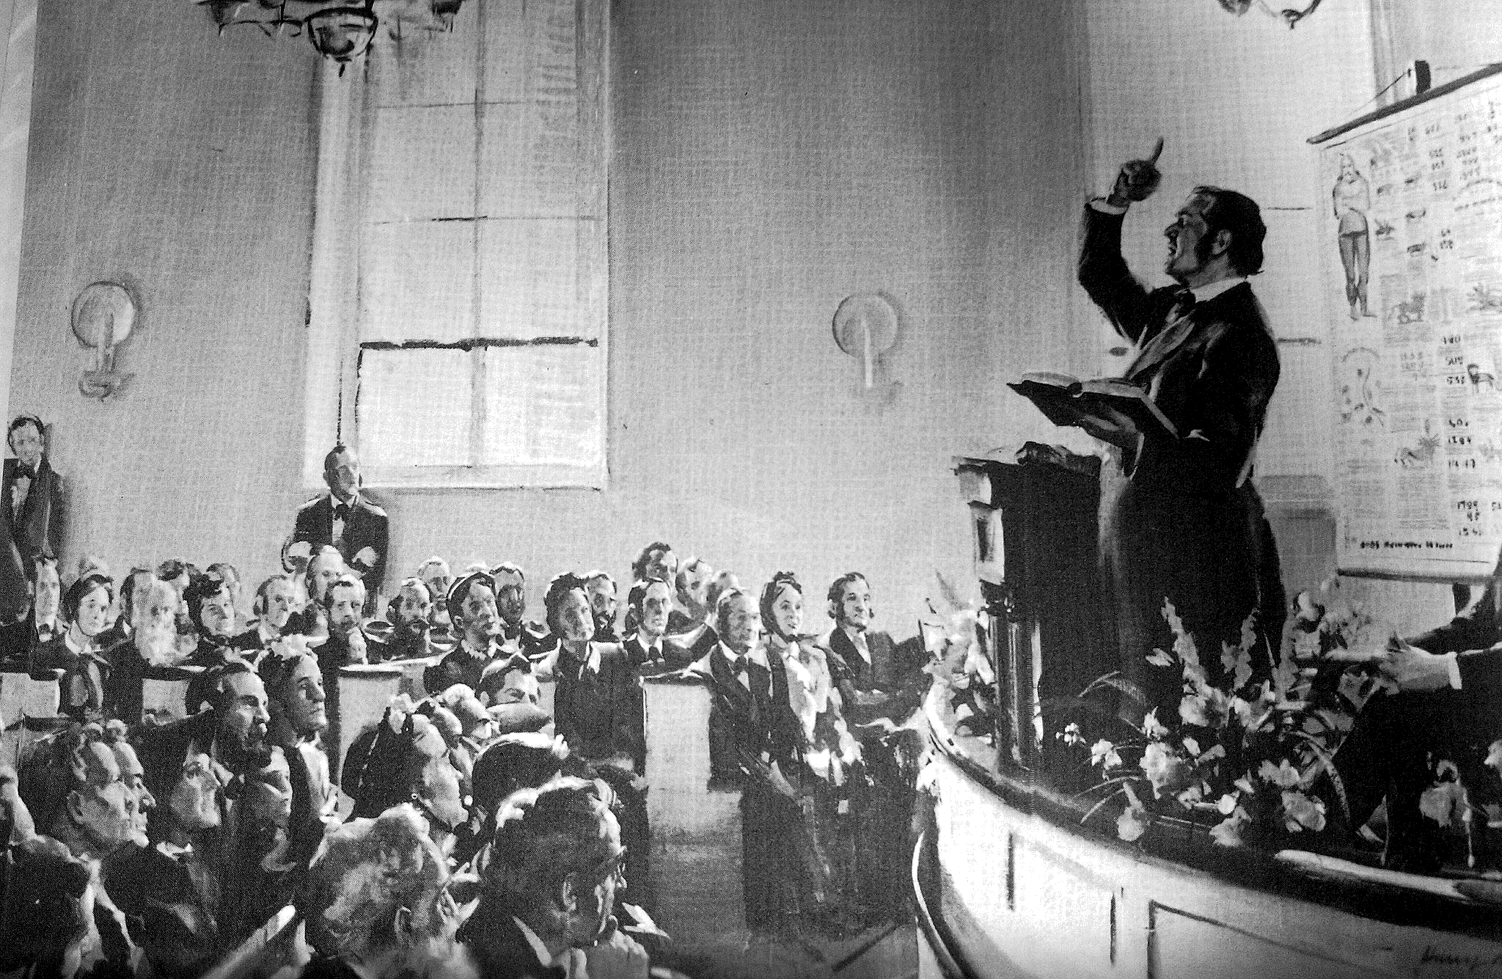
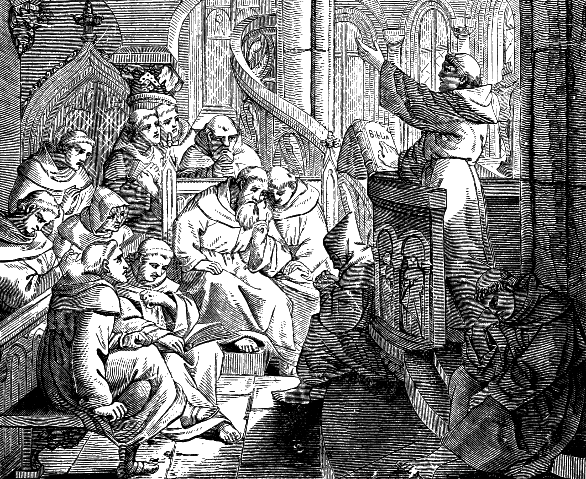
THE REFORMATION:
Yesterday & Today
SYLVESTER BLISS

Source:
Advent Shield and Review, Vol. 1, No. 2
Edited by J. V. Himes, S. Bliss, & A. Hale
September 1844
Original title:
“The Reformation of Luther—its Similarity to the Present Times”
Cover:
Luther begins to Preach in the Monastery
Scenes from the Life of Luther, 1883
William Miller Preaching with Prophetic Chart
Harry Anderson for Review & Herald

Fonts:
FranciscoLucas Briosa
Liberation Sans Narrow
Linux Biolinum
Linux Libertine
Linux Libertine Display

January 2023
practicaprophetica.com
srac.info

Contents
The Reformation: Yesterday & Today 1
Humble Beginnings 1
The Bible vs. Tradition 2
Disputations with Learned Adversaries 3
Misrepresentations 9
The Rise of Fanaticism 9
A Manifold Battle 18
The Feeble Become as David 20
The Parallel to Today 22
Satan’s Last Parochial Calls (Poem) 26

The Reformation: Yesterday & Today
The Reformation of Luther—its Similarity to the Present Times
By Sylvester Bliss

Humble Beginnings
THERE is, in every great reformation, a similarity in the evils to be corrected, in the instruments by which they are to be corrected, and in the character of the opposition to the progress of truth.
In reading D’Aubigné’s History of the Reformation of Luther, we have been particularly struck with the number of coincidences which it presents to what we have witnessed in the progress of the doctrine of the Advent in our own day.
- It had the same humble beginning;
- Encountered the same obstacles;
- Was attacked by the same weapons, with the same spirit, and
- Met with the same hindrances in its progress.
These coincidences are so numerous, that with a change of names and places we could almost fancy we were reading the history of the Advent doctrine.
We find that the great truths which were then about to be agitated, had slumbered in the church so long, that their existence was almost unknown; while the errors which prevailed, and which it was necessary to expose and eradicate, had so long been the prevailing belief, that they had been supposed to have been the faith of the Church from the days of the apostles.
God chose an obscure monk—LUTHER—a man of great natural ability, as the first instrument in the great work which was then commenced.
An old wooden chapel, thirty feet long, and twenty broad,
–was the cradle of the Reformation, in which it was first to any purpose preached; and a contemporary remarked that it might…
...be aptly compared to the stable in which Christ was born.
Among the thousand cathedrals and parish churches with which the world was filled, not one was chosen for the glorious announcement of everlasting life. Such a beginning forcibly reminds us of Mr. Miller and our own Chardon Street Chapel, which was but a stable at first.
In a short time, [says D’Aubigné,] the little chapel of Luther could no longer contain the crowds that flocked thither;
–his doctrines astonished his auditors, his fame spread far and wide, and many flocked from distant places to hear.

The Bible vs. Tradition
Luther obtained a profound knowledge of the word of God; he reasoned out of the Scriptures in a way that was new and astonishing to the people, and God raised him up friends. He then went forth supposing the church had only to hear the truth—to be shown the evidences of its authenticity, and she would receive it. His motto was,
The writings of the apostles and prophets are more certain and sublime, than all the sophisms of the schools.
Multitudes listened to him with admiration, and marveled that they had not earlier seen and acknowledged, truths, which he made so plain; and they compared his preaching to a new light arising after so long a night. Pious souls were attracted and penetrated by the sweetness of his doctrine. The firmness with which Luther appealed to the Scriptures gave power to his teachings, and his audiences acknowledged that he believed what he taught, and that his life corresponded with his precepts. The more men loved the Christian virtues, the more they inclined towards him.
As Luther continued his labors, he saw more of the corruptions of the Church, and of the hopelessness of the expectation that she would embrace the truth. Those who wished to stand well with Rome and with society, spoke of him as a proud fellow and an ignorant monk, instead of meeting him with opposing arguments. For a time Luther’s works were read in the theological schools with but little sensation; at a later period all gave ear to admire or oppose.
He had no desire of becoming a reformer; he was distrustful of his own powers, and moved only as God seemed to open the door for him. He sought not to please men, but God; and so followed where his Master called. He had no settled purpose; his only wish was that the watchmen of the Church should arouse themselves, and endeavor to put a stop to the evils that were laying it waste.
But the princes of the church closed their ears to the voice of God, which was making itself heard in so affecting and energetic a manner by the voice of Luther. They would not understand the signs of the times; they were struck with that blindness which had been the ruin of so many.
But, [said Erasmus,] I observe that the more irreproachable men’s morals, and the more evangelical their piety, the less are they opposed to Luther.

Disputations with Learned Adversaries
All Luther’s efforts might have been spent on the air; but the partisans of Rome prevented their ending thus. They fanned the flame instead of extinguishing it. Eager to crush the audacious monk, they raised a shout of indignation; they disputed with and reviled him. On one occasion Tetzel opposed Luther with a series of propositions; but they were overthrown by John Knipstrow—a boy of twenty and yet Tetzel is made a Doctor as a recompense, and contents himself with hurling his anathemas at Luther. The priests raised a shout against the poor monk, and…
Luther’s name resounded from all the Dominican pulpits.
They stirred up the passions of the people, called him a madman, a seducer, a wretch possessed of the devil; [and] his teaching was decried as the most horrible of heresies.
Luther saw the necessity of meeting his adversaries boldly;
But at the same time their weakness discovered to him his own strength, and inspired him with a consciousness of what it really was.
Said he,
They are so ignorant both of human and divine things, that it is humbling to have to dispute with them; and yet it is this very ignorance which gives them their inconceivable boldness, and their brazen front.
At Rome, for a time, they would not condescend to meddle with Luther’s opinions; it is a “squabble among the monks,” said Leo X., “the best way is not to notice it.” But when a Roman censor sees fit to attack him, he employs “ridicule, revilings and threats.”
Luther’s fundamental proposition was:
The word of God, the whole word of God, and nothing but the word of God.
His opponents relied…
...only on the phrases and opinions of St. Thomas.
They discovered more malice, than argument. John Eck, a Doctor of Divinity, speaks of Luther as “his feeble adversary,” a “pestilent man,” “a heretic,” “seditious,” “insolent,” “rash,” “dull,” “stupid,” and “ignorant;” but this only gave Luther fresh courage, who shows in reply that he is not convicted of heresy, either by the Scriptures, or the fathers of the Church; and only by mere opinions. The more Luther was opposed, the more his opinions were read. To every objection the Doctors made, Luther always had a ready reply;
But, [said he,] it is useless to talk to a deaf man these doctors cling to their petty distinctions, though they confess they have nothing to confirm them, but what they call the light of reason.
When he appealed to the princes of the church, some laughed at him; others turned a deaf ear; but Luther ever expressed his wishes, that if they were able from the Scriptures, they would convict him of error. When arraigned before the Legate of the Pope, he said,
Deign to inform me wherein I have erred.
To the Elector of Saxony he wrote,
Let them bring forward their reasons: let them instruct me who desire to be instructed; let the Lord deprive me of His grace, if, when I am shown a better doctrine, I do not embrace it.
But all who attempted the task, were obliged to retire in silence after a vigorous reply from the Reformer. Many replied to him to advance their own fame, but injured their cause by so doing. When they attempted, by contemptible decretals of Roman Pontiffs, not four centuries old, to prove the primacy of the Roman Church, he arrayed against this claim the credible history of the early Church, the express declarations of Scripture, and the conclusions of the council of Nice,—the most venerable of all councils.
While the pulpits were all open to the enemies of the Gospel, they were shut to those who proclaimed it; and…
...it was currently reported of Luther in the meetings of the clergy, that he carried about with him the devil in a small box.
Said Doctor Eck,
I am astonished at the humility and diffidence with which Luther undertakes to stand alone against so many illustrious Fathers; thus affirming that he knows more of those things, than the Sovereign Pontiff, the councils, divines, and universities; it would, no doubt, be very wonderful if God had hidden the truth from so many saints and martyrs, till the advent of him.
Luther replied,
The Fathers are not opposed to me—St. Augustine, St. Ambrose, and the most eminent divines say as I do;
–and he claimed that Eck…
...ran over Scripture without touching it.
D’Aubigné says, that in Luther’s controversy with Dr. Eck, the Doctor…
...obtained the victory in the opinion of those who do not understand the question, and who had grown gray in scholastic studies; but Luther, in the judgment of those who have intelligence and modesty.
They saw Luther relying on the word of God, while Eck took his stand on the traditions of men; and though defeated, he…
...gave himself up to the intoxication of what he tried to represent as a victory; [and] the more he felt his weakness, the louder were his clamors.
At another time a princess inquired,
Who is this Luther? an ignorant monk; well, you are learned and so many; write against him; the world will surely believe a company of learned men, rather than a single monk of no learning.
But the learned found it easier to condemn and burn his writings, than to reply. The Pope attempts to silence him by a bull of excommunication; Luther, in return, excommunicates the Pope. When overwhelmed with reproaches, and accused of standing alone, teaching new doctrines, he replied,
Who knows whether God has not called me for this very purpose? Moses was alone when the Israelites were led out of Egypt; Elijah was alone in the time of king Ahab; Ezekiel was alone at Babylon. God has never chosen for His prophet, either the high priest, or any person of exalted rank; but generally men of mean condition—like Amos, a simple shepherd. The saints in every age have been called upon to rebuke the great of this world; and they have more reason to fear, because I am alone and they are many.
Of this I am sure, that the word of God is with me, and it is not with them. They affirm that I bring forth novelties; but I affirm that they are not novelties, but truths which have been lost sight of. I am accused of rejecting the Doctors of the Church; I reject them not, but test their writings by the Bible. It is objected that I am censured; but the Scriptures show that they who persecute are in error; and that the majority are always on the side of false hood.
Such was the manner in which the Reformation was ushered in. Who cannot see that it encountered the same elements which the reformation of our day has been called upon to encounter?
Failing of intimidating Luther, the Church began to exert its influence over those who had embraced his doctrines. At the confessional, the questions were,
Have you read Luther’s writings? and do you approve of his works?
And if they would not renounce them, they were anathematized. This expedient brought many under the yoke of the Church; but it strengthened others in their faith. Luther bade his followers to adhere to the truth of God, if it was at the expense of the “altar, the priest and the church.” And he proved from the prophecies of Daniel, John, Paul, Peter, and Jude, that the Papacy is the Anti-Christ predicted in the Bible; and, said he,
May God hasten the day of the glorious coming of His Son, in which He shall destroy that man of sin.
This caused the people to renounce their attachment to a church, which appeared, in every particular, so directly opposed to the example of its Founder. A man of humble station, holding the word of God in his hand, had stood in the presence of earthly dignities, and they had quailed before him. Learned divines and astonished theologians saw the weapons of their scholastic logic shivered in their hands.
Academicians, lawyers, nobles, the inferior clergy, many even of the monks, and vast numbers of the common people, embraced the Reformation.
The Papists, in answer to Luther’s arguments from the Scriptures, replied:
The Bible—it is like wax; you may stretch and mould it any way, and prove from it any doctrine you please.
But they could not disprove from it Luther’s doctrines. Their cry was,
He refuses to be set right;...these Lutherans are a motley rabble of insolent grammarians, disorderly monks, and ignorant, misled and perverted plebeians.
Again, when seeing Luther’s advantage, they would say,
Only give up “such and such points which are unimportant,” and all will be well;...we agree in all essential points the only question between us relates to some secondary points.
When Luther visited Worms, at the summons of the Emperor Charles V, crowds flocked to see him; some of whom had conceived an idea of him as a prodigy of wisdom; others as a monster of iniquity; and yet on hearing him, all were struck with the joy of his countenance, and the wisdom of his discourses, which the Papists ascribed to the influence of the devil; and anyone, who manifested the least interest in his cause, was instantly cried down as a heretic.

Misrepresentations
The enemies of the truth never failed to circulate inventions of pretended doctrines of Luther; and nothing was too absurd and silly for them to ascribe to his belief: but all those things only recoiled on their own heads. The Reformation, which only sprung up in the hearts of a few monks, spread abroad, lifted itself on high, and assumed a station of publicity. Like the waters of the sea, it rose by degrees, until it overspread a wide expanse.
The Bishop of Constance complained that evil-minded persons were reviving doctrines, which had been condemned; and that learned and unlearned men were alike every where irreverently discussing the most exalted mysteries. And the partisans of Rome, with that blind infatuation common to those who have long held power, were pleasing themselves with the thought, at every seeming advantage, that the Reformation was forever at an end. Many of those weak persons, who, when things were nearly balanced, were found on the side of truth, whenever their own interest was concerned, were quite willing to take up again with error. When such left the cause, the priests were ready to exclaim,
We have silenced him who troubles Israel.
The most celebrated schools and professors gave their verdict against the Reformation, and pronounced the doctrines of Luther heretical; he, however, showed them that the heresy was in Rome and the schools, while the catholic truth was in Wittemberg.

The Rise of Fanaticism
When all the efforts of Rome, to crush the Reformation, had failed, and the frail bark, which had been tossed in every direction by so many winds, and been well nigh wrecked, had now apparently righted itself, it was called to encounter obstacles in another form. Says D’Aubigné:
Whenever a great ferment is working in the Church, some impure elements are sure to mingle with the testimony given to truth; and some one or more pretended reforms arise out of man’s imagination, and serve as evidences or countersigns of some real reformation in progress. Thus many false Messiahs in the first century of the Church, were an evidence that the true Messiah had already come. The Reformation of the sixteenth century could not run its course without presenting the like phenomenon, and it was first exhibited in the little village of Zwickau.
There were dwelling at Zwickau a few men, who, being deeply moved by the events passing around them, looked for special and direct revelations from the Deity, instead of desiring, in meekness and simplicity, the sanctification of their affections. These persons asserted that they were commissioned to complete that Reformation which in their view Luther had but feebly begun. “What is the use,” asked they, “of such close application to the Bible? Nothing is heard of but the Bible. Can the Bible preach to us? Can it suffice for our instruction? If God had intended to instruct us by a book, would He not have given us a Bible direct from heaven? It is only the Spirit that can enlighten! God himself speaks to us, and shows us what to do and say.
Thus did these fanatics, playing into the hands of Rome, impugn the fundamental principle on which the whole Reformation is based; namely, the perfect sufficiency of the Word of God.
Nicolas Storch, a weaver, publicly declared that the angel Gabriel had appeared to him by night, and after revealing to him matters he was not allowed to divulge, had uttered the words, “You shall sit on my throne!” A senior student of Wittemberg, named Mark Stubner, joined Storch, and forthwith abandoned his studies,—for, according to his own statement, he had received immediately from God the ability to interpret holy Scripture. Mark Thomas, also a weaver, associated himself with them; and another of the initiated, by name Thomas Munzer, a man of fanatical turn of mind, gave to the new sect a regular organization.
Resolving to act according to the example of Christ, Storch chose from among his followers twelve apostles and seventy disciples. All these loudly proclaimed, as we have lately heard it asserted by a sect of our own days, that apostles and prophets were at last restored to the Church. Such preaching made a deep impression on the popular mind. Not a few devout persons were startled by the thought that prophets were again given to the Church, and those on whom the love of the marvelous had most power, threw themselves into the open arms of the eccentric preachers of Zwickau.
But scarcely had this heresy, which had shown itself of old in the days of Montanism, and again in the middle ages, drawn together a handful of separatists, when it encountered in the Reformation a strong opposing power. Nicholas Haussman, to whom Luther gave that noble testimony—“What we teach, he acts,” was at this time the pastor of Zwickau. This good man was not led away by the pretensions of the false prophets. Supported by his two deacons, he successfully resisted the innovations Storch and his followers were seeking to introduce.
The fanatics, repelled by the pastors of the church, fell into another extravagance; they formed meetings, in which doctrines subversive of order were publicly preached. The people caught the infection, and disturbances were the consequence; the priest bearing the sacrament, was pelted with stones, and the civil authority interfering, committed the most violent of the party to prison. Indignant at this treatment, and intent upon justifying themselves and obtaining redress, Storch, Mark Thomas, and Stubner, repaired to Wittemberg. Making sure of co-operation, they waited upon the University Professors, to receive their sanction.
“We,” said they, “are sent by God to teach the people. The Lord has favored us with special communications from himself; we have the knowledge of things which are coming upon the earth. In a word, we are apostles and prophets, and we appeal, for the truth of what we say, to Doctor Luther.”
The Professors were amazed. “Who commissioned you to preach?” inquired Melancthon of Stubner, who had formerly studied under him, and whom he now received at his table. “The Lord our God.” “Have you committed anything to writing?” “The Lord our God has forbidden me to do so.” Melancthon drew back, alarmed and astonished.
“There are indeed spirits of no ordinary kind in these men,” said he; “but what spirits?...none but Luther can solve the doubt. On the one hand let us beware of quenching the Spirit of God; and on the other, of being seduced by the spirit of the devil.”
It was not long before one who listened to these enthusiasts might have thought that there were no real Christians in all Wittemberg, save only those who refused to come to confession, persecuted the priests, and ate meat on fast days. The bare suspicion that he did not reject, one and all, the ceremonies of the Church as inventions of the devil, was enough to subject a man to the charge of being a worshiper of Baal. “We must form a church,” they exclaimed, “that shall consist of the saints alone!”
Thus it was that doctrines were put forth directly opposed to the Reformation. The revival of letters had opened a way for the reformed opinions. Furnished with theological learning, Luther had joined issue with Rome;—and the Wittemberg enthusiasts, similar to those fanatical monks exposed by Erasmus and Reuchlin, pretended to trample under foot all human learning! Only let Vandalism once establish its sway, and the hopes of the world were gone; and another irruption of barbarians would quench the light which God had kindled among Christian people.
It was not long before the results of these strange lessons began to show themselves. Men’s minds were diverted from the Gospel, or prejudiced against it: the school was almost broken up; the demoralized students burst the bands of discipline, and the states of Germany recalled such as belonged to their several jurisdictions. Thus the men who aimed at reforming, and infusing new vigor into every thing, had brought all to the brink of ruin. “One more effort,” thought the partisans of Rome, who, on all sides, were again lifting their heads, and all will be ours!”
The prompt repression of these fanatical excesses was the only means of saving the Reformation. The evil, therefore, was gaining ground, and no one stepped forward to arrest its progress. Luther was absent far from Wittemberg. Confusion and ruin impended over the city. The Reformation beheld, proceeding, as it were from its own bosom, an enemy more to be dreaded than Popes and Emperors. It was as if on the brink of an abyss.
“Luther! Luther!” was the cry from one end of Wittemberg to the other. The burghers were clamorous for his re-appearance. Divines felt their need of the benefit of his judgment; even the prophets appealed to him. All united in entreating him to return.
We may guess what was passing in the Reformer’s mind. The harsh usage of Rome seemed nothing when compared with what now wrung his heart. It is from the very midst of the Reformation that its enemies have gone forth. It is preying upon its own vitals; and that teaching, which, by its power, had sufficed to restore peace to his troubled heart, he beholds perverted into an occasion of fatal dissensions in the Church.
“If I knew,” said Luther, at an earlier period, “that my doctrine had injured one human being, however poor and unknown, which it could not, for it is the very Gospel,—I would rather face death ten times over, than not retract it. And lo! now, a whole city, and that city Wittemberg itself, is sinking fast into licentiousness.”
True, indeed, the doctrine he had taught had not been the cause of all this evil; but from every quarter of Germany voices were heard that accused him as the author of it. Some of the bitterest feelings he had ever known oppressed his spirits at this juncture, and his trial was of a different kind. “Was this, then,” he asked himself, “to be the issue of the great work of Reformation? Impossible!” He utterly rejected the doubts that presented themselves. God has begun the work—God will fulfill it. “I prostrate myself in deep abasement before the Eternal,” said he, “and I implore of Him that His name may rest upon this work, and that if anything impure has mingled in the doing of it, He will remember that I am but a sinful man.”
Luther was aware that the ancient and primitive Apostolic Church must, on the one hand, be restored and opposed to that Papal power which had so long oppressed it,—and on the other hand, be defended against enthusiasts and unbelievers, who affected to disown it, and were seeking to set up some new thing, regardless of all that God had done in past ages.
He set about his work in the spirit of a humble pastor—a tender shepherd of souls. “It is with the Word we must contend,” observed he, “and by the Word we must refute and expel what has gained a footing by violence. I would not resort to force against such as are superstitious;—nor even against unbelievers! Whosoever believes let him draw nigh, and whoso believes not, stand afar off. Let there be no compulsion. Liberty is of the very essence of Faith.”
The most noted of the prophets were not at Wittemberg when Luther arrived there. Nicolas Storch was on a progress through the country. Mark Stubner had quitted the hospitable roof of Melancthon.
Stubner exhorted them to stand firm. “Let him come forth,” interposed Cellarius; “let him give us the meeting; let him only afford us opportunity to declare our doctrine, and then we shall see…”
Luther had but little wish to meet them. He knew them to be men of violent, hasty, and haughty temper, who would not endure even kind admonitions, but required that every one should, at the very first summons, submit to them as to a supreme authority. Such are enthusiasts in every age. Nevertheless, as an interview was requested, Luther could not decline it. Besides it might be doing service to the weak of the flock to unmask the imposture of the prophets.
Accordingly the meeting took place. Stubner opened the conversation. He showed how he proposed to restore the Church and reform the world. Luther listened to him with great calmness. “Of all you have been saying,” replied he, at last, gravely, “there is nothing that I see to be based upon Scripture. It is a mere tissue of fiction.” At these words Cellarius lost all self-possession. Raising his voice like one out of his mind, he trembled from head to foot, and striking the table with his fist, in a violent passion, exclaimed against Luther’s speech as an insult offered to a man of God.
On this Luther remarked, “Paul declared that the signs of an apostle were wrought among the Corinthians, in signs and mighty deeds. Do you likewise prove your apostleship by miracles?” “We will do so,” rejoined the prophets. “The God whom I serve,” answered Luther, “will know how to bridle your gods.” Stubner, who had hitherto preserved an imperturbable silence, now fixing his eyes on the Reformer, said, in a solemn tone, “Martin Luther, hear me while I declare what is passing at this moment in your soul. You are beginning to see that my doctrine is true.” Luther was silent for a few moments, and then replied, “The Lord rebuke you, Satan.” Instantly the prophets lost all self-command. They shouted aloud, “The Spirit, the Spirit.” The answer of Luther was marked by the cool contempt and cutting homeliness of his expressions: “I slap your spirit on the snout!” said he.
Hereupon their outcries redoubled. Cellarius was more violent than the rest. He stormed till he foamed at the mouth,—and their voices were inaudible from the tumult. The result was, that the pretended prophets abandoned the field, and that very day they left Wittemberg.
“The Sacred Writings,” said Luther, “were treated by them as a dead letter, and their cry was, ‘the Spirit! the Spirit!’ But assuredly, I, for one, will not follow whither their spirit is leading them! May God, in His mercy, preserve me from a Church in which there are only such saints. I wish to be in fellowship with the humble, the weak, the sick, who know and feel their sin, and sigh and cry continually to God from the bottom of their hearts to obtain comfort and deliverance.” These words of Luther have a depth of meaning, and indicate the change which his views were undergoing as to the nature of the Church. They, at the same time, show how opposed the religious principles of the rebels were to the religious principles of the Reformation.
The most noted of these enthusiasts was Thomas Munzer; he was not without talent; had read his Bible, was of a zealous temperament, and might have done good, if he had been able to gather up his agitated thoughts, and attain to settled peace of conscience. But with little knowledge of his own heart, and wanting in true humility, he was taken up with the desire of reforming the world, and, like the generality of enthusiasts, forgot that it was with himself he should begin. Certain mystical writings, which he had read in his youth, had given a false direction to his thoughts. He made his first appearance in public at Zwickau;—quitted Wittemberg on Luther’s return thither, not satisfied to hold a secondary place in the general esteem, and became pastor of the small town of Alstadt, in Thuringia. Here he could not long remain quiet, but publicly charged the Reformers with establishing, by their adherence to the written Word, a species of Popery, and with forming churches which were not pure and holy.
“Luther,” said he, “has liberated men’s consciences from the Papal yoke; but he has left them in a carnal liberty, and has not led them forward in spirit towards God.”
He considered himself as called of God to remedy this great evil. The Revelations of the Spirit, according to him, were the means by which the Reformation he was charged with should be effected. “He who has the Spirit,” said he, has true faith, although he should never once in all his life, see the Holy Scriptures. The heathen and the Turks are better prepared to receive the Spirit than many of those Christians who call us enthusiasts.” This remark was directed against Luther. “In order to receive the Spirit,” continued he, “we must mortify the flesh—wear sackcloth—neglect the body—be of a sad countenance—keep silent—forsake the haunts of men—and implore God to vouchsafe to us an assurance of His favor. Then it is that God will come to us, and talk with us, as He did of old with Abraham, Isaac, and Jacob. If He were not to do so, He would not deserve our regard. I have received from God the commission to gather together His elect in a holy and eternal union.”
The agitation and ferment which were working in men’s minds were not a little favorable to the spread of these enthusiastic ideas. Men love the marvelous and whatever flatters their pride. Munzer having inoculated with his own views a portion of his flock, abolished the practice of chanting, and all the other ceremonies annexed to public worship. He maintained that to obey princes “devoid of understanding,” was to serve, at one and the same time, God and Belial; and then setting off at the head of his parishioners to a chapel in the neighborhood of Alstadt, to which pilgrims were accustomed to resort from all quarters, he totally demolished it.
After this exploit, being obliged to leave the country, he wandered from place to place in Germany, and came as far as Switzerland, everywhere carrying with him, and communicating to all who gave ear to him, the project of a general revolution. Wherever he went he found men’s minds prepared. His words were like gunpowder cast upon burning coals, and a violent explosion quickly ensued.
That moral agony which Luther had first undergone in his cell at Erfurt, was perhaps at its height after the revolt of the peasants. On the side of the princes it was repeated, and in many quarters believed, that Luther’s teaching had been the cause of the rebellion; and groundless as was the charge, the Reformer could not but feel deeply affected by the credit attached to it. On the side of the people, Munzer and all the leaders of the sedition represented him as a vile hypocrite and flatterer of the great, and their calumnies easily obtained belief. The strength with which Luther had declared against the rebels, had given offense even to men of moderate opinions. The partisans of Rome exulted, all seemed against him, and he bore the indignation of that generation: but what most grieved him was that the work of heaven should be thus degraded by being classed with the dreams of fanatics.
This fanaticism broke forth in lamentable disorders. Alleging, in excuse, that the Saviour had exhorted us to become as little children, these poor creatures began to go dancing through the streets, clapping their hands, footing it in a circle, seating themselves on the ground together, and tumbling each other in the sand. Some there were who threw the New Testament into the fire, exclaiming, “The letter kills, the spirit gives life;” and several, falling into convulsions, pretended to have revelations from the Holy Spirit.
The fanatics, unrestrained, ran into the greatest excesses; revolt was encouraged, blood was shed, and towns were pillaged; and the mercy of God alone preserved His cause. But the firmness with which Luther, and those whom God had made foremost in the work, met and protested against those delusions, showed to the world that the Reformation was entirely distinct from the fanaticism of those spirits. Its character was distinctly seen; and it was demonstrated that its mission was to keep constantly a middle course between all extremes—remote alike from fanatical distortion and political disorders, on the one hand; and from the death-like slumber of the papal rule on the other.

A Manifold Battle
The battle which the Reformation fought was not one, but manifold. It had to combat at once several enemies; and after having protested against the decretals, and the sovereignty of the Popes—then against the cold apothegms of rationalists, philosophers, and schoolmen,—it took the field against the reveries of enthusiasm, and the hallucinations of mysticism; opposing alike to these three powers, the sword and the buckler of God’s Holy Revelation. Says D’Aubigné,
We cannot but discern a great resemblance, a striking unity,—between these three powerful adversaries. The false systems which, in every age, have been the most adverse to evangelical Christianity, have ever been distinguished by their making religious knowledge to emanate from man himself.
1. Rationalism makes it proceed from reason;
2. Mysticism from a certain internal illumination;
3. Roman Catholicism from an illumination derived from the Pope.
These three errors look for truth in man; Evangelical Christianity looks for it in God alone: and while Rationalism, Mysticism, and Roman Catholicism acknowledge a permanent inspiration in men like ourselves, and thus make room for every species of extravagance and schism,—Evangelical Christianity recognizes this inspiration only in the writings of the Apostles and Prophets; and alone presents that great, noble, and living unity which continues to exist unchanged throughout all ages.
The office of the Reformation has been to re-establish the rights of the word of God, in opposition, not only to Roman Catholicism, but also to Rationalism and Mysticism.
Luther perseveres in his soul-charming enterprise. He translates the entire Scriptures, and gives them to the people in their own language. This was joyfully welcomed by such as loved the Lord Jesus Christ; but it was scornfully rejected by such as preferred the traditions and ordinances of men. The ignorant priests were dismayed at the thought, that burghers, and even rustics, would now be able freely to discuss with them the precepts of the Lord. And Rome, in the 16th century, used the same means to destroy the religion of Jesus, that heathenism did in the first; but without effect.
The more Rome prohibited the reading of the Scriptures, so much the more people were anxious to read them. All who knew how to read, studied the New Testament with eager delight. They carried it about with them and committed large portions of it to memory.
Henry VIII, the royal king of England, indignant that a humble monk should set the learned world at defiance, laid aside his royal dignity, and descended from his throne into the arena of theological dispute; expecting, at one full blow, to annihilate the Reformation from the earth. He could not conceal the contempt which he felt for his “feeble adversary” and was not sparing of hard epithets, calling him “an infernal wolf,” a “poisonous serpent,” and “a limb of the devil.”
When his work appeared, the Catholic party set no bounds to its praises, and it was by them received with “profound adulation;” they styled it “the most learned work the sun ever saw.” He was compared to a St. Augustine, a Constantine, a Charlemagne, and a “Second Solomon;” and the whole Roman world exulted with joy.
Luther read Henry’s work with a smile, mingled with disdain. The falsehoods, and insults, and personalities it contained, the air of contempt the king affected, and the thought that the Pope and enemies on all sides regarded it as having demolished the Reformation, filled him with indignation. He showed how Henry only supported his statements by “decrees and doctrines of men.”
As for me, [says he,] I do not cease my cry of the Gospel! the Gospel! Christ! Christ!—and my enemies are as ready with their answer—Custom! Custom! Ordinances! Ordinances! Fathers! Fathers! That your faith should not stand in the wisdom of men, but in the power of God, says St. Paul. And the Apostle, by this thunder clap from heaven, at once overturns and disperses, as the wind scatters the dust, all the foolish thoughts of such a one as Henry! Alarmed and confounded, the Aquinas's, Papists, Henrys, fall prostrate before the power of these words. To all the decisions of Fathers, of men, of angels, of devils, I oppose, [says he,] not the antiquity of custom, not the habits of the many, but the word of the Eternal God—the Gospel—which they themselves are obliged to admit. It is to this book that I keep—upon it I rest—in it I make my boast—in it I triumph and exult. The King of heaven is on my side; therefore I fear nothing.
And thus, with argument drawn from the word, did Luther demolish and scatter to the winds all the sophisms of his opposers. And though all seemed to combine against him, yet this new sect, few in number, with no organization, or acting in concert, or concentration of power, carried consternation to the heart of Rome. Luther’s writings were read in the boroughs, cities and hamlets; even the village school-master had his fireside audiences. Some persons in every place would be impressed with the truth and receive the word, and men were raised up to proclaim it far and wide, at whose eloquence the people were astonished. Such preaching excited terrible opposition; and the clergy, aided by the magistrates, used every means to win back their hearers, whose souls were escaping from bondage.

The Feeble Become as David
But there was an irresistible energy, and accordance with the Scriptures, in the new preaching, which won the heart; and sometimes the people, irritated at the thought how long they had been duped, drove away their priests. Persecution often scattered the favorers of the Reformation to new places, where it had never before been heard. There they would find some hospitable roof where they would preach to the listening townsmen, and sometimes from the pulpit of a church. If not permitted to enter there, any place became a temple; and their words would spread like fire through the town, and no effort could stay their progress. Simple Christians with the Bible in their hand, were ever ready to defend their doctrines. Says D’Aubigné,
Individuals were often seen with the New Testament in hand, offering to justify the doctrine of the Reformation. The Catholics, who adhered to Rome, drew back in dismay; for the study of Holy Scripture was reserved to the priests and monks alone. The latter being thus compelled to come forward, discussion ensued; but the priests and monks were soon overwhelmed with the Scriptures quoted by the laity, and at a loss how to meet them. “Unhappily,” says Cochlæus, “Luther had persuaded his followers that their faith ought only to be given to the oracles of Holy Writ.”
Often clamors were heard in the crowd, denouncing the shameful ignorance of the old theologians, who had till then been regarded by their own party as among the most eminently learned. Men of the humblest capacity, and even the weaker sex, by the help of the knowledge of the Word, persuaded, and prevailed with many. Extraordinary times produced extraordinary actions.
At Ingolstadt a young weaver read the works of Luther to a crowded congregation, in the very place where Doctor Eck was residing. The university council of the same town, having resolved to oblige a disciple of Melancthon to retract,—a woman, named Argula de Staufen, volunteered to defend him, and challenged the doctors to a public disputation. Women, children, artisans, and soldiers, had acquired a greater knowledge of the Bible than learned doctors or surpliced priests.
Thus on public occasions, in their encounters with the Roman Doctors, they would carry on the assault with an ease and confidence that embarrassed the dullness of their adversaries, and exposed them before all to deserved contempt. The clergy, in the irritation of their defeat, went the length of calling the Gospel truth, “an invention of hell.” And the different parties of Romanists, the Dominicans, Augustinians, Capuchins, so long opposed to each other, were reduced to the necessity of living together—an anticipated purgatory for those poor monks.
The whole of the authorities, civil and ecclesiastical, combined to crush the Reformation, which they called “a new and strange heresy,” which was taught “by those who were neither priests or monks, and had no business to preach.” The torch and the fagot were lighted; and men were called to testify to their faith by their blood, and seal it with their lives. And yet it spread; and men went everywhere preaching the word.
Throughout Germany, particularly in the Saxon states, in France, and Holland, in Switzerland, and England, and still in other lands, the Lord caused the truth to take deep root, and to spring up and bear much fruit. All the persecutions of the civil and ecclesiastical authorities only served to extend it farther; and all the fanaticism which the devil endeavored to infuse into its ranks, served but to envelop it in darkness.
It was the cause of God; and He preserved it from dangers which assailed it alike on either hand; so that it became like a goodly tree, with stately trunk its roots extended deep, and its boughs far and wide, and clothed with perennial verdure; withstanding all the assaults of Rome for near three hundred years.

The Parallel to Today
But, alas! How obscured have become the principles for which Luther so strenuously and triumphantly contended! In these last days the reformed church has sunk into the same lethargy and stupor, from which Luther, with the thunders of the Gospel, aroused it. The odious practices of Rome, and her disgusting mummeries, it is true, have not been again embraced. But there are again:
- the same respect for the opinions of men,
- the same fear of the human church,
- the same reliance upon creeds and formulas,
- the same worldly-mindedness, and love of the things which now exist,
- the same deadness, and coldness, and lukewarmness, and putting far off the day of the Lord, and
- the same substitution of human commentaries for the unadulterated word of God;
–so that when the angel, flying through the midst of heaven, began to preach…
Revelation 14
6 ...the everlasting Gospel to them that dwell on the earth, and to every nation, and kindred, and tongue, and people,
7 Saying with a loud voice, Fear God and give glory to Him, for the hour of His judgment is come;
–she was unwilling to heed the cry. And when the servants were sent forth at supper time, to say to them that were bidden,
Luke 14
17 Come, for all things are now ready,
–the great body of them began…
18 ...with one consent to make excuse;
–and they turned away, one to his farm, another to his merchandise, and another to his marriage feast, saying, I pray you have me excused, I cannot come; and so they refused to go out to meet the Bridegroom.
But He who never slumbers or sleeps has set in progress another reformation, the anti-type of that of the days of Luther. He has raised up men of the same energetic, self-denying spirit, who have gone into the field wielding the same weapons, with the same results that were then witnessed.
In the days of Luther one of the German princes dreamed that he saw a monk writing with a mighty pen, the feather end of which reached to Rome and caused the lions there to growl and roar; and that from out of this pen proceeded thousands of others, all of which were busily employed in writing against the Pope. So has the same pen, with all its auxiliary helps, been called into exercise now; and it has caused the lions of the church to snarl and growl with all the venom that was manifested then.
The reformation now encounters the same obstacles which it encountered then; it meets the same contumely and reproach; the same contempt is manifested towards it; the same arguments and sophisms are arrayed against it; it encounters alike the hatred of the church and world; and every legal measure is resorted to, to crush it. It also has the same internal enemies, endeavoring to eat out its very vitals, and to wreck the ship of Zion on the rocks and quicksands of fanaticism, by leading those who favor it into unseemly excesses, and the extravagancies of mysticism.
The battle which it is called to fight is as manifold as was that of Luther. Like that, it is called to contend against the cold apothegms of rationalists, philosophers, and schoolmen, and against the reveries of enthusiastic hallucinations. It is showing to the world that its mission is to keep constantly a middle course, between all extremes; remote alike from fanatical distortions, and the death-like slumber of the church.
It also is crowned with the same success in its encounters with the Doctors of the day, whose efforts to crush it have only displayed their own weakness. The most humble individuals, with the word of God in their hands, have distanced those who, pleading the customs of men, have retired abashed. This cause, like that, is also the cause of God. It is His Almighty power which has thus far sustained it. He will continue to preserve it from foes without, and foes within, until it has accomplished all that God designs of it.
But we may learn from the history of the reformation of Luther, how every good cause will be assailed in manifold and divers manners; and thus be enabled to shun the pitfalls which beset our path, and the snares which are laid on every side. To accomplish this, we need much wisdom from on high; but if we take the word of God alone, and look to Him for guidance, He will sustain our feeble steps and refresh our waiting spirits, until the last loud trump shall shortly break upon the listening ear, and all the sleeping saints, arising from their dusty beds, shall with the righteous living join in one glad chorus, to sing the song of Moses and the Lamb.
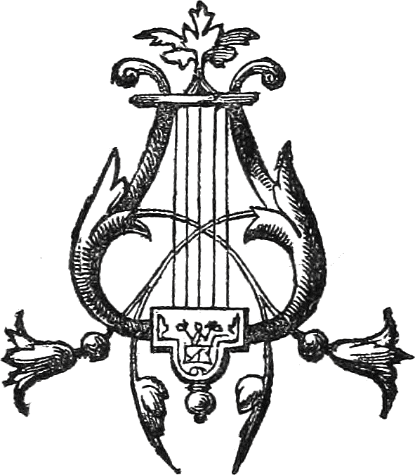

Satan’s Last Parochial Calls
I
Dark frowns are on his brow—
And shuddering in his heart;
He fears his kingdom now
Will speedily depart:—
Portentous signs marked in the sky,
Have warned the Tempter’s doom is nigh.
II
The darkening sun at noon,
Brought fear and trembling dread—
The falling stars and bloody moon
Pale consternation fed:—
Yet th’ quaking doomed-one, with his host,
Strives to arouse with empty boast.
III
And so hell’s deeps resound
With the “grizzly terror’s” voice;
And the legions to be bound
Fiendish and grim rejoice!
But their sinning hearts are seared and dry,
For they know their torment time is nigh!
IV
“Up, Beelzebub! Lucifer! Chieftains of hell!
You princes of strength, to the ‘field!’
For six thousand years we have ruled the ‘world’ well,
And now shall we passively yield?
V
“Has the ‘time’ of our ‘torment’ arrived so soon?
Has the earth already waxed old?
No! no! in Time’s day ‘tis only just noon,
As we earthly subjects have told!
VI
“For ages to come, in our millennium,
We’ll till our parsonage farm!
(Aside—Yet, I tremblingly fear, this is the last year—
In secret I am in alarm!)
VII
“And in great wrath I’ll down on the earth,
And work all my engines with fury;
For, surely, long yet on my throne shall I sit,
Undoomed by the Judgment’s Grand Jury.”
VIII
Thus in his destroying, as eager as ever,
He seeks his ancient domain—
Proclaims to his subjects—submit he will never!
But o’er earthly kingdoms will reign!
IX
Lo, the chief in high places his mission he takes—
Breathes a thought that works like a spell
Of sweet peace and safety, an opiate, makes
Men quaff it—on earth proudly dwell!
X
“How fair is the world—its colors how bright!
Our tabernacle here let us build!
For Time’s golden age is dawning in light—
Soon with glory the earth will be filled!
XI
“Mechanics, machinery, and every art,
Their maximum soon will attain;
The thought that these things are soon to depart,
Is foolish, nonsensical, vain!
XII
“How flames the red torch of each chariot car!
As it rages in thundering tone,—
See! ‘they run like the lightning,’ and speed them afar,
Raging,—and gleaming,—and gone!
XIII
“Yes, Earth, you have goods for many a year
Laid up in rich bountiful store!
‘Eat, drink, and be merry,’ have never a fear,
The Judge is not yet at the door!
XIV
“For many are running ‘up and down’—to and fro,
And the knowledge does greatly increase:
That the Lord is at hand, we choose not to ‘know;’
Long yet may our churches have peace!”
XV
So speak the deluded, by tempter inspired
To prophesy out of the heart;
To conquer the world all Christendom’s fired:
By the world she is conquered in part!
XVI
Thus “the god of this world,” he covers the truth
With his lies and specious devices;
And each liege subject deems blindly, forsooth,
‘Tis another his master entices.
XVII
He well can deceive, and makes them believe
That the judgment is not surely nigh;
He tempts men to wrest the precious truth blest,
And swift to destruction they fly!
XVIII
His snare it is laid with the fowler’s tried skill,
And catches “both people and priest,”
Save those who would do only Jesus’ blest will,
Of the flock, the simplest and blest.
XIX
The Savior’s right hand is extended to save
These “little ones,” humble and meek;
And when to His care they tremblingly yield,
Thus to them He kindly does speak:—
XX
“Fear not, little flock, my Father’s good will
Is to give you the kingdom prepared;
In patience keep watching—all righteousness fill—
The kingdom shall shortly be shared.”
XXI
But the “spirits of devils,” that miracles make,
Adown on the earth gather now;
And the kingdoms from slumber affrighted awake,
For battle-clouds threaten upon the night’s brow!
XXII
Each minion of hell is abroad at his post,
For Satan in wrath has come down;
Already they’re making their Belshazzar boast
That the Lord on His people does frown.
XXIII
For contest they gather, with hearts hissing strife,
All they who love not the Lord;
But the tried and the faithful are watching for “life,”
And trustingly lean on His word.
XXIV
The tempter goes on his parochial way,
And gives to each hearer his portion;
He tells them, afar, very far, is God’s day,
So they worship the world with devotion.
XXV
Thus down on the earth he came in great wrath,
To work all his engines with fury;
He hoped that long yet on his throne he should set,
Undoomed by the Judgment’s Grand Jury.
XXVI
Yet the Judge from on high now stands at the door,
And Satan will shortly be bound;
His boasted long reign on the earth will be o’er,
When the trump of the Judgment shall sound!
XXVII
Behold it is past! the second woe’s past!
And the third woe quickly will come!
The hosts of the wicked are numbering fast,
And hastening now is their doom!
E. C. C.
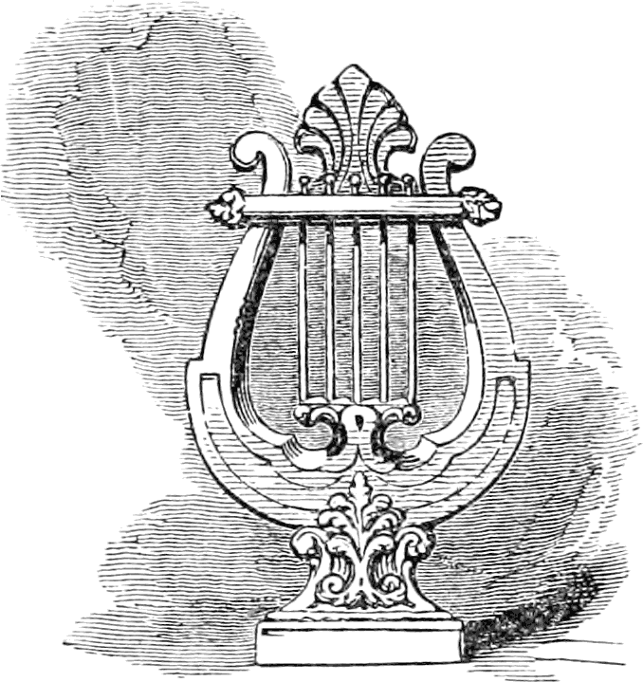

Although Himes, Bliss, and Hale published The Advent Shield, this particular article had a “B” at the end, so I assume it was written by Bliss.
The Mormons.
Zechariah 12:8.

