^{The} Sanctuary

The Center of Christ’s Work

O. R. L. Crosier
Source:
The Law of Moses
Day Star Extra (Cincinatti)
February 1846
Cover:
Orion Nebula
VISTA infrared survey telescope,
ESO Paranal Observatory, Chile
Credit: ESO/J. Emerson/VISTA

Fonts:
Corinthia
Bodoni MT Condensed
Linux Biolinum
Linux Libertine
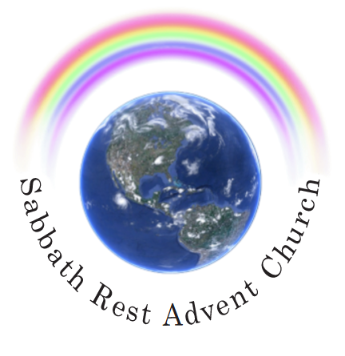

April 2023
practicaprophetica.com
srac.info

Contents
Endorsements i
Introduction iii
- The Law of Moses 1
- Legal Types and Antitypes 9
The Passover 9
The Feast of Unleavened Bread 11
First Fruits 11
The Feast of Weeks 12
- The Sanctuary 13
What is the Sanctuary? 13
The New Covenant Sanctuary 16
Casting Down the Sanctuary 18
Palestine Is Not the Sanctuary 19
A Resting Place for the Lord 22
- The Priesthood of Christ 25
The Melchizedek Priesthood 25
The Levitical Priesthood 26
Definition of Atonement 31
Daily Atonement 34
Yearly Atonement 35
- The Antitype 41
Two Apartments 42
Day of Final Atonement Not Fulfilled at the Cross 44
Forgiveness Cleanses the Person, Not the Sanctuary 46
- The Age to Come 51
- The Scape-Goat 63
- The Transition 69
Closing Salutation 77

Appendix A: Notice 78
Appendix B: A Further Letter 79
The Memorial of Trumpets 79
The Jubilee Trumpet 80
The Jubilee Year 81
The Feast of Tabernacles 82
A Meeting with O. R. L. Crosier 84

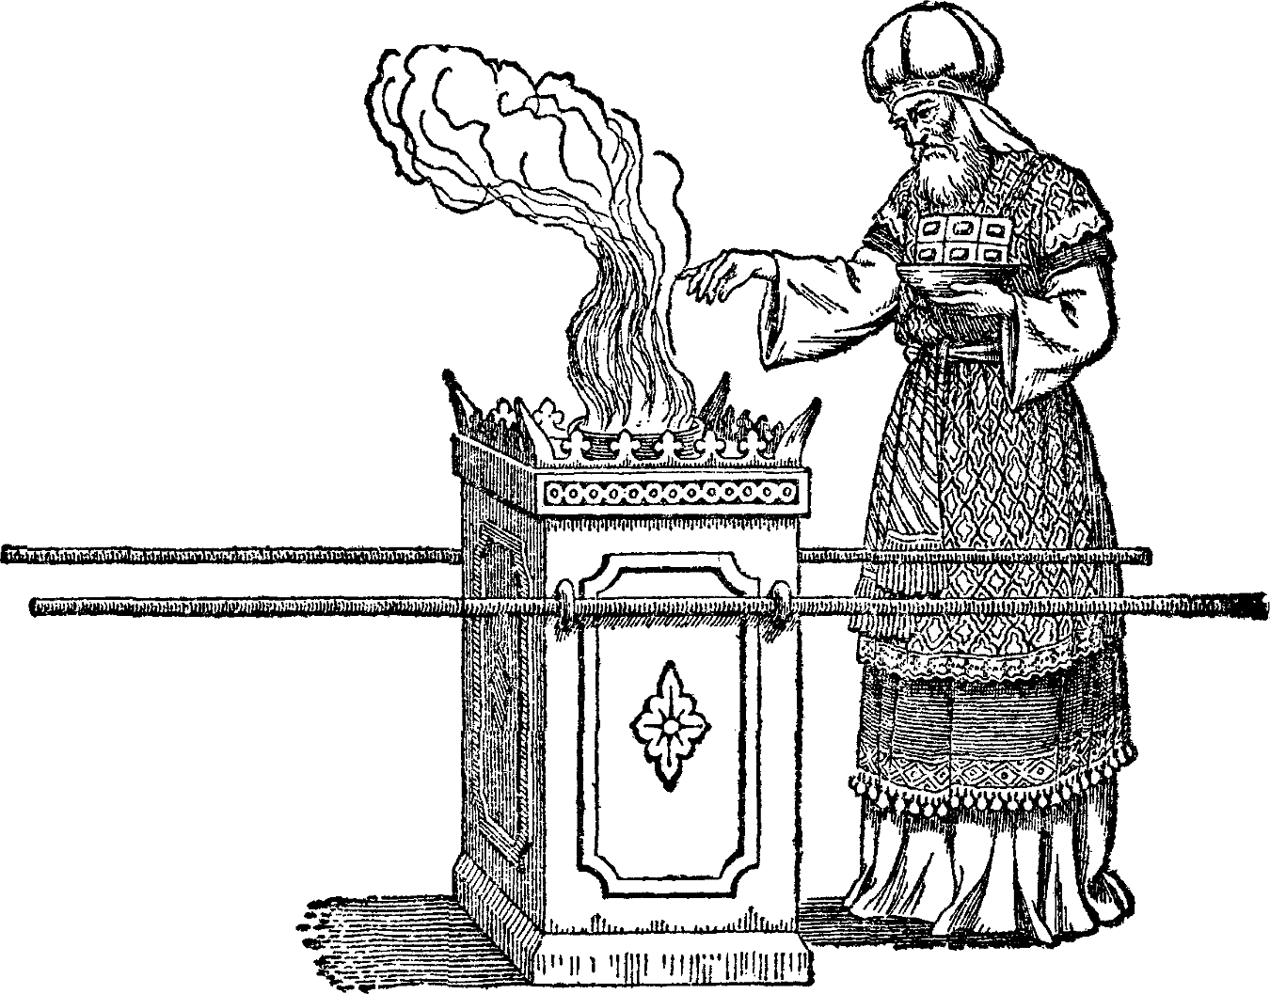

Endorsements
Ellen G. White
A Word to the Little Flock, p. 12
(from a Letter to Eli Curtis, April 21, 1847)
I BELIEVE the Sanctuary, to be cleansed at the end of the 2300 days, in the New Jerusalem Temple, of which Christ is a minister. The Lord showed me in vision, more than one year ago, that Brother Crosier had the true light, on the cleansing of the Sanctuary, etc; and that it was his will, that Brother Crosier should write out the view which he gave us in the Day-Star Extra, February 7, 1846. I feel fully authorized by the Lord, to recommend that Extra, to every saint.

Arthur L. White
The Ellen G. White Biography: Vol. 1 – The Early Years, p. 107-108
The Place of the Vision in Confirming the Sanctuary Truth
SIGNIFICANTLY, the Day-Star Extra dated February 7, 1846, had been devoted to the Bible study of Hiram Edson and O. R. L. Crosier in which they set forth from the Scriptures the evidence for the understanding that the two phases of ministry in the earthly sanctuary service were a type of Christ’s ministry in the heavenly sanctuary. Consequently, according to Edson and Crosier, events that were to come to pass, beginning on October 22, 1844, were events taking place in heaven.
The investigation supporting these conclusions had taken place at the Hiram Edson home in western New York state over a period of a number of months. The existence of this Bible study was unknown to Ellen Harmon when she was given the vision in Exeter in mid-February, 1845, nor had there been time for the February 7, 1846, issue of the Day-Star to reach her before she wrote of the vision for the readers of that journal. The vision, as published on March 14, gave unique confirmation to the conclusions of the Edson and Crosier Bible study.
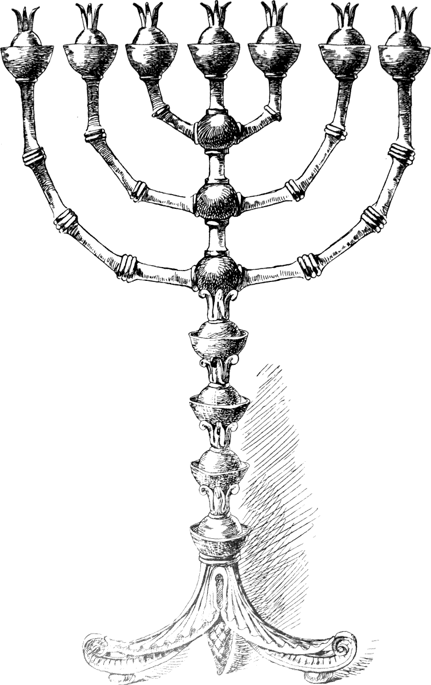

Introduction
THIS booklet is the substance of Crosier’s original Day-Star Extra publication from 1846, which was titled, The Law of Moses, and published in Cincinnati, Saturday, February 7, 1846. by O. R. L. Crosier.
In 1850, the article was republished in the Advent Review, under the title, The Sanctuary, but it only included the sections dealing with the Sanctuary in particular. For the sake of completeness, and also because the other chapters are also full of value and interest, I am including the whole original article in this publication.
It is remarkable how clearly Crosier grasped the antitypical fulfillments, and to what degree the correct understanding of the cleansing of the Heavenly Sanctuary, as a fulfillment of the 2300 day prophecy of Daniel 8:14 and the antitype of the Day of Atonement, helped to set all the other last-day events in their proper place and order.
The understanding of the Sanctuary in heaven, and what Christ was doing there, set apart the Sabbath-keeping Adventists from all other Christian bodies. It also opened up huge insights into the book of Revelation, which is full of “temple language.”
In this first publication on that topic, Crosier covers most of the essential truths, in a concise, yet thorough manner. For example, he covers:
- The parallel between the Old Testament Sanctuary services and the “pattern” or real Temple in heaven where Christ ministers.
- The division of that temple into Holy and Most Holy, and the significance of that division in the Heavenly Sanctuary.
- The seven basic feasts that distinguished the religious Year, and their antitypes.
- The difference between the forgiveness of sin from the sinner and the blotting out of sin from the sanctuary.
- The fact that the Day of Atonement was not fulfilled at the Cross.
- The Scapegoat transaction as a symbolic picture showing how sin will eventually be put back on its author, Satan.
Historical Background
The historical background of this document was as follows. The Adventists in America expected Christ to come in October 1844, according to the 2300-day (year) prophecy of Daniel 8:14, which ended at that time. This prophesy pointed to the “cleansing of the sanctuary,” which Miller, and some other Adventists, applied to the church. Miller stated:
“Then shall the sanctuary be cleansed or justified,” means the true sanctuary which God has built of lively stones to His own acceptance, through Christ, of which the temple at Jerusalem was but a type...and when that New Jerusalem is perfected, then shall we be cleansed and justified; for Paul says to the Philippians, 3:20-21, “For our conversation is in heaven; from whence also we look for the Saviour, the Lord Jesus Christ, who shall change our vile body, that it may be fashioned like unto His glorious body, according to the working whereby He is able to subdue all things to himself;” that is, “they that are His at His coming.” We see by these texts—and many more might be quoted—that the spiritual sanctuary will not be cleansed until Christ’s second coming; and then all Israel shall be raised, judged, and justified in His sight.
But the 22nd of October came and went, and the believers were severely disappointed. The prophecies, which were so clear and precise throughout history up until that point, seemed to have failed.
The next day, one Adventist, Hiram Edson of New York state, was walking out into his field to pray, when he had a vision of Christ in the temple in heaven. He suddenly realized that the “cleansing of the sanctuary” must have referred to the “sanctuary in heaven” as that was the antitype of the earthly sanctuary, and the focus of Christ’s work since the New Testament times. After Christ was resurrected, He began His work as High Priest in the sanctuary in heaven, and to there, the New Testament believers looked in faith, just as in the Old Testament times, they had looked to the earthly temple in the the earthly Jerusalem.
This was quite a breakthrough, and Edson and Crosier sat down and studied the matter out for a while, and in March of 1845, published their findings on the Sanctuary in a small paper that they had been using to share the Advent message. Apparently:
Mrs. Edson sold some of her silverware to finance the printing.
Later in February 1846, a more complete written article, titled “The Law of Moses” was published in the Cincinnati Day Star Extra. That is the substance of this current booklet.
A few years later, Crosier rejected this understanding and left the Sabbath-keeping Adventists. Much later, in 1899, he wrote a letter explaining his writings on these subjects, and claiming that the “sanctuary” teachings were only written…
“...to explain how and why the door of mercy was shut.”
This seems hard to believe, since the term “shut door” does not even occur in the main manuscript. There is much more to this study than simply an attempt to use the Sanctuary teaching to explain “why the door of mercy was shut.” That people can “shut the door of mercy” to themselves by hardening their heart towards the presentation of truth is nonetheless true, and was certainly the case on a worldwide extent in the time of Noah.
The Adventists who went through the Great Disappointment in 1844, wondered for a few months afterwards if there was any more work to do in warning the world, or if the time for mercy had indeed closed. But the light that came to them quickly clarified the issue. Along with the opening of the Sanctuary truth with all it’s implications, came a further responsibility to share these truths with all who would hear.
Using the terminology of Revelation 10, the Adventists had taken the “little book” of Daniel, that was unsealed and open, and had “eaten it.” It’s message, that the “sanctuary would be cleansed” was “in their mouth, sweet as honey,” as they thought it meant that Christ would soon appear. But when this failed to happen as they expected, it made their “belly bitter” with disappointment.
But as the Sanctuary truth unfolded, the real meaning of the “cleansing of the sanctuary” unfolded, and they had these new truths to proclaim, before Christ could return.
Revelation 10
10 And I took the little book out of the angel’s hand, and ate it up; and it was in my mouth sweet as honey: and as soon as I had eaten it, my belly was bitter.
11 And he said unto me, You must prophesy again before many peoples, and nations, and tongues, and kings.
The topic of this book is the beginning of the unfolding of that Sanctuary truth. May it sweeten your taste with the promise of Christ’s soon return.
Frank Zimmerman
practicaprophetica.com
- The Law of Moses
Malachi 4
4 Remember the Law of Moses, my servant, which I commanded unto him in Horeb for all Israel, with the statutes and judgments.
5 Behold, I will send you Elijah the prophet before the coming of the great and dreadful day of the Lord:
THE commandment of this verse to remember the law of Moses, is the last one in the Old Testament, and given in connection with a prophetic description of “the great and dreadful day of the Lord,” as though the law contained something further descriptive of that day. Perhaps we have paid too little attention to the law, not seeing its import and the light it was designed to shed on…
Hebrews 9 [also 10:1]
11 ...the good things to come.
Our Saviour and the apostles taught from Moses as well as the prophets,
Luke 24
27 ...the things concerning himself.
The Mosaic law is what Paul in Hebrews calls the “first covenant”:
Hebrews 8 [quoting Jeremiah 31:31-32]
7 For if that first covenant had been faultless, then should no place have been sought for the second.
8 ...I will make a new covenant with the house of Israel and with the house of Judah:
9 Not according to the covenant that I made with their fathers in the day when I took them by the hand to lead them out of the land of Egypt…
1 Kings 8
9 There was nothing in the ark save the two tables of stone, which Moses put there at Horeb, when the Lord made a covenant with the children of Israel, when they came out of the land of Egypt.
This was not the covenant of promise made with Abraham, nor does it at all affect that. The covenant of promise made to Abraham and his seed, Christ, was confirmed 430 years before the Law was given, and…
Galatians 3
15 ...no man disannulls or adds thereto.
17 And this I say, That the covenant that was confirmed before of God in Christ, the Law, which was four hundred and thirty years after, cannot disannul, that it should make the promise of God of none effect;
The inheritance is not of the Law, but of promise:
18 For if the inheritance be of the law, it is no more of promise: but God gave it to Abraham by promise.
Hence righteousness comes not by the Law, but by faith in the promises.
19 Wherefore then serves the law? It was added because of transgressions, till the seed should come to whom the promise was made.
In the day that...
Genesis 15
6 [Abraham] believed the Lord, and He counted it to him for righteousness,
–the Lord made a covenant with him saying,
18 Unto your seed have I given this land, from the river of Egypt unto the great river, the river Euphrates;
At the same time He assured him of the 400 years afflictions, at the end of which He delivered Israel from Egypt, and gave them the Law, which He called a covenant, in Horeb, near Sinai.
2 Chronicles 5
10 There was nothing in the ark save the two tables which Moses put therein at Horeb, when the Lord made a covenant with the children of Israel, when they came out of Egypt.
Exodus 24
3 And Moses came and told the people all the words of the Lord, and all the judgments: and all the people answered with one voice, and said, All the words which the Lord has said will we do.
4 And Moses wrote all the words of the Lord, and rose up early in the morning, and built an altar under the hill, and twelve pillars, according to the twelve tribes of Israel.
5 And he sent young men of the children of Israel, which offered burnt offerings, and sacrificed peace offerings of oxen unto the Lord.
6 And Moses took half of the blood, and put it in basons; and half of the blood he sprinkled on the altar.
7 And he took the book of the covenant, and read in the audience of the people: and they said, All that the Lord has said will we do, and be obedient.
8 And Moses took the blood, and sprinkled it on the people, and said, Behold the blood of the covenant, which the Lord has made with you concerning all these words.
Exodus 34
27 And the Lord said unto Moses, Write these words: for after the tenor of these words I have made a covenant with you and with Israel.
28 And he was there with the Lord forty days and forty nights; he did neither eat bread, nor drink water. And he wrote upon the tables the words of the covenant, the ten commandments.
Deuteronomy 5
1 And Moses called all Israel, and said unto them, Hear, O Israel, the statutes and judgments which I speak in your ears this day, that you may learn them, and keep, and do them.
2 The Lord our God made a covenant with us in Horeb.
3 The Lord made not this covenant with our fathers, but with us, even us, who are all of us here alive this day.
This covenant was to continue only…
Galatians 3
19 ...till the seed [Christ] should come;
–then “a new covenant” was made:
Isaiah 42
1 Behold my servant, whom I uphold; my elect, in whom my soul delights; I have put my spirit upon Him: He shall bring forth judgment to the Gentiles.
6 I the Lord have called you in righteousness, and will hold your hand, and will keep you, and give you for a covenant of the people, for a light of the Gentiles;
Isaiah 49
5 And now, says the Lord that formed me from the womb to be his servant, to bring Jacob again to him, Though Israel be not gathered, yet shall I be glorious in the eyes of the Lord, and my God shall be my strength.
6 And He said, It is a light thing that you should be my servant to raise up the tribes of Jacob, and to restore the preserved of Israel: I will also give you for a light to the Gentiles, that you may be my salvation unto the end of the earth.
7 Thus says the Lord, the Redeemer of Israel, and His Holy One, to him whom man despises, to him whom the nation abhors, to a servant of rulers, Kings shall see and arise, princes also shall worship, because of the Lord that is faithful, and the Holy One of Israel, and He shall choose you.
8 Thus says the Lord, In an acceptable time have I heard you, and in a day of salvation have I helped you: and I will preserve you, and give you for a covenant of the people, to establish the earth, to cause to inherit the desolate heritages;
9 That you may say to the prisoners, Go forth; to them that are in darkness, Show yourselves. They shall feed in the ways, and their pastures shall be in all high places.
He confirmed the [margin: a] covenant, the new one:
Daniel 9
27 And He shall confirm the covenant with many for one week: and in the midst of the week He shall cause the sacrifice and the oblation to cease.
This covenant was the Gospel:
Mark 1
14 Now after that John was put in prison, Jesus came into Galilee, preaching the gospel of the kingdom of God,
15 And saying, The time is fulfilled, and the kingdom of God is at hand: repent, and believe the gospel.
Matthew 4
23 And Jesus went about all Galilee, teaching in their synagogues, and preaching the gospel of the kingdom, and healing all manner of sickness and all manner of disease among the people.
Galatians 4
24 These are the two covenants…
...and neither of them the Abrahamic, but both involved in that in its comprehensive sense. Paul contrasts these two covenants, calling the latter the “better covenant,” the “perfect;” whereas the former,
Hebrews 7
19 ...the Law, made nothing perfect;
–but only had “a figure,” “patterns,”
Hebrews 10
1 ...a shadow of the good things to come,
Colossians 2
17 ...but the body, [the substances of those legal shadows,] is of Christ.
The Law should be studied and “remembered” as a simplified model of the great system of redemption, containing symbolic representations of the work begun by our Saviour at His first advent, when He came “to fulfill” the Law. And this work is to be completed in:
Ephesians 1
14 The redemption of the purchased possession, unto the praise of His glory.
Redemption is deliverance purchased by the payment of a ransom, hence it cannot be complete till man and the earth shall be delivered from the subjection and consequences of sin; the last act of deliverance will be at the end of the 1000 years. To this the shadow of the Law extended.
That the significance of the Law reaches beyond the first advent is evident from these considerations:
- The cleansing of the Sanctuary formed a part of the legal service, and its antitype was not to be cleansed till the end of the 2300 days:
Daniel 8
14 And he said unto me, Unto two thousand and three hundred days; then shall the sanctuary be cleansed.
- The Sabbaths under the Law typify the great Sabbath, the seventh millennium.
- The Jubilee typifies the release and return to their possessions of all captive Israel, this cannot be fulfilled till the resurrection of the just.
- The autumnal types were none of them fulfilled at the first advent.
- The legal tenth day atonement was not, neither could it be fulfilled at that time.
Although He…
Colossians 2
14 Blotted out the handwriting of ordinances that was against us, which was contrary to us, and took it out of the way, nailing it to His cross;
–yet, after His resurrection, both He and His apostles made use of the law in proof of His Messiahship. He was buried and arose, and shed down the Holy Ghost in direct fulfillment of the types, which would not have been the case if the significance of the law had terminated at the cross. In fact His anointing and crucifixion were only the beginning of its fulfillment, as being the beginning of that great system of redemption whose shadows were contained in the law.
All will admit that some of the types have been fulfilled and that others have not. As they are yet to be fulfilled, it becomes us to remember and study the law to learn their nature and import.
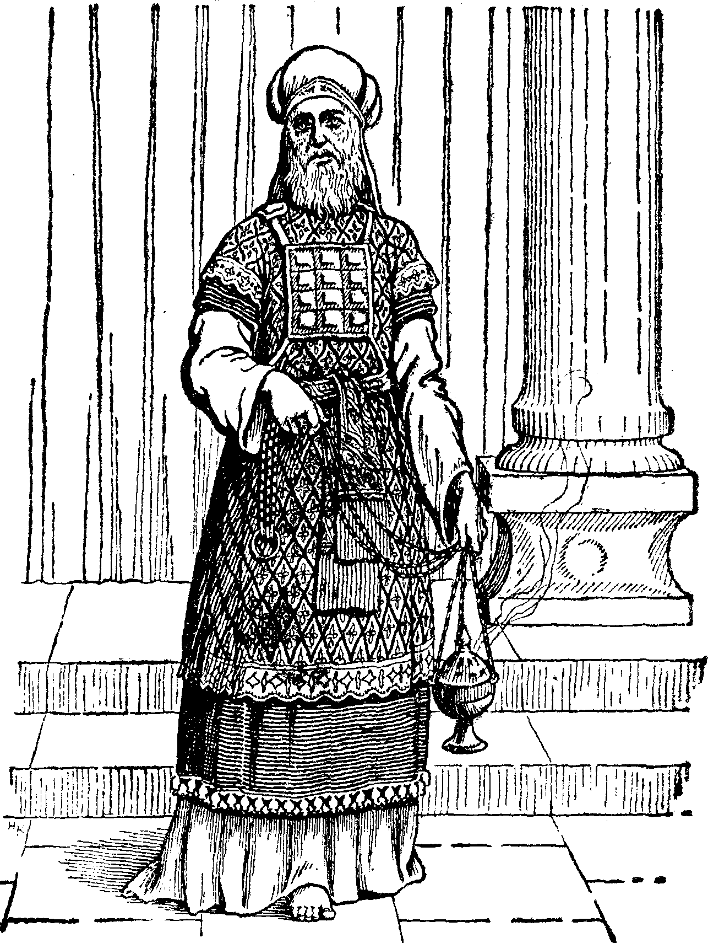
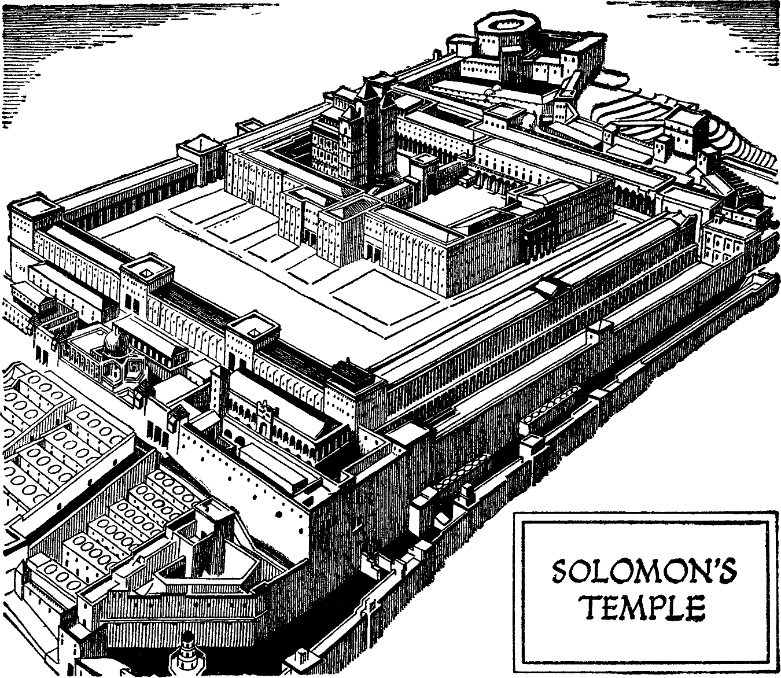
- Legal Types and Antitypes
THAT some of the legal types have met their antitypes is beyond controversy. By learning the manner of their fulfillment, and the principle as to time on which they are fulfilled; we can the more understandingly proceed to the investigation of the other types.
There are two classes of yearly feasts:
- The Vernal, and
- The Autumnal.
The former met their antitypes at the first Advent, but the latter are to be fulfilled in connection with and after the second Advent. The vernal types were:
Feast | Time
The Passover | 14th Day of the First Month
The Feast of Unleavened Bread | 15th to 22nd Day of the First Month
Waving of the First Fruits | 16th Day of the First Month
Feast of Weeks, or Pentecost | 50 Days after the Third Feast
Our Saviour was scrupulously precise in commencing their fulfillment at the very times they were respectively observed under the Law, as the brethren have repeatedly shown. But we have evidently erred in circumscribing the latitude of their fulfillment, they being fulfilled during the Gospel Dispensation.

The Passover
1 Corinthians 15
3 For I delivered unto you first of all, that which I also received, how that Christ died for our sins according to the scriptures.
1 Corinthians 5
7 Christ our Passover is sacrificed for us.
Paul considered it of the first importance to deliver unto us the fact that Christ died for our sins in fulfillment of the slaying of the Paschal lamb. This he received from the law, though the law nowhere says the words that His crucifixion should be the antitype of slaying the Paschal lamb; yet so clear was the fulfillment, that it furnished unanswerable proof that Jesus was the Messiah.
The Jews could not lay hands on Him till His hour had come, then, being…
Isaiah 53
7 ...brought as a lamb to the slaughter,
He expired, “our Passover,” in the very month, day, and hour, of slaying the legal Passover. It is ascertained that the Paschal antitype began at the crucifixion; but where must it end? Let the Saviour answer:
Luke 22
15 And He said unto them, With desire I have desired to eat this Passover with you before I suffer;
16 For I say unto you, I will not any more eat thereof, until it be fulfilled in the kingdom of God.
17 And He took the cup and gave thanks, and said, Take this, and divide it among yourselves:
18 For I say unto you, I will not drink of the fruit of the vine, until the kingdom of God shall come.
The Paschal feast must be “fulfilled in the kingdom of God,” which, according to verse 18, was then, and is yet to “come.” The Paschal antitype is not finished. The Lord instituted His Supper for the New Covenant in place of the Paschal feast of old, and as oft as we do it we show forth His death till He comes. One extreme of the Paschal antitype is His death, and the other His second coming, hence it spans and is fulfilled during the Gospel Dispensation.

The Feast of Unleavened Bread
In the antitype, this feast appears to run parallel with the Paschal antitype.
1 Corinthians 5
7 Purge out therefore, the old leaven that you may be a new lump, as you are unleavened. For even Christ our Passover is sacrificed for us.
8 Therefore let us keep the feast, not with old leaven neither with the leaven of malice and wickedness; but with the unleavened bread of sincerity and truth.
The type was carnal, the bread made of grains, the antitype spiritual, the bread is truth, the Word of God received in sincerity. The bitter herbs with which it was eaten seem fitly to typify the afflictive trials of Christians in this state.
As they began on the 14th at the Passover to eat unleavened bread and bitter herbs, so the afflictive trials of the church began when the…
Zechariah 13
7 ...Shepherd was smitten and the sheep scattered.
But they will end, and the Bible be superseded,
1 Peter 5
4 When the chief Shepherd shall appear,
–and gather the “flock of slaughter” with joy to our beloved Zion.

First Fruits
This was a handful of the first ripe fruit or grain.
1 Corinthians 15
4 And that He was buried, and that He rose again the third day according to the scriptures:
20 But now is Christ risen from the dead, and become the firstfruits of them that slept.
23 But every man in his own order: Christ the firstfruits; afterward they that are Christ’s at His coming.
Acts 26
23 That Christ should suffer, and that He should be the first that should rise from the dead, and should show light unto the people, and to the Gentiles.
It showed that Christ “rose again the third day according to the scriptures,” “the first fruits of them that slept,” thus laying the foundation of the resurrection to life. The fruits appear to be connected with...

The Feast of Weeks
At this feast, two loaves of the new flour baked with leaven were waved before the Lord.
Acts 2
1 When the day of Pentecost was fully come...
–the Holy Ghost, the principle of life, came upon the disciples. This, which is the only thing recorded as the antitype of the feast of weeks, is to abide with the church till it shall quicken the bodies of the saints…
1 Corinthians 15
23 ...at His coming.
It must now appear evident that the vernal antitypes having begun with the opening of the Gospel Dispensation will close with its close.
From analogy we must conclude that the autumnal antitypes will occupy a period of time relative to that occupied by their types in somewhat the proportion of the vernal antitypes. In other words, the period of their fulfillment must constitute a dispensation of many years.

- The Sanctuary
THE Sanctuary was the heart of the typical system. There the Lord placed His name, manifested His glory, and held converse with the High Priest relative to the welfare of Israel. While we inquire from the Scriptures what the Sanctuary is, let all educational prejudice be dismissed from the mind. For the Bible clearly defines what the Sanctuary is, and answers every reasonable question you may ask concerning it.
The name, Sanctuary, is applied to several different things in the Old Testament, neither did the Wonderful Numberer tell Daniel what Sanctuary was to be cleansed at the end of the 2300 days, but called it the Sanctuary, as though Daniel well understood it. And that he did, is evident from the fact that he did not ask what it was.
But as it has now become a matter of dispute as to what the Sanctuary is, our only safety lies in seeking from the New Testament, the Divine comment upon it. Its decision should place the matter beyond all controversy with Christians.

What is the Sanctuary?
Paul freely discusses this subject in the Epistle to the Hebrews, to whom the typical covenant pertained.
Hebrews 9
1 Then verily the first covenant had also ordinances of divine service, and a worldly sanctuary.
2 For there was a tabernacle made; the first, wherein was the candlestick, and the table, and the shewbread; which is called the sanctuary [or Hagia, “holy”].
3 And after the second veil, the tabernacle which is called the [Hagia Hagion] Holiest of all;
4 Which had the golden censer, and the ark of the covenant overlaid round about with gold, wherein was the golden pot that had manna, and Aaron’s rod that budded, and the tables of the covenant;
5 And over it the cherubims of glory shadowing the mercy-seat; of which we cannot now speak particularly.
A particular description is found in the last four books of the Pentateuch. “Sanctuary” was the first name the Lord gave it:
Exodus 25
8 And let them make me a sanctuary; that I may dwell among them.
This name covers not only the tabernacle with its two apartments, but also the court and all the vessels of the ministry. This Paul calls the Sanctuary of the first covenant…
Hebrews 9
9 ...which was a figure for the time then present, in which were offered both gifts and sacrifices.
11 But Christ being come a High Priest of good things to come by a greater and more perfect tabernacle, not made with hands;
The priests entered the “figures” or “patterns of the true.” It is manifest that both Moses and David had prophetic visions of the New Jerusalem with its Sanctuary and Christ, as the officiating Priest:
- Moses received the patterns of the Sanctuary, built at Sinai when he was with the Lord forty days in the cloud on the Mount; and
- David received the patterns of that built by Solomon, which superseded Moses’ with its chambers, porches, courts, the courses of the priests and Levites, and all the vessels of service, etc., “by the Spirit;”
1 Chronicles 28
10 Take heed now; for the Lord has chosen you to build a house for the sanctuary: be strong, and do it.
11 Then David gave to Solomon his son the pattern of the porch, and of the houses, and of the treasuries, and of the upper chambers, and of the inner parlors, and of the place of the mercy seat,
12 And the pattern of all that he had by the spirit, of the courts of the house of the Lord, and of all the chambers round about, of the treasuries of the house of God, and of the treasuries of the dedicated things:
13 Also for the courses of the priests and the Levites, and for all the work of the service of the house of the Lord, and for all the vessels of service in the house of the Lord.
When that built by Moses was superseded by Solomon’s, the Ark was borne from the former to the latter. Solomon’s temple had shared in the seventy years desolation of Jerusalem. Daniel prayed...
Daniel 9
17 Cause your face to shine upon your Sanctuary that is desolate.
This was the typical Sanctuary built by Solomon. It was rebuilt after the captivity:
Nehemiah 10
39 For the children of Israel and the children of Levi shall bring the offering of the corn, of the new wine, and the oil, unto the chambers, where are the vessels of the sanctuary, and the priests that minister, and the porters, and the singers: and we will not forsake the house of our God.
The Sanctuary comprehended not only the Tabernacle, but also all the vessels of the ministry, enclosed by the court in which the tabernacle stood. So the court in which the Temple stood was properly called the Sanctuary. We learn the same from:
2 Chronicles 29
18 We have cleansed all the house of the Lord, and the altar of burnt-offering, with all the vessels thereof, and the shew-bread table with all the vessels thereof.
21 And they brought seven bullocks, and seven rams, and seven lambs, and seven he goats, for a sin offering for the kingdom, and for the sanctuary, and for Judah.
The altar of burnt-offering with its vessels stood before the Temple in the inner court, the whole of which are called “the sanctuary.”

The New Covenant Sanctuary
The “true” sanctuary, of which the earthly was a pattern, are the “heavenly places themselves,” into which Christ entered when He entered “heaven itself.” When He ascended to the right hand of the Father, “in the heavens,” He became…
Hebrews 8
2 A minister of the Sanctuary [or Hagion, Holies] and of the true tabernacle, which the Lord pitched and not man.
That is the Sanctuary of the…
6 ...better [the new] covenant.
The Sanctuary to be cleansed at the end of 2300 days is also the Sanctuary of the new covenant, for the vision of the treading down and cleansing, is after the crucifixion.
We see that the Sanctuary of the new covenant is not on earth, but in heaven. The true tabernacle which forms a part of the new covenant Sanctuary, was made and pitched by the Lord, in contradistinction to that of the first covenant which was made and pitched by man, in obedience to the command of God.
Now what does the same apostle say the Lord has pitched?
Hebrews 11
10 A city which has foundations whose builder and maker is God;
What is its name?
Hebrews 12
22 The heavenly Jerusalem;
Revelation 21
2 And I John saw the holy city, new Jerusalem, coming down from God out of heaven, prepared as a bride adorned for her husband.
2 Corinthians 5
1 A building of God, a house not made with hands eternal in the heavens;
John 14
2 My Father’s house of many mansions;
When our Saviour was at Jerusalem, and had pronounced its house desolate, the disciples came to Him to show Him the buildings of the temple. Then He said:
Matthew 24
1 There shall not be left here one stone upon another that shall not be thrown down:
That temple was their Sanctuary, which had been built by men:
1 Chronicles 22
19 Arise therefore, and build the sanctuary of the Lord God, to bring the ark of the covenant of the Lord, and the holy vessels of God, into the house that is to be built to the name of the Lord.
Such an announcement, that their Sanctuary would be torn down, would tend to fill them with sadness and fear, as foretelling the derangement, if not the total prostration of their entire religious system. But to comfort and teach them, He says,
John 14
2 In my Father’s house are many mansions.
Standing, as He was, on the dividing line between the typical covenant and the anti-typical, and having just declared the house of the former no longer valid, and foretold its destruction, how natural that He should point His disciples to the Sanctuary of the latter, about which their affections and interests were to cluster, as they had about that of the former.
The Sanctuary of the new covenant is connected with New Jerusalem, like the Sanctuary of the first covenant was with Old Jerusalem. As that was the place where the priests of that covenant ministered, so this is in heaven, the place where the Priest of the new covenant ministers. To these places, and these only, the New Testament applies the name “Sanctuary,” and it does appear that this should forever set the question at rest.

Casting Down the Sanctuary
The vision of Daniel concerned the Sanctuary:
Daniel 8
11 And the place of His Sanctuary was cast down;
This casting down was in the days and by the means of the Roman power; therefore, the Sanctuary of this text was not the Earth, nor Palestine, because the former was cast down at the fall, more than 4,000 years, and the latter at the captivity, more than 700 years previous to the event of this passage, and neither by Roman agency.
The Sanctuary cast down is His against whom Rome magnified itself, which was the Prince of the host, Jesus Christ. And Paul teaches that His Sanctuary is in heaven. Again,
Daniel 11
30 For the ships of Chittim shall come against him; therefore, shall he be grieved and return, and have indignation [the staff to chastise] against the holy covenant [Christianity], so shall he do; he shall even return and have intelligence with them [priests and bishops] that forsake the holy covenant.
31 And arms [civil and religious] shall stand on his part, and they [Rome and those that forsake the holy covenant] shall pollute the Sanctuary of strength.
What was this that Rome and the leaders of Christianity should jointly pollute? This combination was formed against the “holy covenant,” and it was the Sanctuary of that covenant they polluted; which they could do as well as to pollute the name of God. This was the same as profaning or blaspheming His name.
In this sense this “politico-religious” beast polluted the Sanctuary, and cast it down from its place in heaven, when they called Rome the holy city, and installed the Pope there with the titles, “Lord God the Pope,” “Holy Father,” “Head of the Church,” etc., and there, in the counterfeit, “temple of God,” he professes to do what Jesus actually does in His Sanctuary. The Sanctuary has been trodden under foot, the same as the Son of God has.

Palestine Is Not the Sanctuary
But as we have been so long and industriously taught to look to the earth for the Sanctuary, it may be proper to inquire, by what Scriptural authority have we been thus taught? I can find none. If others can, let them produce it.
Let it be remembered that the definition of Sanctuary is “a holy or sacred place.” Is the earth, is Palestine such a place? Their entire contents answer, No! Well, says one, is not Palestine called the Sanctuary? I think not.
Exodus 15
17 You shall bring them in and plant them in the mountain of your inheritance, in the place, O Lord, which You have made for yourself to dwell in; in the Sanctuary, O Lord, which your hands have established.
What is it which the Lord “has made to dwell in,” which His “hands have established”? Paul says it is…
Hebrews 11
10 ...a city;
Hebrews 8
2 ...a Tabernacle;
2 Corinthians 5
1 ...a building in the heavens.
And the Lord has chosen Mount Zion in Palestine for the place of its final location:
Psalm 132
13 For the Lord has chosen Zion; He has desired it for His habitation.
14 This is my rest forever; here will I dwell; for I have desired it.
Psalm 78
54 He brought them to the border of the Sanctuary, even to this mountain.
This was its chosen border or place; but it was not called the Sanctuary itself, any more than Mount Moriah, on which the Temple was built, was called the Temple itself. Did they regard that land as the Sanctuary? If they did not, we should not. A view of the text in which the word occurs will show:
Exodus 25
8 ...let them make me a Sanctuary...
Exodus 30
13 ...the shekel of the Sanctuary...
There are above twenty others like it.
Exodus 36
1 Then wrought Bezaleel and Aholiab, and every wise-hearted man, in whom the Lord put wisdom and understanding to know how to work all manner of work for the service of the Sanctuary.
Leviticus 4
6 ...before the vail of the Sanctuary.
Leviticus 10
4 ...carry your brethren from before the Sanctuary...
Leviticus 12
4 ...nor come into the Sanctuary...
Leviticus 16
33 ...he shall make atonement for the tabernacle...
Leviticus 19
30 ...reverence my Sanctuary...
Leviticus 21
12 ...nor profane the Sanctuary of his God...
Numbers 3
31 ...the vessels of the Sanctuary...
32 ...the charge of the Sanctuary...
Numbers 4
12 ...they minister in the Sanctuary…
15 And when Aaron and his sons have made an end of covering the Sanctuary and all the vessels of the Sanctuary, as the camp is to set forward; after that the sons of Kohath shall come to bear it.
16 ...in the Sanctuary, and the vessels thereof.
Numbers 8
19 That there be no plague among the children of Israel when the children of Israel come nigh unto the Sanctuary.
Numbers 18
1 You and your sons and your Father’s house with you shall bear the iniquity of the Sanctuary.
Numbers 19
20 ...he has defiled the Sanctuary of his God...
Joshua 24
26 [Joshua] took a great stone and set it up there under an oak that was by the Sanctuary of the Lord.
1 Chronicles 9
29 ...all the instruments of the Sanctuary...
1 Chronicles 22
19 ...build the Sanctuary...
1 Chronicles 24
5 ...governors of the Sanctuary...
1 Chronicles 28
10 The Lord has chosen you to build a house for the Sanctuary.
2 Chronicles 26
18 ...go out of the Sanctuary...
2 Chronicles 30
19 ...the purification of the Sanctuary.
I have given nearly every text, and, I believe, every different form of expression in which the word occurs till we come to the Psalms, so that every one can see what they understood the Sanctuary to be. And of the fifty texts quoted, not one applies it to the land of Palestine, nor any land.

A Resting Place for the Lord
That Sanctuary, though enclosed with curtains, was called “the house of the Lord,” and was pitched at the city of Shiloh at the time of dividing the land. Hence it was called the…
Psalm 78
60 ...Tabernacle of Shiloh [safety and happiness].
The Lord forsook it when the Philistines took the ark and delivered His strength into captivity, and His glory into the enemy’s hand. The ark came back to Beth-shemesh, and was shortly after brought back to Kirjath-jearim, in the care of the house of Abinadab.
David’s first attempt to move the ark was cut short, and it was carried to the house of Obed-edom. Afterwards it was brought to the city of David which is Zion.
At the direction of Solomon, the Ark was conveyed into the Holy of Holies of the temple, which was built in Mount Moriah near Mount Zion.
The Lord has chosen Zion to dwell in rest forever, but as yet He had dwelt there but a short time, and then in curtains made with hands. But when He shall appear in His glory He will have “mercy on Zion” and build it up; then Jerusalem upon it, shall be:
Isaiah 33
20 ...a quiet habitation, a tabernacle that shall not be taken down.
And then…
Isaiah 30
19 The people shall dwell in Zion at Jerusalem.
The Song of Moses is evidently prophetic, and contemplates the happy scenes of the Eden Zion. And so Ezekiel has it. The Lord will bring the whole house of Israel up out of their graves into the land of Israel; and then set His Sanctuary and tabernacle in the midst of them for evermore.
The Sanctuary is not “the land of Israel” nor the people; for it is set in their midst, and is built and forms a part of the city whose name is,
Ezekiel 48
35 The Lord is there.

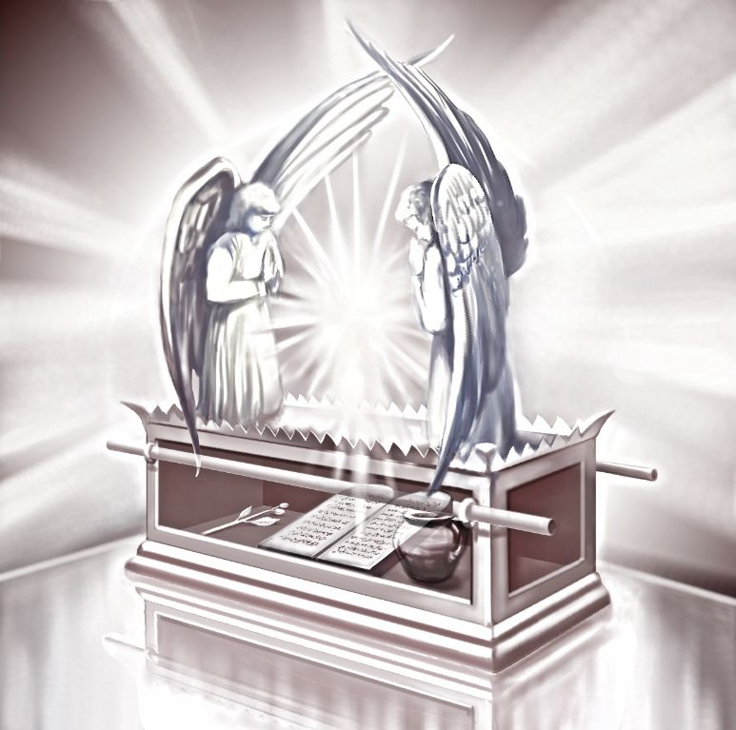
- The Priesthood of Christ
THE priesthood of the worldly Sanctuary of the first covenant belonged to the sons of Levi; but that of the heavenly, of the better covenant, to the Son of God. He fulfills both the Priesthood of Melchizedek and Aaron. In some respects the Priesthood of Christ resembles that of Melchizedek; and in others that of Aaron or Levi.

The Melchizedek Priesthood
- He was “made a High Priest forever, after the order of Melchizedek.”
Order: taxis, signifies “series, succession.”
Christ, like Melchizedek, had no priestly descent of pedigree. He never followed nor will have a successor in office. And “because He continues ever, has an unchangeable Priesthood,” “which passes not from one to another.” The Priesthood of Levi to be continuous had many and a succession of priests, “because they were not suffered to continue by reason of death.”
- Being after the order of Melchizedek, He is superior to the sons of Levi; because He blessed and received tithes from them in Abraham.
- He is King and Priest; a King by birth, being from the tribe of Judah, and a Priest by the oath of His Father.
- Being himself perfect, and His priesthood unending, He is able to “perfect forever” and “save them to the uttermost that come unto God by Him, seeing He ever lives to make intercession for them.”

The Levitical Priesthood
He was not called after the order of Aaron; i.e. not in his succession; but this does not at all prove that the Priesthood of Aaron was not typical of the Priesthood of Christ. Paul distinctly shows that it is. After calling upon us to...
Hebrews 3
1 ...consider the Apostle and High Priest of our profession [or religion], Christ Jesus,
–he lays the foundation of the investigation by drawing the analogy between Moses over his house [oikos, “people”] and Christ over His. He says,
Hebrews 3
5 Moses verily was faithful in all his house, as a servant, for a testimony of those things which were to be spoken after.
This clearly shows that the Mosaic economy was typical of the divine. He shows that Christ was called of God to be a High Priest…
Hebrews 5
4 ...as was Aaron.
Like Aaron and his sons, He took upon Him flesh and blood, the seed of Abraham,
Hebrews 4
15 ...was in all points tempted like as we are, yet without sin,
Hebrews 2
10 ...[was made] perfect through suffering,
17 [And] in all things it behooved Him to be made like unto His brethren; that He might be a merciful and faithful High Priest in things pertaining to God, to make reconciliation for the sins of the people.
Both were…
Hebrews 5 [also Hebrews 8:3]
1 ...ordained for men in things pertaining to God: that (they might) offer both gifts and sacrifices for sins.
Paul evidently considered the Levitical priesthood typical of Christ’s from the pains he takes to explain the analogies and contrasts between them.

Priests Die, Christ Lives
Hebrews 7
23 And they truly were many priests, because they were not suffered to continue by reason of death:
24 But this Man, because He continues ever, has an unchangeable priesthood.

Daily Offerings, One Offering
27 Who needs not daily, as those high priests to offer up sacrifices, first for His own sins, and then for the people’s; for this He did once when He offered up himself.

Infirmity, Perfection
28 For the law makes men high priests which have infirmity; but the word of the oath which was since the law, makes the Son who is consecrated [margin: perfected] for evermore.

Old Covenant, New Covenant
Hebrews 8
6 But now has He obtained a more excellent ministry [than theirs], by how much also He is the mediator of a better covenant [than theirs].

Old Tabernacle, New Tabernacle
Hebrews 9
11 But Christ being come a High Priest of good things to come, by a greater and more perfect tabernacle [than theirs].

Blood of Animals, Blood of Christ
12 Neither by the blood of goats and calves, but by His own blood, He entered in once into the holy place.
13 For if the blood of bulls and of goats and the ashes of a heifer sprinkling the unclean sanctifies to the purifying of the flesh;
14 How much more shall the blood of Christ, who, through the eternal spirit offered himself without spot to God purge your conscience.

Made with Hands, Made by God
24 For Christ is not entered into the holy places made with hands, which are the figures of the true; but into heaven itself.

Repeated Sacrifices, One Sacrifice
25 Nor yet that He should offer himself often, as the high priest enters into the holy place every year with blood of others;
26 But now once in the end of the world has He appeared to put away sin by the sacrifice of himself.

Subject to Sin, Without Sin
27 And as it is appointed unto [the] men [priests] once to die, but after this the judgment:
28 So Christ was once offered to bear the sins of many; and unto them that look for Him shall He appear the second time without sin unto salvation.

A Shadow, The Reality
Hebrews 10
1 For the law having a shadow of good things to come, and not the very image of the things can never with those sacrifices which they offered year by year continually, make the comers thereunto perfect;
14 But by one offering He has perfected forever them that are sanctified.

Bulls and Goats, Christ in Humanity
4 It is not possible that the blood of bulls and of goats should take away sins;
5 ...but a body have You prepared me.
These are a part of the contrasts or comparisons the Apostle draws between the Levitical priesthood and Christ’s, and there is a resemblance in every instance, but Christ’s is superior to Levi’s. I add one more:

Earthly Service, Heavenly Service
Hebrews 8
4 For if He were on earth He should not be a priest, seeing that there [many, they] are priests that offer gifts according to the law:
5 Who serve unto the example and shadow of heavenly things.
The features of the substance always bear a resemblance to those of the shadow, hence the “heavenly things” referred to in this text must be priestly service “in the heavens” performed by our High Priest in His Sanctuary; for if the shadow is service, the substance is service also.
As the priests of the law served unto the example and shadow of the heavenly service we can from their service learn something of the nature of the heavenly service.
Hebrews 8
5 Moses was admonished of God when he was about to make the tabernacle; for, See, says He, that you make all things according to the pattern shown to you in the Mount.
None can deny that, in obedience to this admonition, Moses made or instituted the Levitical priesthood; it was then “according to the pattern” which the Lord showed him, and that pattern was of heavenly things. If there was not another text to prove that the Levitical priesthood was typical of the Divine, this would abundantly do it.
Yet some are even denying this obvious import of the priesthood; but if this is not its import, I can see no meaning in it. It is an idle round of ceremonies without sense or use, as it did not perfect those for whom it was performed.
But looked upon as typical of the heavenly, it is replete with the most important instruction. As this is the application made of it by the New Testament, so we must regard it, while we examine the atonement made under the Levitical priesthood.
Hebrews 9
6 Now when these things [the worldly Sanctuary with its two apartments and the furniture in each] were thus ordained, the priests went always [daily – Hebrews 7:27, 10:11] into the first tabernacle, accomplishing the service of God.
7 But into the second went the high priest alone once every year, not without blood, which he offered for himself, and for the errors of the people.
Here Paul divides the services of the Levitical priesthood into two classes:
- One daily in the Holy, and
- The other yearly in the Holy of Holies.
Their stated daily services, performed in the Holy and at the brazen altar in the court before the tabernacle, consisted of a burnt-offering of two lambs, one in the morning and the other at even, with a meat-offering which was one tenth of an ephah of flour mingled with the fourth part of an hin of beaten oil, and a drink-offering which was one-fourth of an hin of strong wine. The meat-offering was burnt with the lamb, and the drink-offering was poured in the Holy.
In connection with this, they burned on the golden altar in the Holy, sweet incense, which was a very rich perfume, when they dressed and lighted the lamps every evening and morning. The same was afterwards done at the Temple.
This did not atone for sins either individually or collectively. The daily service described was a sort of continual intercession; but the making of atonement was a special work for which special directions are given. Different words are used both in the Old Testament and New, to express the same idea as At-one-ment.

Definition of Atonement
The italicized words are, in the text, synonymous with atone or atonement.
Exodus 29
36 You shall cleanse the altar when you have made an atonement for it.
Leviticus 12
8 The priest shall make an atonement for her and she shall be clean.
Leviticus 14
2 This shall be the law of the leper in the day of his cleansing.
21 The priest shall make an atonement for him and he shall be clean.
The atonement could not be made for him till after he was healed of the leprosy. Till he was healed, he had to dwell alone without the camp.
Leviticus 14
3 The priest shall go forth out of the camp; and the priest shall look, and behold if the plague of the leprosy be healed in the leper;
4 Then shall the priest command to take for him that is to be cleansed two birds alive and clean...
The law was the same in cleansing a house from the leprosy. The stones affected with the plague were removed and the house “scraped within round about” and then repaired with new material. Physical uncleanness is now all removed and we would call it clean; but not so; it is only just prepared to be cleansed according to the law.
Leviticus 8
15 And Moses took the blood, and put it upon the horns of the altar round about with his fingers and purified the altar, and poured the blood at the bottom of the altar, and sanctified it, to make reconciliation upon it.
Leviticus 14
49 And he shall take to cleanse the house two birds...
52 And he shall cleanse the house with the blood of the bird...
53 ...and make an atonement for the house, and it shall be clean.
Leviticus 16
18 And he shall go out unto the altar that is before the Lord, and make an atonement for it.
19 And he shall sprinkle of the blood upon it with his finger seven times, and cleanse it and hallow it from the uncleanness of the children of Israel.
2 Chronicles 29
24 And the priests killed them, and they made reconciliation with their blood upon the altar, to make an atonement for all Israel...
Jeremiah 33
8 I will cleanse them from all their iniquities...and I will pardon all their iniquities.
Acts 3
19 Be converted that your sins may be blotted out.
Romans 5
9 ...being now justified by His blood…
11 ...by whom we have now received the atonement.
2 Corinthians 5
18 ...who has reconciled us to himself by Jesus Christ...
Ephesians 1
7 In whom we have redemption through His blood, the forgiveness of our sins.
Ephesians 2
16 And that He might reconcile both unto God...
Hebrews 9
13 The blood of bulls sanctifies to the purifying of the flesh; but the blood of Christ shall purge our conscience from dead works.
14 [He is the Mediator for the] redemption of the transgressions, [and to] perfect forever them that are sanctified.
Hebrews 10
14 For by one offering He has perfected for ever them that are sanctified.
From these texts we learn that the words atone, cleanse, reconcile, purify, purge, pardon, sanctify, hallow, forgive, justify, redeem, blot out, and some others, are used to signify, the same work: bringing into favor with God. And in all cases blood is the means, and sometimes blood and water.
The atonement is the great idea of the Law, as well as the Gospel; and as the design of that of the Law was to teach us that of the Gospel, it is very important to be understood.
The atonement which the priest made for the people in connection with their daily ministration was different from that made on the tenth day of the seventh month:
- In making the former, they went no further than in the Holy; but to make the latter they entered the Holy of Holies.
- The former was made for individual cases, the latter for the whole nation of Israel collectively.
- The former was made for the forgiveness of sins, the latter for blotting them out.
- The former could be made at any time, the latter only on the tenth day of the seventh month.
Hence the former may be called the daily atonement and the latter the yearly, or the former the individual, and the latter the national atonement.

Daily Atonement
The individual atonement for the forgiveness of sins was made for a single person, or for the whole congregation in case they were collectively guilty of some sin.
- The 1st chapter of Leviticus gives directions for the burnt-offering;
- The 2nd for the meat-offering;
- The 3rd for the peace-offering; and
- The 4th for the sin-offering, which, as its name implies, was an offering for sins, in which he who offered it attained forgiveness of his sins;
- The trespass-offering was similar to the sin-offering:
Leviticus 4
2 If a soul sin through ignorance...
Leviticus 5
3 ...when he knows of it, then shall he be guilty,
5 And it shall be when he shall be guilty in any of these things, that he shall confess that he has sinned in that thing.
From Numbers 5:6-8, it appears that confession and restitution are necessary in all cases before the atonement could be made for the individual.
Numbers 5
6 When a man or woman shall commit any sin that man commit, to do a trespass against the Lord, and that person be guilty,
7 Then they shall confess their sin which they have done, and he shall recompense his trespass with the principle thereof, and add unto it the fifth part thereof, and give it unto him against whom he has trespassed.
Then he or the elders (if it was for the congregation) brought the victim for the sin or trespass-offering to the door of the tabernacle of the congregation on the north side of the altar of burnt-offering in the court. There he (or the elders) laid his hand on its head and killed it.
Then, the victim being presented and slain, the priest that was anointed took some of the blood into the Holy, and with his finger sprinkled it before the veil of the Sanctuary and put some of it upon the horns of the altar of incense, then poured the remainder of the blood at the bottom of the altar. Thus he made an atonement for the individual, and his sin was forgiven. The carcasses of the sin-offering were taken without the camp and burned “in a clean place.”
It should be distinctly remembered that the priest did not begin his duties till he obtained the blood of the victim, and that they were all performed in the court (the enclosure of the Sanctuary), and that the atonement thus made was only for the forgiveness of sins.
These points are expressly taught in this chapter and the following one on the trespass-offering. Here is an atonement, to make which, the priests only entered the Holy, and to make it they could enter that apartment “always” or “daily.”

Yearly Atonement
Hebrews 9
7 But into the second [the Holy of Holies] went the high priest alone once every year, not without blood, which he offered for himself, and for the errors of the people [laos, nation].
This defines the yearly to be the National Atonement, of which the Lord “speaks particularly” in:
Leviticus 16
2 And the Lord said unto Moses, speak unto Aaron, your brother, that he come not at all times into the holy place within the veil, before the mercy-seat, which is upon the ark; that he die not: for I will appear in the cloud upon the mercy-seat.
For what purpose and when could he enter it?
34 To make an atonement for all Israel [the whole nation], for all their sins once a year
29 ...on the tenth day of the seventh month...
This was the most important day of the year. The whole nation having had their sins previously forgiven by the atonement made in the Holy, now assemble about their Sanctuary, while the High Priest:
- attired in his holy garments for glory and beauty,
- having the golden bells on the hem of his robe that his sound may be heard when he goes in before the Lord,
- the breast-plate of judgment on his heart, with their names therein that he may bear their judgment, also in it the Urim and Thummim (light and perfection), and the plate of pure gold,
- the holy crown, with “HOLINESS TO THE LORD” engraved upon it, placed upon the fore-front of his mitre that he may bear the iniquities of the holy things,
...enters the Holy of Holies to make an atonement to cleanse them, that they may be clean from all their sins before the Lord.
The victims for the atonement of this day were:
- for the priest himself, a young bullock for a sin-offering, and
- for the people, two goats:
  - one for a sin-offering, and
  - the other for the scape-goat, and
  - a ram for a burnt-offering.
He killed or caused to be killed the bullock for a sin-offering for himself.
Leviticus 16
12 Then he shall take a censer full of burning coals of fire from off the altar before the Lord, and his hands full of sweet incense beaten small, and bringing it within the veil;
13 And he shall put the incense upon the fire before the Lord, that the cloud of the incense may cover the mercy-seat that is upon the testimony that he die not.
14 And he shall take of the blood of the bullock, and sprinkle it with his finger upon the mercy-seat eastward; and before the mercy-seat shall he sprinkle of the blood with his finger seven times.
So much in preparation to make an atonement for the people; a description of which follows:
Leviticus 16
15 Then shall he kill the goat of the sin-offering which is for the people and leaving [bring] his blood within the veil, and do with that blood as he did with the blood of the bullock, and sprinkle it upon the mercy-seat.
16 And he shall make an atonement for [cleanse, see marginal references] the holy place [within the veil, verse 2], because of the uncleanness of the children of Israel, because of their transgressions in all their sins: and so shall he do for [i.e. atone for, or cleanse] the tabernacle of the congregation [the Holy] that remains among them in the midst of their uncleanness.
18 And he shall go out [of the Holy of Holies] unto the altar that is before the Lord [in the Holy] and make an atonement for it; and shall take of the blood [for himself], and of the blood of the goat [for the people], and put it upon the horns of the altar round about.
19 And he shall sprinkle of the blood upon it with his finger seven times, and cleanse it, and hallow it from the uncleanness of the children of Israel.
The altar was the golden altar of incense in the Holy upon which the blood of individual atonements was sprinkled during the daily ministration. Thus it received the uncleanness from which it is now cleansed.
Exodus 30
10 Aaron shall make an atonement upon the horns of it once a year, with the blood of the sin-offering of atonement.
At this stage of the work…
Leviticus 16
20 ...he has made an end of reconciling the holy place, and the tabernacle of the congregation, and the altar...
In other words, the Holy of Holies, the Holy, and the altar in the latter. We have before seen that atone, reconcile, cleanse, etc., signify the same, hence at this stage he has made an end of cleansing those places.
As the blood of atonements for the forgiveness of sins was not sprinkled in the court, but in the tabernacle only, the entire work of cleansing the Sanctuary was performed within the tabernacle. These were holy things, yet cleansed yearly.
The holy place within the veil contained the ark of the covenant, covered with the mercy-seat, overshadowed by the cherubims, between which the Lord dwelt in the cloud of divine glory. Who would think of calling such a place unclean? Yet the Lord provided at the time, yea, before it was built, that it should be annually cleansed. It was by blood, and not by fire, that this Sanctuary, which was a type of the new covenant Sanctuary was cleansed. The high priest on this day…
Exodus 28
38 ...bore the iniquities of the holy things which the children of Israel hallowed in all their holy gifts.
These holy things composed the Sanctuary.
Numbers 18
1 And the Lord said unto Aaron, You, and your sons, and your father’s house with you shall bear the iniquity of the Sanctuary.
This “iniquity of the Sanctuary” we have learned was not its own properly, but the children of Israel’s, God’s own people’s, which it had received from them.
And this transfer of iniquity from the people to their Sanctuary was not a mere casualty, incident on scenes of lawless rebellion, bloodshed or idolatry among themselves, not the devastation of an enemy. But it was according to the original arrangement and regular operation of this typical system. For we must bear in mind that all the instructions were given to Moses and Aaron before the erection of the Sanctuary.
Provision was made to make atonement for sins committed in ignorance; but not till after they were known. Then of course they became sins of knowledge. Then the individual bore his iniquity, till he presented his offering to the priest and slew it, the priest made an atonement with the blood, and he was forgiven, then of course free from his iniquity.
Now at what point did he cease to bear his iniquity? Evidently when he had presented his victim slain; he had then done his part. Through what medium was his iniquity conveyed to the Sanctuary? Through his victim, or rather its blood when the priest took and sprinkled it before the veil and on the altar. Thus the iniquity was communicated to their Sanctuary.
The first thing done for the people on the tenth day of the seventh month was to cleanse the Sanctuary itself, thence by the same means, the application of blood. This done, the high priest bore the…
Numbers 18
1 ...iniquity of the Sanctuary [for the people]…
Leviticus 10
17 ...to make atonement for them.
Leviticus 16
20 And when he has made an end of reconciling the holy place [within the veil, verse 2] and the tabernacle of the congregation and the altar [or when he has cleansed the Sanctuary], he shall bring the live goat:
21 And Aaron shall lay both his hands upon the head of the live goat, and confess over him all the iniquities of the children of Israel, and all their transgressions and all their sins, putting them upon the head of the goat, and shall send him away by the hand of a fit man into the wilderness:
22 And the goat shall bear upon him all their iniquities into a land not inhabited [margin, of separation].
This was the only office of the scape-goat, to finally receive and bear away from Israel all their iniquities into an uninhabited wilderness and there retain them, leaving Israel at their Sanctuary, and the priest to complete the atonement of the day by burning the fat of the sin-offerings, and offering the two rams for burnt-offerings on the brazen altar in the court.
The burning without the camp of the carcasses of the sin-offerings closed the services of this important day.

- The Antitype
AS THIS legal system which we have been considering was only a “shadow,” a “figure” and “patterns” of no value in itself only to teach us the nature of that perfect system of redemption which is its “body,” the “things themselves”; which was devised in the councils of heaven, and is being wrought out by “the only Begotten of the Father”; let us, guided by the Spirit of truth, learn the solemn realities thus shadowed forth.
By these patterns, finite as we are, we may like Paul, extend our research beyond the limits of our natural vision to the “heavenly things” themselves. Here we find the entire ministry of the law fulfilled in Christ, who was anointed with the Holy Ghost and by His own blood entered His Sanctuary, heaven itself, when He ascended to the right hand of the throne of the Majesty in the heavens, as…
Hebrews 8
2 A minister of the [Hagion] Holies…
Paul, after speaking of the daily services in the Holy, and the yearly in the Holy of Holies, says,
Hebrews 9
8 The Holy Ghost this signifying that the way of the Holies (Hodon Hagion) was not yet made manifest; while as the first tabernacle was yet standing:
9 Which was a figure for the time then present, in which were offered…
10 ...until the time of reformation:
11 But Christ being come, a High Priest of the [ton] good things to come, by a greater and more perfect tabernacle, not made with hands…
12 ...by His own blood He entered on or into the holy things [eis hagia]...
The phrase, eis hagia (verse 12), is the same as that rendered “holy places” (verse 24). Hagia, in these two verses, is in the acc. pl. neuter and governed by the prep. eis which signifies on, into, upon, or among. Hagia, being a neuter adjective, is properly rendered “holy things.” But Hagia (verse 2), is in the nom. sin. fem. and properly rendered, “Holy place.” The definite article “the,” belonging before “good things” (verse 11 and Hebrews 10:1) makes the expression mean things “good in themselves, or abstractly good.”
This shows the perfect harmony of Hebrews 9:11-12, 23-24 and Hebrews 10:1. The “things” are “good in themselves,” “holy,” or “heavenly,” and in “heaven itself,” where Christ has entered as our High Priest to “minister” for us. And those “holy things” “in heaven” are connected with the “greater and more perfect tabernacle,” “which the Lord pitched and not man”; the same as the holy things of the first covenant were connected with their tabernacle. And all those holy things together make the Sanctuary.

Two Apartments
The Holies (two, verse 8), the way of which was not made manifest till the time of reformation, when Christ shed His own blood, belong to His “greater and more perfect tabernacle,” spoken of in the next verse.
I translate the names literal, because they are not literal in our common version. The Douay Bible has them as here given. The word in Hebrews 9:8, 10, 19, is Hagion, “of the Holies,” instead of the “holiest of all”; and shows that the blood of Christ is the way or means by which He, as our High Priest was to enter both apartments of the heavenly tabernacle.
Now if there be but one place in the heavens, as many say, why were there two in the figure? And why, in applying the figure, does Paul speak of two? Perhaps those who “despise the law” and “corrupt the covenant of Levi” can explain this. If not, we advise them to abide by Paul’s exposition of the matter.
Hebrews 6:19-20, is supposed to prove that Christ entered the Holy of Holies at His ascension, because Paul said He had entered within the veil. But the veil which divides between the Holy and the Holy of Holies is “the second veil.” Hence there are two veils, and that in Hebrews 6, being the first of which he speaks, must be the first veil, which hung before the Holy, and in Exodus was called a curtain.
When He entered within the veil, He entered His tabernacle, of course the Holy, as that was the first apartment; and our hope, as an anchor of the soul, enters within the veil, i.e., the atonement of both apartments, including both the forgiveness and the blotting out of sins.
Those who hold that Christ entered the Holy of Holies at His ascension, and has been ministering therein ever since, also believe, as of course they must, that the atonement of the Gospel Dispensation is the antitype of the atonement made on the tenth day of the seventh month under the law.
If this is so, the events of the legal tenth day, have had their antitypes during the Gospel Dispensation. The first event in the atonement service of that day, was the cleansing of the Sanctuary, as we have seen from Leviticus 16. Then, upon their theory, the Sanctuary of the new covenant was cleansed in the early part of the Gospel Dispensation.
Evidence is not wanting that neither the earth nor Palestine, their Sanctuaries, was then cleansed. I call them “their Sanctuaries,” for they are not the Lord’s. But if the Lord’s new covenant Sanctuary was then cleansed, the 2300 days ended then. But if they are years, which we all believe, they extend 1810 years beyond the 70 weeks, and the last of those weeks was the first of the new covenant or Gospel Dispensation.
The fact that those days reach 1810 beyond the 70 weeks, and that the Sanctuary could not be cleansed till the end of those days, is demonstration that the antitype of the legal tenth day is not the Gospel Dispensation; but a period following that Dispensation.

Day of Final Atonement Not Fulfilled at the Cross
Again, if the atonement of that day is typical of the atonement of the Gospel Dispensation, then the atonement made in the Holy, Hebrews 9:6, previous to that day, was finished before the Gospel Dispensation began. It has been shown that that atonement was made for the forgiveness of sins, and I have found no evidence that such an atonement was made on the tenth day of the seventh month.
The Gospel Dispensation began with the preaching of Christ, and if it is the antitype of the legal tenth day, one of the two things is true:
- Either the Saviour, instead of fulfilling, has destroyed the greater part of the law, the daily service of the Holy which occupied the whole year except one day, the tenth of the seventh month;
- Or else He fulfilled the whole law except one three hundred and sixtieth part of it before the Gospel Dispensation began, and before He was anointed as the Messiah to fulfill the law and the prophets.
One of these two conclusions is inevitable on the hypotheses that the Gospel Dispensation and the atonement made in it, is the antitype of the legal tenth day, and the atonement made in it. Upon which of these horns will they hang?
If on the former, the declaration, “Think not that I am come to destroy the law, or the prophets” pierces them.
But if they choose the latter, it then becomes them to prove that the law, which had a shadow of good things to come, was fulfilled within itself, that the shadow and substance filled the same place and time. Also they will need to prove that the entire atonement for the forgiveness of sins was made before the Lamb was slain with whose blood the atonement was to be made.
Now it must be clear to every one, that if the antitype of the yearly service, began at the first Advent, the antitype of the daily, had been previously fulfilled; and, as the atonement for forgiveness was a part of that daily service, they are involved in the conclusion that there has been no forgiveness of sins under the Gospel Dispensation. Such a theory is wholly at war with the entire genius of the Gospel Dispensation, and stands rebuked, not only by Moses and Paul, but by the teaching and works of our Saviour and His commission to His apostles, by their subsequent teaching and the history of the Christian church.
But again, they say the atonement was made and finished on Calvary, when the Lamb of God expired. So men have taught us, and so the churches and world believe. But it is none the more true or sacred on that account, if unsupported by Divine authority. Perhaps few or none who hold that opinion have ever tested the foundation on which it rests.
- If the atonement was made on Calvary, by whom was it made? The making of the atonement is the work of a Priest? but who officiated on Calvary? Roman soldiers and wicked Jews.
- The slaying of the victim was not making the atonement: the sinner slew the victim, after that the Priest took the blood and made the atonement.
- Christ was the appointed High Priest to make the atonement, and He certainly could not have acted in that capacity till after His resurrection, and we have no record of His doing anything on earth after His resurrection, which could be called the atonement.
- The atonement was made in the Sanctuary, but Calvary was not such a place.
- He could not make the atonement while on earth:
Hebrews 8
4 If He were on earth, He should not be a Priest.
The Levitical was the earthly priesthood, the Divine, the heavenly.
- Therefore, He did not begin the work of making the atonement, whatever the nature of that work may be, till after His ascension, when by His own blood He entered His heavenly Sanctuary for us.

Forgiveness Cleanses the Person, Not the Sanctuary
Let us now examine a few texts that appear to speak of the atonement as passed.
Romans 5
11 By whom we have now received the atonement [margin, reconciliation].
This passage clearly shows a present possession of the atonement at that time the apostle wrote; but it by no means proves that the entire atonement was then in the past.
When the Saviour was about to be taken up from His apostles,
Acts 1
4 He commanded them that they should not depart from Jerusalem, but wait for the promise of the Father,
–which came on the day of Pentecost when they were all…
5 ...baptized with the Holy Ghost.
Christ had entered His Father’s house, the Sanctuary, as High Priest, and began His intercession for His people by “praying the Father” for “another Comforter,” “and having received of the Father the promise of the Holy Ghost,” He shed it down upon His waiting apostles. Then, in compliance with their commission, Peter, at the third hour of the day began to preach,
Acts 2
38 Repent, and be baptized every one of you in the name of Jesus Christ, for the remission of sins.
This word remission, signifies forgiveness, pardon or more literally sending away of sins. Now put by the side of this text another on this point from his discourse at the ninth hour of the same day:
Acts 3
19 Repent therefore; and be converted that your sins may be blotted out when the times of refreshing shall come from the presence of the Lord.
Here he exhorts to repentance and conversion (turning away from sins); for what purpose?
“That your sins may be [future] blotted out.”
Every one can see that the blotting out of sins does not take place at repentance and conversion; but follows, and must of necessity be preceded by them. Repentance, conversion, and baptism had then become imperative duties in the present tense; and when performed, those doing them “washed away,” remitted, or sent away from them their sins, and of course are forgiven and have “received the atonement.” But they had not received it entire at that time, because their sins were not yet blotted out.
How far then had they advanced in the reconciling process? Just so far as the individual under the law had when he had confessed his sin, brought his victim to the door of the tabernacle, laid his hand upon it and slain it, and the priest had with its blood entered the Holy and sprinkled it before the veil and upon the altar and thus made an atonement for him, and he was forgiven.
Only that was the type, and this the reality. That prepared for the cleansing of the great day of atonement, this for the blotting out of sins,
Acts 3
19 ...when the times of refreshing shall come from the presence of the Lord, and He shall send Jesus.
Hence,
Romans 5
11 ...by whom we have now received the atonement,
–is the same as “by whom we have received forgiveness of sin.” At this point the man is...
Romans 6
18 ...made free from sin.
The Lamb on Calvary’s cross is our victim slain;
Hebrews 12
24 Jesus the Mediator of the new Covenant,
Hebrews 9
23 ...in the heavens,
–is our interceding High Priest, making atonement with His own blood, by and with which He entered there. The essence of the process is the same as in the “shadow”:
- Conviction of sin;
- Repentance and Confession;
- Present the Divine sacrifice bleeding.
This being done in faith and sincerity, we can do no more, and no more is required. Then, in the heavenly Sanctuary our High Priest with His own blood makes the atonement and we are forgiven.
1 Peter 2
24 Who His own self bore our sins in His own body on the tree.
His body is the “one sacrifice” for repenting mortals, to which their sins are imputed, and through whose blood in the hands of an active Priest they are conveyed to the heavenly Sanctuary. That was offered “once for all,” “on the tree”; and all who would avail themselves of its merits must through faith, there receive it as theirs, bleeding at the hands of sinful mortals like themselves.
After thus obtaining the atonement of forgiveness we must…
Titus 3
8 ...maintain good works,
–not the...
Romans 3
20 ...deeds of the law;
–but,
1 Peter 2
24 ...being dead to sins, should live unto righteousness.
Romans 5
11 Likewise reckon yourselves to be dead indeed unto sin, but alive unto God through Jesus Christ our Lord.
13 Neither yield your members as instruments of unrighteousness unto sin: but yield yourselves unto God, as those that are alive from the dead, and your members as instruments of righteousness unto God.
This work we all understand to be peculiar to the Gospel Dispensation.

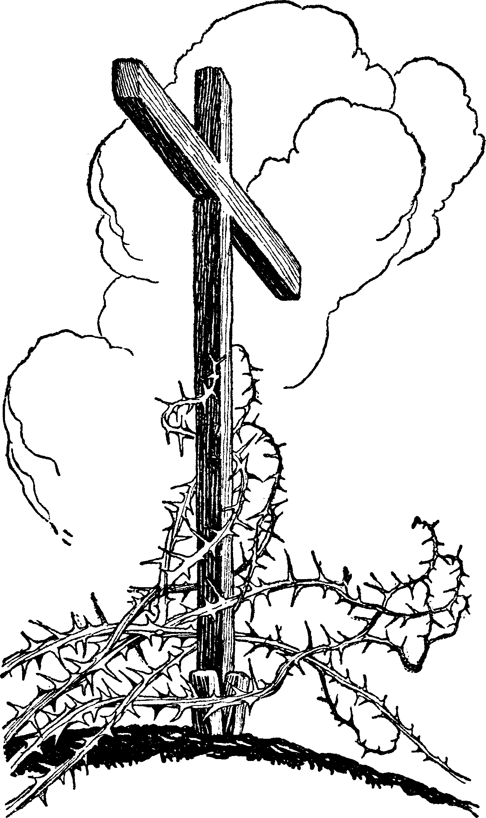
- The Age to Come
ALL believers in the Bible expect a glorious age to follow the present, and entertain some ideas of its nature which they profess to have drawn from the Bible.
The churches think the Bible teaches the final triumph of Christian principles in the conversion of all nations; while we believe that the glories of that age will be ushered in by the personal and visible Advent of Jesus, the resurrection and change of His saints and the destruction of His enemies.
Hence all admit our license to inquire and speak the nature of that age, and certainly we have liberty to learn what the scriptures say on the subject.
Luke 20
34 And Jesus answering said unto them, The children of this world [age] marry and are given in marriage;
35 But they which shall be accounted worthy to obtain that world [age] and the resurrection from the dead, neither marry nor are given in marriage.
“That world” is placed in contrast with “this world”—in “this” they marry and are given in marriage, in “that” they shall do neither; but are exempt from death and are like the angels. Thus He teaches a future and peculiar age, to enjoy which we must also obtain the resurrection from the dead. It will be an age of rewards,
Luke 14
14 ...you shall be recompensed at the resurrection of the just.
15 ...Blessed is he that shall eat bread in the Kingdom of God.
Matthew 19
28 Verily, I say unto you, That you which have followed me in the regeneration, when the Son of Man shall sit in the throne of His glory, you also shall sit upon twelve thrones judging the twelve tribes of Israel.
Matthew 6
9 Our Father who is in heaven, Hallowed be your name.
10 Your kingdom come. Your will be done in earth, as it is in heaven.
Our Father’s Kingdom for which we now pray will then have come, when His will be done on earth as it is in heaven. It will be...
2 Peter 3
7 The day of judgment and perdition of ungodly men...
10 The day of the Lord...in the which the heavens shall pass away with a great noise, and the elements shall melt with fervent heat, the earth also and the works that are therein shall be burned up.
12 The day of God, wherein the heavens being on fire shall be dissolved, and the elements shall melt with fervent heat.
13 Nevertheless we, according to His promise, look for new heavens and a new earth, wherein dwells righteousness.
This identifies “the world to come” with…
Acts 3
21 ...the times of restitution.
Restitution: apokalastasix, restoration of any thing to its former state.
Hence, the introduction of a new and better era: and…
Acts 3
19 ...the times of refreshing:
Refreshing: anapsuxis, refreshing coolness after heat, recreation, rest.
The identity of “the times of restitution” with “the Dispensation of the fullness of times,” is also apparent. As Peter in Acts 3:19 presents the two cardinal points in the atonement: conversion present, and blotting out of sins future; so Paul in Ephesians says:
Ephesians 1
7 In whom we have redemption through His blood, the forgiveness of sins…
13 ...in whom also after that you believed, you were sealed with that holy Spirit of promise,
14 Which is the earnest of our inheritance until the redemption of the purchased possession…
9 Having made known unto us the mystery of His will...
10 That in the dispensation of the fullness of times He might gather together in one all things in [or by] Christ, both which are in heaven, and which are on earth; even in Him.
This gathering is the future object of hope, the same as the redemption [deliverance procured by the payment of a ransom] of the purchased possession. The things to be gathered are in heaven and earth.
Gathered: anakephalaioo, signifies to bring or reduce back again under one head.
That is, the different and sundered parts of the Kingdom, Capitol and King “in heaven,” the subjects and territory “on the earth,” are to be redeemed or gathered again into one kingdom under one “Head,” of the Son of David.
And the Dispensation of the fullness of times is the period in which it is to be done. This is the period of inheritance and follows that “of heirship,” the dispensation of grace. In it the promises of the covenants in their largest sense will be inherited.
We think it has been shown that the atonement of the Gospel dispensation is the antitype of that made by the priests in their daily service, and that prepared for and made necessary the yearly atonement, and cleansed the Sanctuary and the people from all their sins.
It appears like certainty that the antitypes of the daily ministration of the priests and the vernal types stretch through the Gospel Dispensation; as that composed but part of the atonement and antitypes. We have good reason to believe that the remaining antitype, the autumnal, and the remainder of the atonement, the yearly, will be fulfilled on the same principle as to time and occupy a period or dispensation of at least 1000 years.
“That age” will be highly exalted above “this age,” and form the stepping-stone to the unmingled fadeless and eternal glories of the earth redeemed and Edenized again.
Who can find fault, if the Lord has given us in the law the shadows of that age? Who will not rather seek the Spirit of Truth which shall...
John 14
26 ...bring all things to your remembrance,
–even...
Malachi 4
4 ...the Law of Moses,
–and...
John 16
13 ...show us things to come,
–even...
Hebrews 10
1 ...the good things to come.
It will be literally an age of repairs, in which immortal saints will engage under the supervision of the King of kings—an age of restitution, of blotting out of sin with all its direful effects, the age for the redemption of the purchased possession, the grand and final Jubilee, in which all the captives of Zion in and out of the grave, being released and gathered from among the heathen and out of all countries, shall be cleansed from all their iniquities, posses their “own land,” and the wastes shall be built.
Isaiah 58
12 And they that shall be of you shall build the old waste places: you shall raise up the foundations of many generations; and you shall be called, The repairer of the breach, The restorer of paths to dwell in.
They shall be…
Ezekiel 37
22 ...one nation...
24 And David my servant shall be king over them; and they all shall have one shepherd: they shall also walk in my judgments, and observe my statutes, and do them.
26 ...and [I] will set my sanctuary in the midst of them for evermore.
27 My tabernacle also shall be with them: yea, I will be their God, and they shall be my people.
28 And the heathen shall know that I the Lord do sanctify Israel, when my sanctuary shall be in the midst of them for evermore.
They shall know this when Satan shall gather them, Gog and Magog, from the four quarters of the earth about the…
Revelation 20
9 ...camp of the Saints, and the beloved City,
–when they shall...
Ezekiel 38
8 ...come into the land that is brought back from the sword...
11 ...the land of unwalled villages...them that are at rest, that dwell safely, all of them dwelling without walls, and having neither bars nor gates,
12 ...the desolate places that are now inhabited...the people that are gathered out of the nations, which have gotten cattle and goods, that dwell in the midst of the land.
But...
21 ...every man’s sword shall be against his brother.
22 And I will plead against him with pestilence and with blood; and I will rain upon him, and upon his bands, and upon the many people that are with him, an overflowing rain, and great hailstones, fire, and brimstone.
Revelation 20
9 ...and fire came down from God out of heaven, and devoured them.
We have seen that the Dispensation following the Gospel Dispensation is a day of cleansing. Even after the Lord has taken His people from among the heathen and gathered them out of all countries into their own land, which is evidently the same as bringing them up out of their graves into the land of Israel:
Ezekiel 36
24 For I will take you from among the heathen, and gather you out of all countries, and will bring you into your own land.
25 Then [after the resurrection and they are brought into their own land] will I sprinkle clean water upon you, and you shall be clean...
To cleanse the people, that they might be clean from all their sins “before the Lord” was the object of the atonement of the tenth day of the seventh month under the law. The evidence is satisfactory to my mind that that day is the type of the Dispensation of the fullness of times, the age to come.
What! are we to be sinful and unclean when immortal? Let us “be patient”...
Isaiah 28
16 ...he that believes shall not make haste.
The Lord says He will sprinkle them with clean water and cleanse them thereby after He has gathered them into their own land. Whether the sprinkling of water is literal or figurative, it shows that He will perform a cleansing process upon them. Blood and water issued from our Saviour’s side. Objects under the law were cleansed by blood and water; and we have already seen that if those objects were physically unclean, as by the leprosy or anything else, all such uncleanness had to be removed in preparation for the cleansing.
The atonement was made for the object with blood or blood and water, and the atonement cleansed them. So our Saviour after He had cleansed the leper of his disease commanded him to go and offer for his cleansing. So the people were themselves freed from their sins by the atonement previously made for them individually in the Holy, to prepare them for the yearly cleansing.
From this it is manifest that the whole house of Israel will need to have their sins forgiven and their vile bodies changed to fit them for the cleansing spoken of.
The cleansing of the Sanctuary did not finish the cleansing for the people: for, after the Scape-goat had borne away all the iniquities of the people, the high priest had yet to offer the burnt-offerings and burn the fat of the sin-offerings on the altar in the court, which formed a part of the atonement of the day; and it required the whole atonement of that day to cleanse the people.
The cleansing of the Sanctuary, in fulfillment of the law, is the first event in the antitype of the tenth day of the seventh month. We have seen, both from the New Testament and the Old, that this Sanctuary is not earthly but Heavenly, as the Sanctuary of the new covenant forms a part of New Jerusalem.
Here an inferential objection arises, which in many minds overwhelms any amount of Bible argument on this point. It is:
“New Jerusalem cannot be defiled, hence needs no cleansing; therefore, New Jerusalem is not the Sanctuary.”
A very summary process of inferential deduction truly, especially for those who have said so much on the insufficiency of mere inferential testimony. We would advise them to review the grounds of their faith, and see how many and strong arguments they have for the earth or Palestine being the Sanctuary, and how many objections to the Sanctuary of the new covenant being where its Priest is, that are not entirely inferential; and then in place of their inferences, take the plain testimony of the Word and teach it.
But how was the Sanctuary defiled? The Sanctuary of the Old Testament, being on earth, could be, and was, defiled in various ways:
- By an unclean person entering it:
Leviticus 12
4 She shall touch no hallowed thing, nor come into the Sanctuary, until the days of her purifying be fulfilled.
- It could be profaned by the high priest going out of it, while the anointing oil was upon him, for the dead.
- By a man’s negotiating to purify himself.
- All the chief of the priests and of the people polluted it by transgressing very much after all the abominations of the heathen.
Ezekiel 5
11 Surely, because you have defiled my Sanctuary with all your detestable things, and with all your abominations [idolatry], therefore will I diminish you.
Ezekiel 23
38 Moreover this they have done unto me; they have defiled my Sanctuary in the same day, and have profaned my Sabbaths:
39 For when they had slain their children to their idols, then they came the same day into my Sanctuary to profane it;
Zephaniah 3
4 Her priests have polluted the Sanctuary; they have done violence to the law.
- Antiochus polluted it by offering swine flesh upon its altar.
From these texts we can clearly see, that it was moral rather than physical uncleanness that defiled the Sanctuary in the sight of the Lord. True, it did become physically unclean, but that uncleanness had to be removed before the atonement was made by which it was reconciled or cleansed. And that, we have seen was the law of cleansing. The object must be made visibly clean, so to speak, so that we would call it clean, to prepare it for its real cleansing with blood.
Now no one supposes that New Jerusalem is unclean or ever has been, as its type was when overrun, desecrated and desolated by Syrian, Chaldean or Roman soldiery, or trod by wicked priests. Even if it were, the removing of such defilement would not be the cleansing it was to undergo at the end of the 2300 days.
The Sanctuary was unclean in some sense, or else it would not need to be cleansed; and it must in some way have received its uncleanness from man. Removed, as the heavenly Sanctuary is from the midst of mortals and entered only by our Forerunner, Jesus, made a High Priest, it can only be defiled by mortals through His agency, and for them cleansed by the same agency. The legal typical process of defiling and cleansing the Sanctuary through the agency of the priest has been examined.
With that in our minds, let us go to the New Testament. Paul says,
Colossians 1
19 For it pleased the Father that in Him should all fullness dwell,
20 And having made [margin, making] peace through the blood of His cross, by Him to reconcile all things unto himself; by Him I say, whether they be things on earth or things in heaven.
When “things on earth” are spoken of in connection or contrast with “things in heaven,” no one can understand them all to be in the same place. “Things in heaven” are to be reconciled as well as “things on earth.” If they needed reconciling, they were unreconciled; if unreconciled, then unclean in some sense in His sight. The blood of Christ is the means, and Christ himself, the agent of reconciling to the Father both the things in heaven and the things on earth.
People have an idea that in heaven where our Saviour has gone, everything is, and always was perfect beyond change or improvement. But He said,
John 14
2 In my Father’s house are many mansions; if it were not so, I would have told you. I go to prepare a place for you.
He went into heaven, and Paul says that the…
2 Corinthians 5
1 ...building of God, a house not made with hands,
–is in the heavens. For what did He go to His Father’s house? “To prepare a place for you.” Then it was unprepared, and when He has prepared it, He will come again and take us to himself.
Hebrews 9
23 It was therefore necessary that the patterns of things in the heavens should be purified with these; but the heavenly things themselves with better sacrifices than these.
What were the patterns? “The tabernacle and all the vessels of the ministry,” which constituted the worldly Sanctuary. What were the heavenly things themselves? The greater and more perfect tabernacle, and the good things and the holy things. These are all in heaven itself.
Hebrews 9
24 For Christ is not entered into the holy places made with hands, which are the figures of the true; but into heaven itself.
Paul here shows that it was as necessary to purify the heavenly things, as it was to purify their patterns, the worldly. It was therefore necessary. Why? He has before been speaking of the daily ministration of the priests, and its antitype, Christ’s mediation of the new covenant,
15 ...for the redemption of the transgressions.
Under the former the blood of bulls and goats and the ashes of a heifer sanctified to the purifying of the flesh; but under the latter, the blood of Christ purges our conscience.
22 Without shedding of blood is no remission.
The necessity of cleansing the heavenly things, is induced by the atonement being made therein by the blood of Christ for the remission or forgiveness of sins and purifying of our consciences. And almost all things are by the law purged with blood.
The patterns were purified “every year” with the blood of bulls and goats: but in the antitype of that yearly expiation the heavenly things themselves must be purified with the blood of the better sacrifice of Christ himself, once offered.
This reconciles the “things in heaven” and cleanses the Sanctuary of the new Covenant.

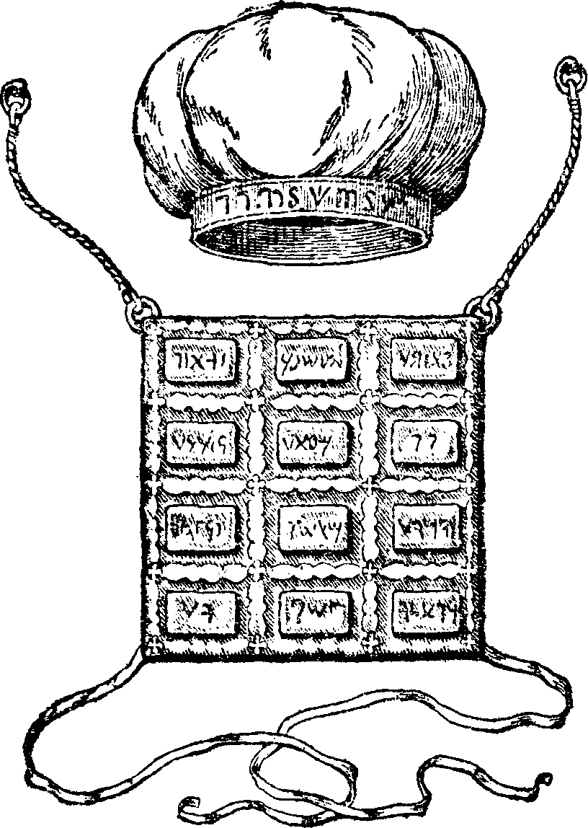
- The Scape-Goat
THE next event of that day after the Sanctuary was cleansed, was putting all the iniquities and transgressions of the children of Israel upon the head of the scape-goat and sending him away into a land not inhabited, or of separation. It is supposed by almost every one that this goat typified Christ in some of His offices, and that the type was fulfilled at the first Advent. From this opinion I must differ; because,
- That goat was not sent away till after the High Priest had made an end of cleansing the Sanctuary; hence that event cannot meet its antitype till after the end of the 2300 days.
- It was sent away from Israel into the wilderness, a land not inhabited, to receive them. If our blessed Saviour is its antitype, He also must be sent away; not His body alone, but soul and body, for the goat was sent away alive, from, not to, nor into, this people; neither into heaven, for that is not a wilderness or land not inhabited.
- It received and retained all the iniquities of Israel; but when Christ appears the second time He will be “without sin.”
- The goat received the iniquities from the hands of the priest and he sent it away. As Christ is the Priest the goat must be something else besides himself, and which He can send away.
- This was one of two goats chosen for that day, one was the Lord’s and offered for a sin-offering; but the other was not called the Lord’s, neither offered as a sacrifice. Its only office was to receive the iniquities from the priest after he had cleansed the Sanctuary from them, and bear them into a land not inhabited, leaving the Sanctuary, priest and people behind and free from their iniquities.
- The Hebrew name of the scape-goat, as will be seen from the margin of verse 8, is “Azazel.” On this verse, William Jenks, in his Comprehensive Commentary has the following remarks:
Scape-goat: see diff. opin. in Bochart. Spencer, after the oldest opinion of the Hebrews and Christians, thinks Azazel is the name of the devil; and so Rosenmire, whom see. The Syriac has Azazel, the angel, (Strong one) who revolted.
- At the appearing of Christ, as taught from Revelation 20, Satan is to be bound and cast into the bottomless pit, which act and place are significantly symbolized by the ancient High Priest sending the scape-goat into a separate and uninhabited wilderness.
Thus we have the Scripture, the definition of the name in two ancient languages both spoken at the same time, and the oldest opinion of the Christians in favor of regarding the scape-goat as a type of Satan.
In the common use of the term, men always associate it with something mean, calling the greatest villains and refugees from justice scape-goats. Ignorance of the law and its meaning is the only possible origin that can be assigned for the opinion that the scape-goat was a type of Christ. Because it is said,
Leviticus 16
22 The goat shall bear upon him all their iniquities into a land not inhabited.
And John said,
John 1
29 Behold the Lamb of God, that takes [margin, bears] away the sin of the world.
It is concluded without further thought that the former was the type of the latter. But a little attention to the law will show that the sins were borne from the people by the priest, and from the priest by the goat.
- They are imparted to the victim.
- The priest bore them in its blood to the Sanctuary.
- After cleansing them from it on the tenth day of the seventh month, he bore them to the scape-goat, and
- The goat finally bore them away beyond the camp of Israel to the wilderness.
This was the legal process, and when fulfilled the author of sins will have received them back again, (but the ungodly will bear their own sins), and his head will have been bruised by the seed of the woman.
The “strong man armed” will have been bound by a stronger than he, “and his house (the grave) spoiled of its goods (the saints).” The thousand years imprisonment of Satan will have begun, and the saints will have entered upon their millennial reign with Christ.
The antitype of the legal tenth day, the Dispensation of the fullness of times, must begin long enough before the 1000 years of Revelation 20 to give time for the cleansing of the Sanctuary, and the antitype of confessing and putting the sins on the head of the scapegoat; which antitype covers the time occupied by:
- The “last end of indignation”;
- The cry of God’s elect to be avenged;
- The travail of Zion;
- Ezekiel in the valley of dry bones;
- The loud cry of the 3rd angel;
- The Laodicean church; and
- The seven last plagues.
Our limits will not admit of particulars here. The first resurrection is fixed at the appearing of Christ, and the beginning of the 1000 years at the first resurrection. The Sanctuary must be cleansed before Christ appears because:

1. No Bearing of Sin at Second Advent
Hebrews 9
28 [He] was once offered to bear the sins of many; and unto them that look for Him shall He appear the second time without sin unto salvation.
Now as His last act in bearing the sins of many is to bear them from the Sanctuary after He has cleansed it, and as He does not appear till after having borne the sins of many, and then without sin; it is manifest that the Sanctuary must be cleansed before He appears.

2. Persecution Between Cleansing and Second Advent
The host are still under the indignation after the Sanctuary is cleansed. Daniel 8. Both the Sanctuary and the host were trodden under foot.
Daniel 8
14 Unto 2300 days then shall the Sanctuary be cleansed [margin, justified].
This is the first point in the explanation, and after this Daniel still…
Daniel 8
15 ...sought for the meaning of the vision,
–and Gabriel came…
19 ...to make him know what should be in the last end of the indignation.
In the explanation which follows; he says nothing about the Sanctuary, because that had been explained by the Wonderful Numberer. He now tells him about the host upon whom the last end of the indignation still rests after the Sanctuary is cleansed. This indignation is the Lord’s staff in the hands of the wicked to chastise His people. It was first put into the hands of the Assyrian and has been inherited by each of his successors, which have in turn been sent…
Isaiah 10
6 ...against a hypocritical nation, to take the prey and to take the spoil and to tread them down like the mire of the streets.
The last end of the indignation is evidently the bitter persecutions, and the severe and searching trial of God’s people, after the Sanctuary is cleansed, and before the indignation is made to cease in the destruction of the little Horn, the fruit and the successor of the Assyrian.

3. Iniquity of the Righteous Removed Before Second Advent
The Sanctuary must be cleansed before the resurrection, for the Lord has provided a comforting message for His people, telling them that it is done.
Isaiah 40
1 Comfort you, comfort you my people, says your God.
2 Speak comfortably to Jerusalem, and cry unto her that her warfare [margin, appointed time] is accomplished, that her iniquity is pardoned: for she has received of the Lord’s hand double for all her sins.
Jerusalem and the Lord’s people are here spoken of, as the Sanctuary and host are in Daniel 8. His people, when Jerusalem’s appointed time is accomplished, are affected and are to be comforted by telling them that “her iniquity is pardoned.”
This must be New Jerusalem, for there was never any time set for pardoning the iniquity of Old Jerusalem, which must have had iniquity of some kind and from some source, else she could not be pardoned of it.
The fact that the Lord has commanded to comfort His people by telling them that Jerusalem’s iniquity is pardoned, is proof positive that she had iniquity, and that it will be removed before His people are delivered and enter her with songs and everlasting joy.
This message is similar to that in Isaiah 52:9. After the good and peaceful tidings have been published, saying unto Zion,
Isaiah 52
7 Your God reigns,
–it is declared:
9 The Lord has comforted His people, He has redeemed Jerusalem.
Jerusalem was in a state from which she had to be redeemed, and that before the resurrection; for the next verse says:
10 All the ends of the earth shall see the salvation of our God.
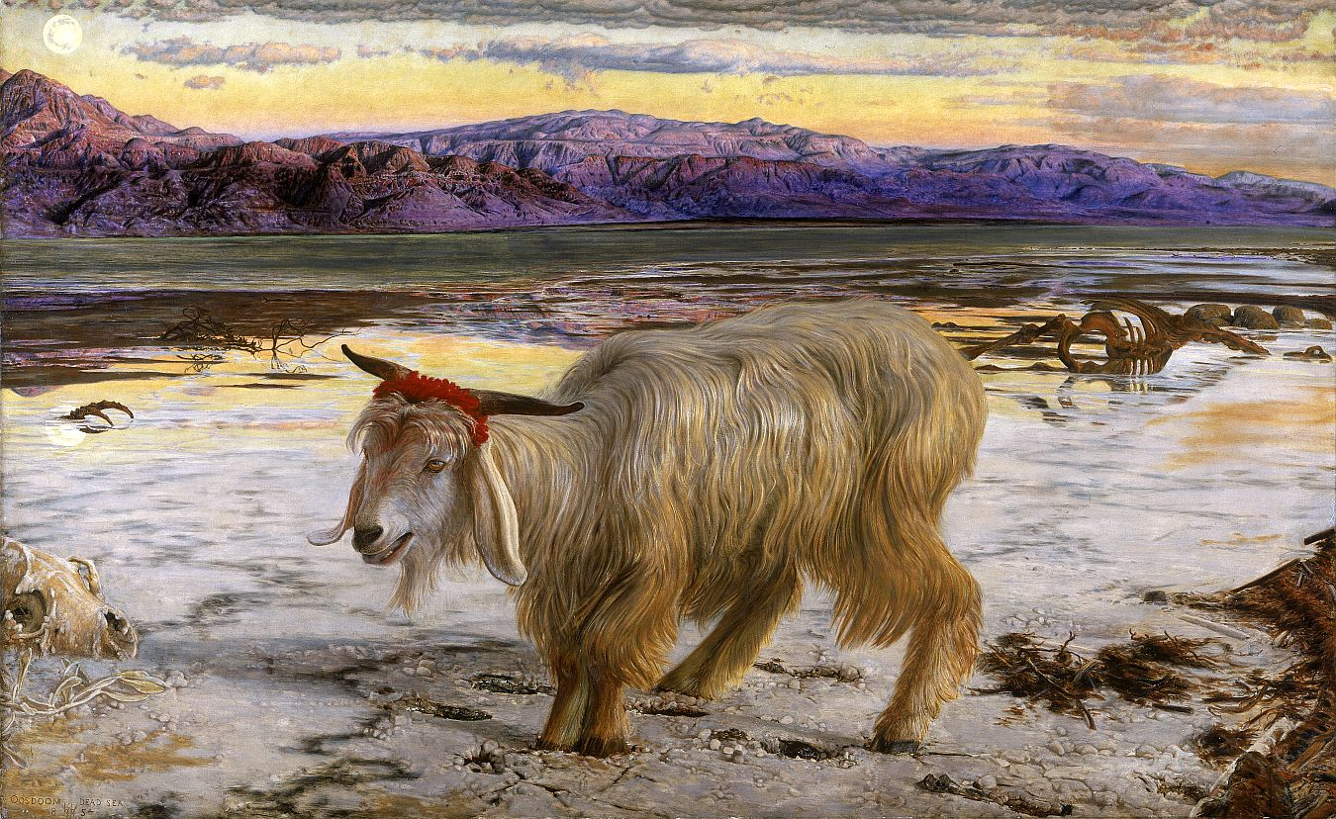
- The Transition
THE opinion generally obtains that the seventh trumpet ushers in the Age to come. The first thing upon its sounding are...
Revelation 11
15 ...great voices saying, The kingdoms of this world are become the kingdoms of our Lord and of His Christ; and He shall reign for ever and ever.
These voices must be heard in the world in which those kingdoms are. It is also evident that the kingdoms sustain a different relation to God at the time these voices are heard, from what they did before the seventh trumpet sounded.
There is a declaration, “He shall reign forever and ever;” and the humble expression of thanks from the four and twenty elders (a symbol of the whole church):
Revelation 11
16 And the four and twenty elders, which sat before God on their seats, fell upon their faces, and worshiped God,
17 Saying, We give You thanks, O Lord God Almighty, which are, and was, and are to come; because You have taken to yourself your great power, and have reigned.
This shows that at that time He began to reign in a special sense. Such voices have been heard since the 7th moon 1844, and produced the effects here described, deep humiliation and profound gratitude.
This change of the relation of the kingdoms of this world to Christ, is the same as making His enemies His footstool, which event was expected by Him while He sat at the right hand of the Father, fulfilling the daily ministration:
Hebrews 10
11 And every priest stands daily ministering and offering oftentimes the same sacrifices, which can never take away sins:
12 But this man, after He had offered one sacrifice for sins for ever, sat down on the right hand of God;
13 From henceforth expecting till His enemies be made His footstool.
Revelation 10 gives in part the character and circumstances of the transition from the Gospel to the following Dispensation. The angel that declares, “there should be time no longer” (verse 6), is not the Lord at His appearing, for after uttering that oath, he told John:
Revelation 10
11 You must prophesy again.
Whatever the nature of this prophesying may be, it certainly follows the oath:
6 And swore by Him that lives for ever and ever, who created heaven, and the things that therein are, and the earth, and the things that therein are, and the sea, and the things which are therein, that there should be time no longer:
7 But in the days of the voice of the seventh angel, when he shall begin to sound, the mystery of God should be finished, as He has declared to His servants the prophets.
I think we have misunderstood verse 7. We have understood or explained verse 6 as the language of the angel, but verse 7 as a declaration of John. But both verses are the language of the angel, verse 7 being a qualification or explanation of verse 6, showing the manner in which time should close.
The angel of the Philadelphia church, having “an open door,” gave the Midnight Cry with the solemn assurance of this oath. He swore, or positively declared,
Revelation 10
6 ...that there should be time no longer,
7 But in the days of the voice of the seventh angel, when he shall begin to sound, the mystery of God should be finished, as He has declared to His servants the prophets.
There are “days” (plural) in which the seventh angel begins to sound. Whether these days are literal or symbolic, which is most in accordance with the character of this book, they denote a short period of time, in which not only the seventh angel begins to sound, but the mystery of God is finished also. Thus we see that the mystery is finished, not in a point but in a period, and while the mystery is finishing, the seventh angel is beginning to sound.
What is the mystery to be finished?
Romans 16
25 ...the mystery which was kept secret since the world began,
26 But is now made manifest.
Ephesians 3
4 ...the mystery of Christ,
5 Which in other ages was not made known unto the sons of men, as it is now revealed unto His holy apostles and prophets by the Spirit;
6 That the Gentiles should be fellow heirs, and of the same body, and partakers of His promise in Christ by the gospel.
2 ...the dispensation of the grace of God.
Ephesians 6
19 ...the mystery of the gospel.
Colossians 1
27 The riches of the glory of this mystery...which is Christ in you, the hope of glory.
These texts show that the mystery of God or Christ is the Gospel Dispensation. It is the period of hope and heirship. While we hope, we pray for the object of hope, and that is glory—as exhibited on the Holy Mount, immortality, the Kingdom and society of Jesus. Until these are obtained we hope; and while we hope the mystery is not finished.
Again, we are heirs during the mystery of God, and when that is finished, we shall become inheritors. We must therefore conclude that the mystery of God will end with the mysterious change from mortal to immortality:
1 Corinthians 15
51 Behold, I show you a mystery; We shall not all sleep, but we shall all be changed,
52 In a moment, in the twinkling of an eye, at the last trump: for the trumpet shall sound, and the dead shall be raised incorruptible, and we shall be changed.
53 For this corruptible must put on incorruption, and this mortal must put on immortality.
54 So when this corruptible shall have put on incorruption, and this mortal shall have put on immortality, then shall be brought to pass the saying that is written, Death is swallowed up in victory.
Then, as the Dispensation of the fullness of times begins with the seventh trumpet, and the Gospel Dispensation reaches to the resurrection, it is manifest that the Dispensation of the fullness of times, begins before the Gospel Dispensation ends. There is a short period of overlapping or running together of the two Dispensations, in which the peculiarities of both mingle like the twilight, mingling of light and darkness.
This was also the manner of change from the Dispensation of the Law to the Gospel. Gabriel said to Daniel,
Daniel 9
24 Seventy weeks are determined upon your people and upon your holy city.
It is presumed that all agree that these 70 weeks reached to the end of the legal dispensation and no further. The Messiah came at the end of the 69 weeks and began to preach the gospel, which Paul calls the New Covenant. And He continued this covenant with many for one week, the last one of the 70.
Hence, the legal Dispensation ended seven years after the Gospel Dispensation began; and the last symbolic week of one was the first of the other; and while one was being finished, the other was being introduced and confirmed or established.
Whether that period is an express type of the crisis period between the Gospel Dispensation and the Dispensation of the fullness of times or not, it furnishes a strong argument from analogy, corroborating the plain testimony of the Word, that there must be such a period. I see no evidence that the latter must be of the same length of the former. To learn its length we must have recourse to other sources of evidence. Yet there is a striking similarity between them.
At that time the world and the mass of God’s professed people were unbelieving, and greatly indifferent about the transpiring events in the Providence of God, momentous as they were. The adherents to the new era were a sect everywhere spoken against. They had little or no reverence for the old and commandment-nullifying traditions of Judaism. They were called movers of seditions, endangering the place and nation; drunken, because filled with the Holy Ghost; and mad, because mighty in the truth.
They had peculiar faith; and their preaching and conduct were such as to cause the professors to accuse them of breaking the law; and finally they denounced and excluded the whole Jewish nation of religionists en mass for their infidelity. The teaching and practice even of our Saviour and the apostles appeared to them contradictory. At times they seemed to recognize the authority of the law, and then again totally to disregard it, and insist upon the new order of things.
He resolved their ten commandments into two, dismissed the woman without being stoned according to the law, forgave sins without the legal sacrifices, healed without requiring to offer according to law, and that even on the Sabbath day. And yet declared that He came not to destroy the law, but to fulfill it.
Again, when He had healed a leper, He charged him to go and show himself to the Priest and offer for his cleansing those things which Moses commanded. He also ate the Passover according to law. Both He and His apostles, on some occasions excluded, and on others admitted the Gentiles to privileges, which according to the law could be enjoyed only by the Jews.
Thus they recognized the presence and claims of both dispensations at the same time; one entering and displacing the other, not instantly, but gradually, by a succession of events, each distinct in itself, but all connected in harmony, transpiring in fulfillment of prophecy, and forming the circumstances of the Advent, which was one distinct event, and the nucleus of all the rest.
A little before His crucifixion Jesus came as King to Jerusalem, the Metropolis and Capitol of that Dispensation; the City was under His absolute authority for a time; He had declared its house desolate and now entered and cleansed the temple.
As then, so now, according to the Scriptures, a series of events constitute the circumstances of our Lord’s appearing, and form the crisis of the two Dispensations.
In that period His crucifixion and resurrection were the principle events to which all others are subservient. But there are other events connected with these, and which must of necessity precede them.
One of these events, as we have already seen, is the cleansing of the Sanctuary. Another is the marriage. That Christ ever was, or ever will be married as human beings are, no one pretends. But that there is a divine transaction, illustrated for our understanding under the figure of a marriage, it is infidelity to deny. Christ is the Bridegroom and New Jerusalem the Bride. The marriage then signifies their union in a special sense, and must take place where the bride is, in the heavens.
The heavens must receive Jesus till the times of restitution, then the Father will send Him from the heavens. He went to His Father’s House in New Jerusalem, and when He has prepared it, He will come again from it to receive us. True the word, gamos, which is rendered marriage, or wedding, signifies the nuptial ceremony, including the banquet; but not the banquet alone, as some would have us believe.
Where is the place of these transactions? With the Bride of course. When the Bridegroom came to the marriage then, He could not have come to the earth from heaven, for then He would have come from instead of to the marriage, but He must have come to the place of marriage, in New Jerusalem.
But, says one,
“How could He come where He was already?”
We must remember that the Bride is not a person, but a City, 12,000 furlongs or 1500 miles square. The central point and fountain of all its glory is the Ancient of days. Christ doubtless has been personally within the limits of that City ever since His ascension, and when the cry in 1844 was given, He came to the Ancient of Days and the scenes of marriage, which in their amplitude will occupy a great part, if not all, of the Dispensation of the fullness of times, then began.
And, as when Christ comes again He will come from New Jerusalem after the scenes of marriage have there begun, everyone will see that He will return to earth from the wedding, and we, waiting, will meet Him and return with Him to the bridal City to share in the festive joy.

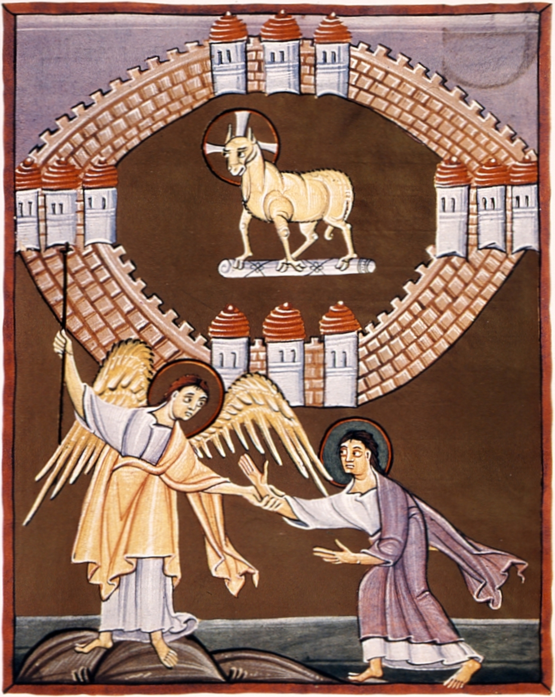

Closing Salutation
Dear Brethren,
I must close for the present and leave the subject with you.
May the Lord correct and enlarge our conceptions of himself and His Plan, and direct our hearts into the patient waiting for Jesus.
Let us in humble obedience follow the Lamb in the expanding developments of His Word and Providence.
O.R.L. Crosier
Canandaigua, NY, Jan. 17, 1846
The Day-Star-Extra Volume 9
Cincinnati, Saturday, February 7, 1846


Appendix A: Notice
This was the original notice at the end of the publication.
To the Brethren and Sisters Scattered Abroad.
We have prayerfully examined the subject presented by Brother Crosier in the light of God’s word, and are fully satisfied it is meat in due season, and if properly examined and understood will settle many difficulties in the minds of many brethren at this time.
In order to get it before the brethren, it becomes necessary to loan the money necessary for its publication, with the expectation that all who feel interested and have means will aid in the expense. The expense as near as we can now ascertain will be about $30. Brethren here, as in most other places, are poor, (but rich in faith) but we can bear one-half of the expense, and will more if necessary.
If more should be refunded than the other half, it will be sent to Bro. Jacobs, or as brethren may direct. The subject, brethren, is now before you, and we do pray you will examine it carefully by the Word. May the Lord add His blessing.
The brethren will please direct to F. B. Hahn, Canandaigua, Ont. CO., N. Y.
Hiram Edson


Appendix B: A Further Letter
A further letter from O. R. L. Crosier
East Hamilton Mad. Co.,
April 13, 1846
Dear Bro Jacobs,
If there is room in your little sheet, I wish to lay before the brethren a few thoughts on the anti-types of the autumnal types. They were:
- the memorial of blowing of Trumpets on the first day of the Seventh month,
- the day of Atonement and Jubilee trumpet on the tenth, and
- the feast of Tabernacles on the fifteenth of the Seventh month.
Some evidences have been presented in the Day-Star Extra to show that the vernal [or spring] types receive their antitypes during the Gospel dispensation and in connection with the anti-typical daily ministration.
So far as I know, it has always been conceded that the fall types were to receive their fulfillment at the Second Advent. Until of late, to escape the consequences of abiding by this obviously scriptural view of those types, some deny it and explain them away or as fulfilled during the Gospel dispensation; thus furnishing another example of prospective faith, but present infidelity—faith in unfilled, and infidelity in fulfilling prophecies.

The Memorial of Trumpets
Trumpets were blown, and burnt offerings, and sin offerings offered on the first day of every month in the year, but the first day of the 7th month was one of special importance, on which was “a holy convocation,” “no servile work” was done, they afflicted their souls, and offered an offering made by fire unto the Lord; and kept the day as a Sabbath.
Their time being lunar, watchmen were stationed on the hills to watch the appearance of the moon. The first who saw it blew his trumpet, and the rest heard and swelled its sound till the hills of Judea resounded with peals of trumpets. In this way the approach of the great day of Atonement was announced.
The fulfillment of this memorial of blowing trumpets must be the proclamation of the coming of the anti-typical day of atonement, which is the dispensation of the fullness of times. The object in either case was to make ready for the atonement.
This was the office of the Advent movement (or Elias) up to the tenth day of the seventh month 1844. The 2300 days ending on that day, the Bridegroom came to the marriage and began the cleansing of the sanctuary which is the first event in the day of atonement.

The Jubilee Trumpet
The trumpet of the jubilee was sounded:
Leviticus 25
9 ...on the tenth day of the seventh month, in the day of atonement.
Hence, we could not have the Jubilee trumpet till the anti-typical day of atonement began, which was in the autumn of 1844.
The midnight cry was not the Jubilee trumpet, because it did not occur “on the tenth day of the seventh month, in the day of Atonement.” That was the last blast in the anti-type of the “memorial of blowing trumpets” “in the new moon” “to make ready” for the day of atonement in which the trumpet of the Jubilee should sound throughout all the land.
This corroborates the view, published by yourself in the Star several months since, as to the identity of the Jubilee trumpet with the Seventh trumpet. This trumpet would only interest those who were to be benefited by the release; hence, would be sounded to Israel only.
Our shut-door position since the 10th of the 7th month 1844 has been peculiarly adapted to the Jubilee trumpet.

The Jubilee Year
Leviticus 25
10 And you shall hallow the fiftieth year, and proclaim liberty throughout all the land unto all the inhabitants thereof: it shall be a jubilee unto you; and you shall return every man unto his possession, and you shall return every man unto his family.
The captives were not only released, but they also returned to their possessions in that year. The period of this release and restoration was not a day, but a year.
11 A jubilee shall that fiftieth year be unto you.
It was the great Sabbatic year, in which the land, as well as the people, was redeemed. The Hebrew servants were only to serve “unto the year of Jubilee”; hence, they were free the moment that year began, and the year was occupied in returning to (or taking) and securing their possessions.
According to the revealed purposes of God, the events to occur in fulfillment of that year are not confined to the limits of one literal year; but the period of their occurrence is the thousand years’ Day of the Lord; the year of the Lord’s redeemed; the Sabbath that remains to the people of God.
Revelation 20: The binding of Satan and loosing of the “captive exiles” from the “prison house,” the “better resurrection” obtained by all the “heirs of promise” mark the beginning of the great and final Jubilee. Then the Redeemer of Israel will...
Isaiah 49
8 ...establish the earth [and] cause to inherit the desolate heritages.
And,
Isaiah 61
4 They shall build...up...the desolation of many generations.
The purchased possessions will be redeemed unto the praise of His glory.
Zechariah 14
10 Jerusalem...shall be...inhabited in her own place.
And the Saints released from suffering, shall reign with Christ in possession of the kingdom under the whole heaven.

The Feast of Tabernacles
The feast of tabernacles was kept seven days, 15th to 22nd of the Seventh month, during which all that were Israelites born, dwelt in booths [tents] which were made of the branches of trees, and they rejoiced before the Lord. It was called also the...
Exodus 23 [also Deuteronomy 16:13-15]
16 ...feast of ingathering, [and was celebrated after they had] gathered in [their] labors [corn and wine] out of the field.
This feast then must meet its anti-type after the harvest of the earth is gathered. We are yet in the reaping time, rather the severing of the tares from the wheat. When this is done the wheat will be gathered. As to the time and circumstances of the gathering the words of our Saviour are explicit and satisfactory.
Matthew 24
30 They shall see the Son of man coming, in the clouds of heaven with power and great glory.
31 And He shall send His angels with a great sound of a trumpet and they shall gather together His elect from the four winds, from one end of heaven to the other.
These words are too plain to be misunderstood and too important to be overlooked. If the personal and visible Second Advent of Jesus in His distinctive character is spoken of in this discourse, it is in the 30th verse. No mere spiritual coming or manifestation answers this prophecy. It is the coming of the Son of Man. If Christ is only Spirit He is not the Son of Man.
After the coming of the Son of Man the harvest of the earth is to be gathered in, and that will begin the anti-type of the feast of Tabernacles; which, in its completion, it is evident, will extend through the millennial joyous reign of the Saints with Christ.
Your unworthy brother waiting for Jesus,
O. R. L. Crosier
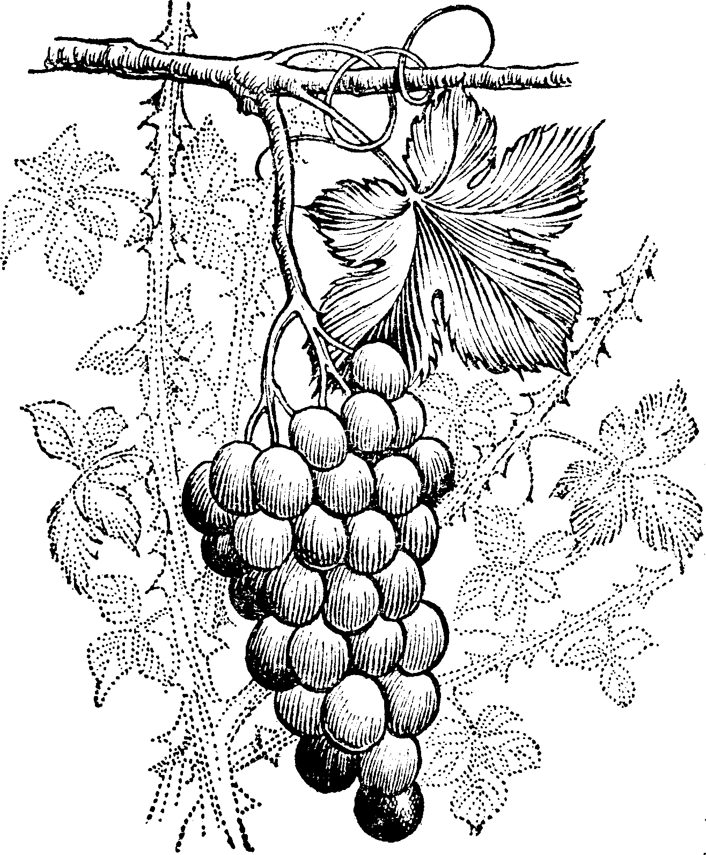

A Meeting with O. R. L. Crosier
By W. A. Spicer
Advent Review, May 29, 1945
OUR periodicals and books dealing with the 1844 movement have frequently mentioned the name of O. R. L. Crosier. He was a friend of Hiram Edson, of western New York.
Hiram Edson was the first to catch a glimpse of the Bible doctrine of the heavenly sanctuary. Young Crosier, school-teacher and preacher, was the man walking over the fields with Edson on that morning of October 23, 1844, the day after the disappointment when Elder Edson stopped alone for a few moments of prayer by a shock of corn. Then it was that the truth was flashed into Brother Edson’s mind,
“The sanctuary to be cleansed is in heaven.”
This earth was not the sanctuary to which Christ was to come in 1844! Hiram Edson told his experience to Crosier and others, and they began immediately to study the Bible doctrine of the sanctuary.
Crosier was the student penman who wrote out the exposition. Hiram Edson led out in securing funds and arranging for its publication. This exposition was a most important step in the development of the advent doctrines.
It came to the attention of our pioneer Sabbath-keepers in New England. Soon Joseph Bates, of Massachusetts, visited Edson and the group with him and gave to them the Sabbath light. Thus two great fundamental truths were shining out, clear and bright.
After having had a part with our pioneers for a year or more in earliest times, Mr. Crosier dropped out of the group. So far as we have heard, our people were not in touch with him in later years. Therefore, when our J. W. Hofstar, a veteran worker in the Netherlands East Indies and in North America, told me recently of having met Mr. Crosier in Michigan years ago, I asked him to write of the interview. Elder Hofstar’s story follows:
In 1904, when I was speaking in our Grand Rapids, Michigan, church on the topic “The Signs of the Times, Past and Fulfilling,” I saw an elderly man, leaning on a cane, walk up the aisle and take a front seat. After he had placed his cane where it would not roll away and make a disturbance, he cupped his hand behind one ear and looked up; in this position he listened attentively to the sermon.
After the service I went to the exit doors to meet those who were leaving the building. I noticed that this elderly man remained near the place where he had been sitting. I therefore walked up to him later and with greeting and extended hand I asked his name. He stated that his name was Crosier.
I then asked him, “Are you related to the proprietor of the shoe store on the corner of Monroe and Lion Streets?”
His answer was, “Yes, that is my son.”
I told him I remembered seeing him there; to which he replied, “That is probably so.”
Continuing, he said, “I enjoyed your remarks very much this morning. You view the signs of the times as we did in the early advent movement and in 1844.”
I then asked him, “Were you interested in the early advent movement, and did you pass through the experience and disappointment of 1844?”
To this Brother Crosier replied, “Yes, I did; I passed through it all. I shared its grief and its distress, and I was present in that all-night prayer meeting and Scripture study held after the disappointment. When the light came concerning the temple in heaven, showing that this had been the object of the prophecies which we thought referred to the return of Jesus and the cleansing of the earth by fire, what a joy this light was to us! Very early in the morning I was on horseback going from place to place to tell the good news and to cheer those whom I could reach.”
At this point our conversation was interrupted; and when I was at liberty to resume it, Brother Crosier had left. His statements were very interesting to me. This was the first time, and it proved to be the only time, that I had the privilege of conversing with one who had lived as a believer through this intensely gripping period of the church.
Brother Crosier seemed to be well, and he said he was well, although his frame was quite bent and he leaned heavily on his stout cane.
We have always remembered kindly the part this companion of one of our early pioneers had in writing out the first exposition of the doctrine of the sanctuary in heaven, though he mingled briefly with that another feature not at all belonging to the sanctuary exposition—the idea of a temporal millennium, which was called the age-to-come doctrine—a teaching that our pioneers did not accept. Perhaps this led to some alienation of feeling.
Mr. Crosier, on his part, did not follow on into other truths that came to light in early days, as the Lord led our pioneers, step by step, into the full advent message that has spread to the ends of the earth.
His story of saddling up the horse that early morning in 1844, to spread the news of the discovery of light on the sanctuary in heaven, is a new contribution to our record. It is a fine addition to the picture of the early dawn of the advent message in western New York.


Miller’s Works, Volume 2 (1842), Lecture 3: “The Two Thousand Three Hundred Days.”
Lest We Forget, Vol 4, Number 3, Page 5, article “O. R. L. Crosier” by Marlene Steinweg, published by Adventist Pioneer Library (www.aplib.org).
Crosier, Letter to A. F. Dugger, February 20, 1899.
Hebrews 8:6.
Hebrews 9:11.
Hebrews 9:9.
Hebrews 9:23.
Matthew 5:17.
Leviticus 16.
Hebrews 4:3.
Leviticus 23.
Zechariah 11:7.
Daniel 8:13, margin.
2 Chronicles 5:2-8.
Daniel 9:2; 2 Chronicles 36:14-21.
Numbers 3:29-31; 10:17, 21.
Hebrews 9:23-24.
Hebrews 8:1.
Exodus 25:8.
Jeremiah 34:16; Ezekiel 20:9, 14, 22; Malachi 1:7.
Revelation 13:6.
Psalm 102:19; Jeremiah 17:12; Hebrews 8:1-2.
Revelation 21:2.
2 Thessalonians 2:1-8.
Daniel 8:13; Hebrews 10:29.
Judges 18:31; 1 Samuel 1:7-24.
Judges 18:1, 10.
1 Samuel 4:3-11.
Verse 21.
1 Samuel 6:12-15.
1 Samuel 7:1-2.
2 Samuel 6:3-4.
2 Samuel 6:10-11.
2 Samuel 6:12-19; 5:6-7.
1 Kings 8:1-6.
2 Chronicles 3:1.
Psalm 132:13-14.
Exodus 15.
Hebrews 7:3.
Hebrews 7:24, margin.
Hebrews 7:23.
Hebrews 7:1, 7, 9, 10.
Hebrews 7:14, 21.
Hebrews 7:25.
Hebrews 3:1-6.
Hebrews 8:1-2.
Hebrews 9:23.
Exodus 29:38-42; Numbers 28:3-8.
Exodus 30:34-38; 31:11; 30:7-9.
1 Chronicles 16:37-40; 2 Chronicles 2:4; 13:3 [see 2 Chronicles 31:3], 13:4-12; Ezra 3:3.
Leviticus 13:45-46.
Leviticus 14:33-57.
Leviticus 5; 6:1-7.
Leviticus 4:24; 1:11; 17:1-7.
Leviticus 4:2-4, 13-15, 22-24, 27-29.
Leviticus 4:5-10, 16-20, 25-26, 30-35.
Leviticus 4:11-12, 21.
Leviticus 16:4, Exodus 28:2.
Exodus 28:35.
Exodus 28:30.
Leviticus 8:9, Exodus 28:36.
Leviticus 16:30.
Leviticus 16:3.
Leviticus 16:5-8.
Leviticus 16:11.
Exodus 30:1-10.
Leviticus 4:14, 5:3-6.
Leviticus 5:1-17; 7:1-8.
Leviticus 17:11.
Leviticus 16:24.
Leviticus 16:27.
Hebrews 9:1-5.
Amos 2:4.
Malachi 2:8.
Hebrews 9:3.
Matthew 5:17.
Hebrews 9:7.
Hebrews 9:6.
Leviticus 4:1-4, 13-15, etc.
Leviticus 4:5-12, 16-21.
John 14:15.
Acts 2:33.
Acts 22:16.
Acts 2:28.
Hebrews 10:12.
Hebrews 10:10.
1 Peter 2:24.
Luke 18:30.
Ephesians 1:10.
Ephesians 1:14.
Ephesians 3:2, 6.
Leviticus 16:30.
Mark 1:41-44.
Ezekiel 36:25.
Leviticus 16:22-30.
Leviticus 21:12.
Numbers 19:20.
2 Chronicles 36:14.
1 Maccabees 1:20-24.
See 2 Chronicles 29.
Leviticus 12 to 15.
Hebrews 9:21.
Hebrews 9:1.
Hebrews 9:11.
Hebrews 9:11-12.
Hebrews 9:25.
Colossians 1:20.
Daniel 8:14.
Leviticus 16:20-21.
Leviticus 16:7-10, 22.
Matthew 12:29, Leviticus 16:21-22.
Daniel 8:19.
Luke 18:1, 8.
Micah 4:10.
Ezekiel 37.
Revelation 14:9.
Revelation 3:14.
Revelation 15 and 16.
1 Thessalonians 4:16.
Revelation 20:4-5.
Isaiah 10:5.
Daniel 8:25; Isaiah 10:12, 25.
Hebrews 10:13.
Matthew 1:14-15; 4:23.
Published in the Day Star, May 11, 1846.
Numbers 28:11-15.
Numbers 29:1-6, Leviticus 23:23, 25.
Revelation 11:15-19.
Leviticus 25:24, 28.
Verse 40.
2 Peter 3.
Hebrews 4:9, margin.
Isaiah 42:6-16; 49:8-12; 51:12-23; Hebrews 6:12.
Ephesians 1:14.
Nehemiah 8:14-15.
Leviticus 23:33-45.

