THE
SEVEN CHURCHES
OF REVELATION
WILLIAM MILLER

Source:
Evidence from Scripture and History of the Second Coming
Lesson 9 and 10
1842
Cover:
Christ Among the Candlesticks
Stothard – Bowyer Bible Artists

Fonts:
Liberation Sans Narrow
Linux Biolinum
Linux Libertine
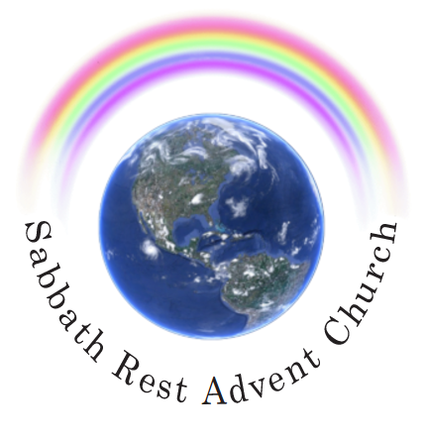
July 2022
practicaprophetica.com
srac.info

Contents
Foreword
The Seven Churches of Revelation 1
A Figure of the Christian Dispensation 1
1. Ephesus 5
2. Smyrna 12
3. Pergamos 16
4. Thyatira 20
5. Sardis 26
6. Philadelphia 29
7. Laodicea 34
1. The Condition of the Church 41
2. The Character of Christians 42
3. The Doctrine Taught 43
4. The Signs of the Times 44

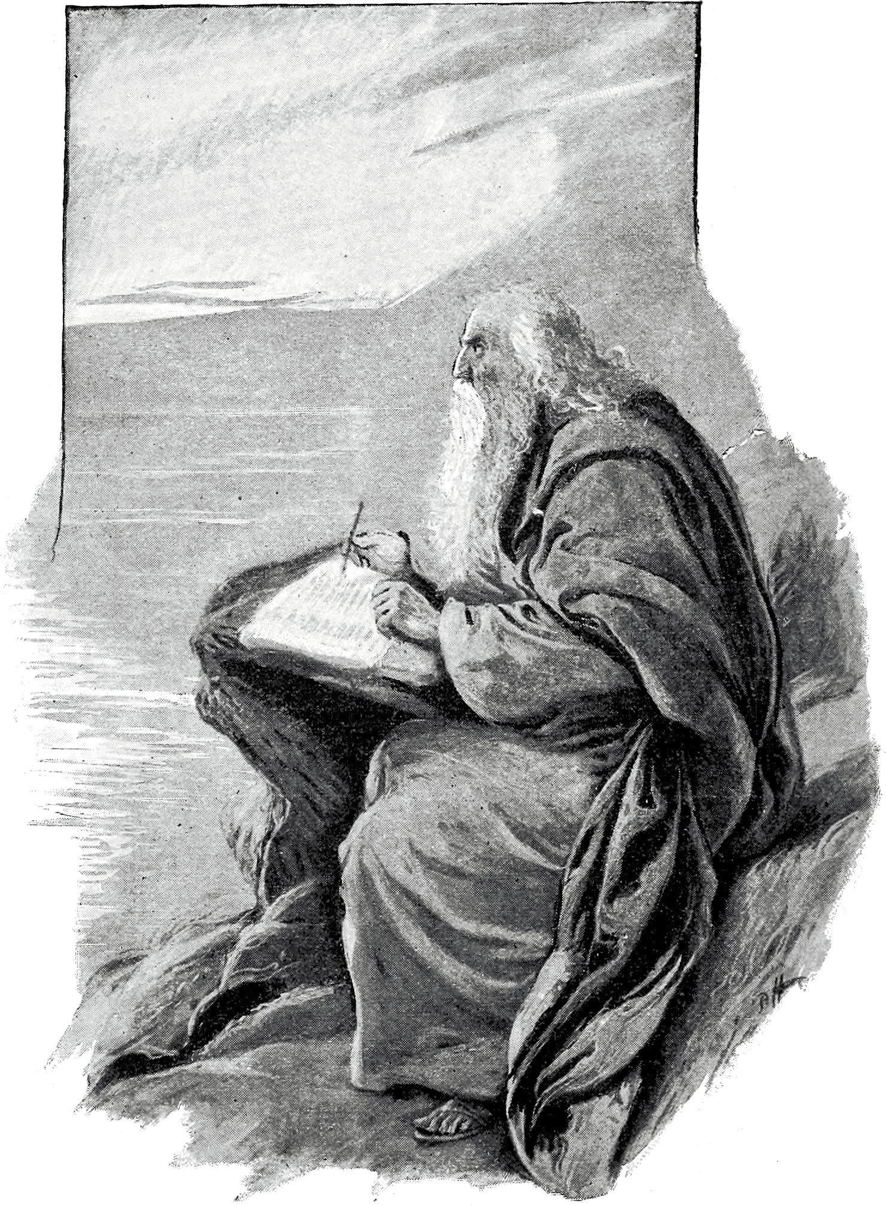John writing Revelation from Patmos
(Art Bible, 1896)

Foreword
THE two articles that make up this booklet were taken from a volume of William Miller’s lectures published in 1842. These are Lecture 9 and 10 from the book, Evidence from Scripture and History of the Second Coming of Christ about the Year 1843; Exhibited in a Course of Lectures.
Since the rise of the Seventh-day Adventist church in the mid-1800’s, quite a few points of prophecy have become clarified. Miller did not have the advantage of the added light that came in after his ministry was finished.
However, this series on the seven churches of Revelation chapter 2 and 3, are very profitable, have mostly stood the test of time, and give a glimpse into Miller’s gospel preaching. The Advent revival was not just a dissertation of prophetic time periods, it was a heartfelt call for full, unreserved surrender to Christ, and unity with Him in His work. The two lectures included here reveal that very clearly.
His expositions on Ephesus, Smyrna, Pergamos, and Thyatira are wonderful, and accurate. The application of the next two churches, Sardis and Philadelphia, to the Waldensian period, and the Reformation, are not quite as accurate. Today, we would regard the condemnation of Sardis, “you have a name that you live, but are dead,” as applying to the Reformation churches, after their founders left the scene.
It was those who came after Luther, Calvin, and Wesley, who were in danger of not watching, and of Christ “coming upon them as a thief.” These were the churches who should have been studying the prophecies regarding Christ’s coming, and known when that coming was “near, even at the doors.”
Miller applies the Philadelphian church to the period of the Reformation. We would correct this to apply it to the very group that arose from Miller’s preaching: the Advent movement. It was this movement that united men and women of all denominations and backgrounds, into one unified body of brotherly love.
The “open door” that Christ set before the Philadelphian church was not just the door of missionary work, as Miller expounds it, but it was the door into the Most Holy Place of the Sanctuary in heaven. The opening of that door marked the beginning of the day of judgment, when “the books were opened,” and the “time of the dead, that they should be judged” commenced.
This was, of course, the point that Miller’s followers did not understand: that the cleansing of the Sanctuary was not the cleansing of this Earth by fire, nor the cleansing of the church by the removal of false professors, but rather the cleansing of the Sanctuary in heaven: the removal of accumulated sin gathered there through the ministry of Christ, our great High Priest.
It was this service that had been foreshadowed by the Day of Atonement in the Old Testament sanctuary services. The completion of this work, preceded by the cleansing of all sin from God’s children on earth, would mark the end of Christ’s ministry, and the time when He would return, “without sin unto salvation.”
Miller’s exposition of the counsels to the Laodicean church are still present truth, and should be read by all today with fear and trembling.
- Frank Zimmerman, July 2022
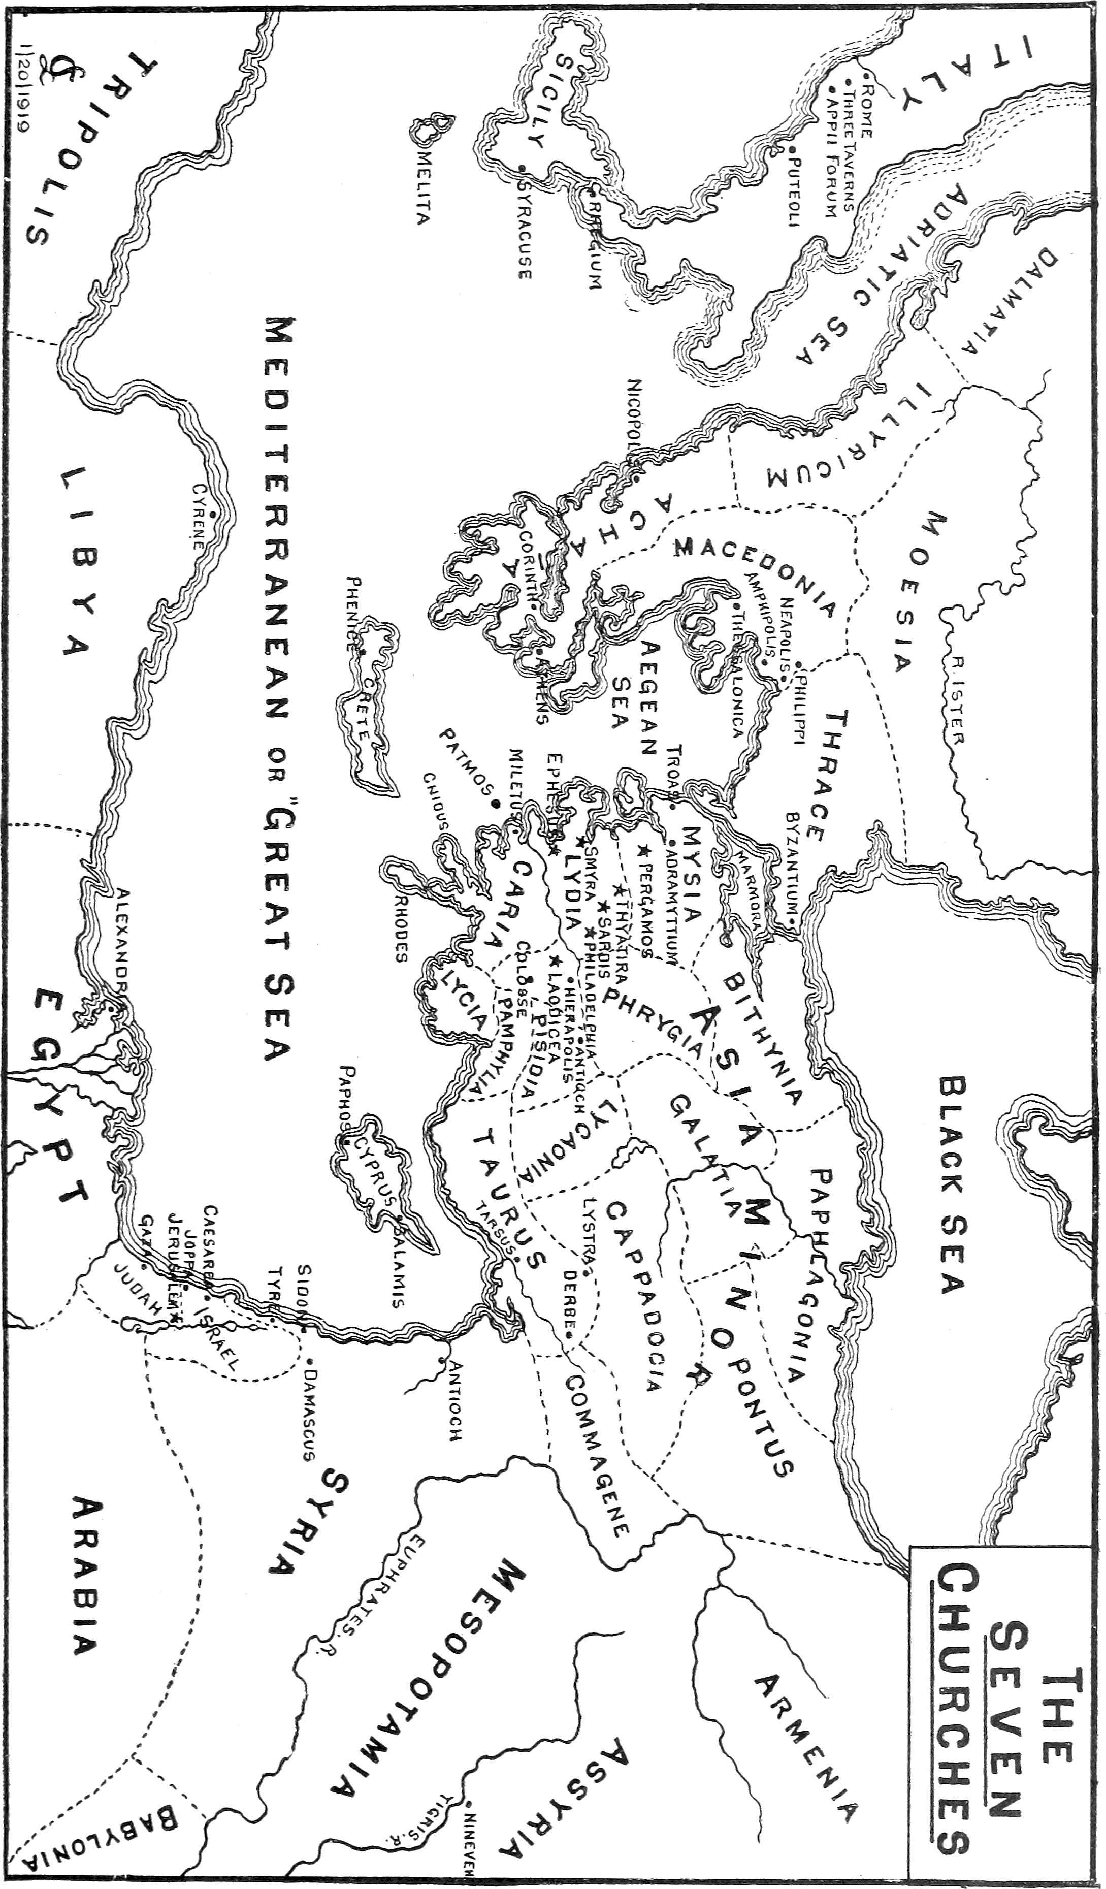
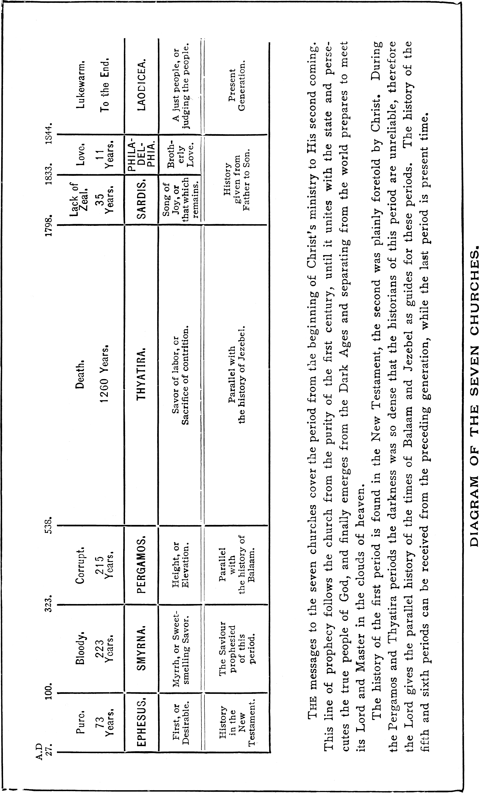The current Adventist understanding of the Seven Churches differs slightly from Miller, in the timing of the Sardis and Philadelphian periods.
(Story of the Seer of Patmos, Haskell, 1905)

The Seven Churches of Revelation
The Epistle to the Seven Churches of Asia, considered as applying to Seven Periods of the Gospel Church
Revelation 1
20 The mystery of the seven stars which you saw in my right hand, and the seven golden candlesticks. The seven stars are the angels of the seven churches; and the seven candlesticks which you saw are the seven churches.
IT HAS generally been believed that the seven churches to whom the angel instructed John to write, were seven different and distinct churches in Asia, and by almost all of our commentators at the present day are understood to mean seven literal churches.
But your speaker is forced, from the reasons which will hereafter be produced, to believe that these seven churches of Asia are to be understood in a figurative sense, alluding to seven periods of the church militant, during the Christian dispensation, down to the first resurrection, and the commencing of the glorious reign of Christ on the earth, commonly called The Millennium.
If this view of the subject should prove to be the correct exposition of the text, how important and interesting is the subject to us who live in the last stage of the church! Then we who live at this day, are particularly, and solemnly and awfully, admonished in what is said by Christ to the church of the Laodiceans, that church corresponding with our stage of the church immediately previous to the commencing of the millennial glory; and how necessary that we should know that these admonitions do most deeply concern us!

A Figure of the Christian Dispensation
This view of the subject will then claim our first attention.
“Were the Seven churches used as a figure of the whole Christian dispensation, or were they not?”
I answer, In my humble opinion, they were. Because, first, the book of Revelation does evidently contain a prophecy of things which did not concern those seven literal churches in Asia; for those churches have long since passed away and become extinct; yet the book of Revelation contains prophecies which are daily fulfilling, and have been for eighteen centuries.
It is also said to be a revelation of things which must shortly come to pass.
Revelation 1
1 The revelation of Jesus Christ which God gave unto Him, to show unto His servants things which must shortly come to pass.
Not things that have been. Yet if Christ is only giving admonitory advice to those seven literal churches, then He is only relating their characters as they then were, and so far as these churches were concerned it would cease to be a prophecy, and the very first verse in Revelation would be violated. Again,
3 Blessed is he that reads and they that hear the words of this prophecy, and keep those things which are written therein; for the time is at hand.
We see that it is called a prophecy in this verse, and must allude to the whole book; but who will pretend that the three chapters in the beginning of Revelation are a prophecy, if we understand them as relating the character of seven literal churches in Asia only? None, none.
Again: the word seven is often used in the word of God as a mystical number, meaning the whole, as seven spirits, seven stars, seven angels, seven candlesticks, seven seals, seven trumpets, seven vials, seven thunders, seven plagues, seven mountains, seven heads, seven eyes, seven horns, seven crowns, seven kings, and seven churches. All these are used in Revelation and apply to or concerning the whole Gospel period.
If, then, the number seven is used so often in this book in a figurative sense, may we not reasonably suppose that it is so used in the dedication of this book to the seven churches in Asia, and the history of those seven churches be prophetic? for no scripture is given for any private interpretation, and surely the instruction in the introduction of the book carries us down to the coming of Christ in the clouds:
Revelation 1
7 Behold, He comes with clouds; and every eye shall see Him, and they also which pierced Him; and all kindred of the earth shall wail because of Him. Even so, Amen.
8 I am Alpha and Omega, the beginning and the ending, says the Lord, which is, and which was, and which is to come, the Almighty.
And why all this descriptive grandeur in the address to these seven churches, if they only were meant? Surely there were other churches of equal importance at that day. Where were the churches at Corinth, Cappadocia, Galatia, Thessalonica, Philippi, Collosse, Rome, Jerusalem, Bithynia, etc.?
Our text shows that the seven churches were to be understood in a figurative or mystical sense:
20 The mystery of the seven stars which you saw in my right hand, and the seven golden candlesticks. The seven stars are the angels of the seven churches; and the seven candlesticks which you saw are the seven churches.
These seven churches are represented by “seven lamps.”
Zechariah 4
2 And said unto me, What do you see? And I said, I have looked, and behold a candlestick all of gold, with a bowl upon the top if it, and his seven lamps thereon, and seven pipes to the seven lamps which were upon the top thereof.
These seven lamps are called...
Zechariah 4
10 ...the eyes of the Lord which run to and fro through the whole earth.
If this is true, then it readily follows that the seven churches of Asia are only used as a figure representing the church “through the whole earth.”
Again: the seven lamps, which are the seven churches, are called the seven spirits of God.
Revelation 4
5 And there were seven lamps of fire burning before the throne, which are the seven spirits of God.
I have clearly proved, and I think it will be admitted by all, that the “seven eyes of the Lord,” and “the seven spirits of God,” are the seven churches to whom John was directed to write or dedicate his book, the Revelation of Jesus Christ. And I will now show that these comprehended the whole church through the whole earth.
Revelation 5
6 And I beheld, and lo, in the midst of the throne and of the four beasts, and in the midst of the elders, stood a Lamb as it had been slain, having seven horns and seven eyes, which are the seven spirits of God sent forth into all the earth.
Again: when we compare the several characteristic marks or events, upon opening the seven seals, with those marks and instructions to the seven churches, we shall be led to admire the beauty, harmony, and consistency of the Revelation of Jesus Christ to His people. And I think the mind will rest satisfied that this view of the subject is the truth, because it so exactly agrees with Christ’s manner of teaching by parables when He was with us in the flesh.
Some may inquire,
“Why were those seven churches in Asia used as figures to represent the church militant in her several conditions to the end of her militant state?”
I answer, (if we may be allowed to answer the why’s or wherefore’s,) because the signification of the names of those seven churches describe the spirit and qualities of the several periods of the Christian church, which they are brought forward to represent, which we shall attempt to show in its proper place.
I shall now endeavor to take up the churches in the order in which they are laid down to us in Revelation.

1. Ephesus
The word Ephesus, means desirable, or chief. This is true concerning the first age of the church, in the apostles’ days, when the Holy Ghost was given the power to work miracles, and the power to distinguish between good and evil spirits, and when all were of one heart and one mind, and the canon of the Holy Scriptures were filling up, and the inspired apostles were setting things in order, and establishing churches through the world. Yes, my brethren, these were desirable times surely.
This church is addressed by the character…
Revelation 2
1 ...that holds the seven stars,
–which are the ministers and servants of Him who holds them,
1 ...in His right hand,
–under His immediate care and control,
1 ...who walks in the midst of the seven golden candlesticks,
–and has said, where two or three are gathered together in His name, there will He be in the midst of them, and has promised that whatsoever they should ask in His name it should be granted unto them. He says,
Revelation 2
2 I know your works.
In that day they brought forth fruits meet for repentance, and they went everywhere preaching that men should repent; and Paul said, when preaching at Athens,
Acts 17
30 But now commands all men everywhere to repent.
Yes, all, saint or sinner, high or low, rich or poor; all, all must repent. And O! my brethren, how much we need these works at the present day!
Revelation 2
5 Remember, therefore, from whence you are fallen, and repent and do your first works.
Again He says,
Revelation 2
2 I know your...labor.
Did not the apostles labor night and day?
2 Thessalonians 3
8 Neither did we eat any man’s bread for nought, but wrought with labor and travail night and day, that we might not be chargeable to any of you.
1 Thessalonians 2
8 So being affectionately desirous of you, we were willing to have imparted unto you, not the gospel of God only, but also our own souls, because you were dear unto us.
9 For you remember, brethren, our labor and travail; for laboring night and day, because we would not be chargeable to any of you, we preached unto you the gospel of God.
Again He says,
Revelation 2
2 ...and your patience.
This, too, will apply to the apostles’ days. For Paul says,
2 Corinthians 6
4 But in all things approving ourselves as the ministers of God, in much patience, in afflictions, in necessities, in distresses.
2 Corinthians 12
12 Truly the signs of an apostle were wrought among you in all patience, in signs, and wonders, and mighty deeds.
And again the apostle says to Timothy,
2 Timothy 3
10 But you have fully known my doctrine, manner of life, purpose, faith, longsuffering, charity, patience.
And who can read the history of the first age of the church, but will admit that works, labor and patience, were prominent features of that age, and virtues which adorned the Christian church in its infancy, more than any age since?
Revelation 2
2 ...and how you cannot bear them which are evil.
Who can read Paul’s instructions to his Corinthian brethren without seeing this text fulfilled?
1 Corinthians 5
11 But now I have written unto you not to keep company, if any man that is called a brother (as though such a one could not be a real brother, but only called so) be a fornicator, or covetous, or an idolater, or a railer, or a drunkard, or an extortioner; with such a one do not to eat.
And had the servants of Christ at the present day the power of the apostles to discern the spirits by which we are governed, how many in this congregation would blush when “a fornicator” is mentioned! How many “covetous” would hide their faces! How many “idolaters” would bow their heads, or “railers” would begin to murmur at the plainness of the speaker! How many “drunkards” would not have staggered into this house! And how many “extortioners” would have stayed at home! O God, You know.
Or who can read the 2nd chapter of the 2nd epistle of Peter, and John’s first epistle, Jude, and others, and not be convinced that the apostles could not bear with them that were evil? Again:
Revelation 2
2 ...and have tried them which say they are apostles, and are not, and have found them liars.
This sentence was fulfilled in the apostles’ days. Simon Magus, after he was professedly a disciple of Christ, was found out by Peter to be in the…
Acts 8
23 ...gall of bitterness and bonds of iniquity.
Hymeneus and Alexander, whom Paul delivered to Satan, that they may learn not to blaspheme. Also Philetus, Demas, and Alexander the coppersmith, were all found to be liars, and many others who went out from them, as the apostle says, because they were not of them.
And how many are there now, my brethren, among us, who, when tribulation comes, will be offended, and go out from us?
Matthew 26
22 Lord, is it I?
Revelation 2
3 And have borne, and have patience, and for my name’s sake have labored, and have not fainted.
Yes, my brethren, it was for the name of Jesus, that the primitive Christians bore the persecutions of their day.
Acts 15
25 It seemed good unto us to send chosen men unto you, with our beloved Barnabas and Paul,
26 Men that have hazarded their lives for the name of our Lord Jesus Christ.
Acts 9
16 For I will show him what great things he must suffer for my name’s sake.
41 And they departed from the presence of the council, rejoicing that they were counted worthy to suffer shame for His name.
And, may I not inquire, how many of us are willing and would rejoice to suffer shame for the name of Christ? Perhaps none. We had rather be called Rabbi, Rev., Dr., etc. We are contending for our names at the present day: for Baptists, Congregationalists, Presbyterians, Methodists, Free-wills, Campbellites, etc.
“If we do not contend earnestly for our sect, they will decrease, and we shall come to nought.”
And I say, May God speed it; so that you all may fall on the word of God, and rally again under the name of Jesus. But we will proceed with our subject.
Revelation 2
4 Nevertheless I have somewhat against you, because you have left your first love.
Can this be true? Did the apostolic church, in its purity, so soon depart from the first principles of the gospel? Yes,
Acts 15
24 Forasmuch as we have heard that certain which went out from us have troubled you with words, subverting your souls, saying, you must be circumcised, and keep the whole law, to whom we gave no such commandment.
Galatians 1
6 I marvel that you are so soon removed from Him that called you into the grace of Christ unto another gospel.
1 Timothy 1
19 Holding faith and a good conscience, which some having put away, concerning faith, have made shipwreck.
2 Timothy 1
15 This you know, that all they which are in Asia are turned away from me.
And Paul further says,
2 Timothy 4
16 At my first answer no man stood with me, but all men forsook me. I pray God lay not this sin to their charge.
Many more evidences might be brought, to prove that many, in that early state of the church, did fall away from the doctrine of grace, which Paul and the apostles taught.
And now, my brethren, how is it with us? Are we built on the truth? Have we a “Thus says the Lord,” for all we believe and do? Are we built on…
Ephesians 2
20 ...the prophets and apostles, Jesus Christ himself being the chief corner-stone?
Look well to your foundation—the day is coming that will try every man’s works.
Revelation 2
5 Remember, therefore, from whence you are fallen, and repent and do the first works, or else I will come unto you quickly, and will remove the candlestick out of his place, except you repent.
In this verse the great Head of the church admonishes the Christians of their former sins in neglecting the doctrine of grace, and falling into the popular errors of the day, which I have before noticed, and warns them of their duty to repent, which is the first and great command under the gospel.
He also gives them notice, that, except they repent, He will remove the “desirable” state of the church into the next, which would be a state of trial, persecution, and poverty.
6 But this you have, that you hate the deeds of the Nicolaitans, which I also hate.
What the deeds of the Nicolaitans were, we are not able, from the word of God, to determine; but from some things hinted at by some ancient authors, we have good reason to believe that Nicholas, one of the seven deacons, departed from the doctrine which the apostles taught, and preached a doctrine which was repugnant to the gospel of Christ, viz., a community or plurality of wives, which led Paul in his instructions to say,
1 Timothy 3
12 Let the deacons be the husband of one wife.
Revelation 2
7 He that has an ear, let him hear what the Spirit says to the churches...
Here we have another evidence, that the branch of the church at Ephesus was not the only church addressed in this epistle and prophecy; for, if so, what propriety in using the word churches, in the plural, when only one church in Asia was spoken of? No, it could not be proper, neither would it have been, as it is so used in every epistle through the whole seven, had not Christ designed it for all the churches in a certain age.
There is also an admonition contained in these last-quoted words, to read, hear, and observe the prophecy now given by the Spirit to John, the inspired servant of Christ; and for all the churches of the age spoken of, to be careful to apply to themselves the admonitions, designed by the Holy Spirit for their immediate benefit.
Revelation 2
8 ...To him that overcomes will I give to eat of the tree of life, which is in the midst of the paradise of God.
How precious is this promise to the faithful and tried souls, who places all his hope, and strength, and dependence, on one who is mighty to save, and on one who has promised to bring him off conqueror over all the enemies of grace, and the powers of hell!
Yes, and, more than all, He has overcome and entered within the veil, as a forerunner for us who believe. May we all, by faith, have a right to this tree of life, this paradise of God.

2. Smyrna
I will now examine the prophecy to the second church, which I understand to commence about the close of the first century, and lasted about two hundred years, until the days of Constantine, 312 AD.
Revelation 2
8 And unto the angel of the church in Smyrna, write.
The signification of the word Smyrna, is myrrh; denoting that the church in this age would be a sweet-smelling savor to God, while she was passing through the fiery ordeal of persecution and affliction, which always has served to weed out those obnoxious plants of pride, popularity, self-dependence—the bane and poison of true faith, piety, and devotion.
And O, my brethren, could we learn wisdom, by what the church has already suffered in the days of our forefathers, we should be more humble, the more worldly peace and prosperity we enjoyed. For it is only in the midst of persecution and trial, that the church manifests great purity of doctrine or life.
How well, then, might this age of the church be compared to myrrh, when she must have been separated from worldly honors, avarice, pride, popularity, and hypocrisy, when the hypocrite and worldling had no motives to unite with and destroy the union of the brotherhood, and when the hireling shepherd could expect no fleece, that would suit his cupidity, to filch from the lambs of Christ!
Revelation 2
8 These things says the first and the last, which was dead and is alive.
In these words we learn the character speaking to the church. It is no less than the mighty God, the everlasting Father, the Prince of Peace.
9 I know your works, and tribulation, and poverty,...
Now, their works were about to be tried; although God knew them that were His, yet He designed to manifest to a world who would be faithful even unto death, and to show that pure and undefiled religion would burn with a brighter flame in tribulation and poverty, and the richness of that faith, which would bring off the true Christian as conqueror over the powers of the world, the temptations of Satan, and corruption of the flesh.
9 ...but you are rich.
Yes, brethren, the true and genuine Christian is rich. For charity can suffer long in tribulation, and the spirit of Christ will make us forsake all for His sake, and endure poverty for the name of Jesus.
Revelation 2
9 ...and I know, [says Christ,] the blasphemy of them which say they are Jews, (that is, people of God,) and are not, but are the synagogue of Satan.
Although Christ knew the hypocrites and false professors that had rushed into His visible kingdom during a time of prosperity that the church had experienced in its Ephesian state, or apostolic age, yet now the time had come, when that candlestick must be removed, and the next age of the church or candlestick be set up; and the same means used by God to purify the silver would purge out the dross, so that the kingdom would again be cleansed of its worldly, hypocritical, and false professors.
10 Fear none of those things which you shall suffer.
The true child of God need not fear to suffer for Christ’s sake, for the sufferings of this present evil world will…
2 Corinthians 4
17 ...work out for us a far more exceeding and eternal weight of glory.
Revelation 2
10 ...behold, the devil shall cast some of you into prison, that you may be tried, and you shall have tribulation ten days.
The devil in this verse means Pagan Rome.
Revelation 12
9 And the great dragon was cast out, that old serpent, called the devil.
17 And the dragon was wroth with the woman, and went to make war with the remnant of her seed, which keep the commandments of God, and have the testimony of Jesus Christ.
How exactly was this prophecy fulfilled in the days of Nero, Domitian, and other Roman emperors, and how faithful has history been to record the ten persecutions between the days of John’s prophecy and the emperor Constantine!
In these ten persecutions of the Roman government, in the text called “ten days,” we learn by the history of those days the church suffered a great diminution in numbers by apostasy and fear; yet those that remained steadfast made up in graces what they lost in numbers; and it was truly a time of trial, for many were cast into prison, and many suffered torture and death, rather than to offer sacrifices to their Pagan gods.
Revelation 2
10 ...be faithful unto death, and I will give you a crown of life.
Yes, my brethren, if we can believe the history of those days, many of the dear disciples of Christ were faithful unto death, and have long enjoyed the crown of life promised in this prophecy.
11 He that has an ear, let him hear what the Spirit says to the churches. He that overcomes shall not be hurt of the second death.
Here, then, we find some of those character who will have part in the first resurrection, the blessed martyrs who were slain for the witness of Jesus.
And in this passage we are again commanded to hear what the Spirit says to the churches—all, all who have ears; not the branch in Smyrna only, but all who have ears. We have long been in the habit of giving away Scriptures to others when it belongs to us and our children; let us therefore apply it home.

3. Pergamos
Revelation 2
12 And to the angel of the church in Pergamos write.
Very earthy elevated is the signification of the word Pergamos; and this church represents the age of Constantine, which lasted more than two hundred years, until the rise of Antichrist, from 312 AD until 538 AD. During this age the church became very earthy, having her worldly policy, and, like the church in the present day,
- attending more to the outward concerns, and the worldly part of religion, than to inward piety and graces of the spirit,
- looking more for forms and ceremonies, than for the life, power, and spirit of the religion of Jesus,
- spending much of their time in building elegant chapels, gorgeous temples, high places to educate their ministry, and adorning them with pictures and pleasant things, and
- filling the hearts of their worshippers with high, popular, and haughty notions.
Yes, my brethren, the age of trial was gone; the holy and secret aspirations of piety fled away, and, now that she had obtained an earthly emperor, her divine Master was forgotten. And here was the falling away mentioned by Paul,
2 Thessalonians 2
3 Let no man deceive you by any means; for that day shall not come except there come a falling away first, and that man of sin be revealed, the son of perdition.
This, then, was the age that prepared the church to receive that monster, the man of sin, the son of perdition, into her bosom, which stung the church with the poison of asps, and filled the temple of God with image worship, and the church with idolatry, selfishness, avarice, and pride.
Revelation 2
12 These things says He which has the sharp sword with two edges.
By the sharp sword with two edges, we must understand the word of God, which denounces heavy judgments on the wicked, and cuts off the corruptions and errors from the church. The Psalmist says,
Psalm 149
5 Let the saints be joyful in glory; let them sing aloud upon their beds.
6 Let the high praises of God be in their mouth, and a two-edged sword in their hand,
7 To execute vengeance upon the heathen, and punishments upon the people.
Paul says,
Hebrews 4
12 For the word of God is quick and powerful, sharper than any two-edged sword, piercing even to the dividing asunder of soul and spirit, and of the joints and marrow, and is a discerner of the thoughts and intents of the heart.
And John saw,
Revelation 1
16 And He had in His right hand seven stars; and out of His mouth went a sharp two-edged sword.
Then this is the meaning of the passage under consideration, “These things says He,” which has the word of God, and showing us the importance of attending to the subject following, by the importance of the speaker, “He that is Christ.” And now, while we read or hear, let us keep in memory that it is no less a personage speaking, than Him of whom the prophets did write; who holds the stars in His right hand, and created and preserves all things by the word of His power. Hear Him.
Revelation 2
13 I know your works, and where you dwell, even where Satan’s seat is.
Here, again, we have an evidence that this church is mystical, “dwelling in Satan’s seat,” the fourth kingdom, the great red dragon, imperial Rome, whereon the great mystical whore of Babylon sits. The church, in this age, became immediately connected with this power called Satan, which is the devil, Pagan Rome.
Revelation 2
13 ...and you hold fast my name, and have not denied my faith.
In this time of popular religion, and when many, from political and worldly motives, united their names to the people of God, still there were some who held to the doctrine of Christ, and did not deny the faith.
13 ...even in those days, wherein Antipas was my faithful martyr, who was slain among you where Satan dwells.
It is supposed that Antipas was not an individual, but a class of men who opposed the power of the bishops or Popes in that day, being a combination of two words, Anti: opposed, and Papas: father or Pope; and many of them suffered martyrdom at that time, in Constantinople and Rome, where the bishops and Popes began to exercise the power which soon after brought into subjection the kings of the earth, and trampled on the right of the church of Christ.
And, for myself, I see no reason to reject this explanation of the word Antipas in this text, as the history of those times are perfectly silent respecting such an individual as is here named.
Yet many, who opposed the worship of saints and pictures, and the infallibility of the bishop of Rome, were excommunicated, persecuted, and finally driven out from among men, and in the next age of the church had to flee into the wilderness. All this happened in the kingdom of Rome, “where Satan dwells.”
Revelation 2
14 But I have a few things against you, because you have there them that hold the doctrine of Balaam, who taught Balak to cast a stumbling-block before the children of Israel, to eat things sacrificed unto idols, and to commit fornication.
The world have always been endeavoring to draw the church of Christ into fellowship with them, and to a mixed communion of idolatry, as Balaam taught Balak to draw the children of Israel from their God and His commands, by mixing with the Jews in their worship, and, at the same time, by degrees, introduce their priests, their altars and idol worship into their camp.
In Constantine’s day this mode of warfare was introduced with great success by Pagan worshippers, so that in little more than two centuries the greater part of the professed Christian church became the image of the beast of which we are now speaking, viz., Pagan Rome.
Here, then, we see the rise of Papacy on the downfall of Pagan Rome. Whosoever will take the pains of comparing the Pagan manner of worship, forms, and ceremonies with papacy, cannot help being forcibly struck with the similarity of the two.
- One deified their departed heroes and poets, the other her departed saints and votaries.
- The one consulted her oracles and priests for laws and instruction, and other her Popes and cardinal.
- The one had her altars, images, and statues, the other her chapels, pictures, and crosses. Both had them erected in every public place, for the multitude to fall before and worship.
- Both had their holy fire, holy water, and both claimed to perform miracles; the one by the response of her wooden oracles, and the other by her carnal priesthood.
Here, then, we see how the church, in the fourth and fifth century, was led over the stumbling-block of Paganism, to eat things sacrificed to idols, and to commit fornication.
Revelation 2
15 So, also, have you them that hold the doctrine of the Nicolaitans, which thing I hate.
This doctrine was promulgated in the fourth century. See the church history, and our former observations.
16 Repent, or else I will come unto you quickly, and will fight against them with the sword of my mouth.
Again the Lord calls for repentance, and threatens the judgments of His word upon them that obey not. O! may we take warning, my brethren, and tempt not the heavy judgments of God upon us, for our idolatry and fellowship of that which is not the religion of Jesus.
17 He that has an ear, let him hear what the Spirit says unto the churches. To him that overcomes will I give to eat of the hidden manna, and will give him a white stone, and in the stone a new name written, which no man knows saving he that receives it.
Again, all that have ears are commanded to hear, and those who remain faithful, that do not fall away, receive a promise of spiritual food, and a name and righteousness which none can know but they who receive it.

4. Thyatira
Revelation 2
18 And unto the angel of the church in Thyatira write.
The signification of Thyatira is, a sweet savor of labor or sacrifice and contrition, and is a description of the church, after she is driven into the wilderness by the anti-Christian beast.
This church lasted until about the tenth century; and little of her history is known to the world; but some authors have pretended to trace her into the north-west part of Asia, and in the north-east part of Europe, where they lived until about the tenth century, unknown unto the rest of the world, or taking but little concern with the nations around them. Yet it is said they retained religion in its purity, and held to the doctrines of the word of God.
At any rate this church is represented as being in a state of heavy trial, and subject to seduction by some power represented by that woman Jezebel, of which I shall speak in its place.
Revelation 2
18 ...These things says the Son of God, who has His eyes like unto a flame of fire, and His feet are like fine brass;
–representing, as in all the other declarations to the churches, that the character addressing them is no less than the mighty God, the omniscient, omnipotent, and omnipresent Jehovah, who says,
19 I know your works, and charity, and service, and faith, and your patience, and your works; and the last to be more than the first.
When this church existed, which was when Antichrist began her reign, there was great need of the exercise of those graces of the spirit which in this passage are enumerated.
First, in works they had to, and without doubt did, combat the anti-Christian doctrines which began in the sixth century to overwhelm the Christian world, such as worshipping angels, departed saints, subjection to councils and bishops, infallibility of the Pope, etc.
They, in charity, too, had many of their brethren to sustain while combatting these errors against the power of this beast.
They did much service in holding up the hands of their pious teachers and pastors who were not led away by this wicked one.
How much faith, too, must they have been in possession of to have withstood the power of their councils, the excommunications of the Pope, and a majority of their brethren who had fallen into Papal errors!
How much patience to have remained unwavering amidst persecution when driven from their homes, their country and friends, into the wilderness, where God prepared a place for her!
And how much more necessary were their last works to support each other in exile, poverty, and distress, the natural consequence of being driven from among men!
But these things were so, according to the best account we can obtain of those times.
Revelation 2
20 Notwithstanding, I have a few things against you, because you suffer that woman Jezebel, which calls herself a prophetess, to teach and to seduce my servants to commit fornication, and to eat things sacrificed to idols.
In this verse we have strong testimony that the exposition we have given of the seven churches is correct; for no character given the woman Jezebel will apply so exactly, as the woman sitting on the scarlet-colored beast, full of names of blasphemy,
Revelation 17
4 ...having a golden cup in her hand full of abominations and filthiness of her fornication.
Jezebel is a figurative name, alluding to Ahab’s wife, who slew the prophets of the Lord, led her husband into idolatry, and fed the prophets of Baal at her own table. A more striking figure could not have been used to describe the Papal abomination. It is very evident from history, as well as from this verse in Revelation, that the church of Christ did suffer some of the Papal monks to preach and teach among them.
Revelation 2
21 And I gave her space to repent of her fornication, and she repented not.
22 Behold I will cast her into a bed, and them that commit adultery with her into great tribulation, except they repent of their deeds.
23 And I will kill her children with death; and all the churches shall know that I am He which searches the reins and hearts, and I will give unto every one of you according to your works.
We cannot be mistaken in the character given to this mystical Jezebel, when we compare the descriptions here used, and the judgments threatened, with other passages of like import in Revelation, where mystical Babylon is described and threatened.
Revelation 9
20 And the rest of the men which were not killed by these plagues, yet repented not of the works of their hands, that they should not worship devils and idols of gold, and silver, and brass, and stone, and of wood, which neither can see, nor hear, nor walk:
21 Neither repented they of their murders, nor of their sorceries, nor of their fornication, nor of their thefts.
If these last texts mean Antichrist, of which I believe none have any doubt, that is, no commentator that I have been able to consult, then it is equally evident that this woman, Jezebel, in this prophecy of the church in Thyatira, means the same; and the conclusion is strong that the Thyatira church represents the churches in some age of Antichrist, and the prophecy contained in the verses we have already quoted are the judgments God has and will pour out on that great city that rules over the kings of the earth, and has for ages past trodden the church under foot, and contaminated the people of God by her seductions, sorceries, and fornications.
Revelation 2
24 But unto you I say, and unto the rest in Thyatira, as many as have not this doctrine, and which have not known the depths of Satan as they speak, I will put upon you none other burden.
25 But that which you have already, hold fast till I come.
In these verses the church which has not fellowshipped the anti-Christian doctrine, and has not followed the practices of the satanic blasphemies of their abominations, are here promised to experience no other persecution except what they may experience from the beast or woman Jezebel, which is another proof of this being Antichrist; for the church in Thyatira has long been extinct, if there ever was such a church, and was when the man of sin was revealed; and yet they are promised to have none other burden until He come, as it is more than implied that this power is to stand until He comes. For Paul says,
2 Thessalonians 2
8 Whom He shall consume with the spirit of His mouth, and destroy with the brightness of His coming.
This is Daniel’s fourth kingdom, which was to be broken without hand, and to be carried away like the chaff of the summer threshing-floor before the wind, that no place be found for it.
Revelation 2
26 And he that overcomes and keeps my works unto the end, to him will I give power over the nations,
27 And he shall rule them with a rod of iron; as the vessels of a potter shall they be broken to shivers: even as I received of my Father.
28 And I will give him the morning star.
29 He that has an ear, let him hear what the Spirit says to the churches.
In closing the prophecies to the churches, our divine Instructor carries them down to that day when He shall come to be admired in all them that believe, and to glorify His saints, to crown them His in His kingdom of glory, to break in pieces all the kingdoms of the earth as a potter’s vessel is broken to shivers, as the last text says, which proves that when Christ comes, He will bring all the saints with Him, and this too when the kingdoms of this world and Antichrist will be destroyed.
And this proves another important point in which many good and pious people are greatly mistaken, viz., that there will not be a thousand years’ happy reign previous to Christ’s coming the second time without sin unto salvation. What happy reign can there be while the kingdoms of the earth stand as they now do; while the anti-Christian beast has power to seduce and draw the servants of God into idolatry, and lull to her serpentine folds thousands and tens of thousands human beings yearly, and deceive the nations by her siren song of mother church; while by means of her poison, subtle, secret, and deep, she is undermining and sapping the foundation of every religious sect but her own; of every civil government but such as will resign their power unto her control?
And now, while I am speaking, she is exerting an influence in this once favored land, by means of her Jesuits, that will set father against son, and son against father, and drench our country in blood. Can this monster of murder, iniquity, and blood, retain her life, her standing in society, and we have a happy reign? No. She must and will sink like a millstone in the mighty deep, and God will avenge the blood of His servants. Her flesh must be eaten by dogs; yea, the kings of the earth shall eat her flesh, and God shall consume her with fire before the happy reign comes.
“Come, Lord Jesus, come quickly.”
Now, three more churches remain, which will complete the prophetic history of the church through all the ages of the New Testament times until the state of trial shall be fulfilled, and the church shall enter her glorified kingdom in triumph.
You have undoubtedly been led, by the comparison of the churches with the history thus far, to admire the agreement of the prophecy of the four churches with the history of the times; and truly this is one of the greatest evidence we have of the truth of the divine inspiration of revelation, and this evidence fixes the authenticity of the Scriptures beyond a reasonable doubt.
I shall now claim a few moments’ indulgence while I attempt to show where and when the other three churches have been or will be fulfilled.

5. Sardis
Revelation 3
1 And unto the angel of the church in Sardis write.
Song of joy, or that which remains, is the signification of Sardis. The last signification is the one which the heavenly Instructor has affixed himself to this church in the second verse,
Revelation 3
2 Be watchful, and strengthen the things which remain.
The church preceding this had passed a long, dark, and benighted age of the world, and every writer of these times calls them the Dark Ages; and truly it was an age of superstition, bigotry, and ignorance; therefore we must reasonably suppose that but few were the true worshippers of God, and those few enjoying but a faint knowledge of divine things. But we will pursue our course.
1 ...These things says He that has the seven spirits of God, and the seven stars; I know your works, that you have a name, that you live, and are dead.
The same character that has addressed the other churches, still gives himself a quality by which we may know that it is He who is called God-man, having the spirit of God, and as man governing His church as the star of Bethlehem.
This church began about the tenth century, and lasted until the Reformation under Luther, Calvin, and others. They had a name, were called Waldenses, Valdenses, etc.
1 ...and are dead;
–that is, she was or would be of little use to the rest of the world, hiding her influence within her own sphere, and of course did not manifest her light to the world, was inactive, idle, not performing the work which God had commanded them to perform, to set their light on the candlestand, that it might give light to all.
This was the case with the church in the valleys of Piedmont during the time of the crusades to the Holy Land; and while the Pope had the command of all the armies of Europe, the church lived in these valleys of the Pyrenees, nearly in the centre of Europe, unknowing and unknown.
Revelation 3
2 Be watchful, and strengthen the things which remain, that are ready to die; for I have not found your works perfect before God.
Although the church in this age retained some of the leading principles of the gospel, the ordinances were in part retained among them, yet towards the close of this Sardis age, the Papal monks and priests were sent in among them, and many of the Waldenses became corrupted by the Papal beast and her doctrine. Therefore the admonition, “Be watchful, and strengthen the things which remain.”
Revelation 3
3 Remember how you have received and heard, and hold fast and repent. If, therefore, you shall not watch, I will come on you as a thief, and you shall not know what hour I will come upon you.
The judgment threatened in this verse, “I will come upon you,” is undoubtedly a prophecy of the persecution of the Waldenses and Lollards, by the Papal authority, and through the inquisition, as an instrument, about the close of the fourteenth century, when, for their departure from the true doctrine of the gospel, and the commands of God, they were persecuted and scattered among all nations, so that by the judgments of God, for their transgressions, they were made instruments in the hands of God of spreading the knowledge of the gospel among the nations, which they ought to have done in obedience to His word, and for the love of souls. And these judgments served the double purpose of punishment for sin, and opening a door for a more general display of salvation.
4 You have a few names even in Sardis which have not defiled their garments, and they shall walk with me in white, for they are worthy.
There were a few even in this age of moral darkness who followed Christ in His laws and ordinances, and they receive the promise of justification before God, “they shall walk with me in white.”
5 He that overcomes, the same shall be clothed in white raiment, and I will not blot out his name out of the book of life; but I will confess his name before my Father and before His angels.
Whenever the phrase, “he that overcomes,” is used, it always implies, I think, in the Scriptures, that the persons addressed are, or will pass through a time of persecution; and in this text the church in this age is shown that those only who can endure tribulation and persecution will be acknowledged at the bar of God as the children of faith.
And then this church is again warned to hear and believe what the Spirit says to the churches:
Revelation 3
6 He that has an ear, let him hear what the Spirit says to the churches.

6. Philadelphia
I shall now attempt to show to what age we may calculate the Philadelphia church should answer, and when this prophecy was fulfilled.
Revelation 3
7 And to the angel of the church in Philadelphia write, These things says He that is holy, He that is true, He that has the key of David, He that opens and no man shuts, and shuts and no man opens.
This verse is a description of the character addressing the church and gives an account of His holiness, His veracity, authority, and power, and leaves us without a doubt that it is Jesus the son of David, the Holy One of Israel, the faithful and true witness, He that has all power in heaven and in earth. And He thus addresses them,
Revelation 3
8 I know your works: behold, I have set before you an open door, and no man can shut it, for you have a little strength, and have kept my word, and have not denied my name.
The signification of the name of this church, Philadelphia, is brotherly love, and this age began about the time of the Reformation; for then God opened an effectual door for the gospel to be spread which no man or set of men, has been able to shut. And the early reformers displayed a zeal and fearlessness in their cause which astonished their friends and confounded their enemies.
At this time, too, Christian love and fellowship was evidently one of the strongest marks of the day and manifested that the work was of God.
9 Behold, I will make them of the synagogue of Satan which say they are Jews and are not, but do lie...
The characters here spoken of are the same as those who sit in Satan’s seat, who profess to be Christians, but are anti-Christians; they are worshippers of the Papal beast, professing to be the mother church, but are only that part which are fallen away, as Paul has told us,
2 Thessalonians 2
3 ...there should come a falling away first, and then the man of sin should be revealed,…
4 Who opposes, (or is anti,) and exalts himself (calling themselves Jews, a figurative expression, or name for Christian) above all that is called God.
Revelation 3
9 ...behold, I will make them to come and worship before your feet, and to know that I have loved you.
This sentence shows that Antichrist would be humbled in this age of the church and brought to take the back ground, or in some measure lose her civil power over the Protestant church and be humbled at her feet.
Has not this prophecy been accomplished strictly according to the letter? Witness Great Britain, Germany, and other nations. And to this day she has not been able to bring into subjection any of the Protestant states, and is only permitted to dwell among them by toleration. And although within a few years past she seems to be making an effort to regain her lost power and authority, yet it is but a last struggle, a dying gasp; for soon she must and will fall, to rise in civil power no more forever.
Revelation 3
10 Because you have kept the word of my patience, I also will keep you from the hour of temptation which shall come upon all the world to try them that dwell upon the earth.
This part of the prophecy was fulfilled on or before the French revolution, when Atheism and Deism made such rapid progress through Europe or the Roman government, which in prophecy is called the earth.
And it is a fact, that through this age of profligacy and corruption, the church retained her principles as pure and with as little defection as any age in modern times; although men of the world were led away by the plausible writings of Voltaire, Hume, Tom Paine, and others, yet it had no effect on the Christian church: and the promise, “I will keep you from the hour of temptation,” was fully and faithfully accomplished; and the very means that Satan used to destroy the religion of Jesus Christ, or “the twelve fishermen,” was the means of bringing the church out of the wilderness.
And those governments of the world which had for more than twelve centuries persecuted the children of God, now granted free toleration for all men to worship God according to the dictates of their own conscience. And from this period we may see the…
Revelation 14
6 ...angel flying through the midst of heaven having the everlasting gospel to preach to them that dwell on the earth.
Now the church began to awake to the subject of missions; and while the world was tempted and tried, the kingdoms of the earth shaken to their center, (yet not destroyed;) while the civil power of the mother of harlots, the inquisition of Spain, and the horrible means of torture, persecution, slavery, and cruelty, were all swept away in one revolution,—the church, by the power of Him who had promised to “keep them,” passed through the fiery ordeal without the smell of fire on her garments.
Revelation 3
11 Behold, I come quickly; hold that fast which you have, that no man take your crown.
In this verse we have notice of His second coming, and that it would be quickly; by which I understand that the age of the seventh church, which was yet to come, would be short, and the second coming of Him, who will overcome and subdue all things, would be quickly.
He likewise admonishes us to hold fast that which we have, giving us, as I understand, warning that the next age of the church would be an age of invention; of “lo here’s,” of departure from the true faith, of denying the crown of the church, the twelve stars, the apostles’ doctrine.
And amidst the confusion of the doctrines and revelations of the present day, if anyone should inquire of me what sentiment it would be best for them to embrace, I would first point them to the Bible, and second, back to the fathers and teachers of the last century, and say,
“Hold fast that they held; let no man take your crown.”
Let us then, my brethren, be watchful, and remember,
Revelation 3
12 Him that overcomes will I make a pillar in the temple of my God, and he shall go no more out; and I will write upon him the name of my God, and the name of the city of my God, which is New Jerusalem, which comes down out of heaven from my God; and I will write upon him my new name.
The blessings promised in this text are to be realized when the New Jerusalem comes down from God out of heaven; then shall the spiritual born child of heaven be a pillar in the temple of God, in that building made without hands; then, too, will he receive that rich inheritance that is laid up in heaven for those that love God, and there obtain that eternal crown, that immortal life which is now hid with Christ in God, and then and there realize...
Titus 2
13 That blessed hope at the glorious appearing of the great God and our Saviour Jesus Christ.
“And he shall go no more out” of that glorious temple; no tempting devil there, for he will be chained; no persecuting kingdom, for they will all be destroyed and carried away like the chaff of the summer threshing-floor.
Then he will receive the new name, “The Lord our righteousness,” for the Lord is there. Then, too, as a citizen of the glorified kingdom, the New Jerusalem, married to the Lamb, he shall live and reign with Him forever and forever.
Revelation 3
13 He that has an ear, let him hear what the Spirit says unto the churches.
This closes the prophecy to the sixth church; and now let us see to it that we do not lose the blessings promised by refusing to hear what the Spirit says to the churches. Hear, and your souls shall live; disobey, turn a deaf ear, refuse the offered grace, and you will die; for the soul that sins shall die.

7. Laodicea
It now remains for me to show the age of the seventh or Laodicean church, and the characteristic marks of that church or age.
And if I am right in considering these churches in a mystical sense, as our text more than implies, and our arguments and references strongly prove, in my humble opinion, then, this part of our subject becomes doubly interesting to us, who live in the very age of the fulfilment of this prophecy. Yes, my brethren, we live at the very time when the great head of the church says,
Revelation 3
14 And unto the angel of the church in Laodicea write, These things says the Amen, the faithful and true witness, the beginning of the creation of God.
Laodicea signifies the judging of the people, and may have reference to the church in its last stage, when God would pour out His justice and judgment upon a guilty world, and upon a haughty, proud, and self-exalted church, and spue them out of His mouth. This idea may be warranted from the subject in connection.
The address to this church begins by showing that it is the closing up of this dispensation, by saying,
14 ...These things says the Amen.
It also teaches us that it commences the judgment, or prepares for a judgment, by bringing forward “the faithful and true witness.” It also shows the universality of this judgment by the knowledge of the witness being “the beginning of the creation of God.”
Revelation 3
15 I know your works, that you are neither cold nor hot: I would you were cold or hot.
To be neither cold nor hot in religious things implies a profession of religion without a spiritual life, or the middle way between the world and Christ; taking much pains after worldly things, to the neglect of spiritual things; endeavoring to move between the doctrine of Christ and the doctrine of men; “taking the middle ground,” as I have often heard it expressed.
16 So then, because you art lukewarm, and neither cold nor hot, I will spue you out of my mouth.
For this cause, that is, because they are engaged more for show, honors, or profits of this world than for God, He would spue them out of His mouth. The word spue is used in three places in Scripture, besides the one under consideration; in Leviticus 18:28; 20:22; Jeremiah 27:27; and in all these places stands connected with the judgments of God upon Israel, or the nations spoken of, and implies a shaking out, or driving from their present standing, either among nations or in the kingdom of Christ, as the case may be.
And this passage, I suppose, alludes to the time when God has promised, saying,
Hebrews 12
26 Yet once more I shake not the earth only, but also heaven.
So we may expect a shaking of the church of Christ, if this is the age spoken of,
27 ...that those things which cannot be shaken may remain.
This, too, is the age when the wise and foolish virgins are sleeping and slumbering together.
Revelation 3
17 Because you say, I am rich, and increased with goods, and have need of nothing, and know not that you are wretched, and miserable, and poor, and blind, and naked.
Our heavenly Instructor has given us in this verse the reason why they are lukewarm: “because you say, I am rich.” The church in this Laodicean state, like the rich man, will be laying up goods, or making great calculations for the outward or worldly concerns of the church for many years to come, building places for worship, establishing colleges, high schools, academies, theological institutions, to raise up a popular ministry, that the world may be pleased, the ministry well supported, and they become the most popular sect of the day, “increased with goods.” This, too, is the church.
What shall be called the goods of the church? It is those contributions which are deposited for charitable and pious uses, such as Paul informed his brethren to lay by them in store on the first day of the week. These will be increased to a great and astonishing degree in this age of the church. Theological writings and publications, too, are the goods of the church: there will be a great increase of these.
“Come, see what great things we are doing,”
–will be the general language of the church, and the names of donors and the sums they contribute will be published through the world.
Revelation 3
17 ...and know not that you are wretched,
The corruptions of the church will be kept out of sight; and pride, popularity, self-righteousness, depravity, will be the besetting sins of the members and great body of public professors, and few, very few of the ministers of the churches will be valiant or bold enough to tell them the truth.
Revelation 3
17 ...and miserable,
Real piety will be very little enjoyed; the hopes of a large body of professors will be but the hope of a hypocrite.
17 ...and poor,
Without a tried faith, suffering but little or no persecution, the church will lack those riches which are more precious than fine gold, the trial of their faith.
17 ...and blind,
–without faith, living by things seen more than on the promises of God.
17 ...and naked.
–having on their own righteousness.
18 I counsel you to buy of me gold tried in the fire.
That is, the Amen, the faithful and true witness, counsels the Laodicean church to buy the gold tried in the fire, which may mean either that faith which will stand the fiery trial of temptation and persecution, or that truth which is like…
Proverbs 25
11 ...apples of gold in pictures of silver;
Revelation 3
18 ...that you may be rich;
–rich in faith or in the knowledge of the truth;
18 ...and white raiment that you may be clothed,
–that raiment which John saw the saints in heaven clothed with, which is the righteousness of the saints, the imputed righteousness of Christ, “the Lord our righteousness.” If it is not so, why counsel the church to buy of Him? Yes, my brethren, we are counselled to buy a raiment without spot or wrinkle,
Revelation 3
18 ...and that the shame of your nakedness do not appear.
Truly, when Christ comes, and we find we have been trusting in self, although we have called ourselves by His name, we have worn our own clothing, and eat our own bread, and instead of being clothed upon, we shall find ourselves naked. Shall we not be ashamed before Him at His coming, if we are in this situation when He comes? O, what an awful thought! Therefore let us now receive the further admonition,
18 ...and anoint your eyes with eye-salve, that you may see.
To anoint the eyes, in a figurative sense, is to examine the truth and evidences of Scripture, that we may see clearly our state and standing as it respects our character towards God and our hope in His future aid, promises, and blessings. It is to see our sins, and feel the need of help, to know our weakness, and trust in His strength—in one word, it is to repent and believe in the gospel of Jesus Christ. For He says,
19 As many as I love I rebuke and chasten: be zealous therefore and repent.
Here, then, is one comfortable promise to this lukewarm church. If there is any tried, chastened, penitent soul in this church, this laodicean state or age of the church, they have the promise of His love, His everlasting love, His unchangeable love; His loving kindness He will not take from him, although He should…
Psalm 89
32 ...visit their transgressions with a rod, and their iniquity with stripes.
Be zealous, therefore, brethren, and repent.
Revelation 3
20 Behold, I stand at the door and knock.
He that is the Amen is now at the door. In this Laodicean age of the church He comes; He knocks by His judgments, by the fulfillment of the signs, by His word, by all the means of grace that God has ever used to alarm the sleepy, slumbering virgins of His approach. He gives the cautionary word,
20 Behold, I stand at the door and knock; if any man hear my voice and open the door, I will come in to him, and will sup with him, and he with me.
In this passage of prophecy we are brought down to the marriage supper of the Lamb—another and a strong testimony that the churches are to be considered in a mystical sense, and the language or subject prophetical. For this is certainly the saying of Jesus, the faithful and true witness;
Revelation 19
10 ...for the testimony of Jesus is the spirit of prophecy.
7 Let us rejoice and be glad, and give honor to Him; for the marriage of the Lamb is come, and His wife has made herself ready.
8 And to her was granted that she should be arrayed in fine linen, clean and white; for the fine linen is the righteousness of saints.
9 And he said unto me, Write, Blessed are they which are called to the marriage supper of the Lamb. And he said unto me, These are the true sayings of God.
We see, my friends, by the similarity of the sentiments given in the marriage supper, and those admonitions and prophecies to the Laodicean church, that they must mean one and the same event. To hear the voice of the bridegroom, and to open the door, and go out to meet Him, is the way which the bride makes herself ready; and His supping with them and they with Him, shows that it is when Christ shall come, and live, and reign with them.
Revelation 3
21 To him that overcomes will I grant to sit with me in my throne, even as I also overcame, and am set down with my Father in His throne.
Here is another expression which proves we are brought down to the end of time, “to him that overcomes.” What can the faithful and true witness mean by this expression? He explains himself, “even as I also overcame.” How did Christ overcome when He sat down with His Father? I answer, By bursting the bands of death, by conquering the grave, He arose a glorious conqueror, and was seated at the right hand of God. Then this is the true meaning of the text,
“To him that has part in the first resurrection, will I grant to sit with me in my throne.”
Revelation 20
6 Blessed and holy is he that has part in the first resurrection; on such the second death has no power; but they shall be kings and priests of God, and of Christ, and shall reign with Him.
What light may we not receive from the word of God, when taken together, when explained by its own language, when kept unbroken!
Revelation 3
22 He that has an ear, let him hear what the Spirit says unto the churches.
This closes what I call, and what Christ, I think, calls, a prophecy.
Revelation 1
3 Blessed is he that reads, and they that hear the words of this prophecy, and keep those things which are written therein; for the time is at hand.
This Laodicean church began about 1798 AD, and will last the forty-five years. When this dispensation will close, the judgment will set, and the books will be opened; the hypocrites will be spued out of the church, and the sanctuary cleansed.
Will the situation of the church, the character of Christians, the doctrines taught, and the signs of the times warrant us to believe that we live in the Laodicean age of the church? Let us for a moment examine the evidence and see.

1. The Condition of the Church
The situation of the church, enjoying peace in and among the kingdoms of the earth, enjoying all the privileges of citizens without persecution, making great and many improvements in her worldly concerns, rich in this world’s goods, having at her command many millions of funds, and almost swaying the destines of the world; great, learned and rich men enlisting under her banner, controlling the fashions, customs, and laws of the day, swaying a mighty influence over the education of our youth, and giving a general tone to the literature of the world, increasing her demands for power, establishing bishoprics, presbyteries, national and state conventions, conferences, councils, associations, consociations, societies innumerable; and all these controlled almost exclusively by her clergy. May we not say truly,
“She is rich and increased in goods?”
But is this all? No. Look at her colleges, theological schools, academics, depositories, public edifices, presses, theological writings and publications, in almost every nation, kingdom, state, and territory, and in this country in almost every county and town; and all this by contributions. Well may it be said, she has need of nothing. These things, too, among all sects and denominations, one cannot outdo another apparently, yet each is striving for the mastery.

2. The Character of Christians
In speaking of the character of our brethren, it becomes the speaker to be very careful and unassuming, for God has not made him a judge over his brethren. Therefore, to judge this one is right, and that one wrong, we shall leave for the judgment seat of Christ. But on a general scale surely we may be allowed to examine and compare ourselves with the prophecies.
In all ages back, Christians, when living godly, have been a poor, despised, persecuted people, pilgrims and strangers in the world, plainly showing that this is not their continuing city, but that they are seeking one to come. But is it so now?
Have not professors generally, for more than thirty years, been seeking for the riches of this life, for the honors of the world, and following the fashions of the times as greedily as men of the world? Yes.
And can we distinguish a professor of religion in our public assemblies from a man of the world, except we are informed? No.
Where, then, do Christians plainly show they seek a better country? Nowhere.
May we not live in the same neighborhood with professors for years, and not hear them recommend the religion they profess? Yes.
But do we not hear the same persons talk freely, flippantly, and zealously about the world, the politics and the fashions of the day? Yes.
Is it not a general complaint with all of our churches, of coldness, of a want of spiritual life, and a great failure in active spiritual duties? Yes.
Has not a spirit of sloth and supineness seized upon professors generally? Do not many think, if they have a hired servant to talk religion, and visit the widow and fatherless, and keep themselves unspotted from the world, for them it is enough? Yes.
And does not all this, and much more which might with truth be said on this point, declare loudly that the professors of Christianity, generally, are in a lukewarm state? Yes. We must respond, Yes.

3. The Doctrine Taught
Here again your speaker feels a diffidence in speaking on this subject, knowing that many great, learned, and good men differ on this point; but we must all stand or fall to our own Master, and I must answer how I speak or shun to declare the whole counsel of God.
Your speaker believes that the depravity of the human heart, our dependence on God, and indebtedness to grace, are abundantly taught in the Scriptures. But how stands this doctrine with our public proclaimers at the present day? Some few may preach it, but there is more than ten to one who do not preach it, or, if they do, they so cover it up by their plausible and specious reasoning, that the force of the doctrine and the object of the inspired writers are wholly lost.
We are now taught that man can make himself a Christian as easily as he can turn about in the highway; that obedience or baptism is regeneration; that works are the medium of acceptance with God, and that the righteousness of Christ is not imputed. How can such doctrine be more clearly pointed out than it is by the “faithful and true witness” to the Laodicean church?
Revelation 3
17 ...and know not that you are wretched, and miserable, and poor, and blind, and naked.
That is, they know not their depravity.
18 I counsel you to buy of me (see here their dependence on God) gold tried in the fire, that you may be rich; and white raiment, that you may be clothed, that the shame of your nakedness do not appear; and anoint your eyes with eye-salve, that you may see.
Grace, grace, from the foundation to the top stone. Surely, my dear friends, no candid observer of the doctrine taught at the present day, but what must in his heart acknowledge that the doctrine taught by many, among the different sects, is the same described by our divine Master in the prophecy to the Laodicean church.

4. The Signs of the Times
In the close of Christ’s instructions to the church under consideration, He says,
Revelation 3
20 Behold, I stand at the door and knock; if any man hear my voice,…
Daniel says,
Daniel 12
1 At that time shall Michael stand up, the great Prince which stands for the children of your people.
And Christ says,
Matthew 24
5 For many shall come in my name, saying, I am Christ, and shall deceive many.
These were particular signs given by Christ and the prophets. And how have these come to pass? Witness the great and many reformations which for thirty years have progressed in our land, in Europe, and the islands of the seas. See also the word of God published, in whole or in part, among all nations. See the missionaries of the gospel running to an fro through the whole earth. Do not these indicate that Christ stands at the door, and that His voice has gone out even unto the ends of the world, and that Michael has stood up for the children of your people? Yes.
Again: how many new sects have arisen, how many false Christs have come in this blaze of gospel light, and are drawing away their hundreds and thousands after them! It is almost incredible, when we take into view the light and knowledge under which we live; but all go to prove that Christ is nigh, even at the door.
In reviewing our subject, we learn by the events of the Sardis church, and by the admonitions given, our duty to guard against the introduction of errors into the church, and to strengthen ourselves in the truth; and likewise of being active in all the duties of religion, that we may not only have a name to live, but have the life and power of the gospel, that we may resist all the temptations and fiery darts of the enemies of the church.
By the church of Philadelphia, we learn that if we keep the word of God and the testimony of Jesus Christ, He will keep us from those trials and judgments which He sends on an ungodly and rebellious people, and that God has opened a door for the spread of the gospel, which no power on earth will be able to shut, until the angel standing on the sea and on the land, shall swear that time shall be no longer.
We also learn the importance of having brotherly love and perseverance in holy things, that no man take from us the crown which is laid up for those that love God, and which will be given to them who remain steadfast in Christ Jesus at His coming, which is promised quickly to this church.
By the Laodicean church, we learn the important lesson that we cannot serve two masters; we cannot love the present evil world, and at the same time be the servants of God; that to be lukewarm in religion is to be cast out of His presence, and call down the vengeance of God’s final judgment upon our heads, and, while we may flatter ourselves that we are righteous, find to our everlasting shame, that we are wretched, miserable, poor, blind, and naked.
Think, O think, my dear friends, you that are trusting in your own goodness, when that day of justice shall come, and the faithful and true witness shall stand against you, when your goodness shall pass away like the morning cloud, and the righteous Judge shall pronounce the dreadful sentence, Depart—what must be your feelings?
The world, which you here worshipped, is burning up; the friends with whom you here associated are gone to meet the Lord in the air, or are sinking with you into endless and hopeless misery.
The Saviour, whose name you are now ashamed to own, or whose righteousness you think you need not, is now your Judge, seated on a great white throne, from whose face the heavens and the earth shall flee away. Think, O sinner! where will you be found?

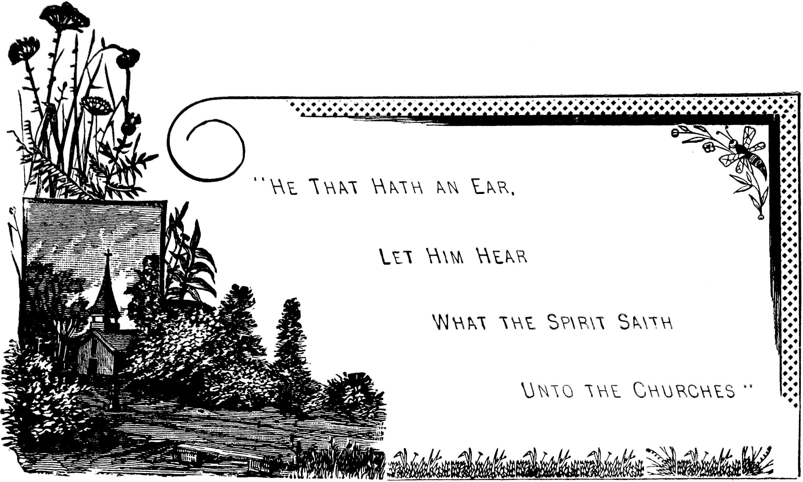

Revelation 3:1.
Revelation 3:3.
Matthew 24:33.
Daniel 7:10.
Revelation 11:18.
Daniel 8:14.
Hebrews 9:28.
Read Revelation 2:1-7, inclusive.
Matthew 18:20.
John 14:13.
1 Timothy 1:20.
2 Timothy 2:17.
2 Timothy 4:10.
2 Timothy 4:14.
1 John 2:19.
Isaiah 9:6.
See Revelation 20:4.
See 1 Kings 18, 19, 21 chapters.
See The History of the Waldenses.
Revelation 17:18.
Daniel 8:10, 13.
Daniel 8:25.
Daniel 2:35.
2 Thessalonians 1:10.
Psalm 2:8-9.
Hebrews 9:28.
Revelation 18:20-21.
1 Kings 21:23; 2 Kings 9:10, 36.
Revelation 17:16.
Revelation 22:20.
Matthew 1:1.
Isaiah 41:14.
Revelation 3:14.
Matthew 28:18.
See Revelation 12:9.
1 Corinthians 9:25; James 1:12; 1 Peter 5:4.
Colossians 3:3.
Jeremiah 23:6; 33:16.
2 Timothy 2:12; Revelation 20:6.
Ezekiel 18:4, 20.
Matthew 25:5.
Isaiah 4:1.
2 Corinthians 5:2-3.
1 John 2:28.
Mark 1:15.
Hebrews 13:14.
See Ephesians 2:4-13.
Revelation 3:10.
Revelation 3:7.
Revelation 10:1-6.
Revelation 3:11.
2 Timothy 4:8.
Revelation 3:11.

