The
Immortality
of the Soul

...is it a Scriptural Doctrine?

A. T. JONES

Source:
Bible Students’ Library No. 70
September 1890
Cover:
Soap Bubble
Raphaël Quinet (flickr.com)



Fonts:
Pristina
Liberation Sans Narrow
Linux Biolinum
Linux Libertine

January 2023
practicaprophetica.com
srac.info

Contents
Introduction 1
- The Resurrection 2
1. No Resurrection – No Immortality 5
2. No Resurrection – No Reward 7
3. Immortality Includes the Body 9
- The Second Coming of Christ 11
- The Judgment 18
Not at Death 21
At the Coming of Christ 22
Bypassing the Judgment 24
Usurping God’s Place 26
- A Clean Universe 28
Man’s Creation and Fall 28
Christ the Redeemer 28
Putting Away Sin 29
Immortalizing Sin and Suffering 30
- The Mission of Christ 33
- Christ Our Life 36
Probationary Time 36
Eternal Life Only in Christ 38
- Which Will We Believe? 42

Introduction
THE doctrine of the natural immortality of the soul is one of the oldest and one of the most widespread doctrines that has ever been in this world. It was preached in the world before ever faith in Christ the Saviour was preached.
Genesis 3
4 The serpent said unto the woman, You shall not surely die.
And from that day to this that doctrine has been believed more generally by the children of men than has the truth of God.
Indeed, in our day the doctrine of the immortality of the soul has gained such favor among even those who profess the word of God as their standard of belief, that to deny it is considered by the majority of them as equivalent to a denial of the Bible itself.
But, instead of such denial being in any way a denial of the truth of revelation, the fact is that the truth of revelation can be logically and consistently held only by the total and unequivocal denial of the doctrine of the natural immortality of the soul. This, the Scriptures plainly show.

- The Resurrection
THERE is no truth more plainly taught nor more diligently insisted upon in the Bible than this:
The future existence of men depends absolutely
upon either a resurrection of the dead
or a translation without seeing death at all.
Paul’s hope for future existence was in the resurrection of the dead. In speaking of his efforts to “win Christ,” he says,
Philippians 3
10 That I may know Him, and the power of His resurrection, and the fellowship of His sufferings, being made conformable unto His death;
11 If by any means I might attain unto the resurrection of the dead.
It was of “the hope and resurrection of the dead” that he was called in question by the council; and when he had afterward to make his defense before Felix, he declared that the resurrection of the dead was the end of his hope, saying,
Acts 24
15 And have hope toward God, which they themselves also allow, that there shall be a resurrection of the dead, both of the just and unjust.
Time and again Paul thus expresses his hope of future life.
Nor is Paul the only one of the writers of the Bible who teaches the same thing. The resurrection of the dead is that to which Job looked for the consummation of his hope.
Job 14
14 If a man die, shall he live again? all the days of my appointed time will I wait, till my change come.
15 You shall call, and I will answer you: you will have a desire to the work of your hands.
Job 17
13 If I wait, the grave is my house: I have made my bed in the darkness.
14 I have said to corruption, You are my father: to the worm, You are my mother, and my sister.
15 And where is now my hope? as for my hope, who shall see it?
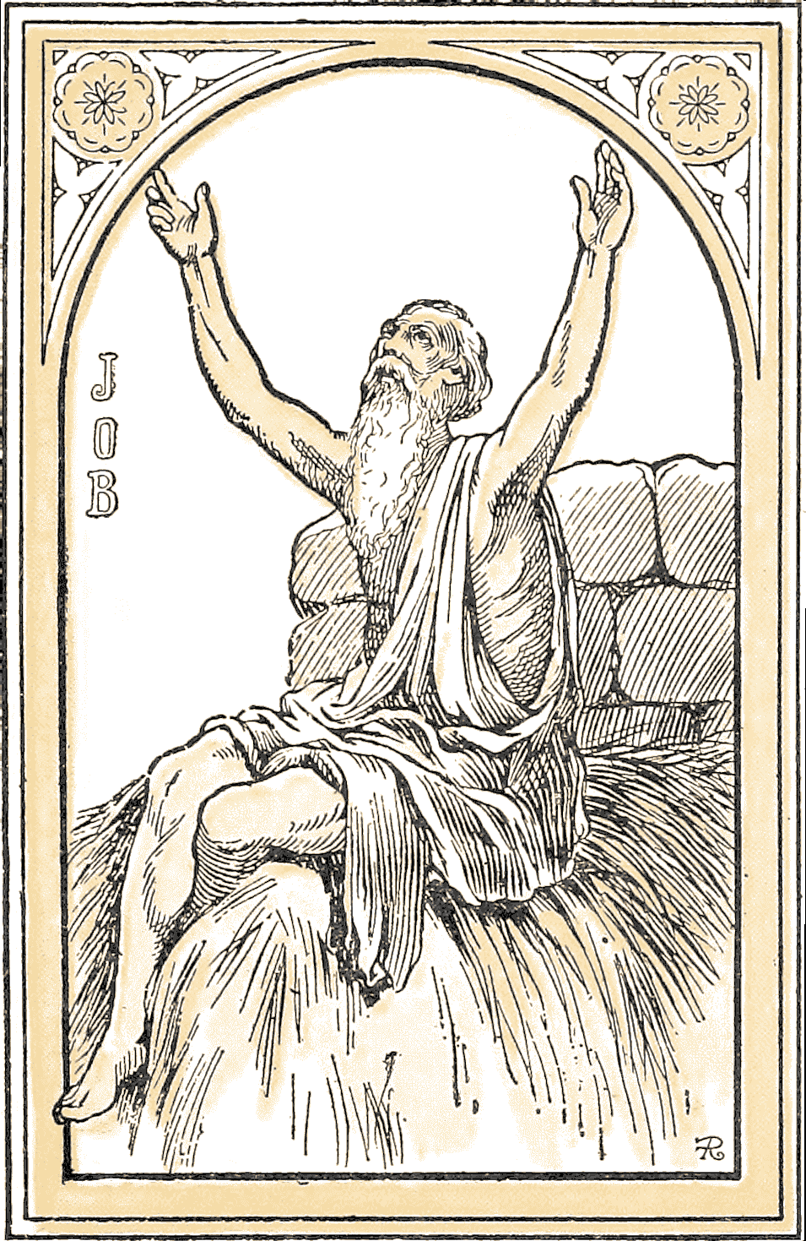
Job 19
23 Oh that my words were now written! oh that they were printed in a book!
24 That they were graven with an iron pen and lead in the rock for ever!
25 For I know that my Redeemer lives, and that He shall stand at the latter day upon the earth:
26 And though after my skin worms destroy this body, yet in my flesh shall I see God:
27 Whom I shall see for myself, and my eyes shall behold, and not another; though my reins be consumed within me.
David says,
Psalm 71
20 You which have showed me great and sore troubles, shall quicken [give life to] me again, and shall bring me up again from the depths of the earth.
And,
Psalm 17
15 As for me, I will behold your face in righteousness; I shall be satisfied when I awake with your likeness.
And what shall we more say? For the time would fail us to tell of Isaiah, and Jeremiah, and Ezekiel, and Daniel, and Hosea, and Micah, and all the prophets and apostles, and of our fathers Abraham, Isaac, and Jacob; for Jesus himself declared that it was the resurrection of the dead of which God spoke when He said,
Matthew 22
32 I am the God of Abraham, and the God of Isaac, and the God of Jacob.
More than this, Jesus pointed His disciples always to the resurrection of the dead, through which alone they could obtain the reward which He promised. In John 6:39-54 we find that no less than four times the Saviour, in giving promise to those who believe in Him, sets it forth as the consummation of that belief that “I will raise him up at the last day.” And in Luke we read:
Luke 14
13 When you make a feast, call the poor, the maimed, the lame, the blind;
14 And...you shall be recompensed at the resurrection of the just.
Paul, however, gives us, upon this subject, a straight-forward, logical argument, which leaves the doctrine of the immortality of the soul not a particle of ground to rest upon. The fifteenth chapter of 1 Corinthians is devoted entirely to an argument in proof of the resurrection of the dead. The apostle first proves, by hundreds of living witnesses who had seen Him after He was risen, that Christ arose from the dead. Still there were some who said,
“There is no resurrection of the dead.”
And in refutation of that idea, he introduces three points of argument, any one of which utterly excludes the doctrine of the immortality of the soul from any place whatever in Christian doctrine.

1. No Resurrection – No Immortality
In verse 16, his premise is,
1 Corinthians 15
16 If the dead rise not...
The first conclusion from that is,
16 ...then Christ is not raised.
Then upon this conclusion follows the logical sequence,
17 ...your faith is vain;
–and upon that another,
1 Corinthians 15
17 ...you are yet in your sins.
From his premise, “If the dead rise not,” the second conclusion is,
18 Then they also which are fallen asleep in Christ are perished.
Nothing can be plainer than that this statement and the doctrine of the immortality of the soul cannot both be true. For if the soul be immortal, as is held, it cannot perish, and, therefore, so far as its existence is concerned, it is utterly independent of the resurrection of the dead.
Is it not supposed by all those who believe the soul to be immortal that all who have passed from this world in the faith of Christ, have gone to heaven, and are now enjoying its bliss? Assuredly it is. Then, if that be the truth, upon what imaginable principle can it be conceived that they “are perished,” if there be no resurrection? What need have they of a resurrection? Have they not, without a resurrection, all that heaven can afford? Upon that theory they certainly have. Then it just as certainly appears that not one of them has perished, even though there never be a resurrection.
Over against this theory stands the word of God, that...
1 Corinthians 15
16 ...if the dead rise not,…
18 Then they which are fallen asleep in Christ are perished.
That word is the truth. Therefore it follows that if there be no resurrection of the dead, there is no hereafter for any who have ever died, or who shall ever die. But God has given assurance to all men that there shall be a hereafter, and that assurance lies in the fact…
Acts 17
31 ...that He has raised Him [Christ] from the dead.
The resurrection of Christ is the God-given pledge that there shall be a resurrection of all the dead:
1 Corinthians 15
22 For as in Adam all die, even so in Christ shall all be made alive,
–and,
Acts 24
15 ...there shall be a resurrection of the dead, both of the just and unjust.
Therefore it is by virtue of the resurrection of the dead, and not by the immortality of the soul, that there will be any hereafter for the dead, whether just or unjust.

2. No Resurrection – No Reward
The second point that the apostle makes in this connection is:
1 Corinthians 15
32 If after the manner of men I have fought with beasts at Ephesus, what advantages it me, if the dead rise not? let us eat and drink; for tomorrow we die.
On this nothing can be better than to present Dr. Adam Clarke’s comment upon this same passage:
I believe the common method of pointing this verse is erroneous; I propose to read it thus: “If, after the manner of men, I have fought with beasts at Ephesus, what does it advantage me? If the dead rise not, let us eat and drink; for tomorrow we die.” What the apostle says here is a regular and legitimate conclusion from the doctrine that there is no resurrection; for if there be no resurrection, then there can be no judgment–no future state of rewards and punishments; why, therefore, should we bear crosses, and keep ourselves under continual discipline? Let us eat and drink, take all the pleasure we can; for tomorrow we die, and there is an end of us forever.
That is sound exegesis, and a just comment upon the words of the apostle. As we have shown, that is the point of Paul’s argument throughout, and it is the thought of the whole Bible upon this subject.
But if the soul be immortal, neither Dr. Clarke’s comment nor Paul’s argument is sound. For if the soul be immortal, whensoever it may be that we die, that is not the “end of us forever,” resurrection or no resurrection. By this it is plain that the doctrine of the immortality of the soul nullifies the plainest propositions of Scripture, and is therefore false.
This view fully explains the query which Dr. Clarke propounds in his remarks at the close of his comments on 1 Corinthians. He says,
One remark I cannot help making: the doctrine of the resurrection appears to have been thought of much more consequence among the primitive Christians than it is now! How is this? The apostles were continually insisting on it, and exciting the followers of God to diligence, obedience, and cheerfulness through it. And their successors in the present day seldom mention it!...There is not a doctrine in the gospel on which more stress is laid; and there is not a doctrine in the present system of preaching which is treated with more neglect!
From the doctor’s insertion of exclamation points and his query, “How is this?” it would appear that he was surprised that it should be so. It is indeed surprising that it should be so. But it is easily enough explained. The fact is that the doctrine of the immortality of the soul has become so all-pervading “in the present system of preaching” that there is no room for the doctrine of the resurrection of the dead. If the doctrine of the immortality of the soul be true, then the doctrine of the resurrection is indeed of no consequence. If that doctrine be true, then all need of laying stress upon the gospel doctrine of the resurrection of the dead is destroyed.
And although “the apostles were continually insisting on” the doctrine of the resurrection of the dead, and although there is “not a doctrine of the gospel upon which more stress is laid,” yet it is through the insidious deceptive influence of the doctrine of the immortality of the soul that the preachers of the present day “seldom mention it,” and that in the present system of preaching there is indeed “not a doctrine that is treated with more neglect,” and nothing is needed to show more plainly than does this the irreconcilable antagonism between the truth of God and the doctrine of the immortality of the soul.

3. Immortality Includes the Body
The third point is:
1 Corinthians 15
36 That which you sow is not quickened, except it die.
To quicken is “to make alive.” What Paul says therefore is,
“That which you sow is not made alive except it die.”
That this is spoken directly of man and his resurrection, is evident from verses 42-44, “It is sown a natural body,” etc.
Now the doctrine of the immortality of the soul is that the body properly has no life, that it is not the real man, but that the soul is the real, living, sentient man, the soul which alone possesses real life. In other words, the body is only the house in which the real man lives. The real “I”—the soul,—dwells within the body, and death is simply the separation of the soul from the body. Death breaks down the house, and lets the occupant free. According to this doctrine, there is no such thing as death, because the body properly has no life, consequently it does not die, and the soul–the real man–is immortal, and it cannot die; therefore, there is in reality no such thing as death.
If this be true, there is not only no such thing as death, but there is, likewise, no such thing as a resurrection of the dead; for upon the apostle’s premise that:
1 Corinthians 15
36 That which you sow is not quickened [made alive] except it die,
–it follows that, as the body, having no life, does not die, it cannot be quickened (raised from the dead); and as the soul does not die, it cannot be raised from the dead; consequently, there is no such thing as a resurrection of the dead.
Therefore it stands proved to a demonstration that the doctrine of the immortality of the soul is utterly subversive of the doctrine of the resurrection of the dead. But the resurrection of the dead is a Bible doctrine; it is the very truth of God. So then it is plain that the doctrine of the immortality of the soul is subversive of the truth of God, and is therefore false, deceptive, and destructive.
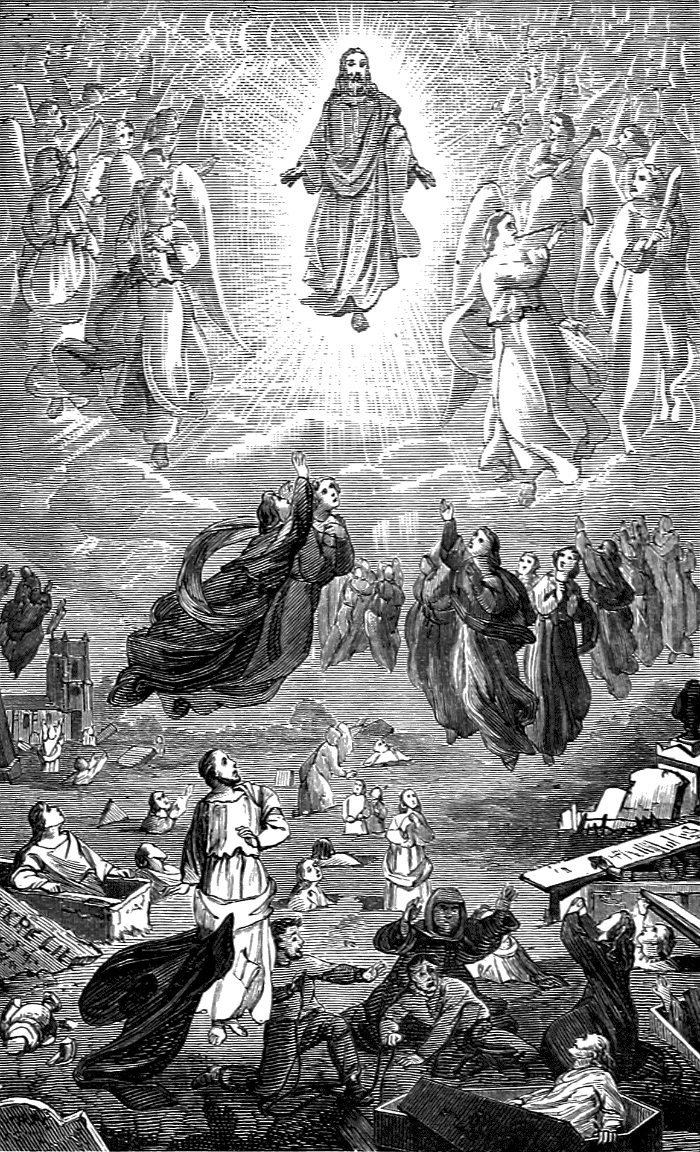Immortality and Eternal Reward at the Resurrection
(Forty Future Wonders, 1903)
- The Second Coming of Christ
THERE is another doctrine of the Bible which holds just as important a place in the divine scheme as does that of the resurrection; and that is, the second coming of the Lord Jesus Christ. This likewise is subverted by a belief in the doctrine of the natural immortality of the soul. The subversion of this truth is, in a measure, involved in that of the resurrection, because without the second coming of Christ there would be no resurrection, and anything that destroys belief in the resurrection of the dead, by that means destroys faith and hope in the second coming of the Lord.
That the event of the resurrection of the dead depends wholly upon the second coming of Christ, is easily shown by the Scripture, which, of course, in these things is the only authority. We have before shown that the righteous are rewarded only at the resurrection; and to show plainly the connection, we will repeat a verse before quoted:
Luke 14
13 When you make a feast, call the poor, the maimed, the lame, the blind.
14 And you shall be blessed; for they cannot recompense you; for you shall be recompensed at the resurrection of the just.
And of His own coming, Jesus says,
Revelation 22
12 Behold, I come quickly; and my reward is with me, to give every man according as his work shall be.
The coming of the Lord, and the resurrection of the righteous dead, are directly connected by Paul thus:
1 Thessalonians 4
16 The Lord himself shall descend from heaven with a shout, with the voice of the archangel, and with the trump of God; and the dead in Christ shall rise first;
17 Then we which are alive and remain shall be caught up together with them in the clouds, to meet the Lord in the air; and so shall we ever be with the Lord.
And again:
1 Corinthians 15
51 We shall not all sleep, but we shall all be changed,
52 In a moment, in the twinkling of an eye, at the last trump; for the trumpet shall sound, and the dead shall be raised incorruptible, and we shall be changed.
53 For this corruptible must put on incorruption, and this mortal must put on immortality.
54 So when this corruptible shall have put on incorruption, and this mortal shall have put on immortality, then shall be brought to pass the saying that is written, Death is swallowed up in victory.
55 O death, where is your sting? O grave, where is your victory?
“Then shall be brought to pass the saying.” When?
52 ...at the last trump,
–certainly;
52 ...for the trumpet shall sound, and the dead shall be raised.
When is it that the trump shall sound?
1 Thessalonians 4
15 For this we say unto you by the word of the Lord,…
16 For the Lord himself shall descend from heaven...with the trump of God; and the dead in Christ shall rise.
1 Corinthians 15
54 Then shall be brought to pass the saying that is written, Death is swallowed up in victory.
Then it is, and not till then, that men shout,
55 O death, where is your sting? O grave, where is your victory?
But through belief in the doctrine of the natural immortality of the soul, it is now sought to be made to appear that this “saying” is “brought to pass” when men die! There can be no more direct perversion of the word of God than to represent this saying as being brought to pass when men die. But what does the doctrine of the immortality of the soul care about the perversion of the word of God? The first time that the doctrine was ever uttered, it was in direct contradiction of the express word of the Lord himself. The Lord said, in the event of man’s disobedience,
Genesis 2
17 You shall surely die;
And the devil said,
Genesis 3
4 You shall not surely die.
And there is no shadow of reason to expect that the doctrine will, in reality, ever assume any other position.
It is not alone a perversion of Scripture to so apply the “saying” in question; it is alike a perversion of the plainest principles of reason and experience. For instance, here are death and a saint of God struggling for the mastery. Presently death obtains the mastery. The saint lies lifeless; death has the victory. When he is dead, is that a time to claim victory over death? When he is being lowered into the grave, is that a time to shout the victory over the grave? Nay, verily. But it is not to be always so. There is One who exclaims,
Revelation 1
18 I am He that lives, and was dead; and, behold, I am alive for evermore, Amen; and have the keys of hell [the grave] and of death.
And when that glorious One...
1 Thessalonians 4
16 ...shall descend from heaven with a shout, with the voice of the Archangel, and with the trump of God,
–and with power that bursts the bars of the cruel grave and destroys the strength of death, then the saint arises triumphant over death, and...
1 Corinthians 15
54 ...then shall be brought to pass the saying that is written, Death is swallowed up in victory.
Then the saint can shout exultingly,
55 O death, where is your sting? O grave, where is your victory?
And,
57 Thanks be to God, which gives us the victory through our Lord Jesus Christ.
And thrice thanks, yea,
1 Peter 1
3 Blessed be the God and Father of our Lord Jesus Christ, which according to his abundant mercy has begotten us again unto a lively hope by the resurrection of Jesus Christ from the dead.
However, it is not alone through the subversion of the doctrine of the resurrection that the doctrine of the immortality of the soul strikes against the coming of the Lord. The issue is directly joined. For by those who believe in the natural immortality of the soul, it is held that those who die in the Lord go straight to heaven; that they go direct to the place where the Lord is; and so they sing,
Then persevere till death
Shall bring you to your God;
He’ll take you, at your parting breath,
To His divine abode.
And obituaries are actually written by them such as the following, which we read not long since in the Christian Cynosure:
“Alvah Palmer went to heaven from [a certain place in New York].”
And then the notice went on to tell when and of what he died, etc. And Dr. Talmage, in relating how a certain saintly woman was “emparadised,” tells how the chariot of Elijah was outdone; for there it must have taken some little time to turn out the chariot and hitch up the horses; but here, in this instance, the transition was all made instantaneously, without waiting for either horses or chariot! And all this when a person died! These are only notable expressions of the common idea of those who believe in the doctrine of the natural immortality of the soul.
Now, if these things be true, if it be true that death brings people to God; that men and women go direct to heaven from their homes in this world, and this so instantaneously that there is no time to get ready the chariot of God, as was done when Elijah went without dying at all, we say if these things be true, then there is literally no place left for the coming of the Lord. It would be simply the height of absurdity to talk about the Lord’s coming to this world after people who are not here at all, but are, and have been, for years and hundreds of years, in heaven,—in the very place which He leaves to come here!
This is why the doctrine of the coming of the Lord is so neglected, so despised, in fact. Believing this, and there is no need to believe in the coming of the Lord; indeed, it is a palpable inconsistency to believe in it. Believing this, and there is no need to look, or wait, for the coming of the Lord; all there is for such to do is to wait till death shall come and take them; and so death,–“the last enemy,” “the king of terrors,”–is given the place and the office of Him who is our life, of...
Revelation 1
5 [Him that] loved us, and washed us from our sins in His own blood.
But this belief is not the “belief of the truth.” There is no element of truth, in any form, in the idea of people going to God or to heaven when they die. Christ himself said as plainly as tongue can speak,
John 13
33 Where I go, you cannot come.
Then when his disciples were troubled because of these words, He told them, in words equally plain, of the event upon which they must place their only hope of being with Him where He is, and that event is,
John 14
3 I will come again, and receive you unto myself, that where I am, there you may be also.
And the word “that” shows positively that it is the only way in which men may ever be with Him where He is. Therefore the coming of the Lord is the Christian’s hope. And the doctrine of the immortality of the soul, in supplanting, as it certainly does, the doctrine of the coming of the Lord, supplants the Christian’s hope. Then when the doctrine of the immortality of the soul sends men to heaven:
- before the end of the world,
- before the sounding of the last trump,
- before the time when the Lord himself shall descend from heaven and raise the dead,
- before He appears in the clouds of heaven with power and great glory, and sends His angels to gather together His elect,
–when the doctrine of the immortality of the soul puts men into heaven before the occurrence of these events, it does it in defiance of the word of Christ, which lives and abides forever.
Therefore we say it stands proved that the belief of the doctrine of the immortality of the soul is subversive of the doctrine of the second coming of Christ, and, in that, is subversive of the truth of God.

- The Judgment
THE judgment is one of the certainties of Bible doctrine. Time and again Jesus sets before us the awful scenes and the all-important decisions of the judgment.
Matthew 12
36 I say unto you, That every idle word that men shall speak, they shall give account thereof in the day of judgment.
Luke 11
31 The queen of the South shall rise up in the judgment with the men of this generation, and condemn them; for she came from the utmost parts of the earth to hear the wisdom of Solomon; and, behold, a greater than Solomon is here.
32 The men of Nineveh shall rise up in the judgment with this generation, and shall condemn it; for they repented at the preaching of Jonas; and, behold, a greater than Jonas is here.
In the parables of:
- the wheat and tares; Matthew 13:24-30;
- the marriage of the king’s son; Matthew 22:1–14;
- the talents; Matthew 25:14–30;
–in fact, in all His teaching, the judgment was made prominent. In Matthew 25:31–46, he sets before us a view of the very judgment itself.
Matthew 25
31 When the Son of man shall come in His glory, and all the holy angels with Him, then shall He sit upon the throne of His glory:
32 And before Him shall be gathered all nations: and He shall separate them one from another, as a shepherd divides his sheep from the goats:
33 And He shall set the sheep on His right hand, but the goats on the left.
34 Then shall the King say unto them on His right hand, Come, you blessed of my Father, inherit the kingdom prepared for you from the foundation of the world:
35 For I was hungry, and you gave me meat: I was thirsty, and you gave me drink: I was a stranger, and you took me in:
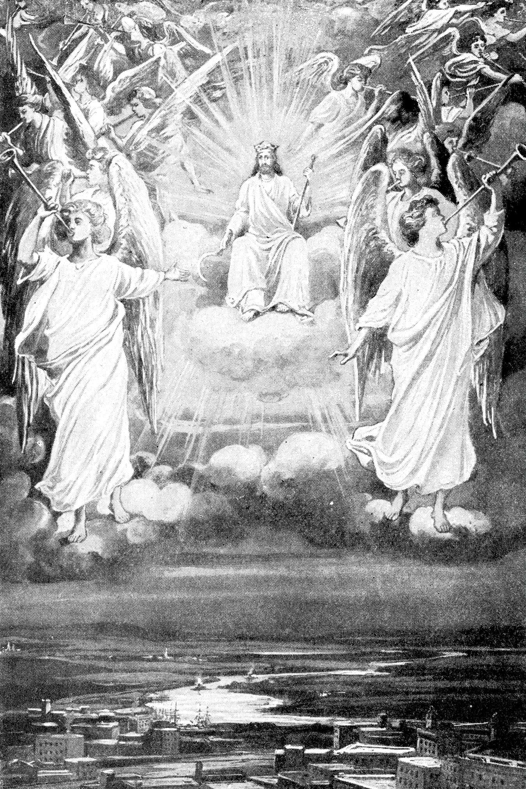Christ coming in Glory
(A World in Perplexity, 1918)
36 Naked, and you clothed me: I was sick, and you visited me: I was in prison, and you came unto me.
37 Then shall the righteous answer Him, saying, Lord, when did we see You hungry, and fed You? or thirsty, and gave You drink?
38 When did we see You a stranger, and took You in? or naked, and clothed You?
39 Or when did we see You sick, or in prison, and came unto You?
40 And the King shall answer and say unto them, Verily I say unto you, Inasmuch as you have done it unto one of the least of these my brethren, you have done it unto me.
41 Then shall He say also unto them on the left hand, Depart from me, you cursed, into everlasting fire, prepared for the devil and his angels:
42 For I was hungry, and you gave me no meat: I was thirsty, and you gave me no drink:
43 I was a stranger, and you took me not in: naked, and you clothed me not: sick, and in prison, and you visited me not.
44 Then shall they also answer Him, saying, Lord, when did we see You hungry, or thirsty, or a stranger, or naked, or sick, or in prison, and did not minister unto You?
45 Then shall He answer them, saying, Verily I say unto you, Inasmuch as you did it not to one of the least of these, you did it not to me.
46 And these shall go away into everlasting punishment: but the righteous into life eternal.
The Old Testament as well as the New tells of the judgment. Solomon says,
Ecclesiastes 12
13 Let us hear the conclusion of the whole matter: Fear God, and keep His commandments; for this is the whole duty of man.
14 For God shall bring every work into judgment, with every secret thing, whether it be good, or whether it be evil.
Daniel says,
Daniel 7
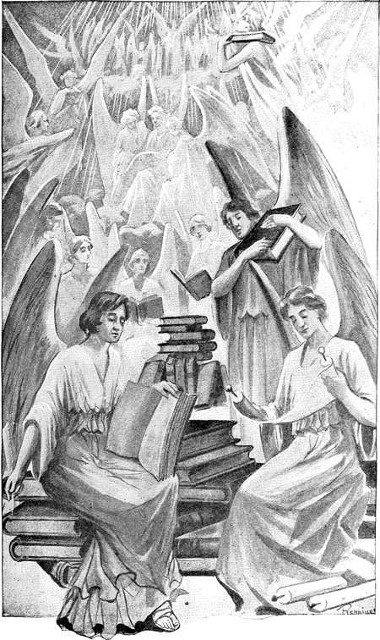“The books were opened.”
9 I beheld till the thrones were cast down, and the Ancient of Days did sit, whose garment was white as snow, and the hair of His head like the pure wool; His throne was like the fiery flame, and His wheels as burning fire.
10 A fiery stream issued and came forth from before Him; thousand thousands ministered unto Him, and ten thousand times ten thousand stood before Him; the judgment was set, and the books were opened.
Isaiah, David, Job, and other prophets speak of this, as well as Solomon and Daniel. Even…
Jude
14 Enoch, the seventh from Adam, prophesied of this, saying, Behold, the Lord comes with ten thousands of his saints,
15 To execute judgment upon all.

Not at Death
This is not a judgment that is constantly going on during men’s lives and completed at their death, so that then their reward is given, whether for good or ill.
Hebrews 9
27 It is appointed unto men once to die, but after this the judgment.
Acts 24
25 [Paul] reasoned of righteousness, temperance, and judgment to come,
–not judgment already come, nor constantly going on. There is a time appointed for the judgment
Acts 17
31 Because He has appointed a day in which He will judge the world in righteousness by that man whom He has ordained; whereof He has given assurance unto all men, in that He has raised Him from the dead.
Romans 2
12 As many as have sinned without law shall also perish without law; and as many as have sinned in the law shall be judged by the law;
16 In the day when God shall judge the secrets of men by Jesus Christ, according to my gospel.
And again:
2 Corinthians 5
10 We must all appear before the judgment seat of Christ; that everyone may receive the things done in his body, according to what he has done, whether it be good or bad.
It is not that alone that he has done in his direct personal acts for which he must account; he must answer for the fruit of his doings:
Jeremiah 17
10 I the Lord search the heart, I try the reins, even to give every man according to his ways, and according to the fruit of his doings.

At the Coming of Christ
The time when men shall receive for that which they have done, whether it be good or bad, is at the coming of Christ, the resurrection of the dead, and the end of the world.
Revelation 11
15 And the seventh angel sounded; and there were great voices in heaven, saying, The kingdoms of this world are become the kingdoms of our Lord and of his Christ; and He shall reign forever and ever.
18 And the nations were angry, and your wrath is come, and the time of the dead that they should be judged, and that you should give reward unto your servants the prophets, and to the saints, and to them that fear your name, small and great; and should destroy them which destroy the earth.
Again we quote the words of Jude:
Jude
14 And Enoch also, the seventh from Adam, prophesied of these, saying, Behold, the Lord comes with ten thousands of His saints,
15 To execute judgment upon all, and to convince all that are ungodly among them of all their ungodly deeds which they have ungodly committed, and of all their hard speeches which ungodly sinners have spoken against Him.
With this agree exactly the words of Christ:
Revelation 22
12 Behold, I come quickly; and my reward is with me, to give every man according as his work shall be.
And Paul, in his charge to Timothy, and to all ministers of Christ, says:
2 Timothy 4
1 I charge you before God, and the Lord Jesus Christ, who shall judge the quick [living] and the dead at His appearing and His kingdom:
2 Preach the word.
Peter also says,
2 Peter 2
9 The Lord knows how to deliver the godly out of temptations, and to reserve the unjust unto the day of judgment to be punished.
More texts might be given on these points, but these are sufficient. From these it is plain that:
- There is a time “appointed” for the judgment;
- This is after death;
- It is the time of reward to all, for good or evil;
- This is called the “day of judgment;”
- It is at the appearing and kingdom of the Lord Jesus Christ;
- Then, and not till then, it is that the righteous receive their reward; and
- The “unjust” are “reserved” until that time to be punished, and are not punished before that great day of judgment.

Bypassing the Judgment
Yet, however plain all this may be, it is equally plain that there is not one of these propositions that the doctrine of the natural immortality of the soul does not tend to subvert. For if, at death, righteous men enter immediately into their reward, and the unrighteous go immediately to the place of punishment, then where is there any possible room for the judgment (unless, perhaps, the absurd idea be adopted that men should spend hundreds or thousands of years in happiness or misery, and then be brought to the judgment to see whether they be worthy of that which they have enjoyed or suffered!!)?
For if at death men enter immediately into their reward or punishment, as the case may be, then it follows, if there be any judgment at all, that instead of there being a time “appointed” “after this” for judgment, there must necessarily be a judgment constantly going on in the life of each individual, and that the judgment closes at his death, and that he in consequence of judgment passed enters then upon his destiny, whether for good or for ill.
It can be seen at a glance that such a view is utterly subversive of the Bible doctrine of the judgment. If such be the truth, then:
- There can be no such thing as a day of judgment when the Lord comes with ten thousands of His saints to execute judgment upon all, because all are judged as fast as they die;
- There can be no such thing as Christ judging the living and the dead at His appearing and His kingdom, because all the dead have been judged when they died;
- There can be no such thing as the “time of the dead that they should be judged” when the seventh angel sounds, and the kingdoms of this world become the kingdoms of our Lord, and of His Christ, for all the dead will have been judged before the seventh angel shall have sounded;
- And there can be no such thing as reserving “the unjust unto the day of judgment to be punished,” because by this theory they are sent to punishment as soon as they die.
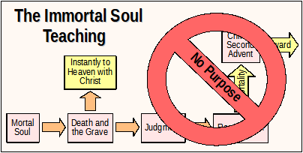
In short, if the doctrine of the immortality of the soul be the truth, the Bible doctrine of the judgment cannot be the truth. And the time has now come when a choice must be made between them. As for us, we choose the Bible, with all its doctrine, and with all that that choice involves.
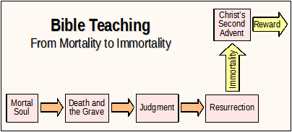
That we do not misrepresent the popular doctrine of the immortality of the soul when we say that it puts men into heaven or hell at death, can be proved by anyone who will consult the hymn books, or the papers of the religious denominations that believe that doctrine, or listen to the average funeral discourse or revival sermon.

Usurping God’s Place
But that the doctrine of the immortality of the soul is subversive of the Bible doctrine of the judgment is not all. By virtue of that doctrine, men have usurped the seat of the Judge of all, and have arrogated to themselves the prerogative of reading into heaven whomsoever they see fit. How often we read that such and such a person is in heaven! But what right has any man to say who is worthy of a place in that bright world? Who knows the heart? None but God alone. He alone it is who pronounces upon the worthiness of men…
Luke 20
35 ...to obtain that world, and the resurrection from the dead,
–and when men take upon themselves to read into heaven this man or that man, they are simply usurping the awful prerogative of the Most High. And without a belief in the doctrine of the natural immortality of the soul, no man would ever think of it.
We repeat: It is God alone to whom belongs the right to pronounce that decision. He will pronounce it in every case, but it will be in the judgment; not at death, but at the resurrection of the dead, and before the assembled universe, and by the voice of the glorious Son of God, who has loved us and has washed us from our sins in His own blood; for:
John 5
27 [He] has given Him authority to execute judgment also, because He is the Son of man.
28 Marvel not at this: for the hour is coming, in which all that are in the graves shall hear His voice,
29 And shall come forth; they that have done good, unto the resurrection of life; and they that have done evil, unto the resurrection of damnation.
Any doctrine that will lead men to thus usurp the prerogative of the Judge of all the earth, cannot be the truth. This is exactly what the doctrine of the immortality of the soul does, therefore it cannot be the truth; and as it is subversive of the Bible doctrine of the judgment, it is not only not the truth, but the belief of it is subversive of the truth.
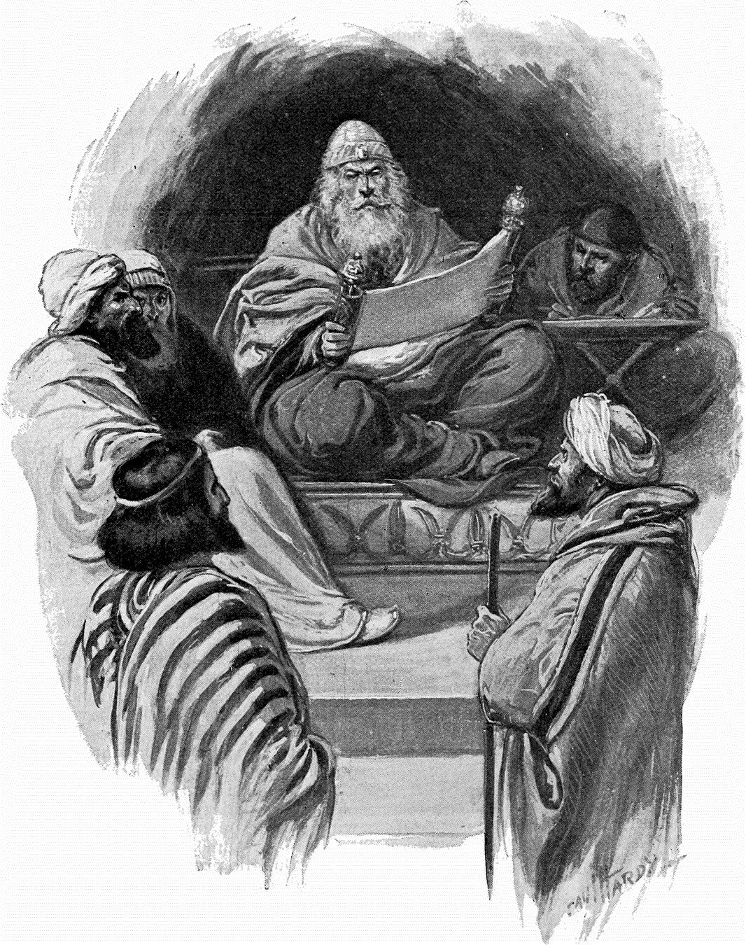The Judge passes sentence, not the people.
(The Art Bible, 1896)
- A Clean Universe

Man’s Creation and Fall
GOD created man upon the earth, and gave him dominion over all upon it. He made him, not as the angels, but lower than they–inferior to the angels:
Psalm 8
5 For You have made him a little lower than the angels, and have crowned him with glory and honor.
Hebrews 2 [margin]
7 You made him a little while inferior to the angels; You crowned him with glory and honor, and did set him over the works of your hands.
God made man upright, but through the deception of Satan he turned to crooked ways–he sinned. And although God had put all things in subjection under him, and “left nothing” that was not “put under him,” yet now, says Paul,
8 We see not yet all things put under him.
Through sin he has been deprived of his glory, and honor, and dominion, which God gave him, and which the Lord intended that he should forever enjoy. This sin was brought upon him by Satan, and, hard upon sin, death followed.

Christ the Redeemer
But when man had thus sold himself under sin, God gave by promise, and in the “fullness of time” He gave in fact, His only-begotten Son,
John 3
16 ...that whosoever believes in Him should not perish, but have eternal life.
When man had so sold himself under sin, under the curse, God gave His dear Son to redeem him from sin, from the curse, and from all condemnation.
Romans 8
1 There is therefore now no condemnation to them which are in Christ Jesus, who walk not after the flesh, but after the Spirit.
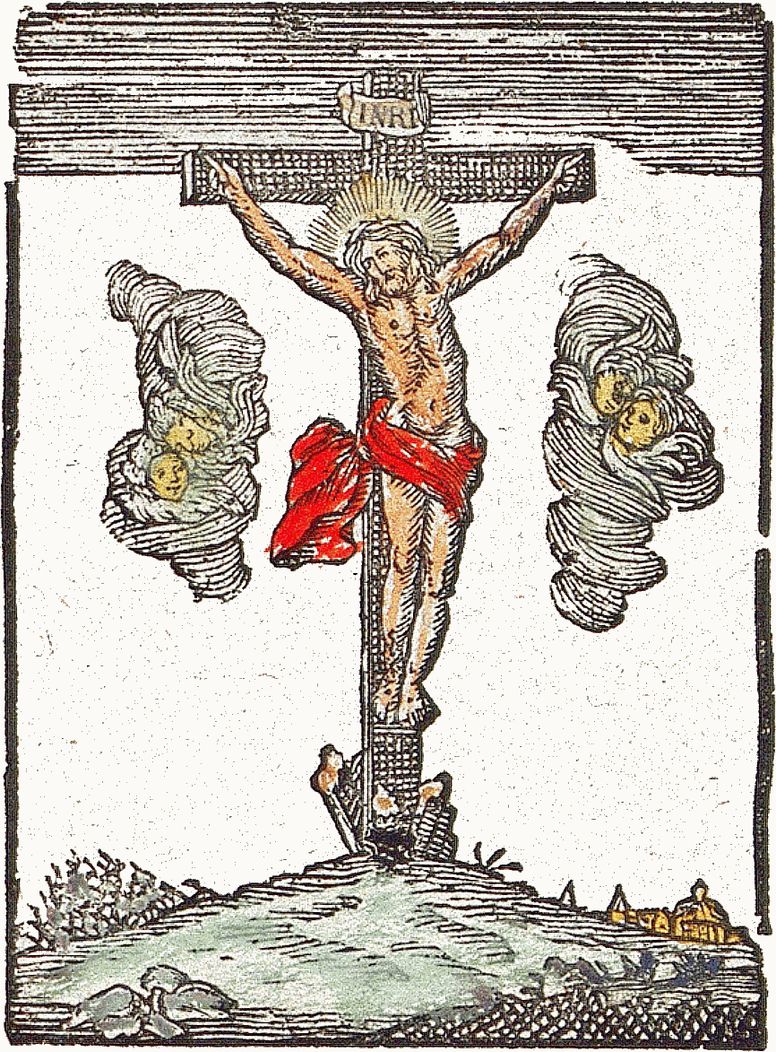
Galatians 3
13 Christ has redeemed us from the curse of the law, being made a curse for us; for it is written, Cursed is everyone that hangs on a tree.
2 Corinthians 5
21 He has made Him to be sin for us, who knew no sin; that we might be made the righteousness of God in Him.
Romans 8
3 For what the law could not do, in that it was weak through the flesh, God sending His own Son in the likeness of sinful flesh, and for sin, condemned sin in the flesh;
4 That the righteousness of the law might be fulfilled in us, who walk not after the flesh, but after the Spirit.

Putting Away Sin
To put away sin and plant righteousness in its stead, is the mission of Christ to this world. That He might accomplish this, He had to make the awful sacrifice of himself, the Creator of the universe.
Hebrews 9
26 Now once in the end of the world has He appeared to put away sin by the sacrifice of himself.
By the greatness of the sacrifice we may judge of the enormity of sin, and how abhorrent it is in the sight of God, and also how widely contrary it is to every principle of the government of the King of eternity. To deliver man from its thralldom He spared not His own Son. Rather than to see the blight and stain of sin upon the fair face of his universe, God gave up the “Son of His love” to die the cruel death of the accursed tree. John says:
1 John 3
8 He that commits sin is of the devil; for the devil sinned from the beginning. For this purpose the Son of God was manifested, that He might destroy the works of the devil.
The work of the devil is sin; for he said, “he that commits sin is of the devil.” Therefore when it is said that the Son of God was manifested to destroy the works of the devil, it is simply expressing, in other words, that which we quoted from Paul, that Christ appeared to put away sin.
As therefore Christ’s mission is to destroy the works of the devil–to put away sin–it follows that as long as there is a vestige of sin remaining, His mission is not accomplished. Whatever, therefore, tends to perpetuate sin, tends just so far to delay the accomplishment of the mission of Christ. And if by any means sin were made eternal, the inevitable result would be to nullify and subvert the mission of Christ.

Immortalizing Sin and Suffering
Now that is exactly what is done by the doctrine of the natural immortality of the soul. The very meaning of the word immortal being “not subject to death,” it follows that if the soul be immortal, it must live eternally, whatever its condition may be; and from this again it follows that when the awful sentence is pronounced,
Revelation 22
11 He that is unjust, let him be unjust still,
–whatsoever soul it be that shall then be unjust must live so to all eternity; which is simply to make sin eternal, and so to subvert the mission of Christ.
That sin is to be eternal is strenuously maintained by those who believe that the soul is immortal. This is shown positively in the doctrine of the eternal torment of the wicked. In fact, the belief in the eternal torment of the wicked is simply the necessary consequence of the belief in the immortality of the soul. We know, for the word of God says it, that the wicked will be punished. We know likewise, by the same authority, that they will be punished as long as they live (aion: a life-time). Now if they live eternally, it is evident that they will be in pain eternally. But the word of God says just as plainly that the wicked shall die as it says anything at all about them.
Romans 6
23 The wages of sin is death.
Ezekiel 18
4 The soul that sins, it shall die.
That word tells us of a time when...
Revelation 5
13 ...every creature which is in heaven, and on the earth, and under the earth, and such as are in the sea, and all that are in them, [shall be heard saying,] Blessing, and honor, and glory, and power, be unto Him that sits upon the throne, and unto the Lamb for ever and ever.
This scripture can never be fulfilled if the doctrine of eternal suffering be true, or, in other words, if the doctrine of the immortality of the soul be true; for every living intelligence joins in the song of joy and praise. Again, we read of a time when...
Revelation 21
4 ...there shall be no more death, neither sorrow, nor crying, neither shall there be any more pain; for the former things are passed away.
If the doctrine of eternal suffering be the truth, it is literally impossible that there can ever come a time when there shall be “no more pain.”
But there stands that faithful word, that there is coming a time when there shall be no more pain; there is coming a time when every voice in the universe will ascribe…
Revelation 5
13 ...honor, and glory, and power...unto Him that sits upon the throne, and unto the Lamb forever and ever.
This is the truth of God; He has given His only-begotten Son that it might be accomplished; and we have seen that the mission of the Son is declared to be...
Hebrews 9
26 ...to put away sin,
1 John 3
8 ...[to] destroy the works of the devil.
And the doctrine of the immortality of the soul, in making sin eternal, and in immortalizing the works of the devil, frustrates the purpose of God and subverts the mission of Christ.

- The Mission of Christ
THE doctrine of the natural immortality of the soul makes the body only worthless clay, formed into a prison that binds, and fetters, and clogs the free action of the soul, while death is the friendly messenger that bursts the prison bars, and sets free the aspiring soul to seek its native sphere. One of the most influential of American preachers said lately, of one who had died, that the person...
...is living, and more thoroughly living today than any of us who are clogged and hampered and chained down by earthly impediment.
This is simply the expression of the common belief of those who hold to the idea that the soul is immortal. Embodied in meter so that it can be sung, it runs on this wise:
Why should we start and fear to die?
What timorous worms we mortals are!
Death is the gate to endless joy;
And yet we dread to enter there.
Now we read in the word of God as follows:
Hosea 13
14 O death, I will be your plagues.
And again we read that:
1 Corinthians 15
26 The last enemy that shall be destroyed is death.
Can it be that God is going to visit with plagues, and destroy, the gate to endless joy? Is He so displeased to have His creatures entering into endless joy that He is determined to destroy the very means by which they enter that blissful state? If the words of this preacher, the language of this hymn, and the doctrine upon which they are founded, be the truth, then the Lord is going to do just the thing that is here pointed out, that is, He is going to visit with plagues, and destroy, the gate to endless joy.
But this is not all. We read further of Christ:
Hebrews 2
14 Forasmuch then as the children are partakers of flesh and blood, He also himself likewise took part of the same; that through death He might destroy him that had the power of death, that is, the devil.
Granting the claim that death is the gate to endless joy, then from this scripture it follows, just as absolutely as logic can demonstrate, that the devil, having the power of death, is the gate-keeper. And so the Lord is not only going to destroy this “gate to endless joy,” but He is going to destroy him that keeps it.
Nor yet is this all. Granting not only the claim based upon the doctrine of the immortality of the soul, that death is the gate to endless joy, but also that the soul is clogged, and hampered, and imprisoned by its confinement in the body, and that it is released by death, it follows that if there had never been any death in the world, no soul could have ever been set free, and there never would have been any gate to endless joy.
And as it was the devil who brought death into the world, therefore, under that doctrine, to him must be accorded the honor of setting men free from this world, and of creating and opening to men the gate of endless joy. But this is the very thing that Christ says that He himself came to do. He says:
John 14
6 I am the way, the truth, and the life; no man comes unto the Father but by me.
John 10
9 I am the door; by me if any man enter in, he shall be saved.
Therefore when the doctrine of the immortality of the soul makes death the gate to endless joy, and the friendly messenger that releases men from this world, it supplants the Saviour of the world, and bestows upon Satan the honor that is due to Christ.
And by all this we lay against the doctrine of the natural immortality of the soul the legitimate and logical charge that it frustrates the purpose of God, that it nullifies the mission of Christ, and supplants the Saviour of the world. And if anything more is needed to show that between that doctrine and the truth of God there is a difference wide as eternity, it will be found in the next chapter.

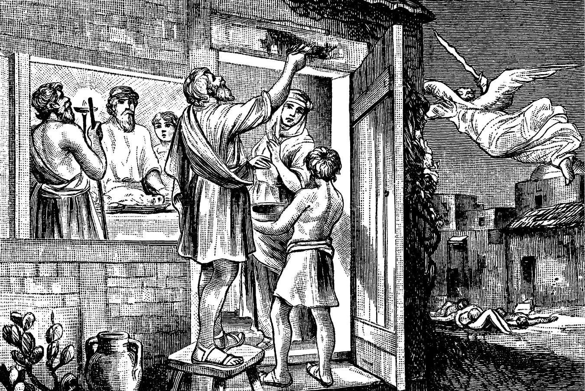Jesus is the Door and the Way
(Biblische Geschichten fur Unterklassen, 1893)
- Christ Our Life
Romans 6
23 For the wages of sin is death; but the gift of God is eternal life through Jesus Christ our Lord.
Romans 5
12 ...sin entered into the world, and death by sin; and so death passed upon all men, for that all have sinned.
Romans 3
23 For all have sinned, and come short of the glory of God.
BUT when man had sinned, and thus brought himself under the doom of death, then Christ, the only-begotten Son of God, presented himself, and was accepted of God, in man’s behalf. God had before pronounced the penalty of death against transgression, and Adam would have died the day he sinned had not the Son of God interceded in his behalf, and presented himself in satisfaction of the demands of the broken law of God.

Probationary Time
But by the love of Christ and the mercy of God, man was given a second probation, a second opportunity to attain to righteousness. Only for the mediation of Christ, the race of man would have ceased the day that Adam sinned. Only for Christ, there never would have lived a man after Adam. So that every man who has ever lived, or who shall ever live, from the sin of Adam to the end of the world, owes that life to the fact that Christ, the Son of God, offered himself when Adam sinned.
This is shown in the words of Christ:
John 10
10 I am come that they might have life, and that they might have it more abundantly.
Christ offering himself in behalf of Adam is the only means by which men have life at all:
10 I am come that they might have life.
But this life is only temporal. It is only extended as an opportunity for man to prove himself worthy of eternal life, that he may show himself worthy of having life more abundantly; for as Christ said, He is come that they might have life,
John 10
10 ...and that they might have it more abundantly.
The way in which men use the life which is already given, will decide whether they shall have life more abundantly, or whether they shall have life at all. The man who shows himself abusive of the trust of God, and ungrateful for His favor shown in granting this life, only shows himself unworthy of that which he already has, and much less can he be intrusted “more abundantly” with anything pertaining to life.
In this view is contained the very basic principle of the lesson inculcated in the parable of the unjust steward:
Luke 16
10 He that is faithful in that which is least, is faithful also in much; and he that is unjust in the least, is unjust also in much.
11 If therefore you have not been faithful in the unrighteous riches, who will commit to your trust the true riches?
12 And if you have not been faithful in that which is another man’s, who shall give you that which is your own?
And also in the lesson of the parable of the talents:
Matthew 25
29 Unto everyone that has shall be given, and he shall have abundance; but from him that has not shall be taken away even that which he has.
If men will turn to purposes of iniquity, and transgression, and sin, a life which is committed to them for a time, how can the Lord commit to them this gift for eternity? If this life, which is not their own, they will devote simply as an instrument of unrighteousness unto sin, to rebellion, and unfaithfulness to Him who gives it, how shall He give to such immortal life–a life which, not being subject to cessation, may properly be called their own? To do so would be only to subvert His own authority and the principles of His government. Such a thing He will never do.
But such as devote this life to the honor of Him who gives it, and to righteousness before Him, to them will be given life “more abundantly,” even eternal life, in which to honor and glorify Him; while from all who do not so shall be taken away even that which they have.
Acts 10
34 Of a truth...God is no respecter of persons;
35 But in every nation he that fears Him, and works righteousness, is accepted with Him.
The righteousness which is acceptable with God is the righteousness...
Romans 3
22 ...which is by faith of Jesus Christ unto all and upon all them that believe; for there is no difference;
23 For all have sinned, and come short of the glory of God.
Hebrews 5
9 He became the Author of eternal salvation unto all them that obey Him.

Eternal Life Only in Christ
John 3
16 God so loved the world, that He gave His only-begotten Son, that whosoever believes in Him should not perish, but have everlasting life.
Christ’s coming to this world was not in vain. He came for a purpose, and that purpose is that those who will believe in Him may not perish, but have eternal life. And as surely as those who believe in Him shall have eternal life, just so surely those who do not believe in Him shall perish. If not, if those who do not believe in Him do not perish, then this record which He has given cannot be true.
If, by virtue of the immortality of the soul, those who do not believe in Christ live as long as those who do, then where is there any point in these scriptures? We know full well the meaning that is put upon the word “perish” by those who believe in the doctrine of the natural immortality of the soul; that is, that it means eternal life in misery. But no such idea is contained in the Scripture. Eternal life is the heritage of those who believe in Christ, and of those alone. Nor will language allow any such meaning to be put upon the word “perish.” That word is defined thus:
Perish: to be destroyed; to go to destruction; to pass away; to come to nothing; to be blotted from existence; to die; to lose life.
This is Webster’s definition of perish; and every part of it can be duplicated time and again from the Scriptures. But no part of this definition can be true if the soul be immortal.
In Psalm 37 we read:
Psalm 37
10 For yet a little while, and the wicked shall not be; yea, you shall diligently consider his place, and it shall not be.
Again, in Isaiah, we read a promise of what the Lord will do with those who contend with the “seed of Abraham,” “the friend of God:”
Isaiah 41
11 Behold, all they that were incensed against you shall be ashamed and confounded; they shall be as nothing; and they that strive with you shall perish.
12 You shall seek them, and shall not find them, even them that contended with you; they that war against you shall be as nothing, and as a thing of nought.
But to the meek, to those who learn of Christ, it is promised:
Psalm 37
11 But the meek shall inherit the earth; and shall delight themselves in the abundance of peace.
28 ...the seed of the wicked shall be cut off
29 The righteous shall inherit the land, and dwell therein forever.
All is summed up by the Lord Jesus in one sentence, as follows:
John 3
36 He that believes on the Son has everlasting life; and he that believes not the Son shall not see life.
And again:
John 6
53 Verily, verily, I say unto you, Except you eat the flesh of the Son of man, and drink His blood, you have no life in you.
If these scriptures, from the first to the last, do not show that future life is obtained only in Christ, then it would be impossible for the Lord himself to put words together that would show such a thing. If the Lord wanted to tell men that without believing in Christ they could have no life; that without believing in Him they should perish; if He wanted to tell them that the gift of God is eternal life through Jesus Christ, how would it be possible to tell them so more plainly than He has already told, in the words quoted?
Yet in defiance of these plain, positive scriptures, and in direct subversion of them, the doctrine of the immortality of the soul, which gives to all men immortal life irrespective of Christ, is held by the majority of professed Christians as a veritable article of Christian faith.
Why is it that men will not believe the record that God has given on this subject? Why is it that they will not believe that future life is given alone through Christ? It is no light thing to disbelieve this. Many seem to think, and will even so express themselves, that it makes no difference particularly whether this be believed or not. But it does make a difference. We state it as the simple truth that not to believe that eternal life for man is in Christ alone, is one of the greatest insults that can be offered to the God of heaven.
Please read carefully the following scripture, and see whether we have stated more than the exact truth:
1 John 5
10 He that believes not God has made Him a liar; because he believes not the record that God gave of His Son.
11 And this is the record, that God has given to us eternal life, and this life is in His Son.
12 He that has the Son has life; and he that has not the Son of God has not life.
Here is the plain statement that to believe not a certain “record” is to make God a liar. That record is just as plainly stated to be that the eternal life that is given us “is in the Son” of God, and that:
12 He that has not the Son of God has not life.
Now the doctrine of the immortality of the soul causes men not to believe that record. They who believe the doctrine of the immortality of the soul do not believe that they who have not the Son of God have not life. Therefore the doctrine of the immortality of the soul “has made God a liar,” because it causes men to...
10 ...believe not the record that God gave of his Son.
11 And this is the record, that God has given to us eternal life, and this life is in his Son.
12 He that has the Son has life; and he that has not the Son of God has not life.
Therefore we say that not to believe that future life is given us in Christ alone, is to insult the God of heaven by making Him “a liar.” It does make a difference how we believe on this question; for when God is made a liar, He ceases to be Jehovah, He ceases to be God.

- Which Will We Believe?
NOR is that all; for when the Lord is thus removed from His throne, Satan is put into His place. In the event of man’s sinning,
GOD SAID, “You shall surely die.”
SATAN SAID, “You shall not surely die.”
Which of these told the truth? It is impossible for both to be true. The doctrine of the immortality of the soul teaches that the devil told the truth, for that doctrine teaches that there is no death, and if there be no death, then every man has life, independent of belief in Christ, which, as we have read from the word, makes God a liar. Therefore, the doctrine of the immortality of the soul sets God aside as a liar, and exalts Satan as the one who tells the truth, and as the one who is to be believed.
Here we close our investigation of this subject. These evidences certainly show that the doctrine of the immortality of the soul is subversive of the truth of God. We have proved by logical deduction from sound Scripture premises, that the doctrine of the immortality of the soul:
- is subversive of the doctrine of the resurrection of the dead;
- is subversive of the doctrine of the coming of the Lord;
- is subversive of the doctrine of the judgment;
- is subversive of the mission of Christ;
- supplants Christ in the honor of opening the way from this world to another, and bestows that honor upon Satan; and finally,
- puts God aside as a liar, and exalts Satan to His place as the one who tells the truth.
The logical summary of all this is contained in one word:
Spiritualism.
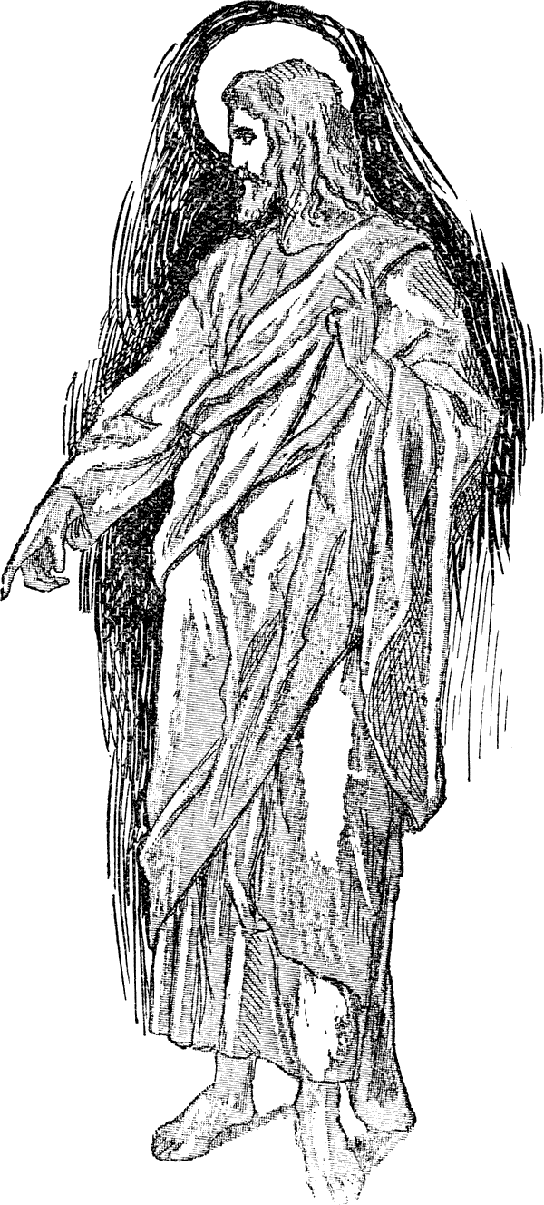
The immortality of the soul is the foundation of Spiritualism; and through the already prevalent belief of that doctrine, Spiritualism will yet lead the world to the active acceptance of every point which we have charged. Therefore, we pray all to flee this thing, and believe...
1 John 5
10 ...the record that God gave of His Son.
11 And this is the record, that God has given to us eternal life, and this life is in His Son.
12 He that has the Son has life; and he that has not the Son of God has not life.


Acts 23:6.
Hebrews 9:27.
George Heath, Hymn: Steadfastness, from the book Hymns and Poetic Essays, 1781. Used afterwards in many Protestant hymn books.
Colossians 3:4.
2 Thessalonians 2:13.
Galatians 4:4.
Colossians 1:13 RV.
Isaac Watts, Hymns and Spiritual Songs, Book 2, Hymn 31, 1707.

