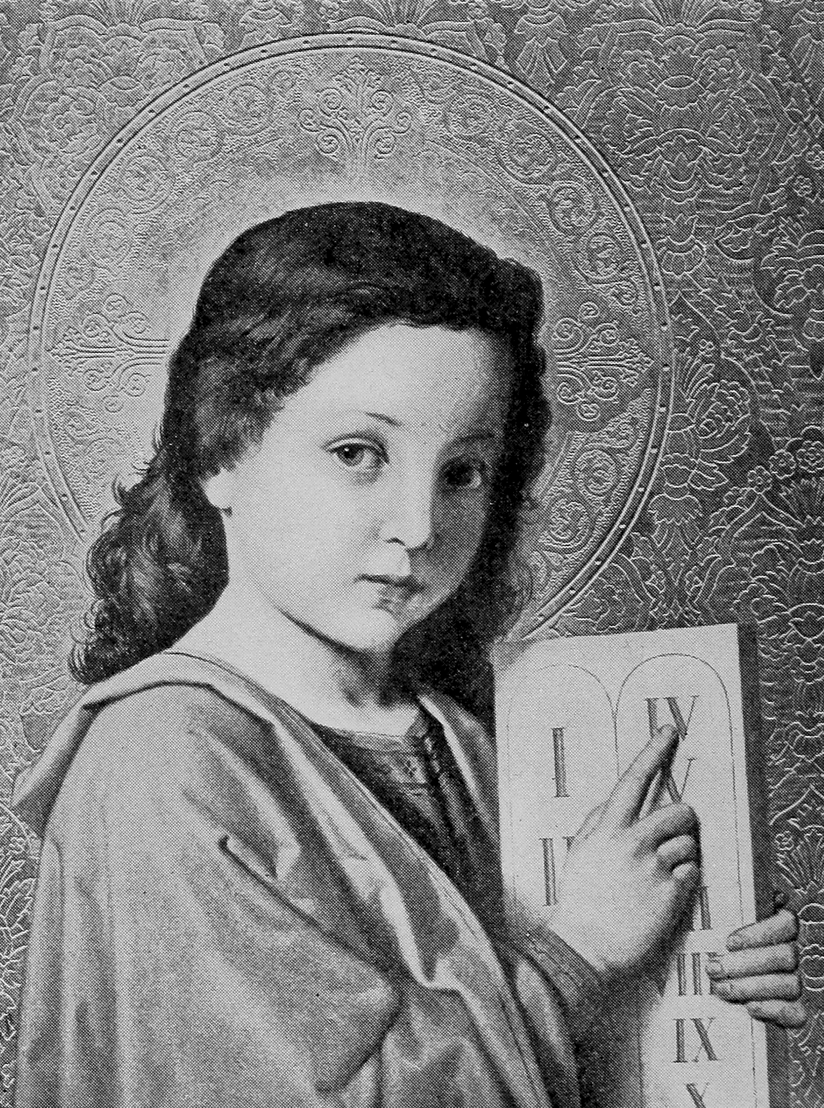
THE SEVENTH-DAY
SABBATH
T. M. PREBLE
Source:
1845 Edition
Original title: “A Tract,
Showing that the Seventh Day Should be Observed as the Sabbath,
Instead of the First Day”
Cover:
Jesus as a Boy, pointing to the Fourth Commandment
Jesus of Nazareth: The Story of His Life written for Children, 1906

Note: This picture was originally made for a Catholic book,
although it was used by some Protestant books as well.
The Catholics remove the second commandment about idols,
so their fourth commandment is actually the fifth, about respecting parents.
Respect for parents was evidently what this picture was intended to convey.
However, in lieu of the well-nigh universal rejection of the Sabbath,
this picture works very well in calling attention to the
down-trodden commandment of God (the real fourth commandment).
And it fits in perfectly with the life of the Saviour,
who called men away from the vain worship of human traditions,
to the pure-hearted worship of God’s commandments.

Fonts:
Liberation Sans Narrow
Linux Biolinum
Linux Libertine
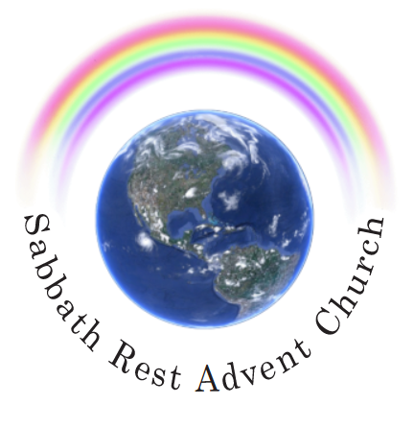
May 2024
practicaprophetica.com
srac.info

Contents
Foreword
Introduction
- The Sabbath to the Saints Scattered Abroad 1
- Supplement 11

Exodus 20
8 Remember the Sabbath day to keep it holy.
9 Six days shall you labor and do all your work:
10 But the seventh day is the Sabbath of the Lord your God: in it you shall not do any work, you, nor your son, nor your daughter, your man-servant, nor your maid-servant, nor your cattle, nor your stranger that is within your gates:
11 For in six days the Lord made heaven and earth, the sea, and all that in them is, and rested the seventh day: wherefore the Lord blessed the Sabbath day and hallowed it.

Foreword
Thomas Motherwell Preble (1810–1907) was a Free Will Baptist minister in New Hampshire and a Millerite preacher. After accepting the teachings of William Miller, Preble was excommunicated from his church.
Preble appears to have accepted the seventh-day Sabbath in 1844, possibly from Frederick Wheeler or someone associated with the Washington, New Hampshire, church. Preble was the first Millerite to advocate the Sabbath in print. In the Feb. 28, 1845, issue of The Hope of Israel, an Adventist periodical in Portland, Maine, was reprinted in tract form in March, 1845, with the title, Tract, Showing That the Seventh Day Should be Observed as the Sabbath. This tract led to the conversion of J. N. Andrews and other Adventist families in Paris, Maine, as well as to Joseph Bates.
Two years later, however, Preble repudiated the Sabbath and later wrote some articles against the Seventh-Day Sabbath in The World's Crisis and a book, entitled First-Day Sabbath.
BECAUSE of Preble’s influence in bringing the Sabbath into the early Seventh-day Adventist church, I’m republishing his small tract, with some better formatting, for easier reading.
Many of the basic truths regarding the Sabbath are nicely summed up in this tract, although it lacks the later gospel emphasis and illumination that was to come through the 1888 message, namely, what the blessing of the Sabbath is, and what it does for the believer.
It is unfortunate that Preble later gave up the truth. I briefly looked at his (long and complicated) book on the First-Day Sabbath. In it, he repeatedly fails to understand the relationship of the Law and the Gospel.
The Law exposes sin, not just in outward acts, but in the inner corruption in the heart. By doing this, it shows us that we are “dead in sins,” and then drives us to Christ, who can cleanse and forgive. Through the Gospel, Christ places within us the same code that is in the written law, but this time, in a living form: His spiritual life. Thus we “establish the Law” through the Gospel, and by its power, “the righteousness of the Law” is “fulfilled in us.” This is the difference between “the letter that kills,” and “the Spirit that gives life.”
There is a blessing in the Sabbath, God’s own life. But the carnal man cannot receive that blessing; only a holy man can keep a holy Sabbath. The gospel then, which makes man holy, unlocks the blessing that is in the Sabbath, and makes it available. Through the blessing given on the Sabbath, we will come to know that it is God alone that sanctifies us, and that only His power can do it.
Every attempt of man to sanctify himself, be it through an Ishmael (child of the flesh), or through a substitute sabbath (Sunday), will fail to teach this lesson, and will leave the recipient without the needed strength to stand in the final days.
It is not surprising to find then, in the prophetic word, that those who reject God’s seventh-day Sabbath, will attempt to invoke the civil power, to make civil laws, in order to make the nations holy again. In the end, their plan shows a reliance on carnal strength and human wisdom, just the opposite of God’s solution.
This will be but a repetition of the sacrifices of Cain and Abel. Abel brought the exact offering that God specified, with the important element of faith and trust in the Divine solution. Cain brought a modified offering, something different than what God had specified. His offering showed trust in human strength and wisdom. He wanted God to bless his plan. But it was rejected of God, and so will the future Cain-like offering be rejected as well.
Frank Zimmerman
practicaprophetica.com

Introduction
THE substance of the following pages, was first published in The Hope of Israel, February 28, 1845. Believing however as I do, the subject contained in this little Tract to be of great importance, and wishing to do what I can to present this truth to the true children of God; I deem it my duty to publish it in the present form, with an enlargement, that it may have as wide a circulation as possible. That the blessing of God may attend it, is the prayer of the Author.
A few Questions for the Reader to Answer, before Reading the following Pages.
- What authority have you in the Old or New Testament, to keep any day as a Sabbath, or day of rest?
- Do you find any command in the New Testament? If not, why do you not observe the day that is appointed in the Fourth Commandment?
- Has the day ever been changed? If so, when and where? Please point to the chapter and verse.
- When you were a child, did not your parents and others who taught you to keep “Sunday holy,” direct you to the “Fourth Commandment” as authority for keeping it thus? Did you ever think of the inconsistency? The commandment says the seventh day, and you were taught to keep the first.
- How could you reprove a person for working, or doing any thing else on Sunday, or the first day of the week, as the same as which makes it wrong to work, etc., on “God’s holy day,” commands the observance of the seventh day, instead of the first?
T. M. Preble
- The Sabbath to the Saints Scattered Abroad
BELIEVING it important for us to have the truth on all subjects, and especially those connected with the immediate coming of Christ, I would present a few thoughts on the Sabbath; not for controversy, but for the consideration of the true “Israel,” who are looking for the “promise,” and speedy “redemption.”
The remarks of Bro. Miller in his Lecture on the Great Sabbath, I like very well, because I believe they are true. In speaking of the Sabbath he says:
Its being contained in the ten commands, written by the finger of God, on both tables of the testimony, graven on stone, to be a sign forever, and a perpetual covenant, proves, in my opinion, beyond the shadow of a doubt, that it is as binding upon the Christian church as upon the Jewish, and in the same manner, and for the same reason.
I hope all will pay particular attention to these remarks of Br. Miller, and also my references at the bottom of the page. Again he says, p. 160, in speaking of the Sabbath as a sign,
It is a sign, because God has given it to us expressly for that purpose. See our test: “To be a sign between me and them,” that is between God and the children of Israel.
Now another question will evidently arise: “Who are the children of Israel?” I answer, while the first covenant was standing, they were the children of Jacob, descendants of the twelve tribes;—but that covenant they broke. This covenant was broken as Moses had foretold. Then Jesus Christ brought in a new covenant which continued the sign of the Sabbath, and prepared another people, by writing His law upon their hearts. These now are the true Israel; for the changing of the subjects never did, nor ever can change the moral law of God. Therefore Paul argues the circumcision of the heart, and says that…
Romans 9
6 ...they are not all Israel, which are of Israel:
7 Neither, because they are the seed of Abraham, are they all children: but, in Isaac shall your seed be called;
8 That is, They which are they children of the flesh, these are not the children of God: but the children of the promise are counted for the seed.
Now if the children of God are the true Israel, and if the Sabbath was given as a sign forever, and a perpetual covenant, I ask, how can it be abolished while there is one Israelite remaining to claim the promise? You have evidently noticed, that all the difficulties on the Sabbath question among Christians have arisen from the foolish, Judaizing notion, that Israel meant only the literal Jew. But when we understand Israel to mean the people of God, the difficulties, every man must acknowledge, all vanish at once.
I say, and I believe I am supported by the Bible, that the moral law was never given to the Jews as a people exclusively, but they were for a reason the keepers of it in charge. And through them the law, oracles and testimony, have been handed down to us. See Paul’s clear reasoning in Romans, 2nd, 3rd, and 4th chapters, on this point.
“Then,” says the objector, “we are under the same obligation to keep the Sabbaths of weeks, months and years, as the Jews were.” No, sir; you will observe that these were not included in the decalogue; they were attachments, added by reason of transgression, until the seed should come, to whom the promise of one eternal day or Sabbath of rest, was made.
Hebrews 4 [margin]
9 Therefore there remains a keeping of a Sabbath to the people of God.
Only one kind of Sabbath was given to Adam, and only one remains for us.
Hosea 2
11 I will cause all her mirth to cease, her feast-days, her new moons, and her sabbaths, and all her solemn feasts.
All the Jewish sabbaths did cease, when Christ nailed them to His cross.
Colossians 2
14 Blotting out the hand writing of ordinances that was against us, which was contrary to us, and took it out of the way, nailing it His cross;
15 And having spoiled principalities and powers, He made a show of them openly, triumphing over them in it.
16 Let no man therefore judge you in meat, or in drink, or in respect of a holy day, or of the new moon, or of the sabbath-days:
17 Which are a shadow of things to come; but the body is of Christ.
These were properly called Jewish sabbaths. Hosea says, “her sabbaths.” But the Sabbath of which we are speaking, God calls “my Sabbath.” Here is a clear distinction between the creation Sabbath and the ceremonial. The one is perpetual; the others were merely shadows of good things to come, and are limited in Christ. The Sabbath which remains is to be kept on the first day of every week, as a perpetual sign that, when Christ shall have finished the work of redemption, we shall enter into that rest which remains for the people of God, which will be an eternal rest.
The sentiments expressed in the above extract, I believe to be true, except the closing part where it is said:
“The Sabbath which remains is to be kept on the first day of every week, as a perpetual sign,” etc.
Now, I ask, how can this be? If we keep the first day as “a sign,” I do not see how we can have our thousand years’ rest in the new earth, till the eighth thousand years, as the first day would be the eighth, reckoning in successive order from creation. But we all as advent believers, have, and do still expect our rest in the seventh thousand years. Therefore I think we should keep the “seventh day” as “a sign,” “according to the commandment.”
I know the reasons which are given in favor of keeping the first day, and they once satisfied me, but fail to do it now, after a thorough examination of the subject. It is said that the resurrection of Christ,—and His often meeting His disciples on the first day of the week—together with the practice of the Apostles, are sufficient reasons for observing the first day of the week.
In regard to the resurrection of Christ being on the first day of the week, I will not deny, though some may think it needs proof. Respecting Christ’s often meeting His disciples on the first day I think we have no positive proof that He ever met with them on this day but once when they were assembled for worship, and this we find in John 20:19. In Matthew all that is said about it is,
Matthew 28
7 Behold He goes before you into Galilee; there shall you see Him...
John appears to be a little more definite and says,
John 20
19 Then the same day at evening, being the first day of the week, when the doors were shut where the disciples were assembled for fear of the Jews, came Jesus and stood in the midst...
In the 26th verse he says,
26 And after eight days,…
Not the eighth day after, as it ought to be, had Christ met with them the next first day. In the 21st chapter, verses 1-3 we find that He met them again at the sea of Tiberias where the disciples were trying to catch fish. We see therefore, that Christ appeared to the disciples while they were “going into the country”—“as they sat at meat”—and when they were “fishing,” but only once when they were assembled for worship, unless their sitting at meat, or “together”—as the margin reads, be considered a meeting of worship.
In relation to the practice of the apostles, there is but one meeting of the disciples on the first day of the week, mentioned in the New Testament, and that is in Acts 20:7. But there are many meetings recorded, which they held on the Sabbath.
I know 1 Corinthians 16:2, is considered proof respecting the first day; but when examined, I thinks it proves the contrary. It says,
1 Corinthians 16
2 Upon the first day of the week, let every one of you lay by him in store as God has prospered him,…
The expression “lay by him in store,” I think plainly implies that they were at home rather than at meeting.
Revelation 1:10, is the only other place that can be construed to favor the first day—John says,
Revelation 1
10 I was in the Spirit on the Lord’s day, and heard behind me a great voice, as of a trumpet.
[But does “Lord’s day” here signify the first day, or the seventh day?] I think the latter, because it is called “the Sabbath of the Lord your God,” but the first, is nowhere called so!!
In regard to the Sabbath, Christ says,
Mark 2
28 The Son of man is Lord also of the Sabbath.
Not a Sabbath, but the Sabbath. He says also,
27 The Sabbath was made for man, and not man for the Sabbath.
He does not say, the Sabbath was made for the Jews, and a Sabbath for the Gentiles, but “THE Sabbath was made for man,”—all mankind.
Some may think that our first day is in reality the seventh, but this is settled when we examine Matthew 28:1, and Luke 23:56, & 24:1, where a plain distinction is made between the two days. Matthew says,
Matthew 28
1 In the end of the Sabbath, as it began to dawn toward the first day of the week.
Luke says,
Luke 23
56 ...and rested the Sabbath day according to the commandment.
Luke 24
1 Now upon the first day of the week, very early in the morning,...
After having examined the ancient custom in relation to the first day, we will now see what it was in regard to the seventh or Sabbath. The first passage I will notice, is the one just quoted in Luke 23:56:
Luke 23
56 And they returned, and prepared spices and ointments; and rested the Sabbath day according to the commandment.
Mark this: “And rested the Sabbath day, ACCORDING TO THE COMMANDMENT. Acts 13:42, says,
Acts 13
42 And when the Jews were gone out of the synagogue, the Gentiles besought that these words might be preached to them the next Sabbath.
44 And the next Sabbath day came almost the whole city together, to hear the word of God.
Acts 16
13 And on the Sabbath we went out of the city by a river side, where prayer was wont to be made.
Acts 17
2 And Paul as his manner was, went in unto them, and three Sabbath days reasoned with them out of the scriptures.
Acts 18
4 And he reasoned in the synagogue every sabbath, and persuaded the Jews and the Greeks.
This is “every Sabbath.”
11 And he continued there a year and six months.
Now if it was Paul’s “manner” to reason in the synagogue “EVERY Sabbath, he must have, in this place, observed seventy-eight Sabbaths. It is evident that Christ had His eye on the observance of the Sabbath, as late certainly as 70 AD, when Jerusalem was destroyed, when He said:
Matthew 24
20 Pray that your flight be not in the winter, neither on the Sabbath day.
But if this “tribulation” spoken of, has reference to the “Papal persecution,” as many believe, then they were directed in the observance of the Sabbath, to a much later period. Paul in Hebrews 4:4, says,
Hebrews 4
4 For He spoke in a certain place of the seventh day on this wise, And God did rest the seventh day from all His works…
Not the first, but the seventh day. A few facts now, to show what those have to acknowledge who keep the first day. In the Encyclopedia of Religious Knowledge, Article: “Sabbath”—we read,
The Sabbath was appointed at the creation of the world, and sanctified, or set a part for holy purposes, “for man,” for all men, and therefore for Christians; since there was never any repeal of the original institution. To this we add, that if the moral law be the law of Christians, then is the Sabbath as explicitly enjoined upon them as upon the Jews. But that the moral law is our law, as well as the law of the Jews, all but Antinomians must acknowledge; and few, we suppose, will be inclined to run into the fearful mazes of that error, in order to support lax notions as to the obligation of the Sabbath; into which, however, they must be plunged, if they deny the law of the decalogue to be binding.”
In the Address to the “Lord’s Day Convention,” held in Baltimore in 1844,—of which John Quincy Adams was President,— we find this remark in recommending the observance of the Christian Sabbath:
It is a law of God, coeval with creation. It is one of the selected few of the ten commandments, that brief but comprehensive expression of His will.
By these extracts, we see that the fourth commandment is acknowledged to be now binding upon us. Oh! that men were consistent. Reader, will you be? God grant that you may.
On the title page of the Second Advent Library, No. xxxviii, written “By S. Bliss,” on The Chronology of the Bible, etc., we read thus:
One day is with the Lord as a thousand years.—St. Peter.
The seventh Day is the Sabbath of the Lord your God.—Ex. 20:10.
I gave them my Sabbaths to be a sign between me and them.—Exodus 20.
Which are a shadow of things to come.—St. Paul.
See what an acknowledgment this is, by Br. Bliss!
A word now in relation to the history. As far as I have been able to examine, during the last six months, since I became convicted on this point, I find the following to be true. The disciples evidently kept the first day of the week as a festival, in commemoration of the resurrection of Christ. But never as the Sabbath.
A controversy however commenced toward the close of the first century to see whether both days would be kept, or only one; and if one should be given up, which one, the first day, or the seventh. This controversy increased century after century till 603 AD, when Pope Gregory passed a law abolishing the seventh-day Sabbath, and establishing the first day.
Eusebius says of Constantine,
That he commanded, through all the Roman Empire, that the first day of the week should be observed as a Sabbath.
The Parliament of England met on Sundays till the time of Richard II. The first law of England made for the keeping of Sunday, was in the time of Edward VI, about 1470. In Bishop Ely’s book, written in 1635, he says,
In St. Jerome’s days, the devoutest Christians, did work on the first day of the week.
And John Calvin, in his Institution of the Christian Religion, page 128, says,
The Old Fathers put in the place of the Sabbath the day we call Sunday.
Mark this! The Old Fathers did it! Not the God of heaven!! Whom will we obey? Thus we see Daniel 7:25 fulfilled, the “little horn” changing “times and laws.” Therefore it appears to me that all who keep the first day of the week for “the Sabbath,” are Pope’s Sunday Keepers!! and God’s Sabbath breakers!!!
Truth is what I am after, and if I had but one day on this earth to spend, I would give up error for truth as soon as I could see it. May the Lord give us wisdom, and help us to keep all…
Revelation 22
14 ...His commandments that we may have right to the tree of live.
Yours, daily looking, and patiently waiting…
Titus 2
13 ...for that blessed hope and glorious appearing of the great God, and our Savior Jesus Christ.
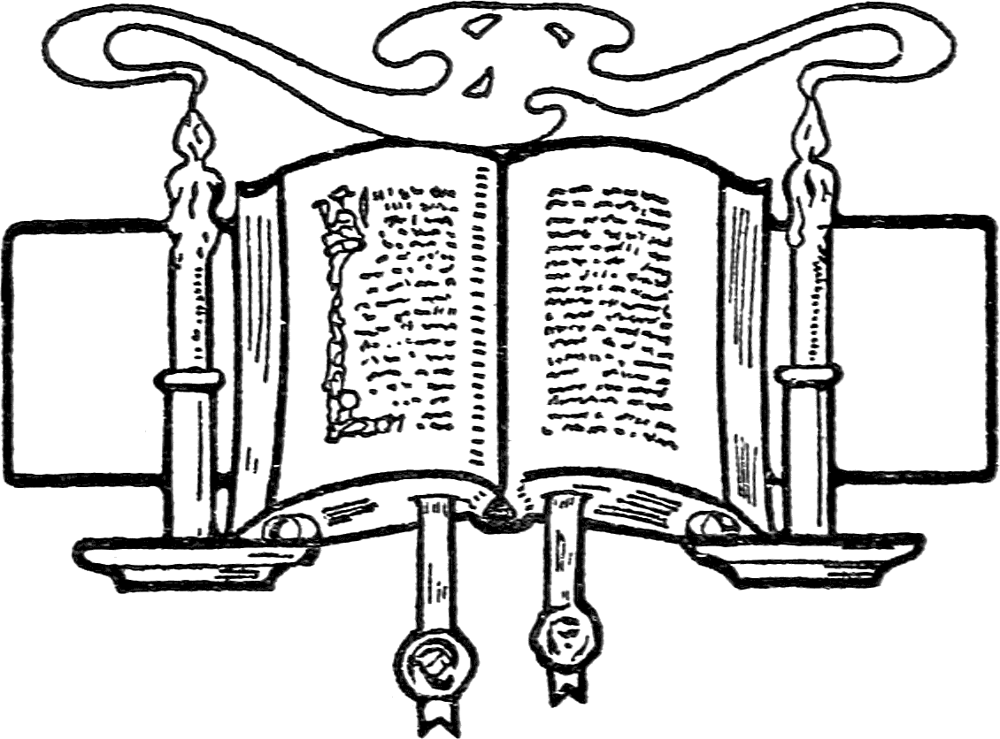
- Supplement
THE word Sabbath, signifies rest: That of Sunday, is so called because it was dedicated to the Sun, by the heathen nations in the north of Europe. Idolatry we see in this, then.
The word Sunday, never occurs in the Bible, and in no instance is the word Sabbath applied to the first day of the week, but always refers to the seventh day.
It is said that the same portion of time which constituted the seventh day from creation, could not be observed in all parts of the earth, on account of the different degrees of latitude and longitude.
The objection, however, amounts to nothing in my mind, as the Sun must rise on this continent at the same time as at the creation of the world. Therefore, though the Sun must rise on this continent at the same time as at the creation of the world. Therefore, though the Sun may rise at a different time in Palestine from what it does here, yet it will make no difference in the time of our beginning the Sabbath on Friday evening, and end on Saturday evening.
The question is frequently asked, whether it would not be best now, as the practice of keeping the first day has become so general, to continue to observe it, although it is not the true Sabbath, as a change of days would make it so difficult to manage our worldly affairs—go to meeting, etc., etc.? This question may be easily answered by asking another, namely:
Acts 4
19 Whether it be right in the sight of God to hearken unto men more than unto God, you judge.
I know by experience that there are some difficulties in the way of keeping God’s Sabbath. But what of that? This wicked world has always opposed the truth, and those who practice it, and they always will. But for one, I had rather obey God, and have His approbation here, and finally enjoy the blessings of the new earth—though all men hate me—than to have the good opinion of men here, and perish at last. Or in other words, and in the language of another,
“I had rather go to Heaven alone, than to Hell, with the multitude.”
And as we have every reason to be daily looking for the Lord to come and call us to judgment, may the reader and the writer, keep all the commands of God, that we may be ready for that day.
AMEN.
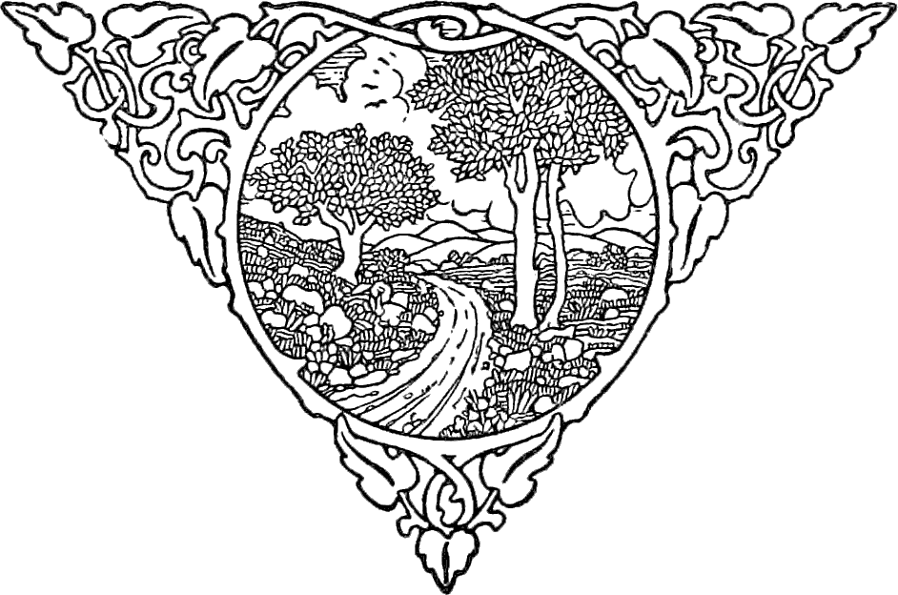
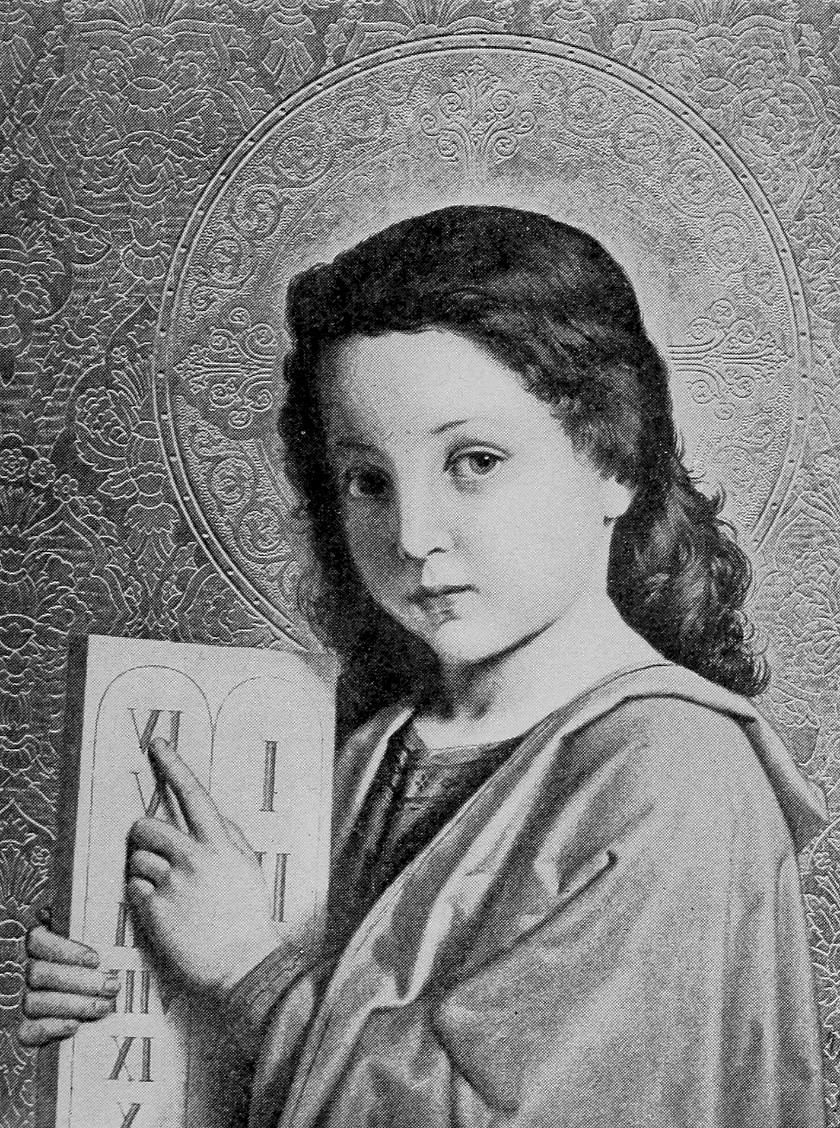

Wikipedia, Article: T. M. Preble.
Ephesians 2:1, 5; Colossians 2:13.
Romans 3:31.
Romans 8:4.
2 Corinthians 3:6.
See Exodus 34:28; Deuteronomy 4:13 & 10:4.
Exodus 31:17; Ezekiel 20:12.
Life and Views, p. 157.
Ezekiel 20:12.
See Leviticus 26:2, 15; also, Deuteronomy 31:10-16.
I hope all will notice the distinction Bro. M. makes between the Jewish Sabbath, and God’s Sabbath; it is evidently true.
Exodus 31:17.
Luke 23:56.
Let all notice that wherever the phrase, “first day of the week” occurs in the New Testament, the word day is in italics showing that it is not in the original, but supplied by the Translators.
Exodus 20:10.
Many say that the Jews only, observed the Sabbath; but this passage, and others also, show us clearly, that the Gentiles observed the Sabbath—See Acts 18:4, on this point.
Baronius’ Councils, p. 603.
Eusebius’ Life of Constantine, Book 4th, Chap. 17, 18.
Bampfield’s Enq., page 116.

