Wesley
ON THE

LAW
JOHN WESLEY

Source:
Sermons on Various Occasions
1771
Cover:
Llanberis, Wales (Thomas Girtin)
From The Art of Sketching from Nature, 1871
by Philip H. Delamotte

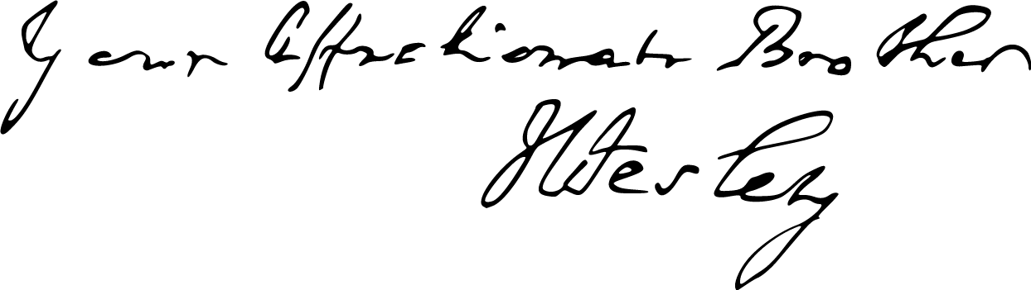

Fonts:
Liberation Sans Narrow
Linux Biolinum
Linux Libertine
Miama Nueva


May 2025
practicaprophetica.com
srac.info

Contents
Foreword
- The Law: Origin, Nature, Properties, and Uses 1
A. The Origin of the Law 4
B. The Nature of the Law 7
C. The Properties of the Law 9
1. The Law is Holy 10
2. The Law is Just 12
3. The Law is Good 13
D. The Uses of the Law 16
1. To Convince the World of Sin 16
2. To Bring Us to Christ 17
3. To Keep Us with Christ 17
- The Law Established Through Faith – I 24
Paul’s Argument 24
Confusion of Many 25
Common Ways of Making the Law Void 26
1. Refusing to Preach the Law 26
2. Teaching That Faith Supersedes Holiness 31
3. Living as If Faith Excused Us from Holiness 34
- The Law Established Through Faith – II 40
How to Establish the Law 41
1. Preach the Whole Gospel 41
2. Preach Faith in Christ to Produce Holiness 46
3. Establishing the Law in Our Own Hearts and Lives 49
Appendix: Concise Outline 54
A. The Origin of the Law 54
B. The Nature of the Law 55
C. The Properties of the Law 55
D. The Uses of the Law 56

Foreword
HERE are the three main sermons from John Wesley, one of the primary founders of the Methodist Church, and leader of the revival of religion in England (and elsewhere) in the 1700’s. These sermons stand in stark contrast to the antinomian teaching that is common in many of the churches of today.
For Adventists, the Law is a central pillar in the revelation of God’s character, and in the work of Salvation. The prophetic significance of the Law for the last days is pointed out in verses such as these:
Revelation 14
12 Here is the patience of the saints: here are they that keep the commandments of God, and the faith of Jesus.
Revelation 11
19 And the temple of God was opened in heaven, and there was seen in His temple the ark of His testament [wherein was the Law]: and there were lightnings, and voices, and thunderings, and an earthquake, and great hail.
Revelation 22
12 And, behold, I come quickly; and my reward is with me, to give every man according as His work shall be.
13 I am Alpha and Omega, the beginning and the end, the first and the last.
14 Blessed are they that do His commandments, that they may have right to the tree of life, and may enter in through the gates into the city.
As well, the final spiritual test that will face the world will be between “the beast and his image,” who enforces a mark in the forehead or in the hand, and the seal of God, which is His character, or Law, fully formed in the living saints. The mark of the beast is a symbol of obedience to a counterfeit of God’s Law. Originally, God’s Law was to be “bound” on the hand and between the eyes:
Deuteronomy 11
13 And it shall come to pass, if you shall hearken diligently unto my commandments which I command you this day, to love the Lord your God, and to serve Him with all your heart and with all your soul,
18 Therefore shall you lay up these my words in your heart and in your soul, and bind them for a sign upon your hand, that they may be as frontlets between your eyes.
This signified heart obedience, or the full restoration of man’s character to the image of God, which it is the work of the Gospel to accomplish.
But the “beast” power has a substitute: to stamp his image on man’s heart and compel obedience to his cause. Therefore, since the work of the enemy of souls is to modify, replace, or annul God’s commandments, the work of God in this time is to establish the Law in the hearts and lives of His children. In order for that to happen, they must have a correct view of the nature, properties, and uses of the Law; and a correct understanding of the relationship of the Law to the Gospel.
These sermons by John Wesley show that he had a good grasp of the Law; not a perfect grasp, or he would have seen the spiritual significance of the seventh-day Sabbath commandment. But nevertheless, his understanding and exposition shows how far modern professed Christians have drifted from the pillars of truth.
Wesley understood that the Law predated Sinai:
“Now this is not, as some may have possibly imagined, of so late an institution as the time of Moses. Noah declared it to men long before that time, and Enoch before him.”
He also understood that the Law was a transcript of God’s character:
“Now, this law is an incorruptible picture of the High and Holy One that inhabits eternity. It is He whom, in His essence, no man has seen, or can see, made visible to men and angels. It is the face of God unveiled; God manifested to His creatures as they are able to bear it; manifested to give, and not to destroy, life—that they may see God and live. It is the heart of God disclosed to man.”
“The law of God (speaking after the manner of men) is a copy of the eternal mind, a transcript of the divine nature: Yea, it is the fairest offspring of the everlasting Father, the brightest efflux of his essential wisdom, the visible beauty of the Most high. It is the delight and wonder of cherubim and seraphim, and all the company of heaven, and the glory and joy of every wise believer, every well-instructed child of God upon earth.”
This exalted description of the Law was similar to that later written by Ellen White (who was raised in the Methodist Church):
Christ’s Object Lessons, p. 305:
God’s law is the transcript of His character. It embodies the principles of His kingdom. He who refuses to accept these principles is placing himself outside the channel where God's blessings flow.
The Great Controversy, p. 434:
The law of God, being a revelation of His will, a transcript of His character, must forever endure, “as a faithful witness in heaven.” Not one command has been annulled; not a jot or tittle has been changed. Says the psalmist:
Psalm 119
89 Forever, O Lord, Thy word is settled in heaven.
Psalm 111
7 ...all His commandments are sure.
8 They stand fast for ever and ever." Psalm 119:89; 111:7, 8.
Patriarchs and Prophets, p. 52:
The law of God is as sacred as God himself. It is a revelation of His will, a transcript of His character, the expression of divine love and wisdom. The harmony of creation depends upon the perfect conformity of all beings, of everything, animate and inanimate, to the law of the Creator.
The Methodist revival of the mid to late 1700’s was the last major Christian revival before the great Second Advent movement of the early to mid 1800’s. What Wesley has written here confirms a continuity of truth, and verifies that the Advent movement was in the line of the progressive unfolding of the light of God. And to those who still hold the “everlasting gospel” as the way to establish the Law in the heart, the light continues to shine, more and more unto the perfect day.
Frank Zimmerman
practicaprophetica.com
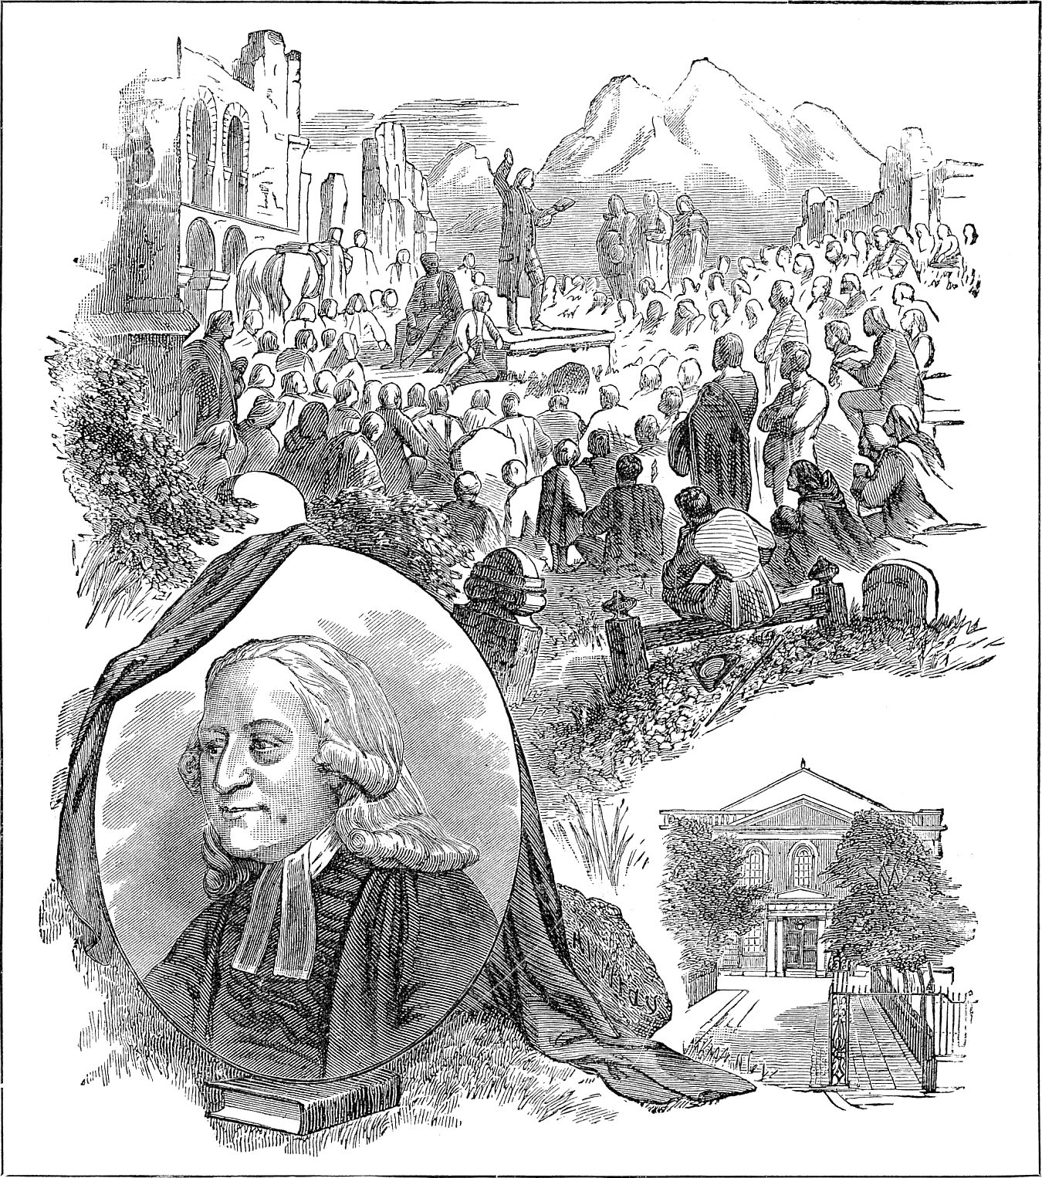John Wesley Preaching in the Open Air
- The Law: Origin, Nature, Properties, and Uses
Sermon’s on Several Occasions
First Series, Sermon 34
Original title: The Original, Nature, Properties, and Use of the Law
Romans 7
12 Wherefore the law is holy, and the commandment holy, and just, and good.
PERHAPS there are few subjects within the whole compass of religion so little understood as this. The reader of this Epistle is usually told,
“By the law Paul means the Jewish law.”
And so, apprehending himself to have no concern therewith, passes on without further thought about it.
Indeed some are not satisfied with this account; but observing the Epistle is directed to the Romans, thence infer that the Apostle in the beginning of this chapter alludes to the old Roman law. But as they have no more concern with this, than with the ceremonial law of Moses, so they spend not much thought on what they suppose is occasionally mentioned barely to illustrate another thing.
But a careful observer of the Apostle’s discourse will not be content with these light explications of it. And the more he weighs the words, the more convinced he will be, that Paul, by the law mentioned in this chapter, does not mean either the ancient law of Rome, or the ceremonial law of Moses. This will clearly appear to all who attentively consider the tenor of his discourse.
Romans 7
1 Know you not, brethren, (for I speak to them that know the law,)...
He begins the chapter to them who have been instructed therein from their youth,
Romans 7
1 ...that the law has dominion over a man as long as he lives?
What! the law of Rome only, or the ceremonial law? No, surely; but the moral law.
2 For, [to give a plain instance,] the woman which has a husband is bound by the [moral] law to her husband so long as he lives; but if the husband be dead, she is loosed from the law of her husband.
3 So then if, while her husband lives, she be married to another man, she shall be called an adulteress: but if her husband be dead, she is free from that law: so that she is no adulteress, though she be married to another man.
From this particular instance the Apostle proceeds to draw that general conclusion:
4 Wherefore, my brethren, [by a plain parity of reason,] you also are become dead to the law, [the whole Mosaic institution,] by the body of Christ,
–offered for you, and bringing you under a new dispensation:
4 ...that you should [without any blame] be married to another, even to Him who is raised from the dead;
–and has thereby given proof of His authority to make the change;
4 ...that we should bring forth fruit unto God.
And this we can do now, whereas before we could not:
5 For when we were in the flesh…
—under the power of the flesh, that is, of corrupt nature, which was necessarily the case till we knew the power of Christ’s resurrection,
5 ...the motions of sins, which were by the law,
—which were shown and inflamed by the Mosaic law, not conquered,
Romans 7
5 ...did work in our members,
—broke out various ways,
5 ...to bring forth fruit unto death.
6 But now we are delivered from the law;
–from that whole moral, as well as ceremonial economy;
6 ...that being dead whereby we were held;
—that entire institution being now as it were dead, and having no more authority over us than the husband, when dead, has over his wife:
6 ...that we should serve Him,
—who died for us and rose again,
6 ...in newness of spirit;
—in a new spiritual dispensation;
6 ...and not in the oldness of the letter;
—with a bare outward service, according to the letter of the Mosaic institution. The Apostle, having gone thus far in proving that the Christian had set aside the Jewish dispensation, and that the moral law itself, though it could never pass away, yet stood on a different foundation from what it did before,—now stops to propose and answer an objection:
7 What shall we say then? Is the law sin?
So some might infer from a misapprehension of those words, “the motions of sins, which were by the law.”
7 ...God forbid!
–says the Apostle, that we should say so. Nay, the law is an irreconcilable enemy to sin.
Romans 7
7 ...Nay, I had not know sin but by the law: for I had not known lust, [evil desire, to be sin,] except the law had said, You shall not covet.
After opening this farther, in the four following verses, he subjoins this general conclusion, with regard more especially to the moral law, from which the preceding instance was taken:
12 Wherefore the law is holy, and the commandment holy, and just, and good.
In order to explain and enforce these deep words, so little regarded, because so little understood, I shall endeavor to show,
- The origin of this law;
- The nature thereof;
- The properties; that it is holy, and just, and good; and
- The uses of it.

A. The Origin of the Law
I shall, first, endeavor to show the origin of the moral law, often called “the law,” by way of eminence. Now this is not, as some may have possibly imagined, of so late an institution as the time of Moses. Noah declared it to men long before that time, and Enoch before him.
But we may trace its original higher still, even beyond the foundation of the world: to that period, unknown indeed to men, but doubtless enrolled in the annals of eternity, when…
Job 38
7 ...the morning stars [first] sang together,
–being newly called into existence. It pleased the great Creator to make these, his first-born sons, intelligent beings, that they might know Him that created them.
For this end He endued them with understanding, to discern truth from falsehood, good from evil; and, as a necessary result of this, with liberty,—a capacity of choosing the one and refusing the other. By this they were, likewise, enabled to offer Him a free and willing service; a service rewardable in itself, as well as most acceptable to their gracious Master.
To employ all the faculties which He had given them, particularly their understanding and liberty, He gave them a law, a complete model of all truth, so far as is intelligible to a finite being; and of all good, so far as angelic minds were capable of embracing it.
It was also the design of their beneficent Governor herein to make way for a continual increase of their happiness; seeing every instance of obedience to that law would both add to the perfection of their nature, and entitle them to a higher reward, which the righteous Judge would give in its season.
In like manner, when God, in His appointed time, had created a new order of intelligent beings, when He had raised man from the dust of the earth, breathed into him the breath of life, and caused him to become a living soul, endued with power to choose good or evil; He gave to this free, intelligent creature the same law as to His first-born children,—not written, indeed, upon tables of stone, or any corruptible substance, but engraven on his heart by the finger of God; written in the inmost spirit both of men and of angels; to the intent it might never be far off, never be hard to understand, but always at hand, and always shining with clear light, even as the sun in the midst of heaven.
Such was the original of the law of God. With regard to man, it was coeval with his nature; but with regard to the elder sons of God, it shone in its full splendor,
Psalm 90
2 Or ever the mountains were brought forth, or the earth and the round world were made.
But it was not long before man rebelled against God, and, by breaking this glorious law, well nigh effaced it out of his heart; the eyes of his understanding being darkened in the same measure as his soul was…
Ephesians 4
18 ...alienated from the life of God.
And yet God did not despise the work of His own hands; but, being reconciled to man through the Son of His love, He, in some measure, re-inscribed the law on the heart of His dark, sinful creature.
Micah 6
8 He [again] showed you, O man, what is good,
–although not as in the beginning,
8 ...even to do justly, and to love mercy, and to walk humbly with your God.
And this He showed, not only to our first parents, but likewise to all their posterity, by…
John 1
9 That true light which enlightens every man that comes into the world.
But, notwithstanding this light, all flesh had, in process of time,
Genesis 6
12 ...corrupted their way before Him;
–till He chose out of mankind a peculiar people, to whom He gave a more perfect knowledge of His law; and the heads of this, because they were slow of understanding, He wrote on two tables of stone, which He commanded the fathers to teach their children, through all succeeding generations.
And thus it is, that the law of God is now made known to them that know not God. They hear, with the hearing of the ear, the things that were written aforetime for our instruction. But this does not suffice: they cannot, by this means, comprehend the height, and depth, and length, and breadth thereof. God alone can reveal this by His Spirit. And so He does to all that truly believe, in consequence of that gracious promise made to all the Israel of God:
Jeremiah 31
31 Behold, the days come, saith the Lord, that I will make a new covenant with the house of Israel, and with the house of Judah.
33 And this shall be the covenant that I will make; I will put my law in their inward parts, and write it in their hearts; and I will be their God, and they shall be my people.

B. The Nature of the Law
The nature of that law which was originally given to angels in heaven and man in paradise, and which God has so mercifully promised to write afresh in the hearts of all true believers, was the second thing I proposed to show.
In order to which, I would first observe, that although the “law” and the “commandment” are sometimes differently taken (the commandment meaning but a part of the law,) yet, in the text they are used as equivalent terms, implying one and the same thing.
But we cannot understand here, either by one or the other, the ceremonial law. It is not the ceremonial law, whereof the Apostle says, in the words above recited,
Romans 7
7 I had not known sin, but by the law.
This is too plain to need a proof. Neither is it the ceremonial law which says, in the words immediately subjoined,
7 ...You shall not covet.
Therefore the ceremonial law has no place in the present question.
Neither can we understand by the law mentioned in the text the Mosaic dispensation. It is true, the word is sometimes so understood; as when the Apostle says, speaking to the Galatians:
Galatians 3
17 The covenant that was confirmed before; [namely, with Abraham, the father of the faithful,] the law, [that is, the Mosaic dispensation,] which was four hundred and thirty years after, cannot disannul.
But it cannot be so understood in the text; for the Apostle never bestows so high commendations as these upon that imperfect and shadowy dispensation. He nowhere affirms the Mosaic to be a spiritual law; or, that it is holy, and just, and good. Neither is it true, that God will write that law in the hearts of those whose iniquities He remembers no more. It remains, that “the law,” eminently so termed, is no other than the moral law.
Now, this law is an incorruptible picture of the High and Holy One that inhabits eternity. It is He whom, in His essence, no man has seen, or can see, made visible to men and angels. It is the face of God unveiled; God manifested to His creatures as they are able to bear it; manifested to give, and not to destroy, life—that they may see God and live. It is the heart of God disclosed to man.
Yea, in some sense, we may apply to this law what the Apostle says of His Son: It is…
Hebrews 1
3 ...the streaming forth or out-beaming of His glory, the express image of His person.
“If virtue,” said the ancient heathen, “could assume such a shape as that we could behold her with our eyes, what wonderful love would she excite in us!”
If virtue could do this! It is done already. The law of God is all virtues in one, in such a shape as to be beheld with open face by all those whose eyes God has enlightened. What is the law but divine virtue and wisdom assuming a visible form? What is it but the original ideas of truth and good, which were lodged in the uncreated mind from eternity, now drawn forth and clothed with such a vehicle as to appear even to human understanding?
If we survey the law of God in another point of view, it is supreme, unchangeable reason; it is unalterable rectitude, it is the everlasting fitness of all things that are or ever were created.
I am sensible, what a shortness, and even impropriety, there is, in these and all other human expressions, when we endeavor by these faint pictures to shadow out the deep things of God. Nevertheless, we have no better, indeed no other way, during this our infant state of existence. As we now know but “in part,” so we are constrained to “prophesy,” that is, speak of the things of God, “in part” also.
Job 37
19 We cannot order our speech by reason of darkness,
–while we are in this house of clay.
1 Corinthians 13
11 While I am a child, I must speak as a child: but I shall soon put away childish things:
–for,
10 When that which is perfect is come, that which is in part shall be done away.
But to return. The law of God (speaking after the manner of men) is a copy of the eternal mind, a transcript of the divine nature: Yea, it is the fairest offspring of the everlasting Father, the brightest efflux of his essential wisdom, the visible beauty of the Most high. It is the delight and wonder of cherubim and seraphim, and all the company of heaven, and the glory and joy of every wise believer, every well-instructed child of God upon earth.

C. The Properties of the Law
Such is the nature of the ever-blessed law of God. I am, in the Third place, to show the properties of it: not all; for that would exceed the wisdom of an angel; but those only which are mentioned in the text. These are three; it is:
- Holy,
- Just, and
- Good.

1. The Law is Holy
And, first, the law is holy. In this expression the Apostle does not appear to speak of its effects, but rather of its nature: as James, speaking of the same thing under another name, says,
James 3
17 The wisdom from above [which is no other than this law, written in our heart] is first pure [agne,—chaste, spotless; eternally and essentially holy].
And, consequently, when it is transcribed into the life, as well as the soul, it is (as the same Apostle terms it),
James 1
27 Pure religion and undefiled;
–or, the pure, clean, unpolluted worship of God. It is, indeed, in the highest degree, pure, chaste, clean, holy. otherwise it could not be the immediate offspring, and much less the express resemblance, of God, who is essential holiness.
It is pure from all sin, clean and unspotted from any touch of evil. It is a chaste virgin, incapable of any defilement, of any mixture with that which is unclean or unholy. It has no fellowship with sin of any kind,
2 Corinthians 6
14 For what communion has light with darkness?
As sin is, in its very nature, enmity to God, so His law is enmity to sin. Therefore it is that the Apostle rejects with such abhorrence that blasphemous supposition, that the law of God is either sin itself, or the cause of sin. God forbid that we should suppose it is the cause of sin, because it is the discoverer of it; because it detects the hidden things of darkness, and drags them out into open day. It is true, by this means (as the Apostle observes),
Romans 7
13 ...sin appears to be sin.
All its disguises are torn away, and it appears in its native deformity. It is true likewise, that...
13 ...sin, by the commandment, becomes exceeding sinful.
Being now committed against light and knowledge, being stripped even of the poor plea of ignorance, it loses its excuse, as well as disguise, and becomes far more odious both to God and man. Yea, and it is true, that...
13 ...sin works death by that which is good;
–which in itself is pure and holy. When it is dragged out to light, it rages the more: when it is restrained, it bursts out with greater violence. Thus the Apostle (speaking in the person of one who was convinced of sin, but not yet delivered from it),
8 Sin, taking occasion by the commandment [detecting and endeavoring to restrain it, disdained the restraint, and so much the more] wrought in me all manner of concupiscence,
–all manner of foolish and hurtful desire, which that commandment sought to restrain. Thus,
9 When the commandment came, sin revived [it fretted and raged the more].
But this is no stain on the commandment. Though it is abused, it cannot be defiled. This only proves that:
Jeremiah 17
9 The heart of man is desperately wicked.
But “the law” of God “is holy” still.

2. The Law is Just
And it is, Secondly, just. It renders to all their due. It prescribes exactly what is right, precisely what ought to be done, said, or thought, both with regard to the Author of our being, with regard to ourselves, and with regard to every creature which He has made.
It is adapted, in all respects, to the nature of things, of the whole universe, and every individual. It is suited to all the circumstances of each, and to all their mutual relations, whether such as have existed from he beginning, or such as commenced in any following period.
It is exactly agreeable to the fitness of things, whether essential or accidental. It clashes with none of these in any degree; nor is ever unconnected with them.
If the word be taken in that sense, there is nothing arbitrary in the law of God. Although still the whole and every part thereof is totally dependent upon His will; so that,
Matthew 6
10 Your will be done,
–is the supreme, universal law both in earth and heaven.
“But is the will of God the cause of His law? Is His will the original of right and wrong? Is a thing therefore right, because God wills it? or does He will it because it is right?”
I fear this celebrated question is more curious than useful. And perhaps in the manner it is usually treated of, it does not so well consist with the regard that is due from a creature to the Creator and Governor of all things. It is hardly decent for man to call the supreme God to give an account to Him. Nevertheless, with awe and reverence we may speak a little. The Lord pardon us if we speak amiss!
It seems, then, that the whole difficulty arises from considering God’s will as distinct from God: otherwise it vanishes away. For none can doubt but God is the cause of the law of God. But the will of God is God himself. It is God considered as willing thus or thus. Consequently, to say that the will of God, or that God himself, is the cause of the law, is one and the same thing.
Again: If the law, the immutable rule of right and wrong, depends upon the nature and fitness of things, and on their essential relations to each other (I do not say, their eternal relations; because the eternal relation of things existing in time, is little less than a contradiction); if, I say, this depends on the nature and relations of things, then it must depend on God, or the will of God; because those things themselves, with all their relations, are the works of His hands. By His will,
Revelation 4
11 ...for His pleasure [alone,] they all are and were created.
And yet it may be granted (which is probably all that a considerate person would contend for,) that in every particular case, God wills this or this (suppose, that men should honor their parents,) because it is right, agreeable to the fitness of things, to the relation wherein they stand.

3. The Law is Good
The law, then, is right and just concerning all things. And it is good as well as just. This we may easily infer from the fountain whence it flowed. For what was this, but the goodness of God? What but goodness alone inclined Him to impart that divine copy of himself to the holy angels? To what else can we impute His bestowing upon man the same transcript of His own nature? And what but tender love constrained Him afresh to manifest His will to fallen man either to Adam, or any of His seed, who like him were…
Romans 3
23 ...come short of the glory of God?
Was it not mere love that moved Him to publish His law after the understandings of men were darkened? and to send His prophets to declare that law to the blind, thoughtless children of men? Doubtless His goodness it was which raised up Enoch and Noah to be preachers of righteousness; which caused Abraham, His friend, and Isaac, and Jacob, to bear witness to His truth. It was His goodness alone, which, when…
Isaiah 60
2 ...darkness had covered the earth, and thick darkness the people,
–gave a written law to Moses, and, through him, to the nation whom He had chosen. It was love which explained these living oracles by David and all the prophets that followed; until, when the fullness of time was come, He sent His only-begotten Son,
Matthew 5
17 ...not to destroy the law, but to fulfill,
–to confirm every jot and tittle thereof; till, having wrote it in the hearts of all His children, and put all His enemies under His feet,
1 Corinthians 15
28 He shall deliver up [his mediatorial] kingdom to the Father, that God may be all in all.
And this law, which the goodness of God gave at first, and has preserved through all ages, is, like the fountain from whence it springs, full of goodness and benignity; it is mild and kind; it is, as the Psalmist expresses it,
Psalm 19
10 ...sweeter than honey and the honey-comb.
It is winning and amiable. It includes:
Philippians 4
8 ...whatsoever things are lovely or of good report; if there be any virtue, if there be any praise...
–before God and His holy angels, they are all comprised in this; wherein are hid all the treasures of the divine wisdom, and knowledge, and love.
And it is good in its effects, as well as in its nature. As the tree is, so are its fruits. The fruits of the law of God written in the heart are...
Isaiah 32
17 ...righteousness, and peace, and assurance for ever.
Or rather, the law itself is righteousness, filling the soul with a…
Philippians 4
7 ...peace which passes all understanding,
–and causing us to rejoice evermore, in the testimony of a good conscience toward God. It is too so properly a pledge, as…
Ephesians 1
14 ...an earnest of our inheritance,
–being a part of the purchased possession. It is God made manifest in our flesh, and bringing with Him eternal life; assuring us by that pure and perfect love, that we are…
Ephesians 4
30 ...sealed unto the day of redemption;
–that He will…
Malachi 3
17 ...spare us as a man spares his own son that serves him, in that day when He makes up His jewels;
–and that there remains for us…
1 Peter 5
4 ...a crown of glory which fades not away.

D. The Uses of the Law
It remains only to show, in the fourth and last place, the uses of the law.

1. To Convince the World of Sin
And the first use of it, without question, is, to convince the world of sin. This is, indeed, the peculiar work of the Holy Ghost; who can work it without any means at all, or by whatever means it pleases Him, however insufficient in themselves, or even improper, to produce such an effect.
And, accordingly, some there are whose hearts have been broken in pieces in a moment, either in sickness or in health, without any visible cause, or any outward means whatever; and others (one in an age) have been awakened to a sense of the wrath of God abiding on them, by hearing that:
2 Corinthians 5
19 God was in Christ, reconciling the world unto himself.
But it is the ordinary method of the Spirit of God to convict sinners by the law. It is this which, being set home on the conscience, generally breaks the rocks in pieces. It is more especially this part of the word of God which is quick and powerful, full of life and energy,
Hebrews 4
12 ...and sharper than any two-edged sword.
This, in the hand of God and of those whom He has sent, pierces through all the folds of a deceitful heart, and:
12 ...divides asunder even the soul and the spirit;
–yea, as it were, the very…
12 ...joints and marrow.
By this is the sinner discovered to himself. All his fig-leaves are torn away, and he sees that he is…
Revelation 3
17 ...wretched, and poor, and miserable, and blind, and naked.
The law flashes conviction on every side. He feels himself a mere sinner. He has nothing to pay.
Romans 3
19 His mouth is stopped, and he stands guilty before God.
To slay the sinner is, then, the first use of the law; to destroy the life and strength wherein he trusts, and convince him that he is dead while he lives; not only under the sentence of death, but actually dead unto God, void of all spiritual life,
Ephesians 2
1 ...dead in trespasses and sins.

2. To Bring Us to Christ
The second use of it is, to bring him unto life, unto Christ, that he may live. It is true, in performing both these offices, it acts the part of a severe school-master. It drives us by force, rather than draws us by love.
And yet love is the spring of all. It is the spirit of love which, by this painful means, tears away our confidence in the flesh, which leaves us no broken reed whereon to trust, and so constrains the sinner, stripped of all, to cry out in the bitterness of his soul, or groan in the depth of his heart,
I give up every plea beside:
Lord, I am damn’d; but Thou hast died.

3. To Keep Us with Christ
The third use of the law is, to keep us alive. It is the grand means whereby the blessed Spirit prepares the believer for larger communications of the life of God.
I am afraid this great and important truth is little understood, not only by the world, but even by many whom God has taken out of the world, who are real children of God by faith. Many of these lay it down as an unquestioned truth, that when we come to Christ, we have done with the law; and that, in this sense,
Romans 10
4 Christ is the end of the law to every one that believes...
“The end of the law:” so He is,
4 ...for righteousness,
–for justification, to every one that believes. Herein the law is at an end. It justifies none, but only brings them to Christ; who is also, in another respect, the end or scope of the law,—the point at which it continually aims.
But when it has brought us to Him it has yet a farther office, namely, to keep us with Him. For it is continually exciting all believers, the more they see of its height, and depth, and length, and breadth, to exhort one another so much the more:
Closer and closer let us cleave
To His beloved Embrace;
Expect His fullness to receive,
And grace to answer grace.
Allowing then, that every believer has done with the law, as it means the Jewish ceremonial law, or the entire Mosaic dispensation; (for these Christ has taken out of the way;) yea, allowing we have done with the moral law, as a means of procuring our justification; for we are...
Romans 3
24 Justified freely by His grace, through the redemption that is in Jesus;
–yet, in another sense, we have not done with this law: for it is still of unspeakable use:
- In convincing us of the sin that yet remains both in our hearts and lives, and thereby keeping us close to Christ, that His blood may cleanse us every moment;
- In deriving strength from our Head into His living members, whereby He empowers them to do what His law commands; and,
- In confirming our hope of whatsoever it commands and we have not yet attained,—of receiving grace upon grace, till we are in actual possession of the fullness of His promises.
How clearly does this agree with the experience of every true believer! While he cries out,
Psalm 119
97 O what love I have unto your law! all the day long is my study in it;
–he sees daily, in that divine mirror, more and more of his own sinfulness. He sees more and more clearly, that he is still a sinner in all things,—that neither his heart nor his ways are right before God; and that every moment sends him to Christ. This shows him the meaning of what is written,
Exodus 28
36 You shall make a plate of pure gold, and grave upon it, Holiness to the Lord.
38 And it shall be upon Aaron’s forehead, [the type of our great High-Priest,] that Aaron may bear the iniquity of the holy things, which the children of Israel shall hallow in all their holy gifts [so far are our prayers or holy things from atoning for the rest of our sin!] and it shall be always upon his forehead, that they may be accepted before the Lord.
To explain this by a single instance: The law says,
Exodus 20
13 You shall not kill;
–and hereby, (as our Lord teaches,) forbids not only outward acts, but every unkind word or thought. Now, the more I look into this perfect law, the more I feel how far I come short of it; and the more I feel this, the more I feel my need of His blood to atone for all my sin, and of His Spirit to purify my heart, and make me…
James 1
4 ...perfect and entire, lacking nothing.
Therefore I cannot spare the law one moment, no more than I can spare Christ; seeing I now want it as much to keep me to Christ, as I ever wanted it to bring me to Him. Otherwise, this…
Hebrews 3
12 ...evil heart of unbelief [would immediately] depart from the living God.
Indeed each is continually sending me to the other,—the law to Christ, and Christ to the law. On the one hand, the height and depth of the law constrain me to fly to the love of God in Christ; on the other, the love of God in Christ endears the law to me, “above gold or precious stones;” seeing I know every part of it is a gracious promise which my Lord will fulfill in its season.
Psalm 119
72 The law of your mouth is better unto me than thousands of gold and silver.
127 Therefore I love your commandments above gold; yea, above fine gold.
Psalm 19
10 More to be desired are they than gold, yea, than much fine gold: sweeter also than honey and the honeycomb.
Who are you then, O man, that…
James 4
11 ...judge the law, and speak evil of the law?
–that rank it with sin, Satan, and death and send them all to hell together? The Apostle James esteemed judging or “speaking evil of the law” so enormous a piece of wickedness, that he knew not how to aggravate the guilt of judging our brethren more, than by showing it included this.
James 4
11 So now, [says he,] you are not a doer of the law, but a judge!
A judge of that which God has ordained to judge you! So you have set up yourself in the judgment-seat of Christ, and cast down the rule whereby He will judge the world!
O take knowledge what advantage Satan has gained over you; and, for the time to come, never think or speak lightly of, much less dress up as a scarecrow, this blessed instrument of the grace of God. Yea, love and value it for the sake of Him from whom it came, and of Him to whom it leads. Let it be your glory and joy, next to the cross of Christ. Declare its praise, and make it honorable before all men.
And if you are thoroughly convinced that it is the offspring of God, that it is the copy of all His inimitable perfections, and that it is…
Romans 7
12 ...holy, and just, and good,
–but especially to them that believe; then, instead of casting it away as a polluted thing, see that you cleave to it more and more. Never let the law of mercy and truth, of love to God and man, of lowliness, meekness, and purity, forsake you.
Proverbs 3
3 Bind it about your neck; write it on the table of your heart.
Keep close to the law, if you will keep close to Christ; hold it fast; let it not go. Let this continually lead you to the atoning blood, continually confirm your hope, till all the…
Romans 8
4 ...righteousness of the law is fulfilled in you,
–and you are...
Ephesians 3
19 ...filled with all the fullness of God.
And if your Lord has already fulfilled His word, if He has already…
Jeremiah 31
33 ...written His law in your heart,
–then,
Galatians 5
1 Stand fast in the liberty wherewith Christ has made you free.
You are not only made free from Jewish ceremonies, from the guilt of sin, and the fear of hell (these are so far from being the whole, that they are the least and lowest part of Christian liberty;) but, what is infinitely more, from the power of sin, from serving the devil, from offending God.
O stand fast in this liberty; in comparison of which, all the rest is not even worthy to be named! Stand fast in loving God with all your heart, and serving Him with all your strength! This is perfect freedom; thus to keep His law, and to…
Luke 1
6 ...walk in all His commandments blameless.
Galatians 5
1 Be not entangled again with the yoke of bondage.
I do not mean of Jewish bondage; nor yet of bondage to the fear of hell: these, I trust, are far from you. But beware of being entangled again with the yoke of sin, of any inward or outward transgression of the law. Abhor sin far more than death or hell; abhor sin itself, far more than the punishment of it.
Beware of the bondage of pride, of desire, of anger; of every evil temper, or word, or work.
Hebrews 12
2 Look unto Jesus;
And in order thereto, look more and more into the perfect law,
James 1
25 ...the law of liberty, and continue therein;
–so shall you daily…
2 Peter 3
18 ...grow in grace, and in the knowledge of our Lord Jesus Christ.
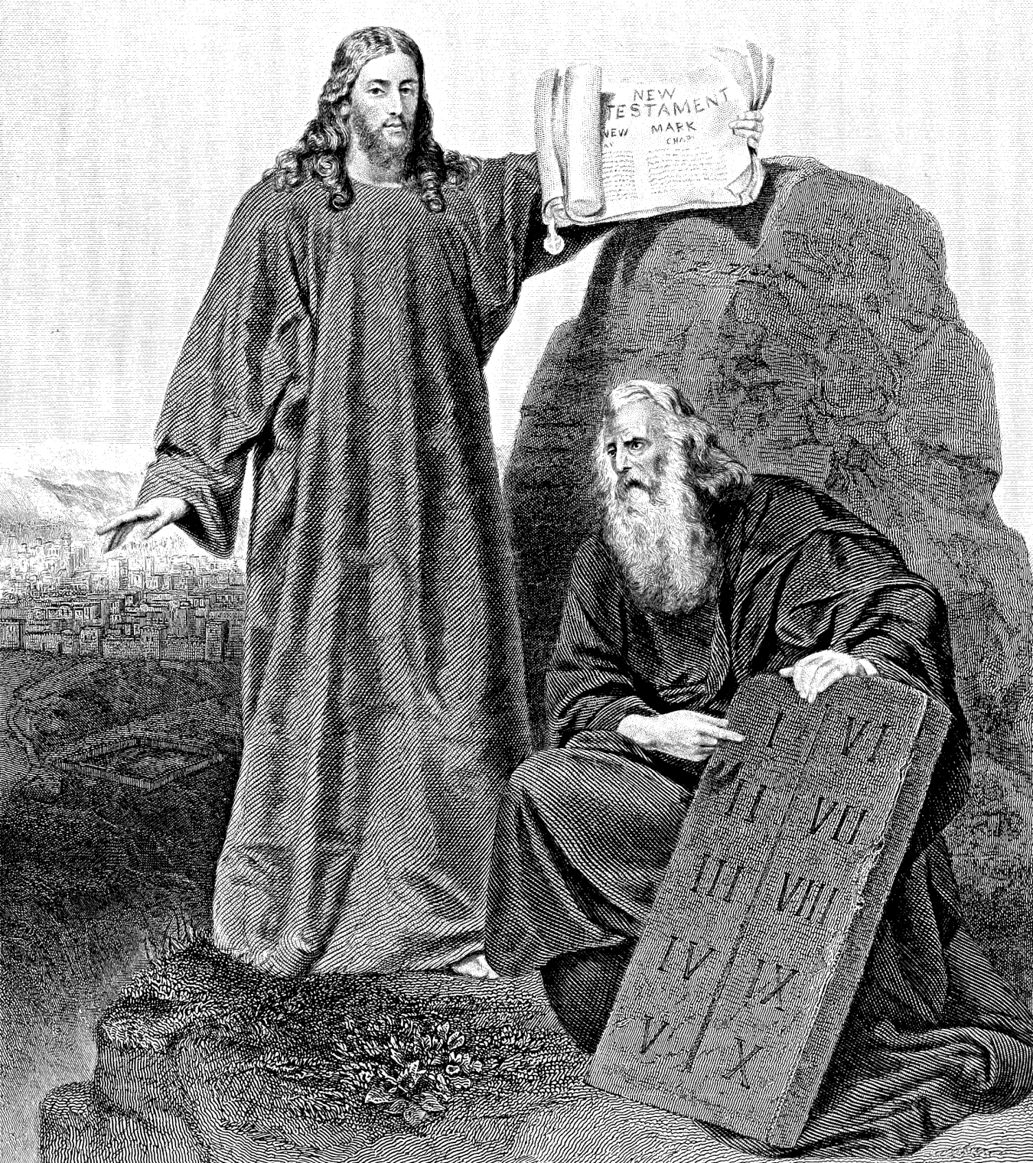
- The Law Established Through Faith – I
Sermons on Several Occasions
First Series, Sermon 35
Romans 3
31 Do we then make void the law through faith? God forbid: yea, we establish the law.
PAUL, having the beginning of this Epistle laid down his general proposition, namely, that:
Romans 1
16 The gospel of Christ is the power of God unto salvation to every one that believes;
–the powerful means, whereby God makes every believer a partaker of present and eternal salvation;—goes on to show, that there is no other way under heaven whereby men can be saved.

Paul’s Argument
He speaks particularly of salvation from the guilt of sin, which he commonly terms justification. And that all men stood in need of this, that none could plead their own innocence, he proves at large by various arguments, addressed to the Jews as well as the Heathens. Hence he infers,
Romans 3
19 ...that every mouth, [whether of Jew or Heathen, must be] stopped [from excusing or justifying himself], and all the world become guilty before God.
20 Therefore, [says he, by his own obedience,] by the words of the law, shall no flesh be justified in His sight.
21 But now the righteousness of God without the law, [without our previous obedience thereto,] is manifested;…
22 Even the righteousness of God, which is by faith of Jesus Christ, unto all and upon all that believe: for there is no difference [as to their need of justification, or the manner wherein they attain it]:
23 For all have sinned, and come short of the glory of God [the glorious image of God wherein they were created];
24 [And all (who attain) are] justified freely by His grace, through the redemption that is in Jesus Christ:
25 Whom God has set forth to be a propitiation through faith in His blood,…
26 ...that He might be just, and yet the justifier of him which believes in Jesus;
–that without any impeachment to His justice, He might show him mercy for the sake of that propitiation.
Romans 3
28 Therefore we conclude, [which was the grand position he had undertaken to establish,] that a man is justified by faith, without the works of the law.
It was easy to foresee an objection which might be made, and which has in fact been made in all ages; namely, that to say we are justified without the works of the law, is to abolish the law. The Apostle, without entering into a formal dispute, simply denies the charge.
31 Do we then, [says he,] make void the law through faith? God forbid! Yea, we establish the law.
The strange imagination of some, that Paul, when he says,
28 A man is justified without the works of the law,
–means only ceremonial law, is abundantly confuted by these very words. For did Paul establish the ceremonial law? It is evident he did not. He did make void that law through faith, and openly avowed his doing so. It was the moral law only, of which he might truly say,
“We do not make void, but establish this through faith.”

Confusion of Many
But all men are not herein of his mind. Many there are who will not agree to this. Many in all ages of the Church, even among those who bore the name of Christians, have contended, that “the faith once delivered to the saints” was designed to make void the whole law. They would no more spare the moral than the ceremonial law, but were for “hewing,” as it were, “both in pieces before the Lord;” vehemently maintaining,
“If you establish any law, Christ shall profit you nothing; Christ is become of no effect to you; you are fallen from grace.”
But is the zeal of these men according to knowledge? Have they observed the connection between the law and faith? and that, considering the close connection between them, to destroy one is indeed to destroy both? That, to abolish the moral law, is, in truth, to abolish faith and the law together? as leaving no proper means, either of bringing us to faith, or of stirring up that gift of God in our soul.

Common Ways of Making the Law Void
It therefore behooves all who desire either to come to Christ, or to walk in Him whom they have received, to take heed how they “make void the law through faith;” to secure us effectually against which, let us inquire,
- Which are the most usual ways of making “void the law through faith?” And,
- How we may follow the Apostle, and by faith “establish the law.”

1. Refusing to Preach the Law
Let us, First, inquire, Which are the most usual ways of making void the law through faith?
Now the way for a Preacher to make it all void at a stroke, is, not to preach it at all. This is just the same thing as to blot it out of the oracles of God. More especially, when it is done with design; when it is made a rule, not to preach the law; and the very phrase, “a Preacher of the law,” is used as a term of reproach, as though it meant little less than an enemy of the gospel.
All this proceeds from the deepest ignorance of the nature, properties, and use of the law; and proves, that those who act thus, either know not Christ,—are utter strangers to living faith,—or, at least, that they are but babes in Christ, and, as such,
Hebrews 5
13 ...unskilled in the word of righteousness.
Their grand plea is this: That preaching the gospel, that is, according to their judgment, the speaking of nothing but the sufferings and merits of Christ, answers all the ends of the law. But this we utterly deny. It does not answer the very first end of the law, namely, the convincing men of sin; the awakening those who are still asleep on the brink of hell. There may have been here and there an exempt case. One in a thousand may have been awakened by the gospel: but this is no general rule. The ordinary method of God is to convict sinners by the law, and that only. The gospel is not the means which God has ordained, or which our Lord himself used, for this end.
We have no authority in Scripture for applying it thus, nor any ground to think it will prove effectual. Nor have we any more ground to expect this, from the nature of the thing.
Matthew 9
12 They that be whole, [as our Lord himself observes,] need not a physician, but they that are sick.
It is absurd, therefore, to offer a physician to them that are whole, or that at least imagine themselves so to be. You are first to convince them that they are sick; otherwise they will not thank you for your labor. It is equally absurd to offer Christ to them whose heart is whole, having never yet been broken. It is, in the proper sense, “casting pearls before swine.” Doubtless “they will trample them under foot;” and it is no more than you have reason to expect, if they also “turn again and rend you.”
“But although there is no command in Scripture, to offer Christ to the careless sinner, yet are there not scriptural precedents for it?”
I think not: I know not any. I believe you cannot produce one, either from the four Evangelists, or the Acts of the Apostles. Neither can you prove this to have been the practice of any of the Apostles, from any passage in all their writings.
“Nay, does not the Apostle Paul say, in his former Epistle to the Corinthians, ‘We preach Christ crucified?’ and in his latter, ‘We preach not ourselves, but Christ Jesus the Lord?’”
We consent to rest the cause on this issue; to tread in his steps, to follow his example. Only preach you just as Paul preached, and the dispute is at an end. For although we are certain he preached Christ in as perfect a manner as the very chief of the Apostles, yet who preached the law more than Paul? Therefore he did not think the gospel answered the same end.
The very first sermon of Paul’s which is recorded, concludes in these words:
Acts 13
39 By Him all that believe are justified from all things, from which you could not be justified by the law of Moses.
40 Beware therefore, lest that come upon you, which is spoken of in the Prophets;
41 Behold, you despisers, and wonder, and perish: for I work a work in your days, a work which you will in no wise believe, though a man declare it unto you.
Now it is manifest, all this is preaching the law, in the sense wherein you understand the term; even although great part of, if not all, his hearers, were either Jews or religious proselytes, and, therefore, probably many of them, in some degree at least, convicted of sin already. He first reminds them, that they could not be justified by the law of Moses, but only by faith in Christ; and then severely threatens them with the judgments of God, which is in the strongest sense, preaching the law.
In his next discourse, that to the Heathens at Lystra, we do not find so much as the name of Christ: The whole purport of it is, that they should…
Acts 14
15 ...turn from those vain idols, unto the living God.
Now confess the truth. Do not you think, if you had been there, you could have preached much better than he? I should not wonder if you thought too, that his preaching so ill occasioned his being so ill treated; and that his being stoned was a just judgment upon him for not preaching Christ!
To the jailer indeed, when…
Acts 16
29 ...he sprang in, and came trembling, and fell down before Paul and Silas,
30 And said, Sirs, what must I do to be saved?
–he immediately said,
31 Believe on the Lord Jesus Christ;
–and in the case of one so deeply convicted of sin, who would not have said the same? But to the men of Athens you find him speaking in a quite different manner; reproving their superstition, ignorance, and idolatry; and strongly moving them to repent, from the consideration of a future judgment, and of the resurrection from the dead. Likewise when Felix sent for Paul, on purpose that he might…
Acts 24
24 ...hear him concerning the faith in Christ;
–instead of preaching Christ in your sense, (which would probably have caused the Governor either to mock or to contradict and blaspheme,)
25 ...he reasoned of righteousness, temperance, and judgment to come,
–till Felix (hardened as he was) “trembled.” Go you, and tread in his steps. Preach Christ to the careless sinner, by reasoning “of righteousness, temperance, and judgment to come!” If you say,
“But he preached Christ in a different manner in his Epistles:”
I answer,
- He did not there preach at all; not in that sense wherein we speak: For preaching, in our present question, means speaking before a congregation.
But, waving this, I answer,
- His Epistles are directed, not to unbelievers, such as those we are now speaking of, but “to the saints of God,” in Rome, Corinth, Philippi, and other places. Now, unquestionably, he would speak more of Christ to these than to those who were without God in the world.
- And yet, Every one of these is full of the law, even the epistles to the Romans and the Galatians; in both of which he does what you term “preaching the law,” and that to believers, as well as unbelievers.
From hence it is plain, you know not what it is to preach Christ, in the sense of the Apostle. For doubtless Paul judged himself to be preaching Christ, both to Felix, and at Antioch, Lystra, and Athens: from whose example every thinking man must infer, that not only the declaring the love of Christ to sinners, but also the declaring that He will come from heaven in flaming fire, is, in the Apostle’s sense, preaching Christ; yea, in the full scriptural meaning of the word. To preach Christ, is to preach what He has revealed, either in the Old or New Testament; so that you are really preaching Christ, when you are saying,
Psalm 9
17 The wicked shall be turned into hell, and all the people that forget God,
–as when you are saying,
John 1
29 Behold the Lamb of God, which takes away the sin of the world!
Consider this well;—that to preach Christ, is to preach all things that Christ has spoken; all His promises; all His threatenings and commands; all that is written in His book; and then you will know how to preach Christ, without making void the law.
“But does not the greatest blessing attend those discourses wherein we peculiarly preach the merits and suffering of Christ?”
Probably when we preach to a congregation of mourners, or of believers, these will be attended with the greatest blessing; because such discourses are peculiarly suited to their state. At least, these will usually convey the most comfort. But this is not always the greatest blessing. I may sometimes receive a far greater by a discourse that cuts me to the heart, and humbles me to the dust. Neither should I receive that comfort, if I were to preach or to hear no discourses but on the sufferings of Christ. These, by constant repetition, would lose their force, and grow more and more flat and dead, till at length they would become a dull round of words, without any spirit, or life, or virtue. So that thus to preach Christ must, in process of time, make void the gospel as well as the law.

2. Teaching That Faith Supersedes Holiness
A Second way of making void the law through faith is, the teaching that faith supersedes the necessity of holiness. This divides itself into a thousand smaller paths, and many there are that walk therein. Indeed there are few that wholly escape it; few who are convinced, we are saved by faith, but are sooner or later, more or less, drawn aside into this by-way.
All those are drawn into this by-way who, if it be not settled judgment that faith in Christ entirely sets aside the necessity of keeping His law; yet suppose it either sets aside the necessity of keeping His law; yet suppose either,
- That holiness is less necessary now than it was before Christ came; or,
- That a less degree of it is necessary; or,
- That it is less necessary to believers than to others.
Yea, and so are all those who, although their judgment be right in the general, yet think they may take more liberty in particular cases than they could have done before they believed. Indeed, the using the term liberty, in such a manner, for liberty from obedience or holiness, shows at once, that their judgment is perverted, and that they are guilty of what they imagined to be far from them; namely, of making void the law through faith, by supposing faith to supersede holiness.
The first plea of those who teach this expressly is, that we are now under the covenant of grace, not works; and therefore we are no longer under the necessity of performing the works of the law.
And who ever was under the covenant of works? None but Adam before the fall. He was fully and properly under that covenant which required perfect, universal obedience, as the one condition of acceptance; and left no place for pardon, upon the very least transgression. But no man else was ever under this, neither Jew nor Gentile; neither before Christ nor since. All his sons were and are under the covenant of grace. The manner of their acceptance is this: The free grace of God, through the merits of Christ, gives pardon to them that believe; that believe with such a faith as, working by love, produces all obedience and holiness.
The case is not, therefore, as you suppose, that men were once more obliged to obey God, or to work the works of His law, than they are now. This is a supposition you cannot make good.
But we should have been obliged, if we had been under the covenant of works, to have done those works antecedent to our acceptance. Whereas now all good works, though as necessary as ever, are not antecedent to our acceptance, but consequent upon it. Therefore the nature of the covenant of grace gives you no ground, no encouragement at all, to set aside any insistence or degree of obedience; any part or measure of holiness.
“But are we not justified by faith, without the works of the law?”
Undoubtedly we are; without the works either of the ceremonial or the moral law. And would to God all men were convicted of this! It would prevent innumerable evils; Antinomianism in particular: for generally speaking, it is the Pharisees who make the Antinomians. Running into an extreme so palpably contrary to Scripture [the Pharisees], they occasion others to run into the opposite one [the Antinomians]. These [the Pharisees], seeking to be justified by works, affright those [the Antinomians] from allowing any place for works.
But the truth lies between both. We are, doubtless, justified by faith. This is the corner-stone of the whole Christian building. We are justified without the works of the law, as any previous condition of justification; but they are an immediate fruit of that faith whereby we are justified. So that if good works do not follow our faith, even all inward and outward holiness, it is plain our faith is nothing worth; we are yet in our sins. Therefore, that we are justified by faith, even by our faith without works, is no ground for making void the law through faith; or for imagining that faith is a dispensation from any kind or degree of holiness.
“Nay, but does not Paul expressly say, ‘Unto him that works not, but believes on Him that justifies the ungodly, his faith is counted for righteousness?’ And does it not follow from hence, that faith is to a believer in the room, in the place, of righteousness? But if faith is in the room of righteousness or holiness, what need is there of this too?”
This, it must be acknowledged, comes home to the point, and is, indeed, the main pillar of Antinomianism. And yet it needs not a long or labored answer. We allow,
- That God justifies the ungodly; him that, till that hour, is totally ungodly;—full of all evil, void of all good:
- That He justifies the ungodly that works not; that, till that moment, works no good work;—neither can he; for an evil tree cannot bring forth good fruit:
- That He justifies him by faith alone, without any goodness or righteousness preceding: and,
- That faith is then counted to him for righteousness; namely, for preceding righteousness; that is, God, through the merits of Christ, accepts him that believes, as if he had already fulfilled all righteousness.
But what is all this to your point? The Apostle does not say, either here or elsewhere, that this faith is counted to him for subsequent righteousness. He does teach that there is no righteousness before faith; but where does he teach that there is none after it? He does assert, holiness cannot precede justification; but not, that it need not follow it. Paul, therefore, gives you no color for making void the law, by teaching that faith supersedes the necessity of holiness.

3. Living as If Faith Excused Us from Holiness
There is yet another way of making void the law through faith, which is more common than either of the former. And that is, the doing it practically; the making it void in fact, though not in principle; the living as if faith was designed to excuse us from holiness.
How earnestly does the Apostle guard us against this, in those well-known words:
Romans 6
15 What then? Shall we sin, because we are not under the law, but under grace? God forbid.
A caution which it is needful thoroughly to consider, because it is of the last importance. The being “under the law,” may here mean,
- The being obliged to observe the ceremonial law:
- The being obliged to conform to the whole Mosaic institution:
- The being obliged to keep the whole moral law, as the condition of our acceptance with God: and,
- The being under the wrath and curse of God; under sentence of eternal death; under a sense of guilt and condemnation, full of horror and slavish fear.
Now although a believer is “not without law to God, but under the law to Christ,” yet from the moment he believes, he is not “under the law,” in any of the preceding senses. On the contrary, he is “under grace,” under a more benign, gracious dispensation. As he is no longer under the ceremonial law, nor under the Mosaic institution; as he is not obliged to keep even the moral law, as the condition of his acceptance; so he is delivered from the wrath and the curse of God, from all sense of guilt and condemnation, and from all that horror and fear of death and hell whereby he was all his life before subject to bondage.
And he now performs (which while “under the law” he could not do) a willing and universal obedience. He obeys not from the motive of slavish fear, but on a nobler principle; namely, the grace of God ruling in his heart, and causing all his works to be wrought in love.
What then? Shall this evangelical principle of action be less powerful than the legal? Shall we be less obedient to God from filial love than we were from servile fear?
It is well if this is not a common case; if this practical Antinomianism, this unobserved way of making void the law through faith, has not infected thousands of believers. Has it not infected you? Examine yourself honestly and closely. Do you not do now what you dared not have done when you were “under the law,” or (as we commonly call it) under conviction?
For instance: You dared not then indulge yourself in food: you took just what was needful, and that of the cheapest kind. Do you not allow yourself more latitude now? Do you not indulge yourself a little more than you did? O beware lest you “sin because you are not under the law, but under grace!”
When you were under conviction, you dared not indulge the lust of the eye in any degree. You would not do anything, great or small, merely to gratify your curiosity. You regarded only cleanliness and necessity, or at most very moderate convenience, either in furniture or apparel; superfluity and finery of whatever kind, as well as fashionable elegance, were both a terror and an abomination to you.
Are they so still? Is your conscience as tender now in these things as it was then? Do you still follow the same rule both in furniture and apparel, trampling all finer, all superfluity, every thing useless, every thing merely ornamental, however fashionable, underfoot? Rather, have you not resumed what you had once laid aside, and what you could not then use without wounding you conscience? And have you not learned to say,
“O, I am not so scrupulous now?”
I would to God you were! Then you would not sin thus, “because you are not under the law, but under grace!”
You were once scrupulous too of commending any to their face; and still more, of suffering any to commend you. It was a stab to your heart; you could not bear it; you sought the honor that comes of God only. You could not endure such conversation; nor any conversation which was not good to the use of edifying. All idle talk, all trifling discourse, you abhorred; you hated as well as feared it; being deeply sensible of the value of time, of every precious, fleeting moment. In like manner, you dreaded and abhorred idle expense; valuing your money only less than your time, and trembling lest you should be found an unfaithful steward even of the mammon of unrighteousness.
Do you now look upon praise as deadly poison, which you can neither give nor receive but at the peril of your soul? Do you still dread and abhor all conversation which does not tend to the use of edifying; and labor to improve every moment, that it may not pass without leaving you better than it found you? Are not you less careful as to the expense both of money and time? Cannot you now lay out either, as you could not have done once? Alas! how has that “which should have been for your health, proved to you an occasion of falling!” How have you “sinned because you was not under the law, but under grace!”
God forbid you should any longer continue thus to “turn the grace of God into lasciviousness!” O remember how clear and strong a conviction you once had concerning all these things! And, at the same time, you were fully satisfied from whom that conviction came. The world told you, you were in a delusion; but you knew it was the voice of God. In these things you were not too scrupulous then; but you are not now scrupulous enough. God kept you longer in that painful school, that you might learn those great lessons the more perfectly. And have you forgot them already? O recollect them before it is too late! Have you suffered so many things in vain? I trust, it is not yet in vain.
Now use the conviction without the pain! Practice the lesson without the rod! Let not the mercy of God weigh less with you now, than his fiery indignation did before. Is love a less powerful motive than fear? If not, let it be an invariable rule,
I will do nothing now I am “under grace,”
which I dared not have done when “under the law.”
I cannot conclude this head without exhorting you to examine yourself, likewise, touching sins of omission. Are you as clear of these, now you “are under grace,” as you were when “under the law?” How diligent were you then in hearing the word of God! Did you neglect any opportunity? Did you not attend thereon day and night? Would a small hindrance have kept you away? a little business? a visitant? a slight indisposition? a soft bed? a dark or cold morning?
Did not you then fast often; or use abstinence to the uttermost of your power? Were not you much in prayer, (cold and heavy as you were,) while you were hanging over the mouth of hell? Did you not speak and not spare even for an unknown God? Did you not boldly plead His cause?—reprove sinners?—and avow the truth before an adulterous generation?
And are you now a believer in Christ? Have you the faith that overcomes the world? What! and are less zealous for your Master now, than you were when you knew Him not? less diligent in fasting, in prayer, in hearing His word, in calling sinners to God? O repent! See and feel your grievous loss! Remember from whence you are fallen!
Bewail your unfaithfulness! Now be zealous and do the first works; lest, if you continue to “make void the law through faith,” God cut you off, and appoint you your portion with the unbelievers!
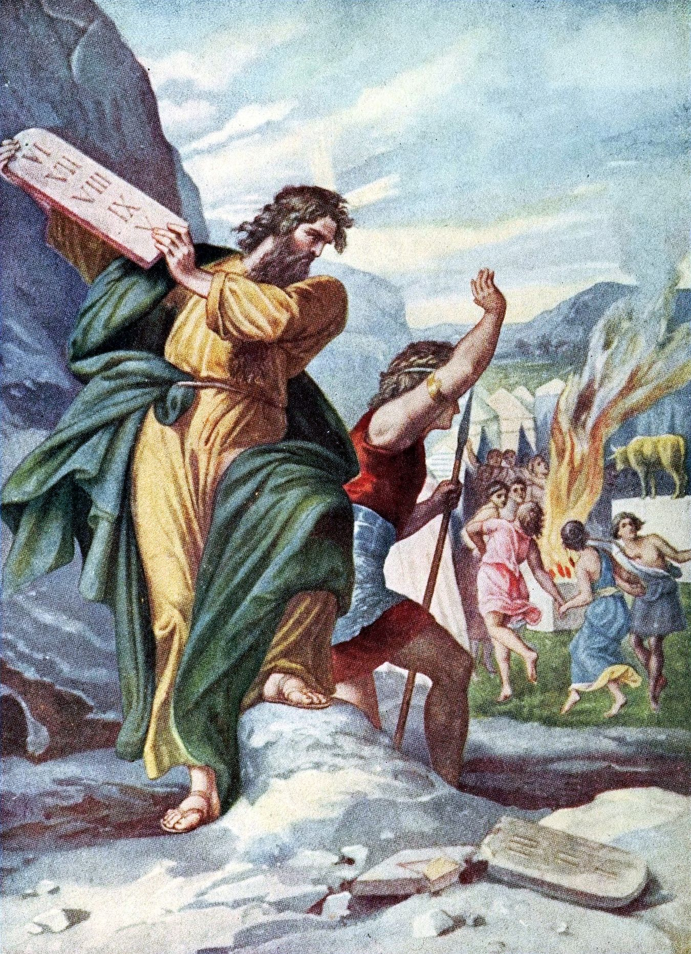
- The Law Established Through Faith – II
Sermons on Several Occasions
First Series, Sermon 36
Romans 3
31 Do we then make void the law through faith? God forbid! Yea, we establish the law.
IT HAS been shown in the preceding discourse, which are the most usual ways of making void the law through faith; namely,
- The not preaching it at all; which effectually makes it all void a stroke; and this under color of preaching Christ and magnifying the gospel though it be, in truth, destroying both the one and the other:
- The teaching (whether directly or indirectly,) that faith supersedes the necessity of holiness; that this less necessary now, or a less degree of it necessary, than before Christ came; that it is less necessary to us, because we believe, than otherwise it would have been; or, that Christian liberty is a liberty from any kind or degree of holiness: (so perverting those great truths, that we are now under the covenant of grace, and not of works; that a man is justified by faith, without the works of the law; and that “to him that works not, but believes, his faith is counted for righteousness:”)
- Or, the doing this practically; the making void the law in practice, though not in principle; the living or acting as if faith was designed to excuse us from holiness; the allowing ourselves in sin, “because we are not under the law, but under grace.”

How to Establish the Law
It remains to inquire how we may follow a better pattern, how we may be able to say, with the Apostle,
Romans 3
31 Do we then make void the law through faith? God forbid: yea, we establish the law.
We do not, indeed, establish the old ceremonial law; we know that is abolished for ever. Much less do we establish the whole Mosaic dispensation; this we know our Lord has nailed to His cross. Nor yet do we so establish the moral law, (which, it is to be feared too many do,) as if the fulfilling it, the keeping all the commandments, were the condition of our justification: If it were so, surely,
Psalm 143
2 ...in His sight should no man living be justified.
But all this being allowed, we still, in the Apostle’s sense, “establish the law,” the moral law.

1. Preach the Whole Gospel
We establish the law, First, by our doctrine; by endeavoring to preach it in its whole extent, to explain and enforce every part of it, in the same manner as our great Teacher did while upon earth. We establish it by following Peter’s advice:
1 Peter 4
11 If any man speak, let him speak as the oracles of God;
–as the holy men of old, moved by the Holy Ghost, spoke and wrote for our instruction; and as the Apostles of our blessed Lord, by the direction of the same Spirit. We establish it whenever we speak in His name, by keeping back nothing from them that hear; by declaring to them, without any limitation or reserve, the whole counsel of God. And in order the more effectually to establish it, we use herein great plainness of speech.
2 Corinthians 2
17 We are not as many that corrupt the word of God...
–kaphleuontes, (as artful men their bad wines;) we do not cauponize, mix, adulterate, or soften it, to make it suit the taste of the hearers:
17 ...but as of sincerity, but as of God, in the sight of God, speak we in Christ;
–as having no other aim, than…
2 Corinthians 4
2 ...by manifestation of the truth to commend ourselves to every man’s conscience in the sight of God.
We then, by our doctrine, establish the law, when we thus openly declare it to all men; and that in the fullness wherein it is delivered by our blessed Lord and His Apostles; when we publish it in the height, and depth, and length, and breadth thereof. We then establish the law, when we declare every part of it, every commandment contained therein, not only in its full, literal sense, but likewise in its spiritual meaning; not only with regard to the outward actions, which it either forbids or enjoins, but also with respect to the inward principle, to the thoughts, desires, and intents of the heart.
And indeed this we do the more diligently, not only because it is of the deepest importance;—inasmuch as all the fruit, every word and work, must be only evil continually, if the tree be evil, if the dispositions and tempers of the heart be not right before God;—but likewise because as important as these things are, they are little considered or understood,—so little, that we may truly say of the law, too, when taken in its full spiritual meaning, it is…
Colossians 1
26 ...a mystery which was hid from ages and generations since the world began.
It was utterly hid from the heathen world. They, with all their boasted wisdom, neither found out God, nor the law of God; not in the letter, much less in the spirit of it.
Romans 1
21 Their foolish hearts were [more and more] darkened;
22 [While] professing themselves wise, they became fools.
And it was almost equally hid, as to its spiritual meaning, from the bulk of the Jewish nation. Even these, who were so ready to declare concerning others,
John 7
49 This people who know not the law are cursed,
–pronounced their own sentence therein, as being under the same curse, the same dreadful ignorance. Witness our Lord’s continual reproof of the wisest among them for their gross misinterpretations of it. Witness the supposition almost universally received among them, that they needed only to make clean the outside of the cup; that the paying tithe of mint, anise, and cumin,—outward exactness,—would atone for inward unholiness, for the total neglect both of justice and mercy, of faith and the love of God. Yea, so absolutely was the spiritual meaning of the law hidden from the wisest of them, that one of their most eminent Rabbis comments thus on those words of the Psalmist,
Psalm 66
18 If I incline unto iniquity with my heart, the Lord will not hear me:
“That is, [says he,] if it be only in my heart, if I do not commit outward wickedness, the Lord will not regard it; He will not punish me unless I proceed to the outward act!”
But alas! the law of God, as to its inward, spiritual meaning, is not hid from the Jews or heathens only, but even from what is called the Christian world; at least, from a vast majority of them. The spiritual sense of the commandments of God is still a mystery to these also. Nor is this observable only in those lands which are overspread with Romish darkness and ignorance. But this is too sure, that the far greater part, even of those who are called Reformed Christians are utter strangers at this day to the law of Christ, in the purity and spirituality of it.
Hence it is that to this day, “the Scribes and Pharisees,” the men who have the form but not the power of religion, and who are generally wise in their own eyes, and righteous in their own conceits,—“hearing these things, are offended;” are deeply offended, when we speak of the religion of the heart; and particularly when we show, that without this, were we to “give all our goods to feed the poor,” it would profit us nothing.
But offended they must be; for we cannot but speak the truth as it is in Jesus. It is our part, whether they will hear, or whether they will forbear, to deliver our own soul. All that is written in the book of God we are to declare, not as pleasing men, but the Lord. We are to declare, not only all the promises, but all the threatenings, too, which we find therein. At the same time that we proclaim all the blessings and privileges which God has prepared for His children, we are likewise to…
Matthew 28
20 ...teach all the things whatsoever He has commanded.
And we know that all these have their use; either for the awakening those that sleep, the instructing the ignorant, the comforting the feeble-minded, or the building up and perfecting of the saints. We know that:
2 Timothy 3
16 All Scripture, given by inspiration of God is profitable, [either] for doctrine, [or] for reproof, [either] for correction or for instruction in righteousness:
17 [And] that the man of God,…
–in the process of the work of God in his soul, has need of every part thereof, that he may at length…
2 Timothy 3
17 ...be perfect, throughly furnished unto all good works.
It is our part thus to preach Christ, by preaching all things whatsoever He has revealed. We may indeed, without blame, yea, and with a peculiar blessing from God, declare the love of our Lord Jesus Christ; we may speak, in a more especial manner, of “the Lord our righteousness.” We may expatiate upon the grace of God in Christ, “reconciling the world unto himself;” we may, at proper opportunities, dwell upon His praise, as…
“...bearing the iniquities of us all, as wounded for our transgressions, and bruised for our iniquities, that by his stripes we might be healed:”
But still we should not preach Christ, according to His word, if we were wholly to confine ourselves to this. We are not ourselves clear before God, unless we proclaim Him in all His offices. To preach Christ, as a workman that needs not to be ashamed, is to preach Him, not only as our great High Priest,
Hebrews 5
1 ...taken from among men, and ordained for men, in things pertaining to God;
–as such,
“reconciling us to God by His blood,”
–and,
Hebrews 7
25 ...ever living to make intercession for us;
–but likewise as the Prophet of the Lord,
1 Corinthians 1
30 ...who of God is made unto us wisdom,
–who, by His word and His Spirit, is with us always,
John 16
13 ...guiding us into all truth;
–yea, and as remaining a King forever; as giving laws to all whom He has bought with His blood; as restoring those to the image of God, whom He had first re-instated in His favor; as reigning in all believing hearts until He has…
Philippians 3
21 ...subdued all things to himself,
–until He has utterly cast out all sin, and brought in everlasting righteousness.

2. Preach Faith in Christ to Produce Holiness
We establish the law, Secondly, when we so preach faith in Christ as not to supersede, but produce holiness; to produce all manner of holiness, negative and positive, of the heart and of the life.
In order to this, we continually declare, (what should be frequently and deeply considered by all “who would not make void the law through faith,”) that faith itself, even Christian faith, the faith of God’s elect, the faith of the operation of God, still is only the handmaid of love. As glorious and honorable as it is, it is not the end of the commandment. God has given this honor to love alone: Love is the end of all the commandments of God. Love is the end, the sole end, of every dispensation of God, from the beginning of the world to the consummation of all things. And it will endure when heaven and earth flee away; for “love” alone “never fails.” Faith will totally fail; it will be swallowed up in sight, in the everlasting vision of God. But even then love, —
Its nature and its office still the same,
Lasting its lamp and unconsumed its flame,—
In deathless triumph shall for ever live,
And endless good diffuse, and endless praise receive.
Very excellent things are spoken of faith, and whosoever is a partaker thereof may well say with the Apostle,
2 Corinthians 9
15 Thanks be to God for His unspeakable gift.
Yet still it loses all its excellence when brought into a comparison with love. What Paul observes concerning the superior glory of the gospel above that of the law may with great propriety be spoken of the superior glory of love above that of faith:
2 Corinthians 3
10 Even that which was made glorious has no glory in this respect, by reason of the glory that excels.
11 For if that which is done away is glorious, much more does that which remains exceed in glory.
Yea, all the glory of faith, before it is done away, arises hence, that it ministers to love: it is the great temporary means which God has ordained to promote that eternal end.
Let those who magnify faith beyond all proportion, so as to swallow up all things else, and who so totally misapprehend the nature of it as to imagine it stands in the place of love, consider farther, that as love will exist after faith, so it did exist long before it. The angels who, from the moment of their creation, beheld the face of their Father that is in heaven, had no occasion for faith, in its general notion, as it is the evidence of things not seen. Neither had they need of faith in its more particular acceptation, faith in the blood of Jesus: for He took not upon Him the nature of angels, but only the seed of Abraham. There was therefore no place before the foundation of the world for faith either in the general or particular sense. But there was for love. Love existed from eternity, in God, the great ocean of love. Love had a place in all the children of God, from the moment of their creation. They received at once from their gracious Creator to exist, and to love.
Nor is it certain (as ingeniously and plausibly as many have descanted upon this) that faith, even in the general sense of the word, had any place in paradise. It is highly probable, from that short and uncircumstantial account which we have in Holy Writ, that Adam, before he rebelled against God, walked with Him by sight and not by faith.
For then his reason’s eye was strong and clear,
And (as an eagle can behold the sun)
Might have beheld his Maker’s face as near,
As th’ intellectual angels could have done.
He was then able to talk with Him face to face, whose face we cannot now see and live; and consequently had no need of that faith whose office it is to supply the want of sight.
On the other hand, it is absolutely certain, faith, in its particular sense, had then no place. For in that sense it necessarily presupposes sin, and the wrath of God declared against the sinner; without which there is no need of an atonement for sin in order to the sinner’s reconciliation with God. Consequently, as there was no need of an atonement before the fall, so there was no place for faith in that atonement; man being then pure from every stain of sin; holy as God is holy.
But love even then filled his heart; it reigned in him without rival; and it was only when love was lost by sin, that faith was added, not for its own sake, nor with any design that it should exist any longer than until it had answered the end for which it was ordained,—namely, to restore man to the love from which he was fallen. At the fall, therefore, was added this evidence of things unseen, which before was utterly needless; this confidence in redeeming love, which could not possibly have any place till the promise was made, that…
Genesis 3
15 ...the Seed of the woman should bruise the serpent’s head.
Faith, then, was originally designed of God to re-establish the law of love. Therefore, in speaking thus, we are not undervaluing it, or robbing it of its due praise; but on the contrary showing its real worth, exalting it in its just proportion, and giving it that very place which the wisdom of God assigned it from the beginning. It is the grand means of restoring that holy love wherein man was originally created. It follows, that although faith is of no value in itself, (as neither is any other means whatsoever,) yet as it leads to that end, the establishing anew the law of love in our hearts; and as, in the present state of things, it is the only means under heaven for effecting it; it is on that account an unspeakable blessing to man, and of unspeakable value before God.

3. Establishing the Law in Our Own Hearts and Lives
And this naturally brings us to observe, Thirdly, the most important way of establishing the law; namely, the establishing it in our own hearts and lives. Indeed, without this, what would all the rest avail? We might establish it by our doctrine; we might preach it in its whole extent; might explain and enforce every part of it. We might open it in its most spiritual meaning, and declare the mysteries of the kingdom; we might preach Christ in all His offices, and faith in Christ as opening all the treasures of His love; and yet, all this time, if the law we preached were not established in our hearts, we should be of no more account before God than “sounding brass, or tinkling cymbals:” all our preaching would be so far from profiting ourselves, that it would only increase our damnation.
This is, therefore, the main point to be considered, How may we establish the law in our own hearts so that it may have its full influence on our lives? And this can only be done by faith.
Faith alone it is which effectually answers this end, as we learn from daily experience. For so long as we walk by faith, not by sight, we go swiftly on in the way of holiness. While we steadily look, not at the things which are seen, but at those which are not seen, we are more and more crucified to the world and the world crucified to us. Let but the eye of the soul be constantly fixed, not on the things which are temporal, but on those which are eternal, and our affections are more and more loosened from earth, and fixed on things above. So that faith, in general, is the most direct and effectual means of promoting all righteousness and true holiness; of establishing the holy and spiritual law in the hearts of them that believe.
And by faith, taken in its more particular meaning, for a confidence in a pardoning God, we establish His law in our own hearts in a still more effectual manner. For there is no motive which so powerfully inclines us to love God, as the sense of the love of God in Christ. Nothing enables us like a piercing conviction of this to give our hearts to Him who was given for us. And from this principle of grateful love to God arises love to our brother also. Neither can we avoid loving our neighbor, if we truly believe the love wherewith God has loved us. Now this love to man, grounded on faith and love to God,
Romans 13
10 ...works no ill to [our] neighbor...
Consequently, it is, as the Apostle observes,
10 ...the fulfilling of the [whole negative] law.
9 For this, You shall not commit adultery; You shall not kill; You shall not steal; You shall not bear false witness; You shall not covet; and if there be any other commandment, it is briefly comprehended in this saying, You shall love your neighbor as yourself.
Neither is love content with barely working no evil to our neighbor. It continually incites us to do good, as we have time and opportunity; to do good, in every possible kind, and in every possible degree, to all men. It is therefore, the fulfilling of the positive, likewise, as well as of the negative, law of God.
Nor does faith fulfill either the negative or positive law, as to the external part only; but it works inwardly by love, to the purifying of the heart, the cleansing it from all vile affections.
1 John 3
3 Everyone that has this faith in himself, purifies himself, even as He is pure;
–purifies himself from every earthly, sensual desire, from all vile and inordinate affections; yea, from the whole of that carnal mind which is enmity against God. At the same time, if it have its perfect work, it fills him with all goodness, righteousness, and truth. It brings all heaven into his soul; and causes him to walk in the light, even as God is in the light.
Let us thus endeavor to establish the law in ourselves; not sinning “because we are under grace,” but rather using all the power we receive thereby, “to fulfill all righteousness.” Calling to mind what light we received from God while His Spirit was convincing us of sin, let us beware we do not put out that light; what we had then attained let us hold fast. Let nothing induce us to build again what we have destroyed; to resume anything, small or great, which we then clearly saw was not for the glory of God, or the profit of our own soul; or to neglect anything, small or great, which we could not then neglect, without a check from our own conscience.
To increase and perfect the light which we had before, let us now add the light of faith. Confirm we the former gift of God by a deeper sense of whatever He had then shown us, by a greater tenderness of conscience, and a more exquisite sensibility of sin. Walking now with joy, and not with fear, in a clear, steady sight of things eternal, we shall look on pleasure, wealth, praise—all the things of earth,—as on bubbles upon the water; counting nothing important, nothing desirable, nothing worth a deliberate thought, but only what is “within the veil,” where Jesus “sits at the right hand of God.”
Can you say,
“You are merciful to my unrighteousness; my sins You remember no more”?
Then for the time to come see that you fly from sin, as from the face of a serpent! For how exceeding sinful does it appear to you now! How heinous above all expression! On the other hand, in how amiable a light do you now see the holy and perfect will of God! Now, therefore, labor that it may be fulfilled, both in you, by you, and upon you! Now watch and pray that you may sin no more, that you may see and shun the least transgression of His law!
You see the motes which you could not see before, when the sun shines into a dark place. In like manner you see the sins which you could not see before, now the Sun of Righteousness shines in your heart. Now, then, do all diligence to walk, in every respect, according to the light you have received! Now be zealous to receive more light daily, more of the knowledge and love of God, more of the Spirit of Christ, more of His life, and of the power of His resurrection! Now use all the knowledge, and love, and life, and power you have already attained: so shall you continually go on from faith to faith; so shall you daily increase in holy love, till faith is swallowed up in sight, and the law of love established to all eternity!
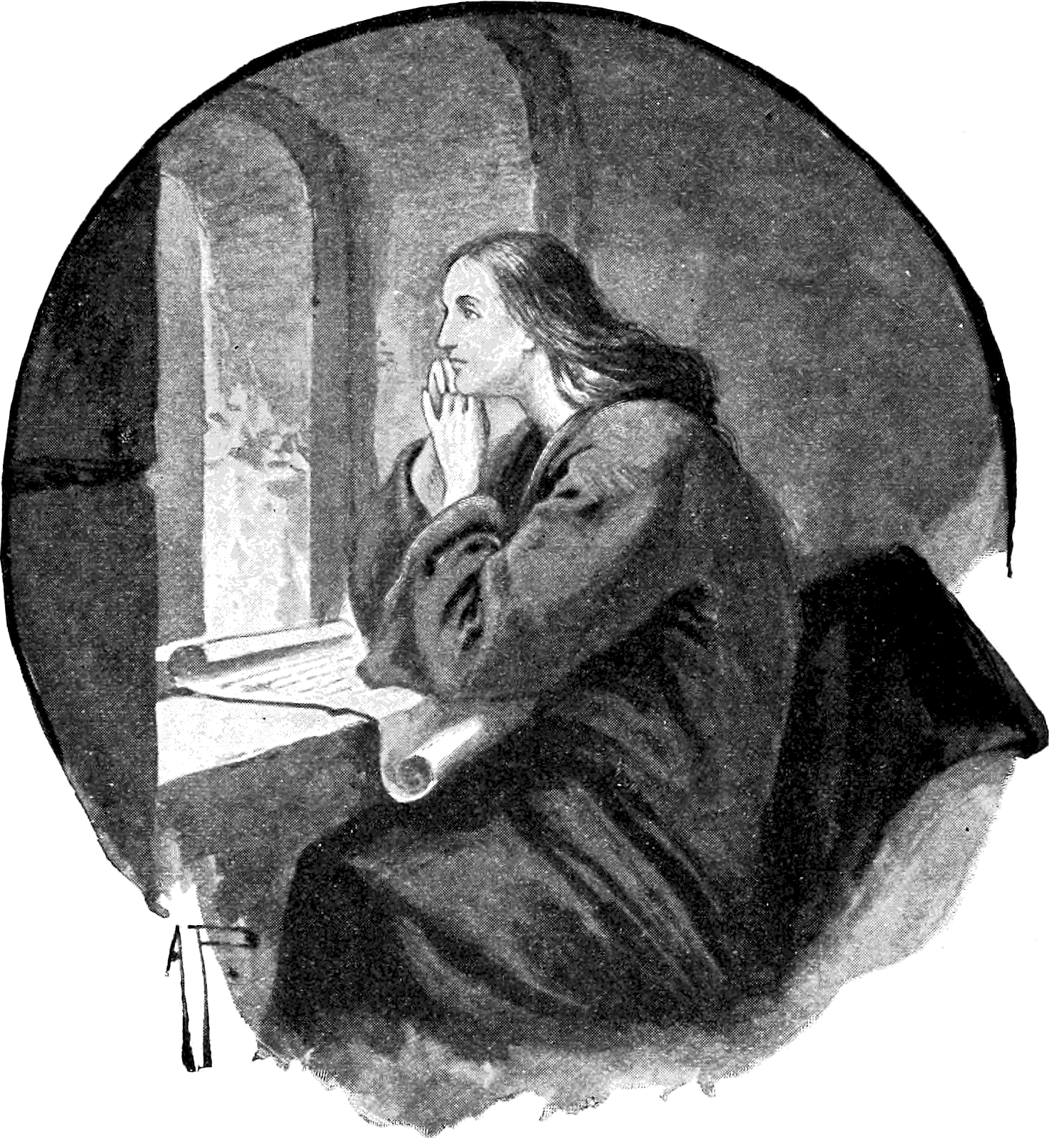“Keep yourselves in the love of God, looking for the mercy
of our Lord Jesus Christ unto eternal life.” Jude 21

Appendix: Concise Outline
From kevinmwatson.com, Feb. 16, 2021
Original title: Concise Outline of “The Law: Origin, Nature, Properties, and Uses”
Note: This is an outline of the first Sermon. Main subheadings are hyperlinked to the original study
- The law is often misunderstood or ignored.
- Paul is referring to the moral law, as can be seen from the beginning of Romans 7.
- “The Apostle having gone thus far in proving that the Christian had set aside the Jewish dispensation, and that the moral law itself, though it could never pass away, yet stood on a different foundation from what it did before, now stops to propose and answer an objection. ‘What shall we say then? Is the law sin?’…‘God forbid!’...The law is an irreconcilable enemy to sin, searching it out wherever it is.”
- This sermon will:
  - Show the Origin of this Law.
  - The Nature of this Law.
  - The Properties of this Law (holy, just, and good).
  - The Uses of this Law.

A. The Origin of the Law
- The moral law goes back even before creation “even beyond the foundation of the world.”
- The moral law was given to angelic minds “to make way for a continual increase of their happiness; seeing every instance of obedience to that law would both add to the perfection of their nature and entitle them to a higher reward, which the righteous Judge would give in its season.”
- When God created humans, He gave them the same law, written “in the inmost spirit both of men and of angels.”
- When humans broke the moral law “God did not despise the work of His own hands; but being reconciled to man through the Son of His love, He in some measure re-inscribed the law on the heart of His dark, sinful creature.”
- God then chose a particular people “to whom He gave a more perfect knowledge of the law. And the heads of this, because they were slow of understanding, He wrote on tables of stone.”
- Today we hear the law of God with our ears, but it must be revealed by the Spirit of God. “Behold, the days come, says the Lord, that I will make a new covenant with the house of Israel. . . . I will put my law in their inward parts, and write it in their hearts; and I will be their God, and they shall be my people.”

B. The Nature of the Law
- The law and the commandment are sometimes taken to be different things, but they are the same. And neither is the same thing as the ceremonial law.
- The law mentioned in Romans 7 is not the Mosaic dispensation.
- “This law is an incorruptible picture of the high and holy One that inhabits eternity. It is He whom in His essence no man has seen or can see, made visible to men and angels.”
- The law is “divine virtue and wisdom assuming a visible form.”
- From another vantage point, the law is “supreme, unchangeable reason; it is unalterable rectitude; it is the everlasting fitness of all things that are or ever were created.”
- “The law of God...is a copy of the eternal mind, a transcript of the divine nature.”

C. The Properties of the Law
- The law is holy, just, and good.
- It is holy: “‘pure religion and undefiled’; or the pure, clean, unpolluted worship of God.”
- Because the law is holy, it is enmity to sin.
- This is why Paul objects so strongly to the suggestion that the law is sin or causes sin. Rather, the law reveals sin.
- The law is just, rendering each their due.
- Wesley acknowledges the question of whether the will of God causes the law and creates right and wrong. “Is a thing therefore right because God wills it? Or does He will it because it is right?” Nevertheless, this question is “more curious than useful.”
- The difficulty of the question comes from thinking about God’s will as something distinct from God. “But the will of God is God himself.”
- The point above is reinforced.
- It may be granted that “in every particular case God wills this or this… because it is right, agreeable to the fitness of things, to the relation wherein they stand.”
- “The law then is right and just concerning all things. And it is good as well as just.” The law is good because it comes from God.
- The law is “mild and kind; it is ‘sweeter than honey and the honeycomb.’ It is winning and amiable.”
- The law is good “in its effects, as well as in its nature.”

D. The Uses of the Law
- The first use is to convince the world of sin.
- The second use of the law is to bring us back to life, through faith in Christ, so that we may live.
- The third use of the law is to “keep us alive.”
- The law is “of unspeakable use, first, in convincing us of the sin that yet remains both in our hearts and lives, and thereby keeping us close to Christ, that His blood may cleanse us every moment; secondly, in deriving strength from our Head into His living members, whereby He empowers them to do what His law commands; and thirdly, in confirming our hope of whatsoever it commands and we have not yet attained, of receiving grace upon grace, till we are in actual possession of the fullness of His promises.”
- The law shows every true believer the truth more and more clearly.
- Illustrated using “You shall not kill.”
- “Therefore I cannot spare the law one moment, no more than I can spare Christ; seeing I now want it as much to keep me to Christ as ever I wanted it to bring me to Him.”
- Who are you, then, to judge or speak evil of the law?
- If you are convinced that the law is holy, just, and good, cling to it all the more.
“And if your Lord has already fulfilled His word, if He has already ‘written His law in your heart’, then ‘stand fast in the liberty wherewith Christ has made you free.’”


See Revelation 13:11-16; 14:9, 11; 15:2; 16:2; 19:20; 20:4.
Compare Revelation 7:2-3, with chapter 14:1, 5.
From the first sermon, in the section on “The Origin of the Law.”
From the first sermon, in the section on “The Nature of the Law.”
1 Corinthians 13:9.
Jude 1:3.
1 Samuel 15:33.
Matthew 7:6.
1 Corinthians 1:23.
2 Corinthians 4:5.
See Acts 13:43.
Acts 17:24-31.
1 Corinthians 9:21.
PP Editor’s note: The word “cheapest” here should be understood as plain, simple, unadorned, such as, for example, buying bread (or flour to make it) instead of cake, or other expensive delicacies.
Jude 1:4.
1 John 5:4.
Revelation 2:5.
Luke 12:46.
Galatians 4:21-28.
Romans 3:28.
Romans 4:5.
Romans 6:14.
Matthew 15:12.
1 Corinthians 13:3.
Jeremiah 23:6.
2 Corinthians 5:19.
Isaiah 53:5; 1 Peter 2:24.
2 Timothy 2:15.
Romans 5:10; Ephesians 1:7; Colossians 1:14.
1 Corinthians 13:8.
Matthew 18:10.
Hebrews 11:1.
Hebrews 2:16.
Exodus 33:20.
1 Corinthians 13:1.
2 Corinthians 4:18.
Galatians 6:14.
2 Corinthians 4:18.
Colossians 3:2.
Galatians 5:6.
Acts 15:9.
Romans 8:7.
1 John 1:7.
Matthew 3:15; Romans 8:4.
Galatians 2:18.
Hebrews 6:19.
Colossians 3:1.
Hebrews 8:12.
Romans 7:13.
Malachi 4:2.
2 Corinthians 4:6.
Romans 1:17.

